**Table Loss**

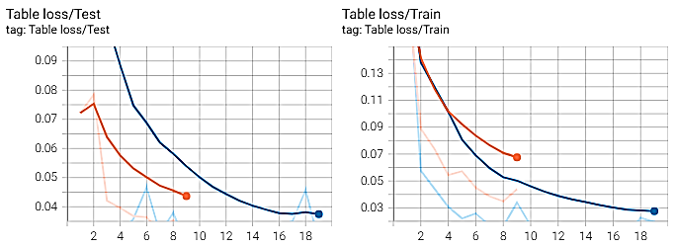

**Our Proposed Architecture**

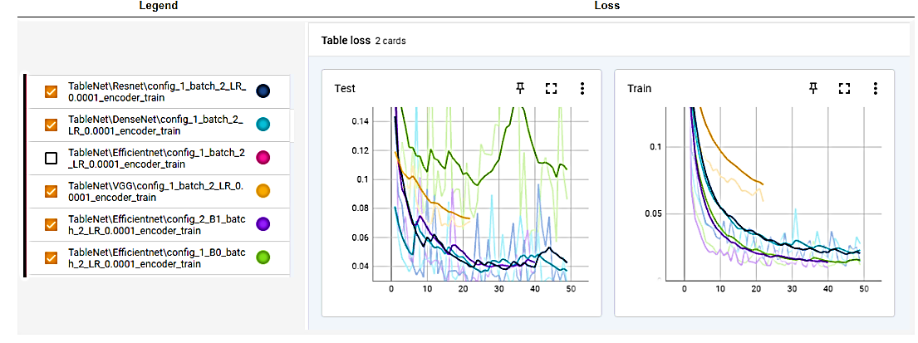

**Original TableNet**

**Column Loss**

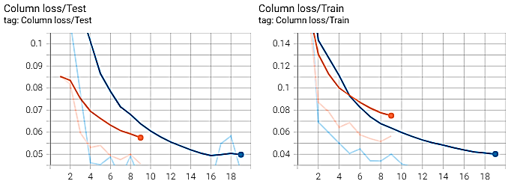

**Our Proposed Architecture**

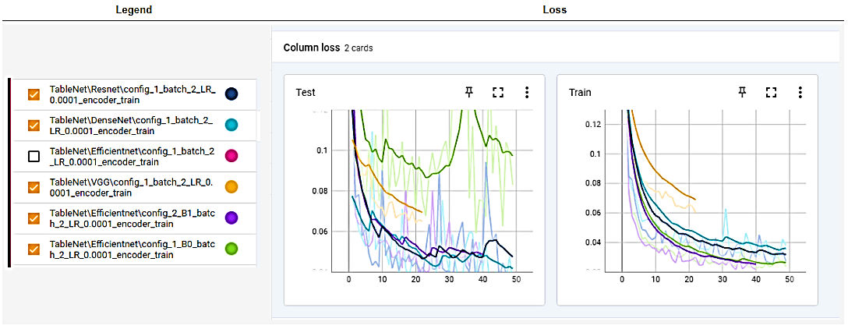

**Original TableNet**

**F – 1 Scores**

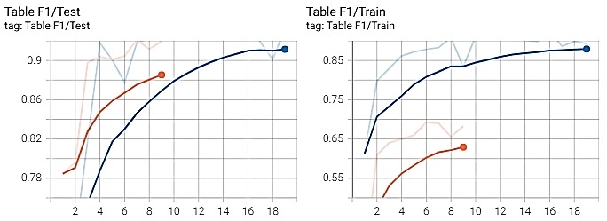

**Our Proposed Architecture**

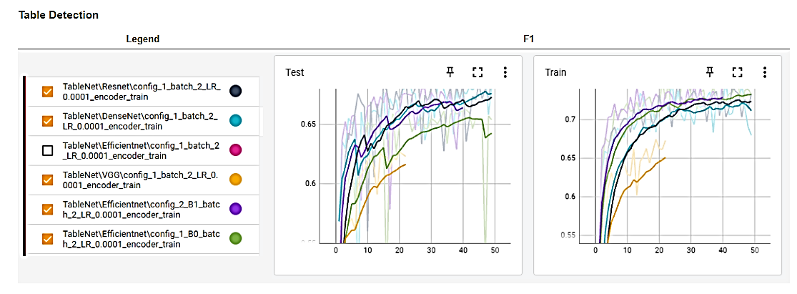

**Original TableNet**