**1)** Estimate the mass of a piston that can be supported by a gas entrapped under the piston in a 250 mm diameter vertical cylinder when a manometer indicates a difference of 117 bar for the gas pressure.

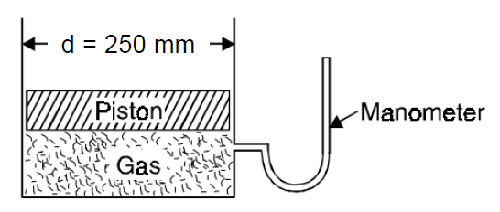

**2)** Gas from a bottle of compressed helium is used to inflate an inelastic flexible balloon, originally folded completely flat to a volume of 0.5 m3. If the barometer reads 780 mm Hg, what is the amount of work done upon the atmosphere by the balloon? Express the work done in any two different unit systems.

**3)** A piston and cylinder machine containing a fluid system has a stirring device as shown in Figure. The piston is frictionless, and it is held down against the fluid due to atmospheric pressure of 103.3 kPa. The stirring device is turned 9600 revolutions with an average torque against the fluid of 1.05 Nm. Meanwhile the piston of 0.6 m diameter moves out 0.65 m. Find the net-work transfer for the system. What will happen if we make the system adiabatic in nature?

