**Biological Systems & Thermodynamics**

## Abstract

***Thermodynamics deals with the study of heat flow through different systems in different conditions. Biological thermodynamics deals with energy transductions within living organisms. Thermodynamics plays an important role in studying the functioning of different chemical processes that take place within these systems.***

## Technical Point of View

### Energy Transformation

Energy transformation taking place within our systems are determined with the help of thermodynamics. Sun is the most important form of energy for living organisms and the formula that determines the wavelength and frequency for this energy is given by:

### 

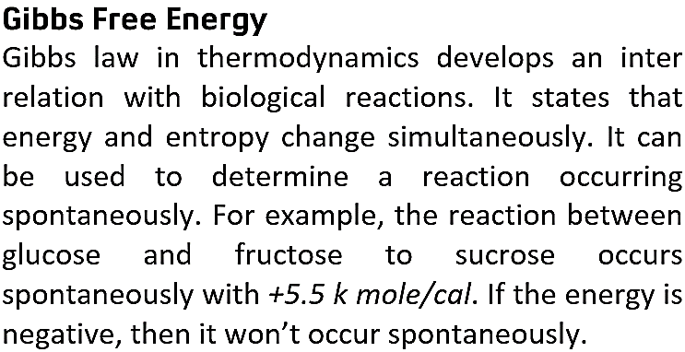

## Experimental Point of View

### Bioengineering Of Thermodynamics of Cells

Cells are complex thermodynamics systems. They are regarded as complex engines to run different thermo-electrical-chemical processes. Different thermo-biochemical behaviors occur between health and disease states. The heat is dissipated into the environment which can be a new approach to study the behavior of cells and control their behavior. The total entropy of the closed biological system dissipating heat in disease state is given by:

The analysis of this new approach concludes that cell behaviors are based on the ion fluxes across the cell membranes.

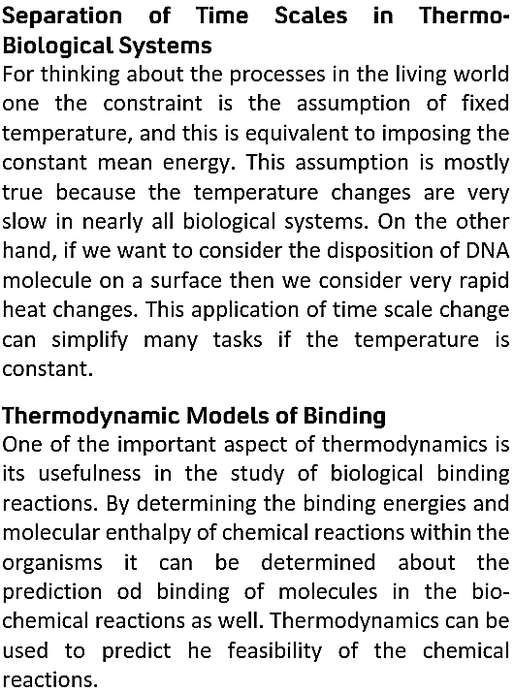

## Computational Point of View

### Energy Conservation in Living Organisms

The processes taking place inside the biological systems such as metabolism and catabolism are either endothermic or exothermic.

The above shows a highly exothermic reaction. Thermodynamics is used in computational aspect of calculation of enthalpies of reactions.

## Numerical Example

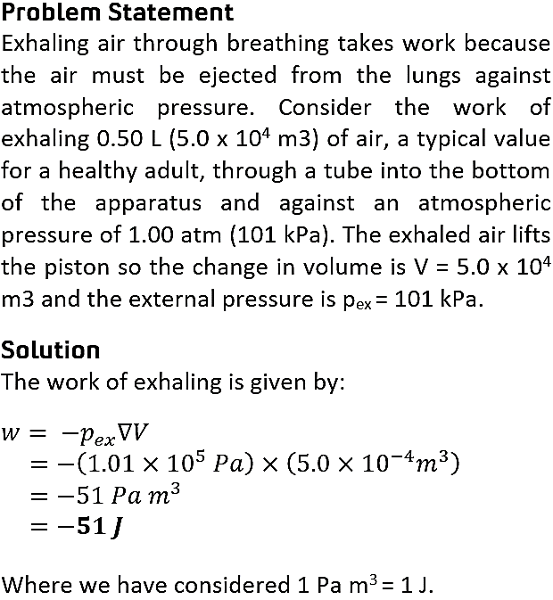

### ATP Cycle and Reaction Coupling

The most significant application of thermodynamics is around ATP and energy consumption rate which is an important parameter for modelling energy demands for cell growth.

The hydrolysis of ATP through water mediated breakdown Is also studied under thermo-biological reactions.



Reaction coupling is given by:

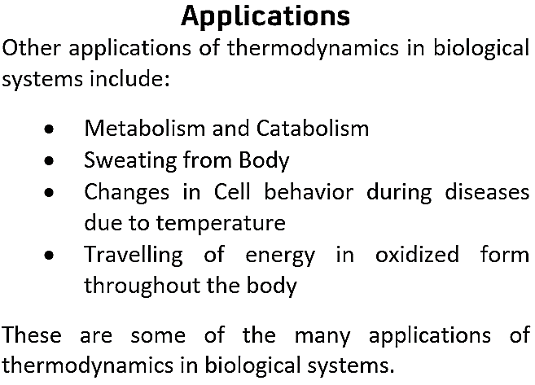

## Conclusion

Thermodynamics plays a vital role in determining the physical processes going on within the living bodies. From heat of enthalpies to physical binding of molecules everything can be predicted with the help of thermodynamics. Moreover, with the help of thermodynamics different physical applications are made such as calorimeter which are used in different places. In a nutshell everything involves thermodynamics.