**Nanotechnology & Thermodynamics**

## Abstract

***Nanotechnology is expected to significantly affect long-term development within and across many disciplines. However, when working with materials and particles at a much smaller scale, it becomes a challenge to keep unavoidable processes in – check and for that purpose we study the effects of thermodynamics on such a scale extensively, under a collective term of nanothermodynamics. This report aims to get a brief overview of the applications in which thermodynamics is extensively utilized and discuss their technical, experimental, and computational aspects.***

## Introduction

The laws and principles of thermodynamics find applications in almost all the sectors of science and engineering. Although the classicalthermodynamics laws uphold universally, however, they prove to be insufficient when dealing with the likes of genetics, microfluids, and nanoparticles, etc.

The primary premise of nanothermodynamics, as put forth by T. L. Hill, is that a large collection of subsystems must behave and act as a large system. Thus, nanothermodynamics serves as a bridge between the macro and microscopic thermal properties.

## Different Approaches to Nanothermodynamics

An overview of two of the most famous approaches to nanothermodynamics are discussed in this section:

### Hill’s Theory

Hill introduced a new thermodynamic potential by conceptualizing finite size effects within the macroscopic thermodynamics called the sub-division potential, *Usub*, and it is defined as:

**Where***: U is the internal energy, S is the entropy, V is the volume, N is the number of particles, Nsub is the number of sub-divisions*

Fundamentally, the sub-division potential*, U****sub***, denotes the change in required to take *N* interacting particles from a bath of clusters into the system.

### Tsallis’ Theory

Unlike Hill’s theory, the Tsallis’ approach aims to redefine entropy by considering the non – extensivity of small systems, rather than redefining internal energy *U*. The mathematics involved with this approach is too complex for the scope of this report.

## Practical Utilization of Nanothermodynamics

We shall only look at those applications of Nanothermodynamics that is both related to what has been discussed above as well as how relevant it is to the authors of this report, that is, university students.

### Microprocessors

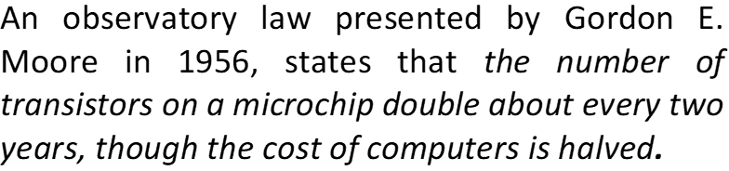

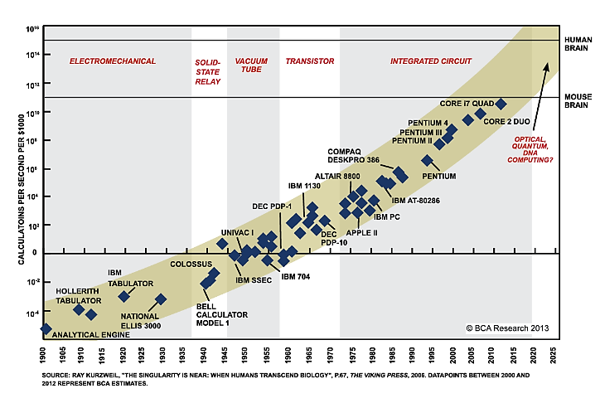

*Moore’s Law*

Presently, transistors in microprocessors reaching 10 – 3 nm in size, at this scale, traditional power dissipation methods, i.e., using copper heatsinks, delidding the chip, etc. fail to cool the ensemble down. The total power consumption of a CPU via logical activity of transistors is given by:



Cooling a microprocessor at this scale, becomes an extensive application of thermodynamics and poses a major challenge to the future of computation. This cooling demand may be represented as:



*Which is the required thermal resistance of the die*

Thermal management is arguably the biggest technical as well as an economic challenge in the fabrication of transistors. These thermal solutions are then faced with the problem of cost and is often the reason why newer technologies may find barriers to introduction particularly if it cannot supplant an existing product on a cost – efficiency basis. Collectively, all these factors are dealt with and under the study of Thermodynamics.

### Nanothermodynamic Properties of Ferromagnetic Nanoclusters

Nanostructural materials, compared to ordinary materials have much preferable and sophisticated thermal properties. The mean energy for each particle in such a cluster is given as:

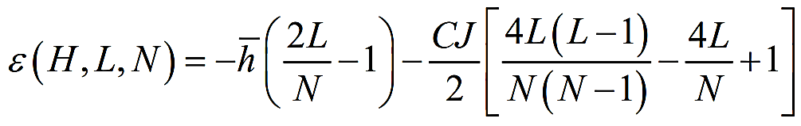

here represents the magnetic permeability of vacuum.

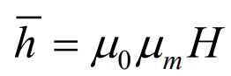

For this partition function, we can find the total thermodynamic properties as follows:





### 

### Low Temperature Sintering

*Sintering is defined as the collective result of thermally activated atomic level processes through diffusion, creep, plastic and viscous flow and evaporation.* The following expression the most common model for the sintering of free particles:

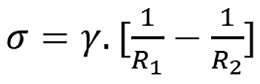

Where:

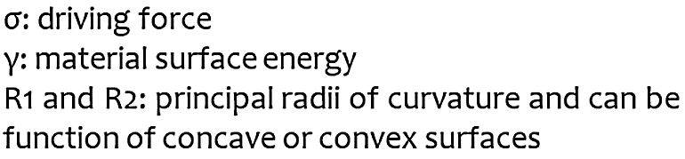

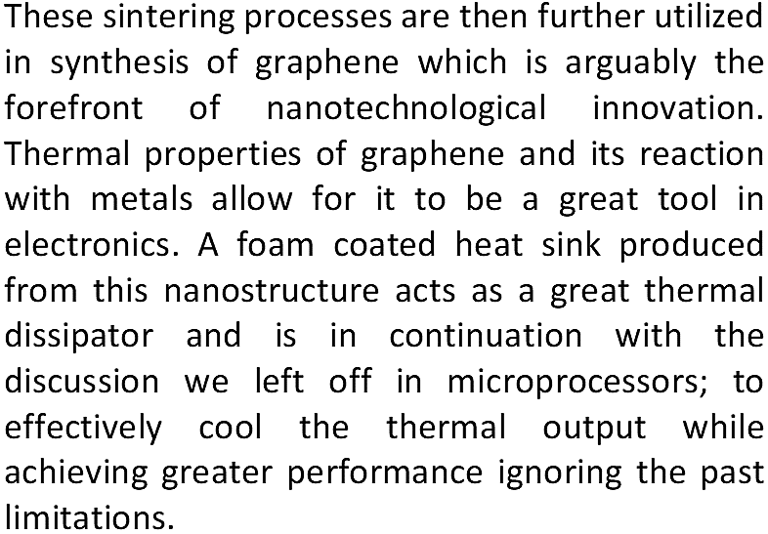

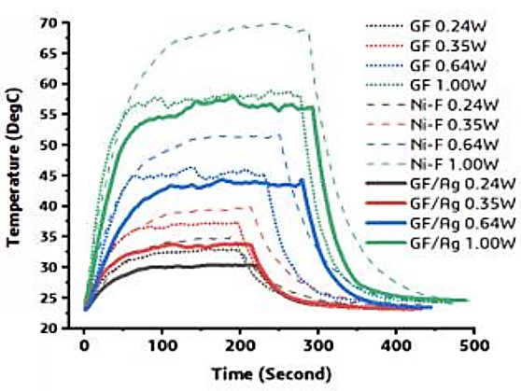

This graph displays and abstracts thermal cooling properties of graphene foam with respect to other modern day heat sinks.

## Conclusion

