**National University of Sciences & Technology**

**School of Electrical Engineering and Computer Science**

**Department of Basic Sciences**

**MATH-243: Vector Calculus (3+0): BEE-2k20-C Fall 2021**

|  |  |
| --- | --- |
| Activity # 1 | |
| Maximum Marks: $5$ | Instructor: Dr. Naila Amir |
| Date: $29-09-2021$ | Duration: 10 Minutes |
| Name: Muhammad Umer | CMS ID: **345834** |

**Question:**

Sketch the solid described by the following inequalities:

$$0≤r≤4\cos{θ}; 0≤θ≤\frac{π}{2}; 0≤z≤5.$$

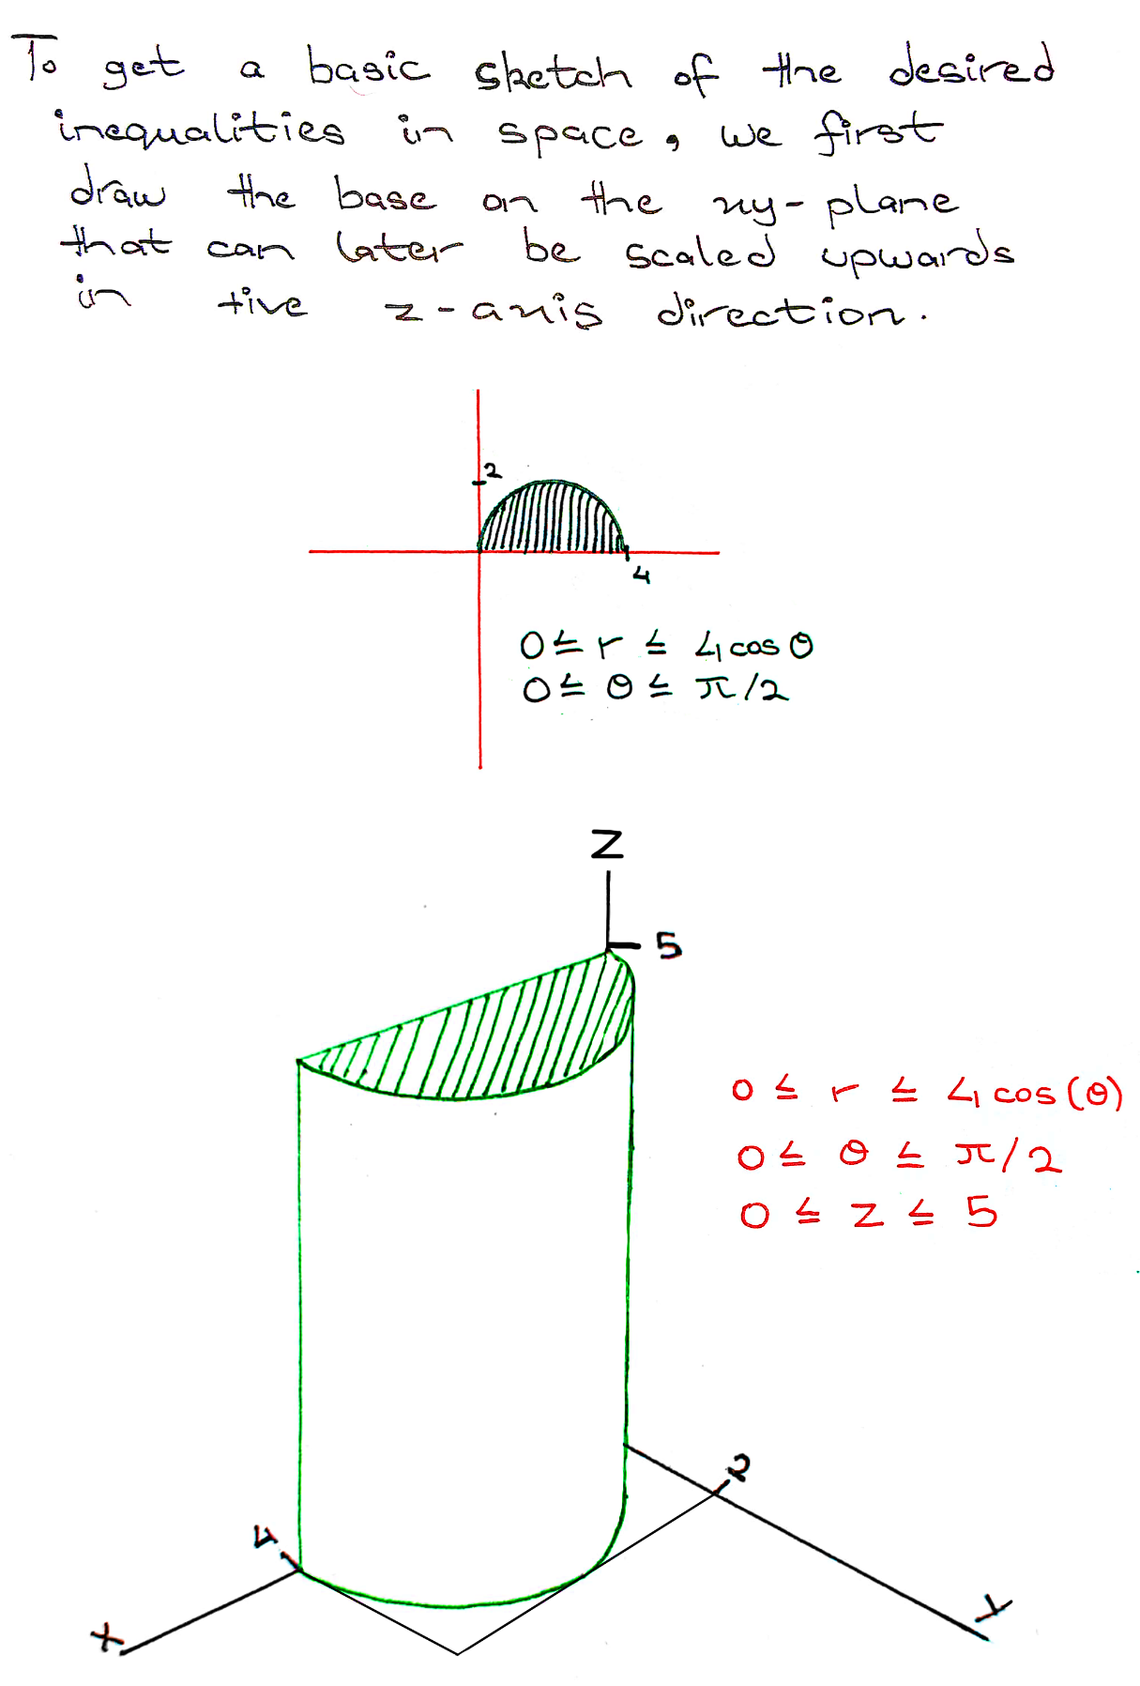

Where the highlighted sections imply that it is a solid cylinder rather than a hollow one; in case of an equality