

# NATIONAL UNIVERSITY OF SCIENCES & TECHNOLOGY

**Electromagnetic Field Theory (EE-241)**

**Assignment # 1**

|  |  |
| --- | --- |
| Submitted to: | Dr. Salman Ghafoor |
| Submitted by: | Muhammad Umer |
| Class: | BEE-12C |
| Semester: | 4th |
| Dated: | 22/03/2022 |
| CMS ID: | 345834 |

# Enhanced Design of PPE Based on Electrostatic Principle to Eliminate Viruses (SARS-CoV-2)

# Summary

The SARS-CoV-2 poses a great threat to human society due to its acute symptoms and its ability to spread from a multitude of ways; It can spread directly through the droplets exhibiting from someone infected with it or from it residing on contact surfaces which find their way then into the human body, etc. The former can only be controlled using mandates and imposing restrictions on human behavior while the infection through latter can be reduced to a much greater degree. It is of great significance especially as health workers get into contact with such surfaces at a much higher rate whilst treating patients of COVID-19 than a layperson.

The objective of this paper tends towards the mitigation of chances of catching SARS-CoV-2 through contact surfaces. From a simplistic perspective, a constructive and self-intuitive idea is presented; Knowing that proteins are the most important structural molecules of viruses, we can cause permanent damage to their structure in terms of electroporation followed by diffusion of ions causing them to disintegrate. The end result is a surface clean of residual droplets of the virus and health workers can now wear their Personal Protective Equipment (PPE) without any risk.

Delving into details and correlating it with existing products, it works much in the same principle as an air purifier or a mosquito swatter. While the air ionizer deposits negative static charge over a surface, the circuit under discussion accumulated positive charges on the metallic surface to produce a high intensity electric field. This alteration stems from multiple studies highlighting the significance of a strong electric field on a virus’ intermolecular structure; mainly in terms of electroporation.

The permanent deformation of the intermolecular structure of the protein within the virus is achieved by inducing a strong dipole in it by means of a strong electric field; Electric field and the induced dipole are strongly and directly related to each other. Mathematically, this relation is expressed as:

$$μ=α×\vec{E}$$

where $α$ is the polarizability factor, $μ$ is the induced dipole and $\vec{E}$ is the generated electric field. Thus, an alteration in electric field may cause a catastrophe leading to sudden damage in the permanent dipole on the body of protein due to its residual charge.

From literature, it is extracted that the coronavirus harbors a net negative residual charge on it and that a very high voltage of 1 – 100 kV is required for the electroporation of viruses to be effective. This voltage is generated from a DC step – up circuit, whose specifications we are now going to investigate. An important factor in this circuit is natural convection cooling; A high number of operating hours without any thermal heat dissipation can result in permanent damage of the equipment itself.

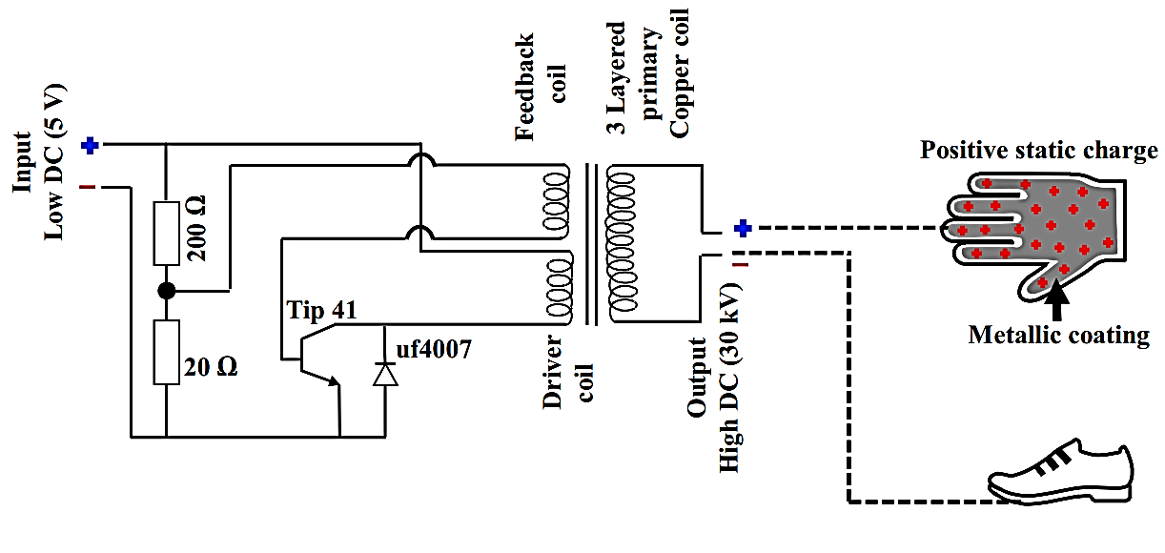

**Figure 1:** Schematic and working of the Circuit

To summarize and brief ourselves on the working of the circuit, we append in this report a figure provided in original paper. The internals of the circuit consist of transistors, a step-up transformer and a diode, effectively converting a 5V – 2A DC input initially to AC and then to a very high DC output. Before moving onto the working of the circuit itself, it should be noted that the most exposed part of the PPE is initially coated with a metallic layer of ablated nano-grooves to accommodate and make it viable for the equipment to be connected to the output of the circuit. Recent experimental work on such coatings points towards their ability to effectively distribute static charge on the very tips of the grooves, contributing towards increased overall conductivity at a microscopic level; Further increasing the build up for a strong electric field necessary to electroporate the protein molecules of the virus.

Since our primary goal is to accumulate positive charges on the metallic surface of the PPE (as coronavirus harbors net negative residual charge on it), we ground the negative terminal of the output (by connecting it to something as simple as a shoe) and the positive terminal is connected to the metallic surface in need of getting cleansed (such as the coated PPE gloves or a filter across the mask). The charge density continuously and gradually increases over the ablated surface causing the layers of air to ionize and induce a net outflow of electric field lines. This high intensity field causes the protein to first electroporate, followed by an electrochemical process, which is diffusion of salt ions into the protein, resulting in the desired disintegration.

Perhaps the greatest advantage of this development is that it can be readily built within a week from commercially available electronic components; implying that it is economically efficient as well. PPE of health workers when in the vicinity of the electrical array generated from the finalized circuit can remove the virus from the equipment’s surface, further enhancing the health worker’s protection as well as making the PPE reusable for a longer period of time, saving the expenses of the hospital.

# Relevancy of Equations with EMFT (EE - 215)

In order to develop the theory behind the technology to electroporate and disintegrate molecular proteins from residual virus particles, the authors, K. Uddip and K. S. Sandip, used theoretical assumptions and made use of equations that hold significant relevance in the course of Electromagnetic Field Theory. Following is a tabular list of such equations with a brief description of them formed from the relevant course material:

|  |  |
| --- | --- |
| **Equation** | **Description** |
| $$∇∙\vec{E}=\frac{ρ}{ϵ_{o}}$$ | Maxwell’s first equation, although substituting for $\vec{D}$; $\vec{D}=\vec{E}ϵ_{o}$; instead of the commonly used form, it states that *the effective electric field through a surface enclosing a volume is equal to the total charge within the volume* |
| $$∇×\vec{E}=0$$ | Maxwell’s second equation for static electric fields; it implies that an electric field is irrotational and since it encloses a simply connected domain, we can deduce that *an electric field is a conservative field* |
| $$W= -\int_{a}^{b}{\vec{F}∙d\vec{l}}$$ | Total work done / potential energy required in moving a charge Q from point a to point b; the negative sign indicates that work is being done by an external agent |
| $$F=\frac{1}{4πϵ_{o}}\frac{Q∙q}{r^{2}}$$ | Coulomb’s law, stating that the magnitude of the force of attraction or repulsion between two point charges is directly proportional to the product of the magnitudes of charges and inversely proportional to the square of the distance between them |
| $$W= -\int_{a}^{b}{\vec{E}∙d\vec{l}}$$ | Total work done / potential energy required in moving a *unit* charge Q, $\vec{F}=Q\vec{E}=\left(1\right)\vec{E}=\vec{E}$, from point a to point b; the negative sign indicates that work is being done by an external agent |
| $$∅(P)=-\int_{P_{o}}^{P}{\vec{E}∙d\vec{l}}$$ | Electrostatic potential difference between two points $P_{O}$ and $P$; note the similarity between this and the equation on the immediate row above, the original paper utilizes this similarity to form a protein – electrostatics relation |
| $$∅(P)=\frac{Q}{4πϵ_{o}r}$$ | Opening the integral above in terms of the position vector $r$; we also know that $\vec{E}=-∇∅$, substituting this in the equation at first row, we get the following relation $↓$ |
| $$∇∙∇∅=∇^{2}∅=-\frac{ρ}{ϵ_{o}}$$ | Poisson equation derived from Maxwell’s first equation by utilizing multiple theories and postulates revolving around electromagnetic fields |