

# NATIONAL UNIVERSITY OF SCIENCES & TECHNOLOGY

**Electromagnetic Field Theory (EE-241)**

**Assignment # 2**

|  |  |
| --- | --- |
| Submitted to: | Dr. Salman Ghafoor |
| Submitted by: | Muhammad Umer |
| Class: | BEE-12C |
| Semester: | 4th |
| Dated: | 20/04/2022 |
| CMS ID: | 345834 |

# Analysis on Electric Field Based on Three Dimensional Atmospheric Electric Field Apparatus

# Summary

Modern lightning location systems (LLSs) have become the most common way to address and geolocate lightning, typically in a thunderstorm. These have gained popularity in the recent years and serve as useful tool in confirming or negating lightning as a cause of damage in forensic investigations as well as administering a lightning warning to the residents of a particular area. However, conventional methods utilized in existing electric field meters can only detect the vertical component of the atmospheric electric field. As a result, electromagnetic propagation errors arise and impose uncertainties in the reported locations of detected lightning.

With an ever-increasing usage of electronic equipment in practically all fields of life, the probability of an electric system being struck by lightning increases as well. Hence, accurately detecting lightning and issuing a forewarning is a critical problem in modern science-backed society. There has been numerous research to identify the charge center in a thunderstorm, however, due to the complexity of the electric field enclosed in it, the atmospheric electric field is affected by the charge distribution in the cloud, as direct function of the changes to the cloud.

Even though some studies in the current literature measure the electric fields along all the three-axis, such as the electro-optic probe by Katsuki et al. or deductions made directly by utilizing the aircraft-based rotating-vane-type NASA’s Marshall Space Flight Center (MSFC), these usually have complex fabrication and an especially inflated cost. Another missing detail in the current literature is the dismissal of the influence of permittivity in the electric field.

In this paper, a 3D electric field model, as shown in the following figure, is proposed to attain a more realistic atmospheric electric field considering the influence of the permittivity. Here, $A$ and $B$ represent the observation sites, $α$ is the azimuth angle and $γ$ is the elevation angle of the thunderstorm.

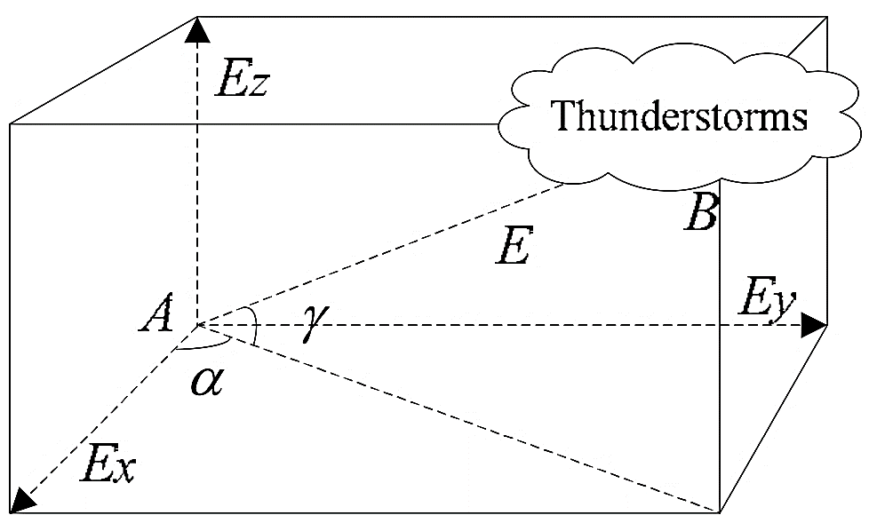

We assume the thunderstorm cloud to be a point charge and the Earth an infinite dielectric plane to obtain a potential distribution function of the thunderstorm at site A.

$$ϕ_{1}=\frac{1}{4πϵ_{1}}[\frac{q}{\sqrt{x^{2}+y^{2}+{\left(z-H\right)}^{2}}}-\frac{ϵ_{2}-ϵ_{1}}{ϵ_{2}+ϵ_{1}}\frac{q_{1}}{\sqrt{x^{2}+y^{2}+{\left(z+H\right)}^{2}}}]$$

Where $ϵ_{1}$ is the permittivity of the air and $ϵ_{2}$ is the permittivity of the dielectric.

The electric field distribution generated by the net charge in the air can be calculated from the identity: $E= -∇∙ϕ.$ Whereas, the distribution curve of electric field imposed by the thunderstorm above and below the ground can be plotted by the method of images.

Permittivity measurement unit is employed in our apparatus that works by changes in the capacitance through different filling mediums between the electrodes. In the figure modeling this unit, Electrodes 1 and 2 are the measurement electrodes whereas 3 and 4 provide the shielding from interference of environmental electric field. The difference $∆C$ of capacitance $C_{x}$ and $C_{air}$ is a linear function of measuring material’s permittivity. The permittivity can then be calculated as: $ϵ_{r}=\frac{∆C}{C_{air}}+1$.

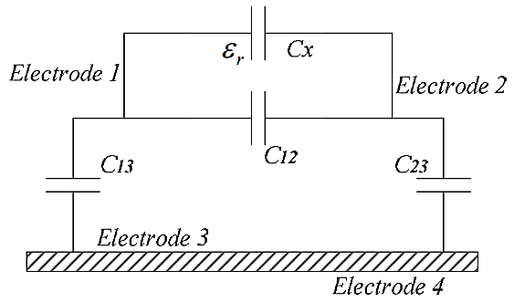

The schematic flowchart of the proposed apparatus is given below. The two sensors (that have already been briefed over previously) convert analog data into electrical pulses that are now ready to be conditioned and converted to digital signals. These digital signals are finally sent to the main control system for acquisition and appropriate calculations to find the potential function and plot out the distribution curve of the electric field.

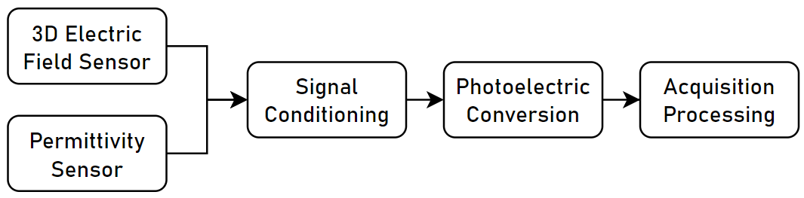

In this study, a high precision electric measurement device was attained through a three dimensional electric field meter with permittivity sensors incorporated into it so as to consider the influence of electric permittivity as well. The results obtained from this apparatus are satisfactory enough to ensure continuous monitoring of atmospheric electric field data.

At the same time, it provides the basis for future multi-station thunderstorm placement, as well as autonomous monitoring and early warning of thunderstorms using cluster analysis. Collectively, this study should assist improve the accuracy and dependability of the lightning automatic warming system.