**Department of Electrical Engineering and   
Computer Science**

**Faculty Member:** Dr. Shakeel Alvi **Dated:** 03/02/2022

**Semester:** 4th **Section:** BEE 12C

**EE-215:** **Electronic Devices And Circuits**

Lab 1: Familiarization with PSpice

**Group Members**

|  |  |  |  |  |
| --- | --- | --- | --- | --- |
| **PLO4/CLO4** | | **PLO5/CLO5** | **PLO8/CLO6** | **PLO9/CLO7** |
| **Name** | **Reg. No** | **Viva /Quiz / Lab Performance**  **5 marks** | **Analysis of Data in Lab Report**  **5 marks** | **Modern Tool Usage**  **5 marks** | **Ethics and Safety**  **5 marks** | **Individual and Team Work**  **5 marks** |
| **Tariq Umar** | **334943** |  |  |  |  |  |
| **Saad Bakhtiar** | **341150** |  |  |  |  |  |
|  |  |  |  |  |  |  |
|  |  |  |  |  |  |  |
|  |  |  |  |  |  |  |

# Laboratory Experiment # 1

## Objectives

1. Learn to set up and implement circuits on PSpice
2. To further expand on the features offered in the PSpice tool-kit
3. Further strengthen their concepts of circuit analysis

## Equipment

The following will be required in this lab experiment:

## Lab PC

## PSpice Software

## Introduction to PSpice

An electrical simulation software, in general, employs mathematical models to mimic the behaviour of real-world electronic devices or circuits. Simulation software is a vital analytical tool that allows you to model circuit operation. Simulating a circuit's behaviour before creating it can help designers save time and money by identifying incorrect layouts and offering insight into the behaviour of electrical circuit designs.

Such a tool becomes an indispensable tool for analysis, design, simulation, and testing prior to circuit implementation on the breadboard and subsequent prototyping as the students progress through the course.

PSpice offers an easy and intuitive way to get simulated values of a circuit. It has the benefit over other simulation softwares in that it does not require connecting a virtual multimeter across different nodes; instead, it provides all nodal voltages, power, and currents through each element instantaneously.

## Conduct of Lab

The students are required to work in groups of four; each student must attempt to understand and use the laboratoy set-up and conduct at least one or two parts of the requirement experimentation.The lab engineer will be available to assist the students. In case some aspect of the lab experiment is not understood the students are advised to seek help from the teacher, the lab attendent or the assigned Lab Engineer.

### Exercise 1

The first part of the lab is briefly given below:

1. **Creating and Simulating a Circuit in PSpice.** For this exercise refer to section 2.1.1 – 2.1.3 and 2.2.1 of the primer. Using the tutorial provided as a guide, simulate the following circuit (figure 1) in PSpice and list down the required values mentioned.

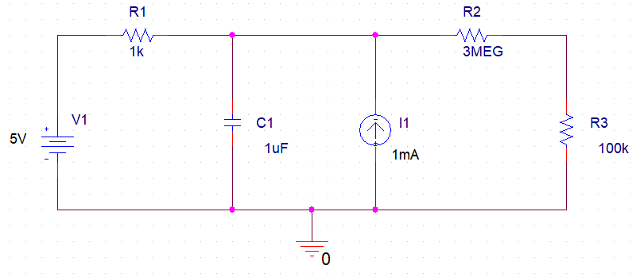

**Figure 1**

1. Determine the voltage and current across the resistor R1.

**VR1 = -0.998 V**

**IR1 = 0.998 mA**

1. Determine voltage and current across the capacitor C1

**VC1 = 5.998 V**

**IC1 = 0 A**

1. Determine the voltage and current across the resistor R2.

**VR2 = 5.805 V**

**IR2 = 1.935 uA**

1. Determine the voltage and current across the resistor R3.

**VR3 = 193.5 mV**

**IR3 = 1.935 uA**

## Simulation Settings & Schematic

The values of voltage and current across each element as asked for in parts b, c, d, and e were filled out with the aid of the figure following the simulation settings.

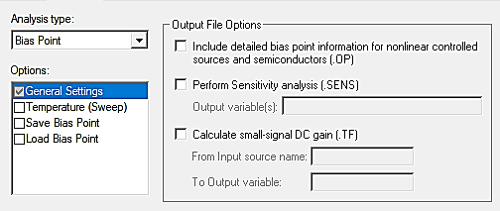

## 

### Exercise 2

This part of the experiment is for dynamic simulations:

1. **DC Sweep Simulation**. A DC sweep is used to check the response of the circuit across a range of DC voltages. For this exercise refer to section 2.2.2 of the primer guide and simulate the circuit given below (figure 2) for voltage 0-20V with a step size of 0.1V.

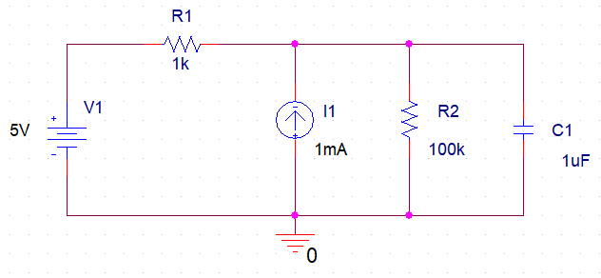

**Figure 2**

1. Use DC Sweep simulation tool to create a graph of **Vin vs. Vout**. Print this graph or save it as a soft copy to be used later for printing purposes.

## Simulation Settings & Schematic

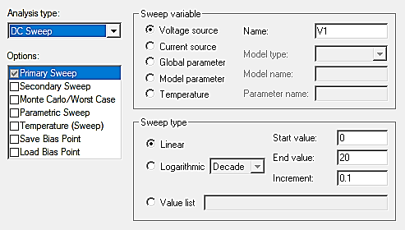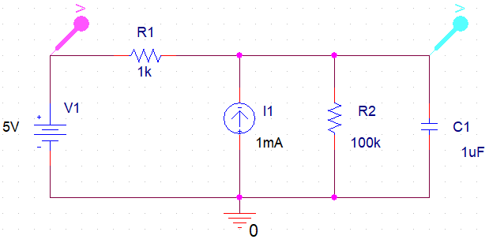

Simple voltage markers are connected at both the source voltage and the capacitor in order to plot the graph of the **input voltage Vin and capacitor voltage Vout.**

## Voltage Graph

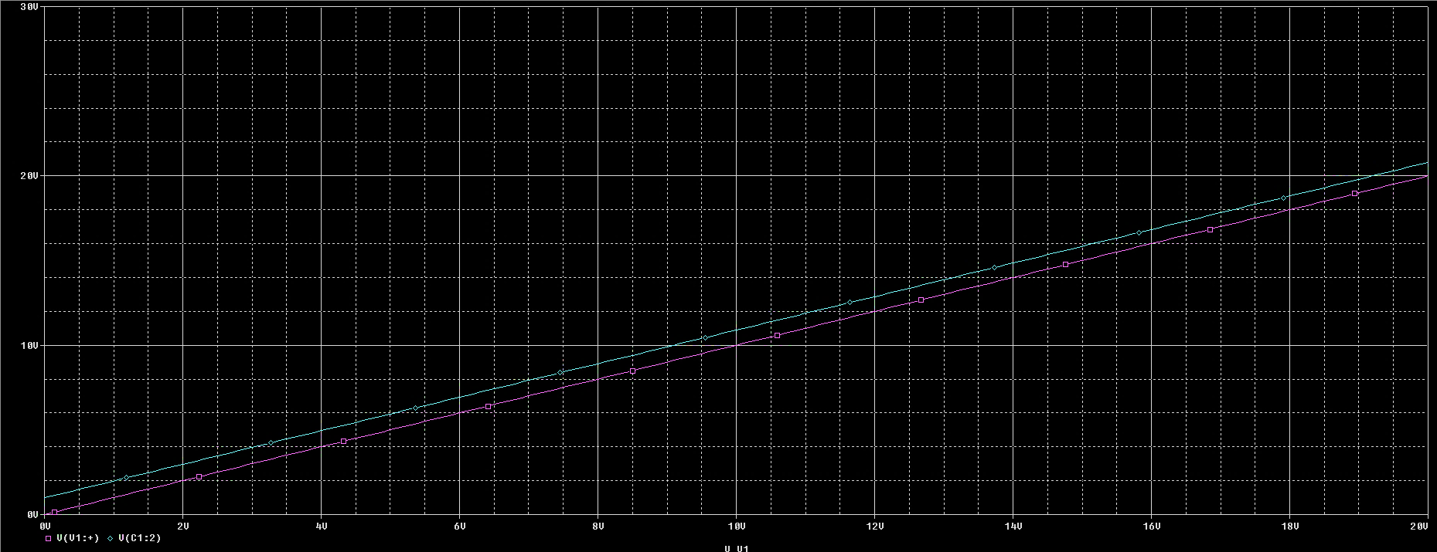

### Exercise 3

This part will allow the students to use transient analysis for dynamic simulations.

1. **Transient Analysis.** Transient Analysis involves simulating the circuit voltage or current w.r.t time. For this exercise refer to section 2.4.1 of the primer guide, and perform transient analysis on the following circuit.

* **Time Domain: Run Time: 1000ms**
* **Use Differential Probes**

*First observe capacitor and source voltages then remove all probes and connect only current probe to observe capacitor current.*

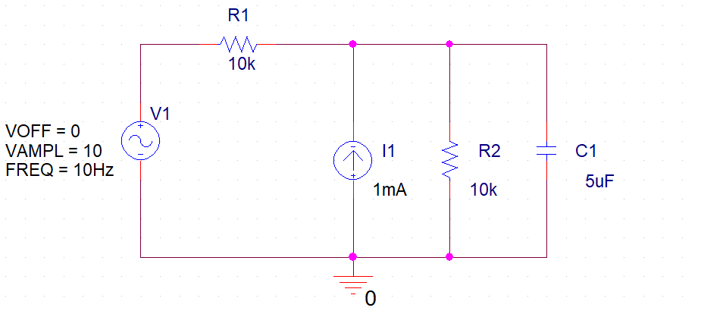

**Figure 3**

1. Enter the values of V1 and I1 as given in Figure 3. Use the transient analysis tool to create a graph of **Vc** and **Ic** versus time. Save the graph and get printout. Can you get a plot of **Vin versus Vc**?

## Simulation Settings & Schematic

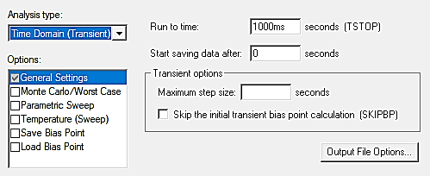

## VC vs. Time

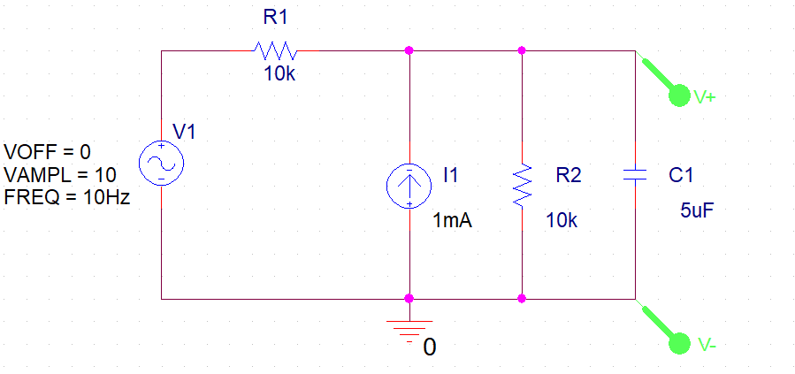

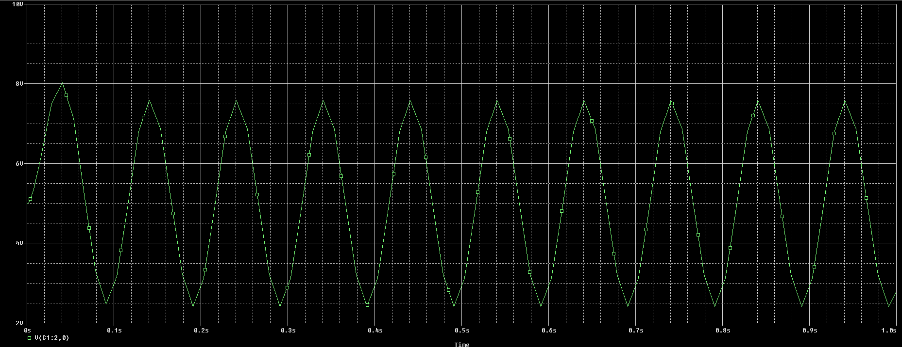

## IC vs. Time

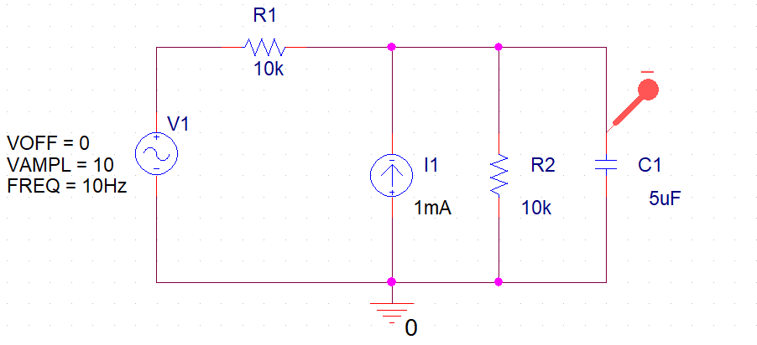

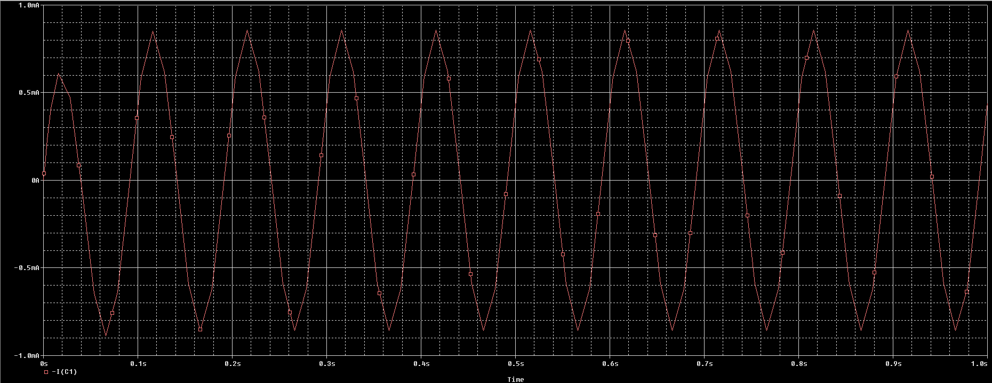

## VIN and VC vs. Time

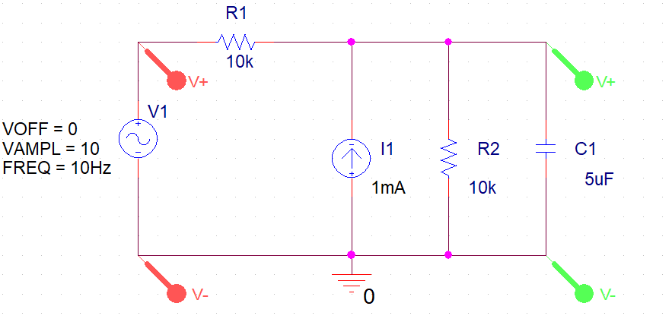

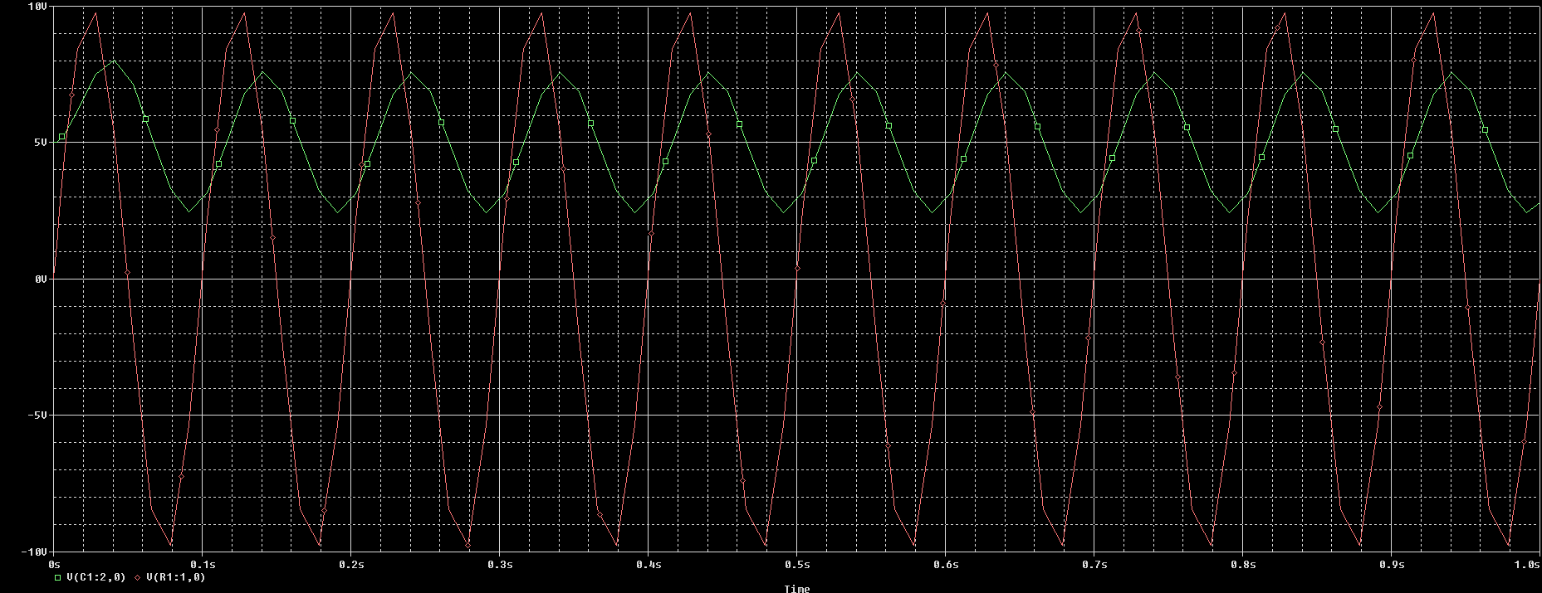

## Note

* Make sure your work is saved and you show the LAB ENGINEER actual simulations that you have performed.
* Lab report is due before the start of next lab

### Conclusion

After the conduction of this lab, we have learnt how to setup and create a project on PSpice, run a simulation and find the values of voltages across and current through different components within a closed circuit. We also played around different simulation profiles relevant to the respective exercises to get a broader grasp over the fundamentals of simulating electrical circuits within the Cadence toolkit.