**Department of Electrical Engineering and   
Computer Science**

**Faculty Member:** Dr. Shakeel Alvi **Dated:** 03/02/2022

**Semester:** 4th **Section:** BEE 12C

**EE-215:** **Electronic Devices And Circuits**

Lab 1: Familiarization with PSpice

**Group Members**

|  |  |  |  |  |
| --- | --- | --- | --- | --- |
| **PLO4/CLO4** | | **PLO5/CLO5** | **PLO8/CLO6** | **PLO9/CLO7** |
| **Name** | **Reg. No** | **Viva /Quiz / Lab Performance**  **5 marks** | **Analysis of Data in Lab Report**  **5 marks** | **Modern Tool Usage**  **5 marks** | **Ethics and Safety**  **5 marks** | **Individual and Team Work**  **5 marks** |
| **Danial Ahmad** | **331388** |  |  |  |  |  |
| **Muhammad Ahmed Mohson** | **333060** |  |  |  |  |  |
| **Muhammad Umer** | **345834** |  |  |  |  |  |
| **Tariq Umar** | **334943** |  |  |  |  |  |
| **Saad Bakhtiar** | **341150** |  |  |  |  |  |

# Laboratory Experiment # 1

## Objectives

1. To gain working knowledge and to explore the features of PSpice the Simulation software.

## Equipment

The following will be required in this lab experiment:

## Lab PC

## PSpice Software

## Introduction to PSpice

1. PSpice is an acronym for Personal Simulation Program with Integrated Circuit Emphasis. Generally an electronic simulation program uses mathematical models to replicate the behavior of actual electronic devices or circuits. Simulation software allows for modeling of circuit operation and is an invaluable analysis tool. Simulating a circuit’s behavior before actually building it can greatly improve design efficiency by making faulty designs known as such, and providing insight into the behavior of electronics circuit designs. As the student go along in the course the use of PSpice will become an essential tool for analysis, design, simulation and testing prior to circuit implementation on the breadboard and subsequently building of a Prototype.
2. PSpice is a powerful tool that allows you quickly obtain the complete list of voltages and currents for any given circuit. Moreover it can be used to display simulation results graphically.The graphing tool is really powerful and has many variations which will be helpful n understanding component characteristics, behaviour and performance under various stimulations and circuit conditions. The student is encouraged to explore various features of PSPICEand master its use.
3. During this lab the student will laso be using a document that has been dveloped by University of Pennsylvania titled PSpice: A Brief Primer . This is available as as a Adobe PDF file on your PC; in case you are unable to find it please contact the Lab Engineer, the Lab assistant or your instructor. Please read this document throughly especially it section 1 before proceeding ahead. The Lab Engineer will be conducting a Viva Voce during the lab and grade you accodingly.
4. The students are required to fill in various simulation results and graph that were generated during the corse of this lab as attachments to the LAB REPORT which will be submitted before start of next Lab.

### Exercise 1

The first part of the lab is briefly given below:

1. **Creating and Simulating a Circuit in PSpice.** For this exercise refer to section 2.1.1 – 2.1.3 and 2.2.1 of the primer. Using the tutorial provided as a guide, simulate the following circuit (figure 1) in PSpice and list down the required values mentioned.

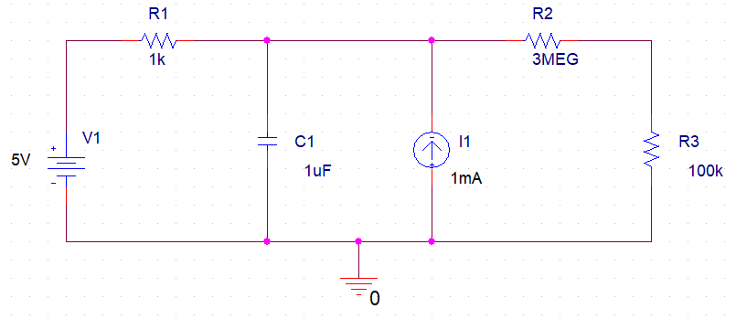

**Figure 1**

1. Determine the voltage and current across the resistor R1.

**VR1 = -0.998 V**

**IR1 = 0.998 mA**

1. Determine voltage and current across the capacitor C1

**VC1 = 5.998 V**

**IC1 = 0 A**

1. Determine the voltage and current across the resistor R2.

**VR2 = 5.805 V**

**IR2 = 1.935 uA**

1. Determine the voltage and current across the resistor R3.

**VR3 = 193.5 mV**

**IR3 = 1.935 uA**

## Simulation Schematic

## 

### Exercise 2

This part of the experiment is for dynamic simulations:

1. **DC Sweep Simulation**. A DC sweep is used to check the response of the circuit across a range of DC voltages. For this exercise refer to section 2.2.2 of the primer guide and simulate the circuit given below (figure 2) for voltage 0-20V with a step size of 0.1V.

*Connect probes at in (source voltage) and out (capacitor voltage) points.*

*(Use simple Voltage marker)*

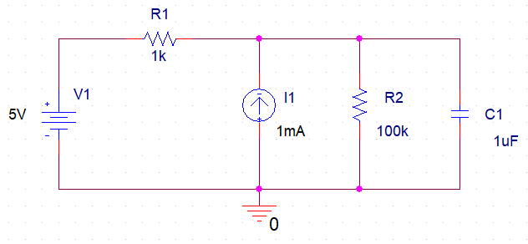

**Figure 2**

1. Use DC Sweep simulation tool to create a graph of **Vin vs. Vout**. Print this graph or save it as a soft copy to be used later for printing purposes.

## Simulation Schematic

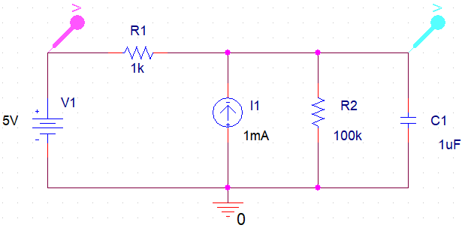

**Voltage Graph**

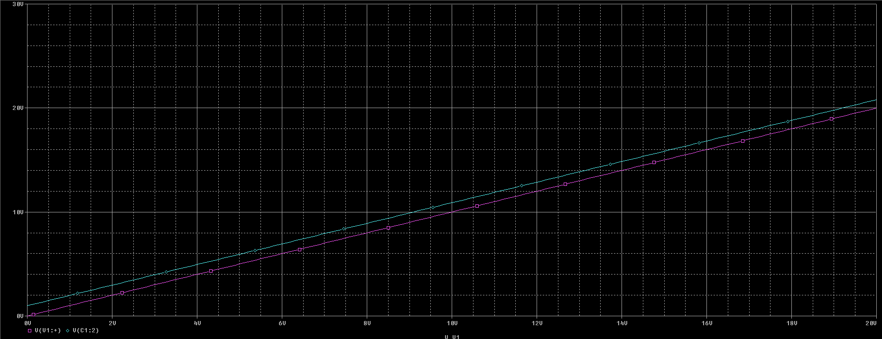

### Exercise 3

This part will allow the students to use transient analysis for dynamic simulations.

1. **Transient Analysis.** Transient Analysis involves simulating the circuit voltage or current w.r.t time. For this exercise refer to section 2.4.1 of the primer guide, and perform transient analysis on the following circuit.

* **Time Domain: Run Time: 1000ms**
* **Use Differential Probes**

*First observe capacitor and source voltages then remove all probes and connect only current probe to observe capacitor current.*

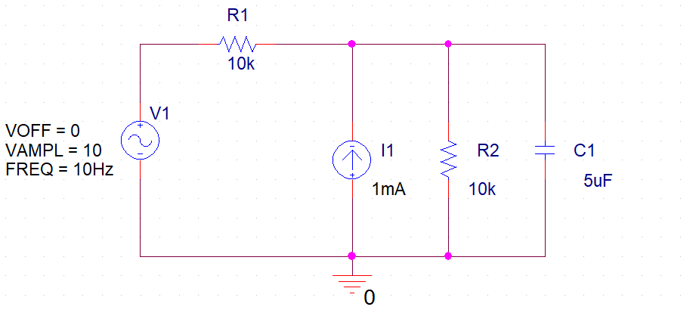

**Figure 3**

1. Enter the values of V1 and I1 as given in Figure 3. Use the transient analysis tool to create a graph of **Vc** and **Ic** versus time. Save the graph and get printout. Can you get a plot of **Vin versus Vc**?

**VC vs. Time**

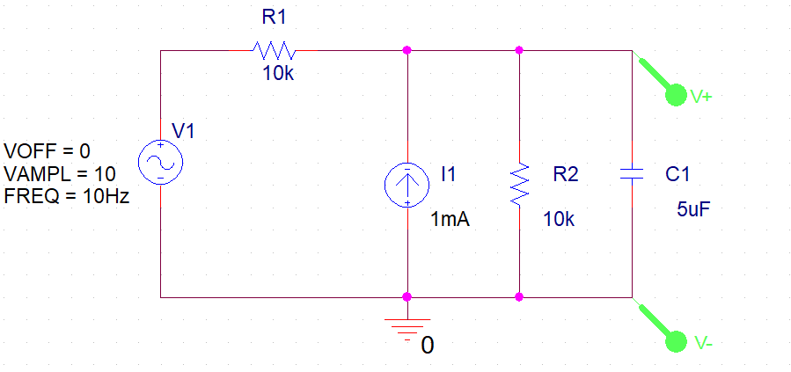

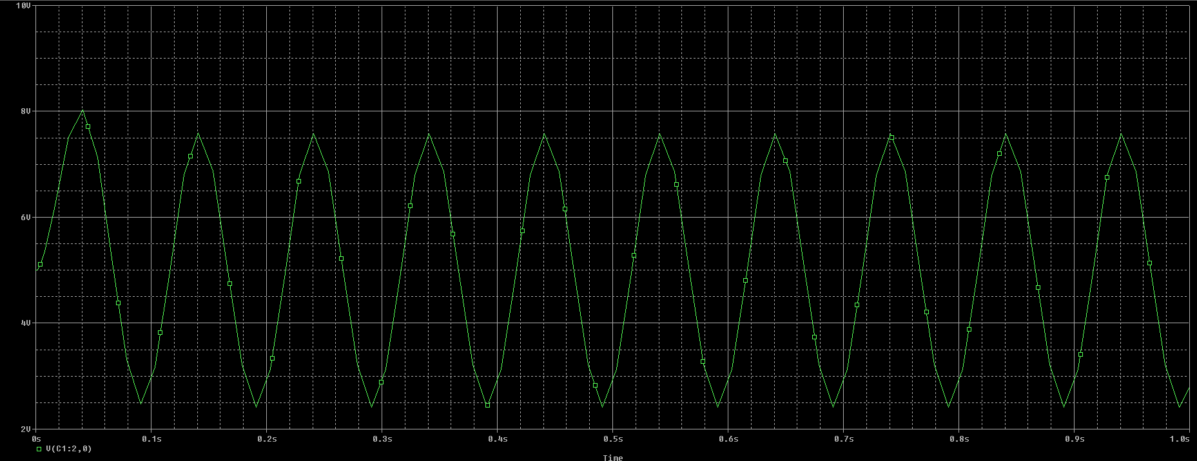

**IC vs. Time**

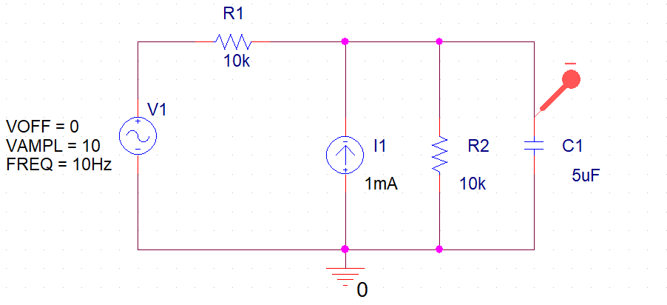

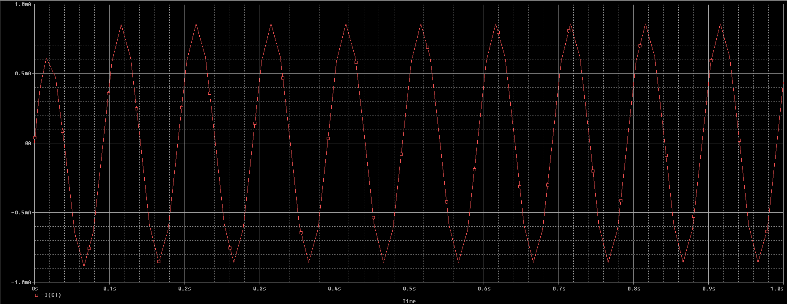

**VIN and VC vs. Time**

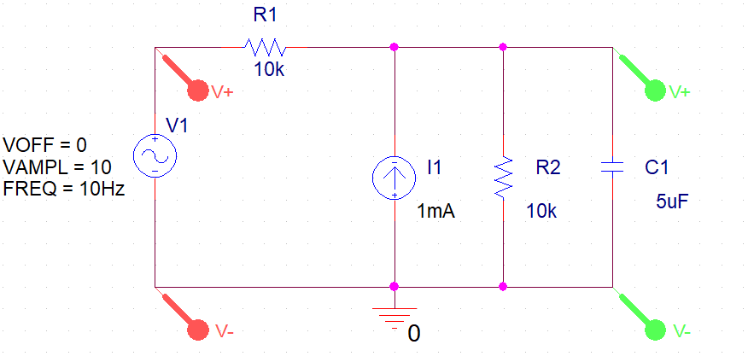

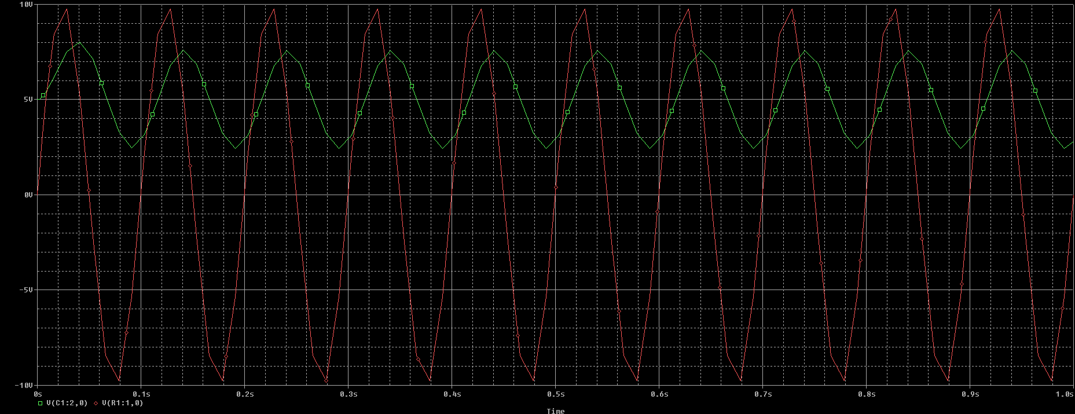

## Note

* Make sure your work is saved and you show the LAB ENGINEER actual simulations that you have performed.
* Lab report is due before the start of next lab

### Conclusion

After conduction of this lab, we have learnt how to setup and create a project on PSpice, run a simulation and find the values of voltages across and current through different components within a closed circuit. <bla bla>