**Department of Electrical Engineering and   
Computer Science**

**Faculty Member:** Dr. Shakeel Alvi **Dated:** 12/05/2022

**Semester:** 4th **Section:** BEE 12C

**EE-215:** **Electronic Devices And Circuits**

Lab 10: Emitter Follower

**Group Members**

|  |  |  |  |  |
| --- | --- | --- | --- | --- |
| **PLO4/CLO4** | | **PLO5/CLO5** | **PLO8/CLO6** | **PLO9/CLO7** |
| **Name** | **Reg. No** | **Viva /Quiz / Lab Performance**  **5 marks** | **Analysis of Data in Lab Report**  **5 marks** | **Modern Tool Usage**  **5 marks** | **Ethics and Safety**  **5 marks** | **Individual and Team Work**  **5 marks** |
| **Danial Ahmad** | **331388** |  |  |  |  |  |
| **Muhammad Ahmed Mohsin** | **333060** |  |  |  |  |  |
| **Muhammad Umer** | **345834** |  |  |  |  |  |
|  |  |  |  |  |  |  |
|  |  |  |  |  |  |  |

# Laboratory Experiment # 10

## Objectives

The primary objective of this lab is to help link theoretical knowledge of the students with practical skills, and to verify the values throughout the circuit (voltages across different nodes and current through different branches) of a BJT Emitter Follower, by means of theoretical calculations, simulation and implementation.

## Equipment

The following will be required in this lab experiment:

* 2N2222A Transistor
* DMM
* Oscilloscope
* Resistors
* Capacitors
* Power Supply
* PSpice Simulation Software

## Conduct of Lab

The common-emitter transistor amplifier configuration is widely used. It provides large voltage gain (typically tens to hundreds) and provides moderate input and output impedance. The AC signal voltage gain is defined as

*AV=Voutput / Vinput*

Where Voutput and Vinput can both be rms, peak, or peak-peak values. The input impedance, Zi, is that of the amplifier (as seen by the input signal). The output impedance Zo, is that seen looking from the load into the output of amplifier.

For the voltage-divider DC bias configuration Figure 1, all DC bias voltages can be approximately determined without knowing the exact value of transistor beta. The transistors AC dynamic resistance **re**  can be calculated using

*re = 26mV / IEQ mA*

AC voltage gain: The AC voltage gain of a CE amplifier under no load can be calculated using:

*Av= -Rc / (RE+re)*

# Exercises

## Exercise 1: Calculations

For the circuit in the following figure:

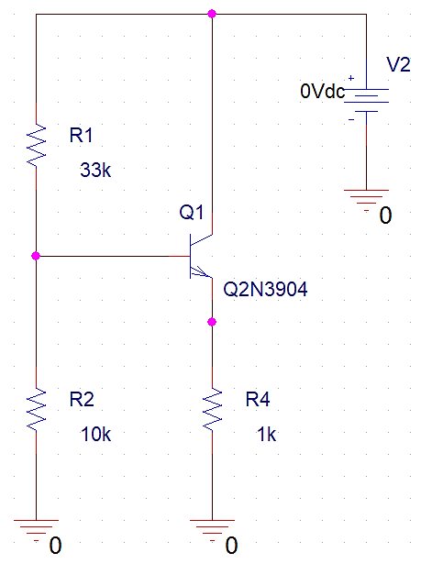

1. **Calculate the DC bias values for the circuit and record them below.**

VB (Calculated) = 2.242 V

VE (Calculated) = 1.570 V

VC (Calculated) = 10 V

IE (Calculated) = 1.57 mA

1. **Calculate re.**

re (Calculated) = 16.667 Ohms

1. **Calculate the amplifier voltage gain:**

**Av (Calculated)** = 1 V/V

## Exercise 2: Simulations



1. **Perform bias point analysis record the values.**

VB (Simulated) = 2.247 V

VE (Simulated) = 1.572 V

VC (Simulated) = 10 V

IE (Simulated) = 1.572 mA

1. **Now add the parts in the dashed boxes and perform a transient analysis. Display both input and output waveforms and sketch them.**

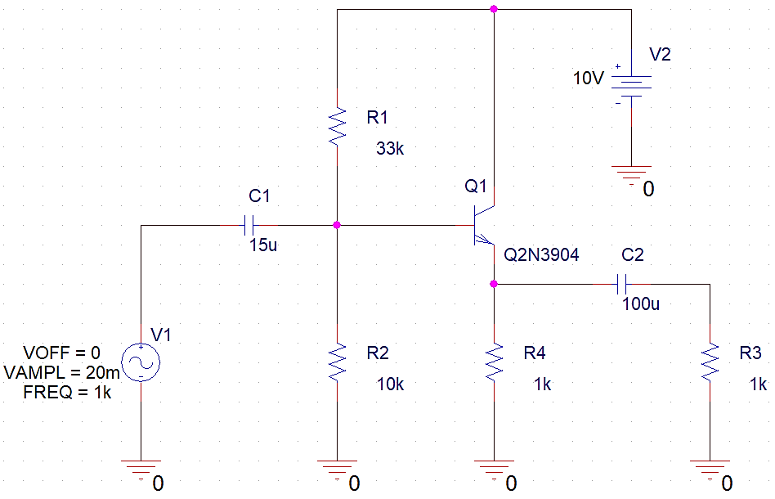

**Input / Output Waveform**

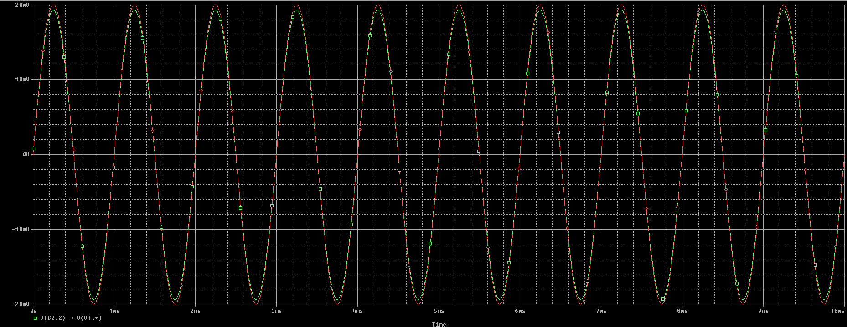

1. **Calculate the amplifier voltage gain for the bypassed emitter:**

**Av (Simulated) =** 1 V/V

1. **Comment on the proximity of the calculated and simulated values.**

The calculated and simulated values are very near to each other. However, the measured values deviate a bit more from the normal due to tolerance associated with each component as well as lack of accurate valued hardware.

# Conclusion

After performing this lab, we have achieved the following goals;

* Further expanded on the theory of transistors, more specifically BJTs
* Used a special BJT configuration to create an Emitter Follower
* Verified the results of circuit analysis through both simulation and implementation