**Department of Electrical Engineering**

|  |  |
| --- | --- |
| **Faculty Member: ­­­_______________** | **Dated: ________________** |
| **Semester:_____________** | **Section: ________________** |

**EE215: ELECTRONIC DEVICES AND CIRCUITS**

**Lab 10: Emitter Follower**

|  |  |  |  |  |
| --- | --- | --- | --- | --- |
| **PLO4/CLO4** | | **PLO5/CLO5** | **PLO8/CLO6** | **PLO9/CLO7** |
| **Name** | **Reg. No** | **Viva /Quiz / Lab Performance**  **5 marks** | **Analysis of data in Lab Report**  **5 marks** | **Modern Tool Usage**  **5 marks** | **Ethics and Safety**  **5 marks** | **Individual and Team Work**  **5 marks** |
|  |  |  |  |  |  |  |
|  |  |  |  |  |  |  |
|  |  |  |  |  |  |  |
|  |  |  |  |  |  |  |

# 

# LABORATORY EXERCISE-10

**Theory and Background**

**Common collector configuration has high input configuration and low output impedance. It has low voltage gain, high current gain and the power gain is medium. This configuration is mostly used for impedance matching, that is high impedance source is used to drive low impedance load.**

The common-collector amplifier is also known as an **emitter-follower**.

In electronics, a common collector amplifier (also known as an emitter follower) is one of three basic single-stage bipolar junction transistor (BJT) amplifier topologies, typically used as a voltage buffer. The voltage gain of an emitter follower is just a little less than one

*AV=Voutput / Vinput*

Where Voutput and Vinput can both be rms, peak, or peak-peak values. The input impedance, Zi, is that of the amplifier (as seen by the input signal). The output impedance Zo, is that seen looking from the load into the output of amplifier.

For the voltage-divider DC bias configuration Figure 1, all DC bias voltages can be approximately determined without knowing the exact value of transistor beta. The transistors AC dynamic resistance **re**  can be calculated using

**re=26mV / IEQ mA (Eq.1)**

**Assuming that IEQ≈ICQ**

AC voltage gain : The AC voltage gain of a CE amplifier under no load can be calculated using

**Av= RL / RL + re (Eq.2)**

AC input impedance is calculated using

**Zi= (B+1)( re** + **RL )****(Eq.3)**

AC output impedance is calculated using

**Zo=****re****(Eq.4)**

**Tutorial Link: https://www.youtube.com/watch?v=Z9ay3SND_h8&ab_channel=LearningElectronics**

**Part 1: Calculations**

For the circuit in figure 1.

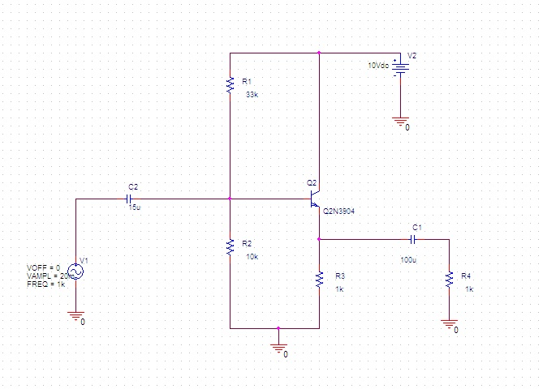

**Fig. 1: Common-Collector amplifier**

1. Calculate the DC bias values for the circuit of figure 1. And Record them below.

VB(Calculated)=________________

VE(Calculated)=________________

VC(Calculated)=________________

IE(Calculated)=________________

1. Calculate **re** using Equation 1.

re(Calculated)=________________

1. Calculate the amplifier voltage gain using Equation 2

Av(Calculated)=________________

**Part 2: Simulation**

1. Construct the circuit, shown in figure 1, in PSpice, Do not add the parts in dashed boxes initially.
2. Perform a bias point analysis and Record the values

VB(Simulated)=________________

VE(Simulated)=________________

VC(Simulated)=________________

IE(Simulated)=________________

1. Now add the parts in the dashed boxes and perform a transient analysis. Display both input and output waveforms and sketch them. (To simulate open circuit at C2, right click the unconnected pin of Capacitor. Create a new column/row and enter “FLOAT” in the name field and “RtoGND” in the value field.
2. Calculate the gain from the waveforms and record the value

Av(Simulated)=________________

1. Comment on the proximity of the calculated and simulated values for part b and d

**Part 3: Implementation**

1. Patch the circuit in figure 1 on a breadboard. **Do not** supply any AC voltage for the first part. Measure the resistances using handheld multimeter and note their values. (keep in mind that the capacitors are polarized. Longer pin is positive and shorter pin is negative
2. Measure the values of

VB(Measured)=________________

VE(Measured)=________________

VC(Measured)=________________

1. Using measured value of VE calculate IE i.e. VE (Measured)/ RE (measured)
2. Using results of Part C and equation 2, find out the **re**

**re(Practical):_________________**

1. Apply an AC signal V_signal=20mV, Peak to Peak with frequency of 1KHz. Observe the output waveform on an oscilloscope and **sketch it**. Measure the resulting output voltage.

Voutput:______________________

1. Calculate the gain of the implemented circuit and record the value below.

**Av(measured):_______________________**

1. Compare all the values especially **re** and **Av** for all the parts (calculated, measured and simulated) and comment on their proximity

**Make sure you have completed all the tasks**