**Department of Electrical Engineering**

|  |  |
| --- | --- |
| **Faculty Member: ­­­­_______________** | **Dated: ________________** |
| **Semester:_____________** | **Section: ________________** |

**EE215: ELECTRONIC DEVICES AND CIRCUITS**

**Lab 03: Characteristics & Applications of Diode**

**(Half Wave Rectification)**

|  |  |  |  |  |
| --- | --- | --- | --- | --- |
| **PLO4/CLO4** | | **PLO5/CLO5** | **PLO8/CLO6** | **PLO9/CLO7** |
| **Name** | **Reg. No** | **Viva /Quiz / Lab Performance**  **5 marks** | **Analysis of data in Lab Report**  **5 marks** | **Modern Tool Usage**  **5 marks** | **Ethics and Safety**  **5 marks** | **Individual and Team Work**  **5 marks** |
|  |  |  |  |  |  |  |
|  |  |  |  |  |  |  |
|  |  |  |  |  |  |  |
|  |  |  |  |  |  |  |

# LABORATORY EXERCISE -3

# Characteristics & Applications of Diode (Half Wave Rectification)

**Objective: To Study the Characteristics & Applications of Diodes**

1. The primary purpose of this lab is to develop a working knowledge of diode. Diodes can be used in variety of circuits for various applications such as rectifiers, clippers/clampers and voltage regulators.

**Components Required**:

1. The following components and test equipment is required.

* PN Diode (D1N4002 or any other diode of the same family)
* Oscilloscope
* Function Generator
* Resistors (1k)
* Capacitors
* Power Supply

**The Experiment:**

1. The experiment is broken down into two exercises. Each exercise has further been divided into parts. Part I involves the simulation of the circuit on PSpice using Orcad-Capture module. The second part involves the practical setup of this circuit and making required measurements, tabulation and its analysis.

**Exercise – I (Part A) [Simulation]**

1. The first part of the experiment is to draw a graph of the I-V relationship of a diode using PSpice; this may be .accomplish by using the DC sweep analysis mode of the simulation.

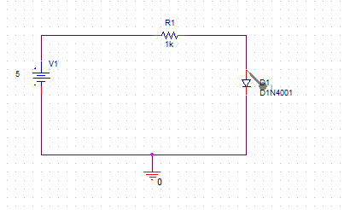

**Figure-1A_1**

* Draw the circuit shown in figure 1A_1 on OrCad capture. Please make sure you have saved the file.
* Since we are analyzing a diode, we would need to draw its I-V characteristic curve. To do that, we need to simulate our circuit using DC Sweep profile settings.
* Change the profile setting as shown in figure 1A_3. Please make sure that you know what do we mean by DC Sweep and how various value changes would affect the graph obtained.
* You should make sure that the name of the voltage source is V1. If there is a different name then you should change it accordingly.
* Place the current marker/probe at the anode(upper pin) of the diode and run the simulation.
* Observe the plot.
* Now Change the Values of DC Sweep and enter **0.1**  for **Start Value.**
* Repeat the experiment by selecting logrithmic scale (not in simulation setting, don’t change linear scale). This can be done by simply selecting the options shown in the given figure 1A_2.
* Note: Only change the scale on the X-Axis to log this can be done by pressing the button with **Vertical lines** as shown in figure 1A_2.

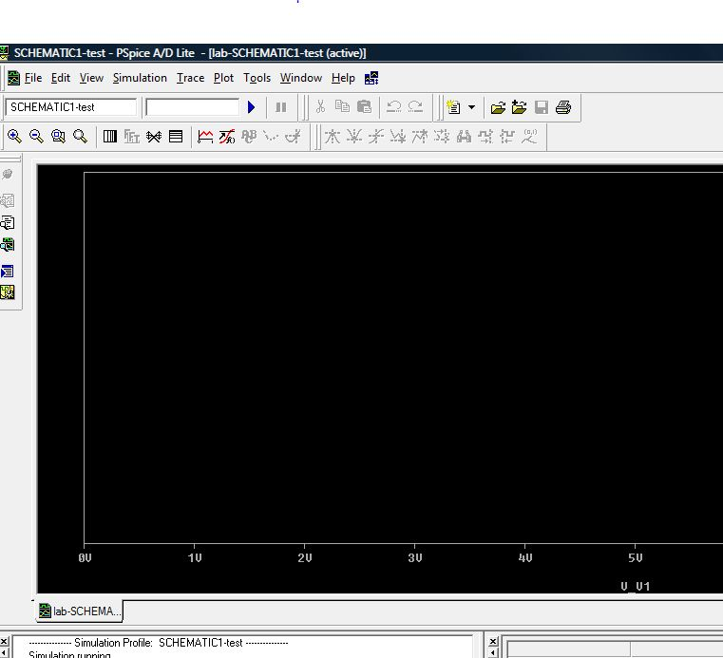

Use these to convert into log

**(Figure 1A_2)**

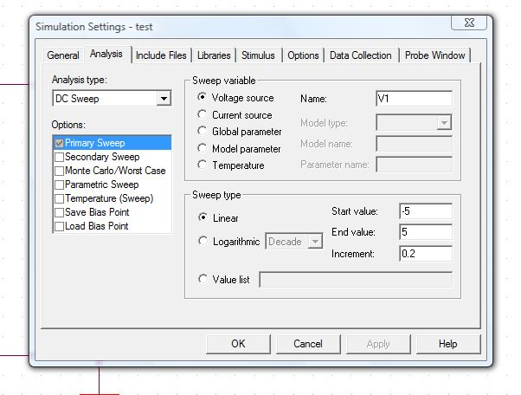

**(Figure 1A_3)**

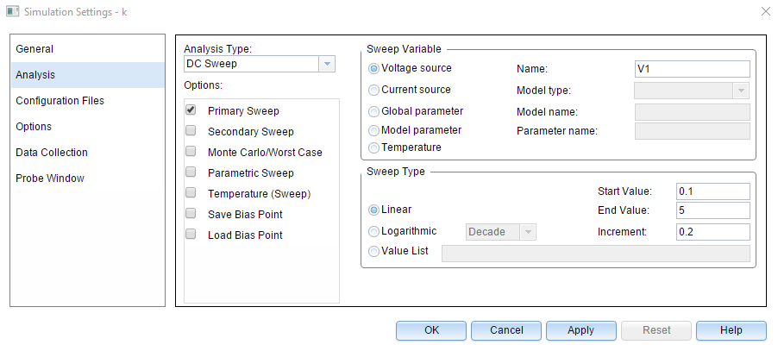

**This is a V-I curve as shown in Fig 0-1. Press Y1 button on a plot window or may be a vertical lines button is available.**

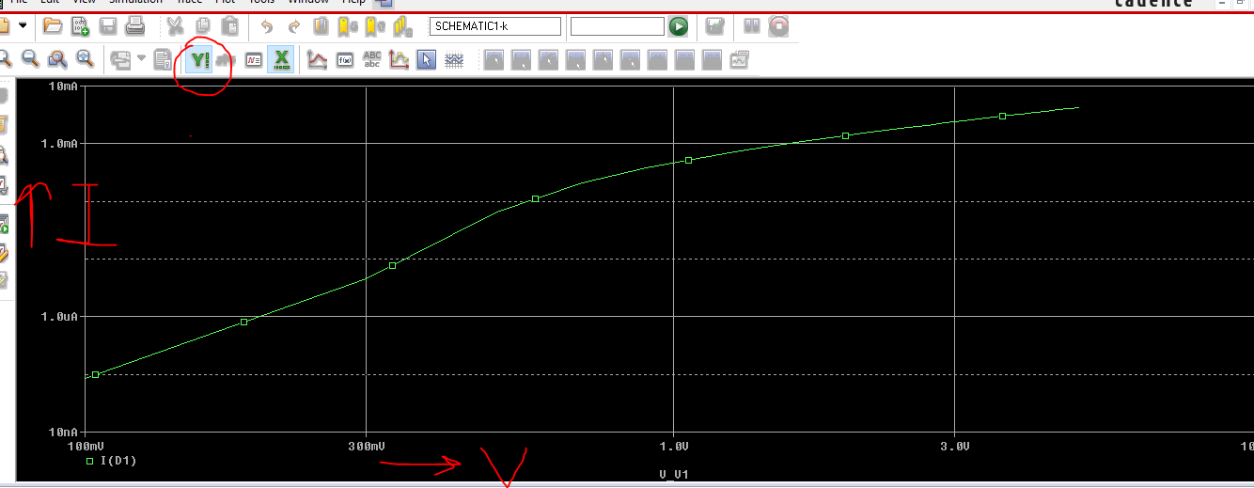

**Fig 0-1**

* Save both graphs and sketch them with explanation. Also, answer the following questions:
  + How can you explain the behavior of the diode by looking at the logarithmic curve?
  + What differences do you observe in the logarithmic curve and linear curve? Which scale would help you understand the diode behavior better?
* Diode resistance is an important parameter of the diode. To observe the change in RD with reference to increasing voltage, you need to follow the following steps:
  + Simulate the circuit given in figure 1A_1 using **linear scale** DC sweep simulation profile.

**Start Value:0**

**End Value:5**

**Increment:0.2**

* + After simulation, add trace as shown in the given figure 1A_4:
  + Change the X-Axis to VD or V(D1:1)
  + Observe the graph obtained

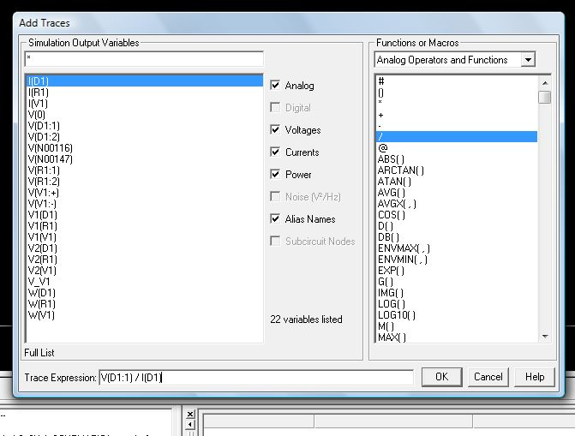

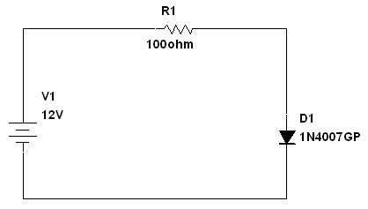**Figure 1A_4**

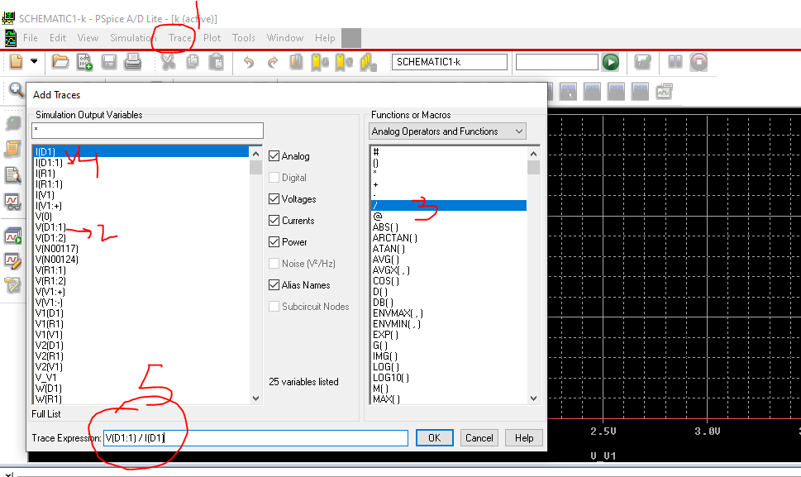

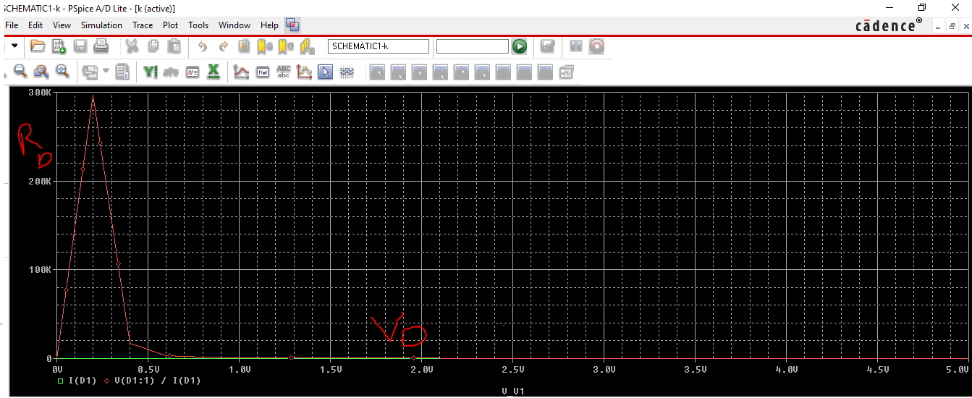

* The graph that you had seen so far was between Vin and ID. Now change the x-axis variable by following the steps as shown in figure 1A_5, figure 1A_6 and figure 1A_7. This would be ID vs VD curve of the diode. How can you explain the behavior of the diode from this curve?

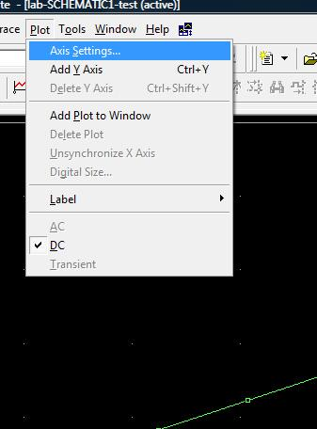

**(Figure 1A_5) – Go to axis settings**

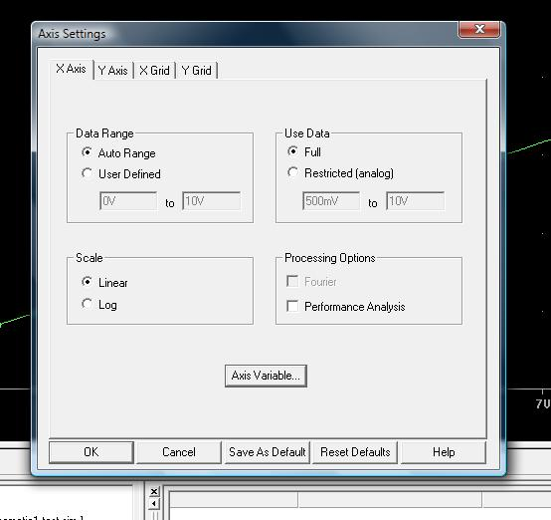

**(Figure 1A_6) – Here select the option “Axis Variable”**

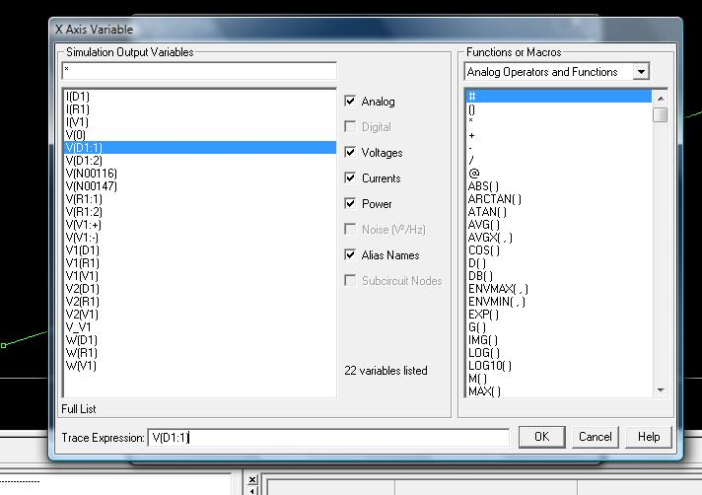

**(Figure 1A_7) – Add V(D1:1) as your x-axis variable**

**Your waveform should be look like this plot.**

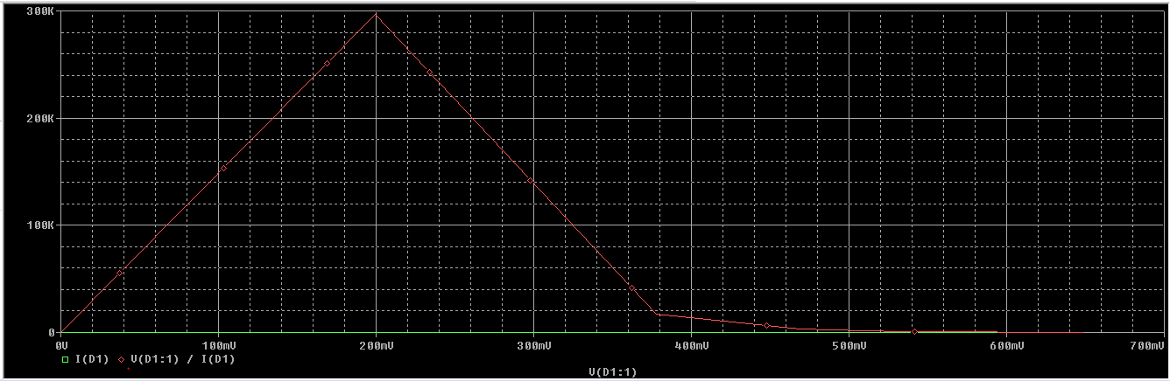

* Answer the following questions
  + Spot the threshhold/cut-in voltage of the diode from the **I-V characteristic** graph? Do you think it is a silicon based diode or germanium based diode? Explain your answer.
  + Explain the behaviour of RD with respect to VD as observed in the graph drawn.

**Exercise – I (Part B) [Implementation]**

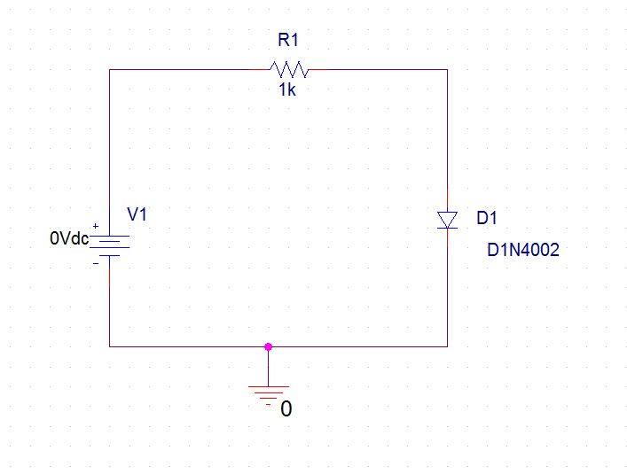

**(Figure 1B_1)**

1. This part of the experiment helps the students to set a simple diode circuit and take measurements for drawing the I-V curves.

**Procedure**

* On a breadboard, setup the circuit given as shown in figure 1B_1.
* Apply the input voltage gradually increasing it from 0V and onwards, in steps of 0.2 volts.
* Measure and tabulate the values of ID and VD until VD becomes almost constant

**Observations/Measurements:**

* Plot ID vs VD forward characteristics using both linear scale and logarithmic scale. Please make sure that you use MS Word/excel features for both linear scale and logarithmic scale plot and include the plot in your lab report. Please follow the lab report format provided by the instructor.
* Determine the threshold voltage of the diode and explain if it is Silicon or Germanium based diode.
* Calculate the values of RD at different input voltages. Plot the graph and explain.

**HALF WAVE RECTIFICATION**

**Exercise – II [Implementation]**

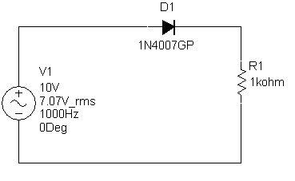

**D1N4002**

**Figure-2B Circuits for Half-Wave Rectifiers.**

**Procedure**

Set up the circuits given in fig-2B. Apply 10 volt peak sine wave as an input signal and see the output signal across the 1K Resistor, on oscilloscope for both, forward bias and reverse bias circuits.

**Observations/Measurements:**

* + Observe the Input and output waveforms on a dual trace oscilloscope. What differences are observed between input and output waveforms and why?
  + If we were to use two diodes in series, how would that affect the output of the circuit? Explain.



