**Department of Electrical Engineering and   
Computer Science**

**Faculty Member:** Dr. Shakeel Alvi **Dated:** 24/02/2022

**Semester:** 4th **Section:** BEE 12C

**EE-215:** **Electronic Devices And Circuits**

Lab 4: Full Wave Rectification

**Group Members**

|  |  |  |  |  |
| --- | --- | --- | --- | --- |
| **PLO4/CLO4** | | **PLO5/CLO5** | **PLO8/CLO6** | **PLO9/CLO7** |
| **Name** | **Reg. No** | **Viva /Quiz / Lab Performance**  **5 marks** | **Analysis of Data in Lab Report**  **5 marks** | **Modern Tool Usage**  **5 marks** | **Ethics and Safety**  **5 marks** | **Individual and Team Work**  **5 marks** |
| **Danial Ahmad** | **331388** |  |  |  |  |  |
| **Muhammad Ahmed Mohsin** | **333060** |  |  |  |  |  |
| **Muhammad Umer** | **345834** |  |  |  |  |  |
|  |  |  |  |  |  |  |
|  |  |  |  |  |  |  |

# Laboratory Experiment # 4

## Objectives

The primary purpose of this lab is to develop a working knowledge of diode. Diodes can be used in variety of circuits for various applications one of which is rectifiers.

## Equipment

The following will be required in this lab experiment:

* PN Diode (D1N4002 or any other diode of the same family)
* Oscilloscope
* Function Generator
* Resistors
* Power Supply

## Introduction

The experiment is broken down into two exercises. Part I involves the simulation of the circuit on PSpice using Orcad-Capture module. The second part involves the practical setup of this circuit and making required measurements, tabulation and its analysis.

## Conduct of Lab

The students are required to work in groups of four; each student must attempt to understand and use the laboratoy set-up and conduct at least one or two parts of the requirement experimentation.The lab engineer will be available to assist the students. In case some aspect of the lab experiment is not understood the students are advised to seek help from the teacher, the lab attendent or the assigned Lab Engineer.

# Exercises

## Part A (Simulation)

In the last lab exercise you experimented with half wave rectifier circuits. Now we will experiment with wave rectification.

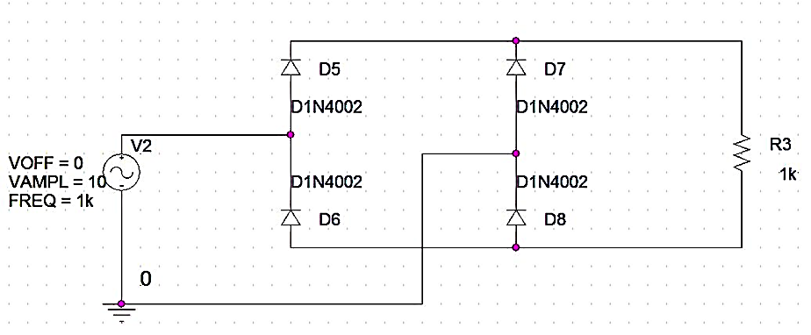

Figure

* Since we need to observe the VIN vs. VOUT graph, we simulate our circuit using the following Time Domain settings.

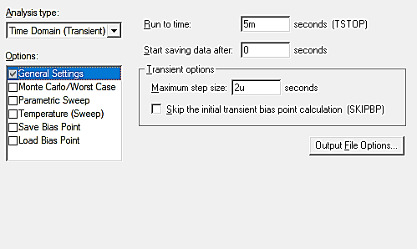

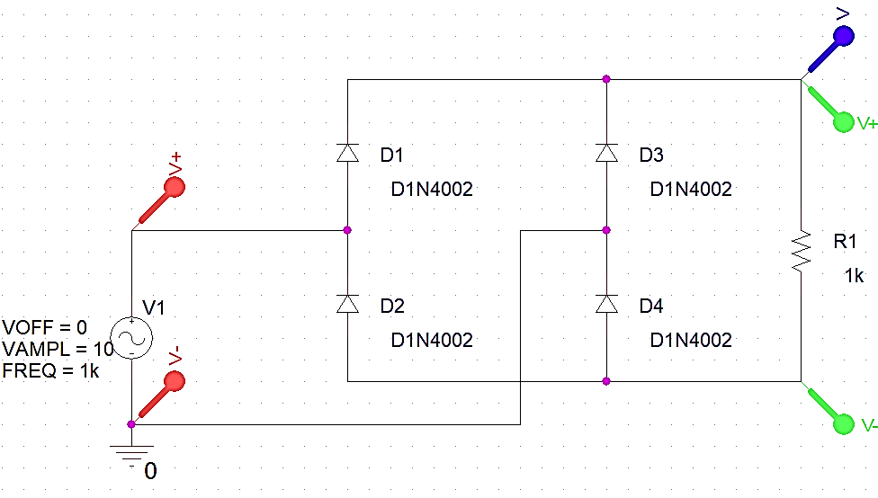

Figure 2

**VIN vs. VOUT**

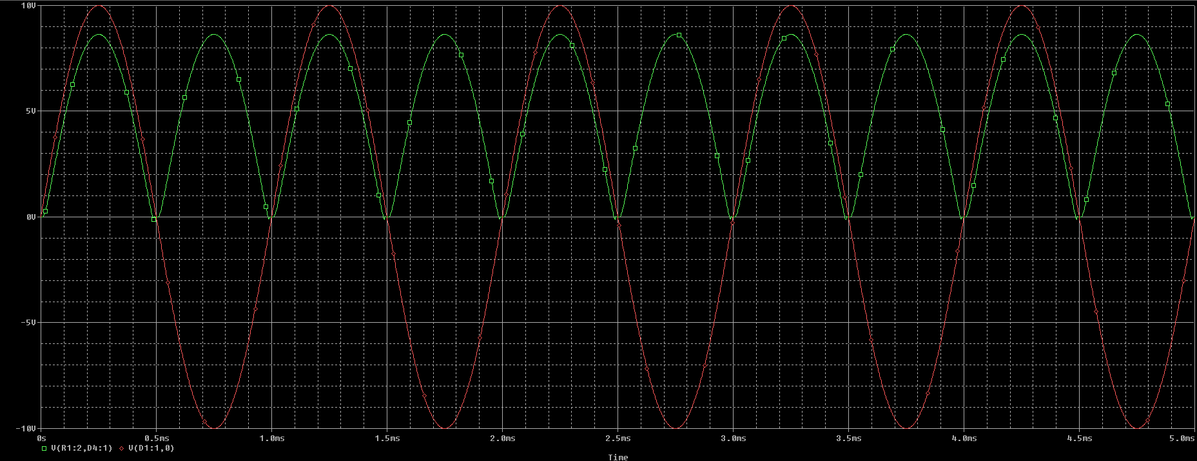

**VIN vs. VOUT : With Level Marker at Resistor**

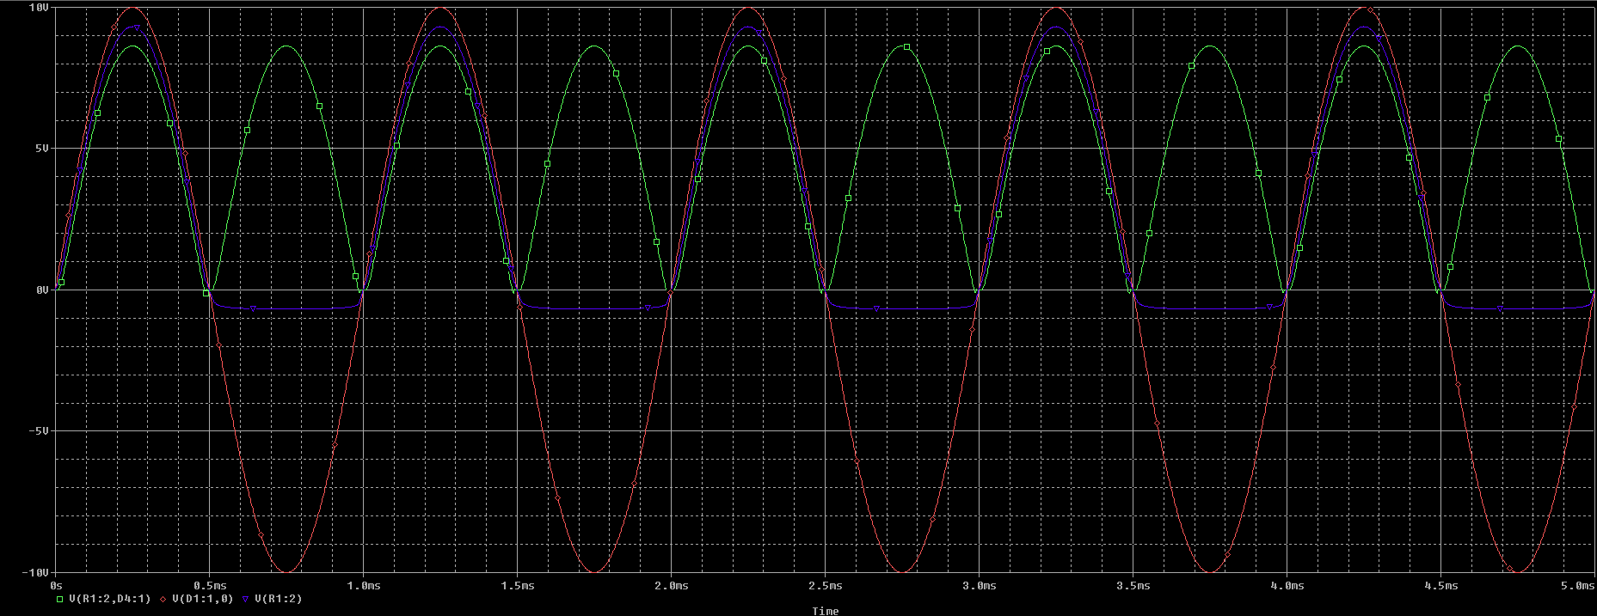

## Part B (Simulation)

Repeat the experiment using a Transformer as shown in figure 1B_1, and the simulation profile given in figure 1A_2 (***Note the Frequency of the source is 60 Hz)***

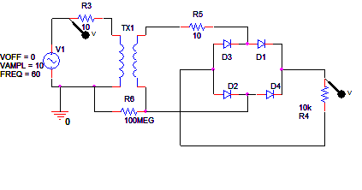

Figure 3

* We simulate our circuit using the following Time Domain settings.

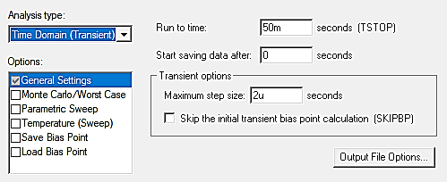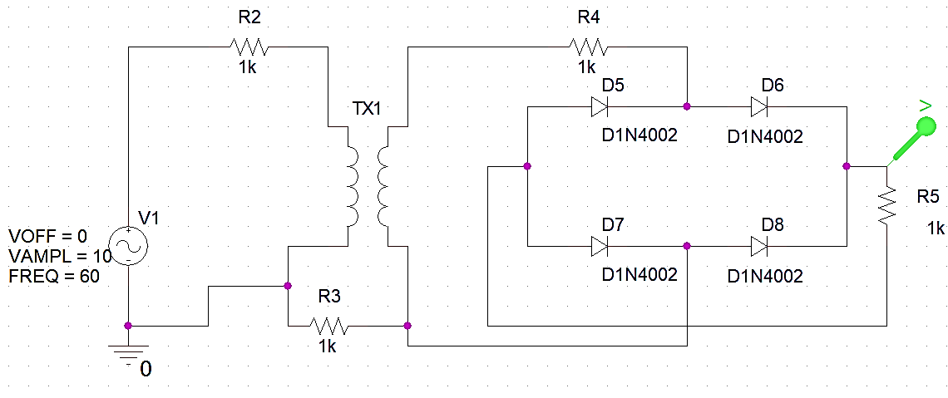

Figure 4

**Voltage Across the Resistor**

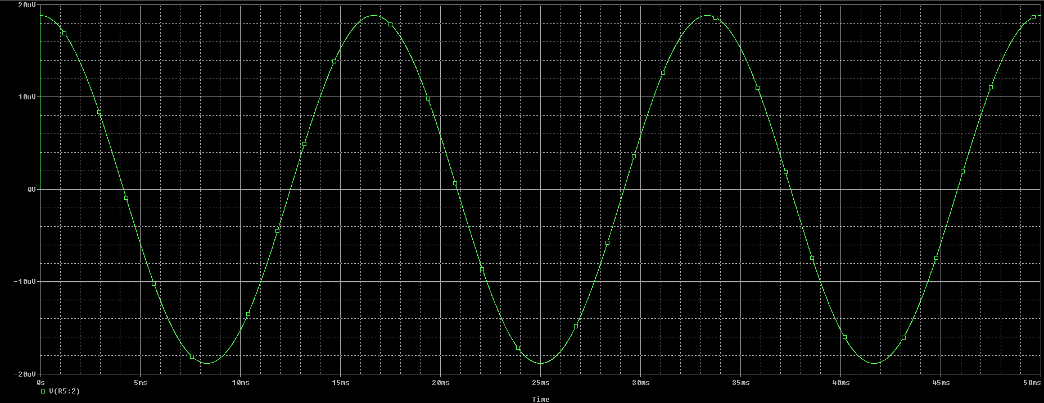

## Observations/Measurements

For the above two exercises answer the following questions in your report:

1. **Calculate the peak inverse voltage (PIV) of the rectifier. Include the calculations in your report.**

The formula to calculate Peak Inverse Voltage is;

**PIV = 2 ESM – 0.7**

Where ESM is the maximum value of the AC voltage across the half of the secondary winding of the transformer.

**PIV = 2 (5) – 0.7**

**PIV = 9.3 V**

1. **Do you observe the difference between peak voltages of the rectified wave and input signal? Measure the voltage and explain why the difference occurs?**

**Answer:** Yes, a difference between peak voltage of the sinusoidal source and rectified output was observed due to the fact that the Diodes were not ideal. The peak voltage of the output wave is 8.634 V which indicates a Voltage Drop of 10 – 8.634 = 1.366 V in the bridge rectifier due to Diodes (0.683 V per Diode).

1. **What difference do you observe between the graph obtained from “voltage differential marker” and “voltage level marker”? Explain why both the graphs are different from each other.**

For the case of voltage differential markers, you have a voltmeter between two power lines, and you can see the voltage between the two lines whilst a level marker just logs the value of the voltage at a single point, with internal grounded circuitry. The difference arises as the reference for the voltage level marker is always at zero potential whereas the differential marker can have a varying reference voltage; at the negative power line.

1. **Another technique used for full wave rectification is the use of centre tapped transformer. Explain which technique is better and why?**

**Answer:** Bridge Rectifier is more useful since no center tapped transformer is required in bridge rectifier, transformer size requirement is less (only about half as many turns are required for the secondary winding of the transformer) and that the PIV of diode is equal to the transformer secondary voltage. Thus bridge rectifier can be used for high voltage application.

## Part C (Implementation of Part A)

After circuit simulation, the next step involves practical implementation of the circuit.



Figure 5

**Procedure**

1. **Patch the circuit as shown in figure 5.**

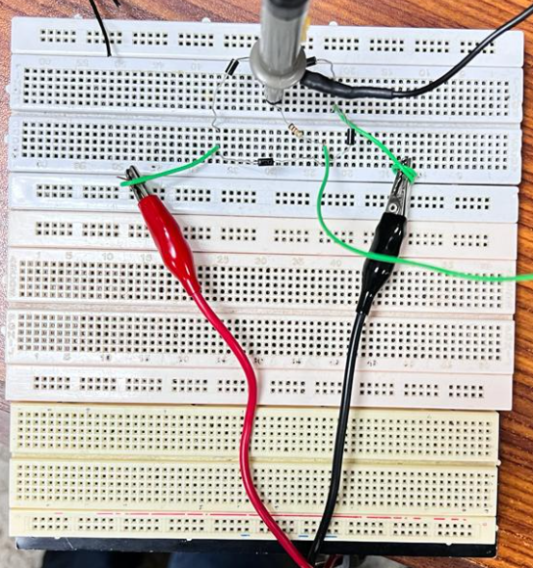

Hardware Implementation

1. **Observe the waveforms of Vout on the oscilloscope. Save your results and include them in your lab report.**

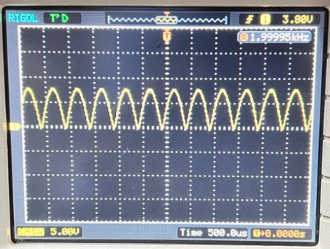

Sine Wave – Fully Rectified

1. **Measure the peak inverse voltage (PIV) of this practically implemented rectifier and compare the results obtained. Explain the differences, if any, in your lab report.**

**Answer:** The PIV of hardware implementation of the circuit (9.16 V) was approx. equal to the Peak Inverse Voltage (9.317 V) obtained in PSpice Simulation.

1. **As you have observed in your graph, we do not still have a pure DC voltage. The rectified voltage is still pulsating. Can you think of any technique that can help you remove these pulses? (Hint: Take a look at your previous labs, you’ve done the procedure).**

**Answer:** The Output voltage is still pulsating. These pulses can be removed by using a filter circuit that employs a capacitor connected in parallel with the load resistor. During the positive half-cycle, the capacitor will charge while during the negative half-cycle, the capacitor will discharge as Vo = Vp e-T/RC. This process will remove pulses from the output, though quite not completely, which can be done by using a Voltage Regulator Circuit. A higher value of RC will result in a more filtered waveform.

1. **Try giving a square wave instead of a sine wave. What differences do you observe?**

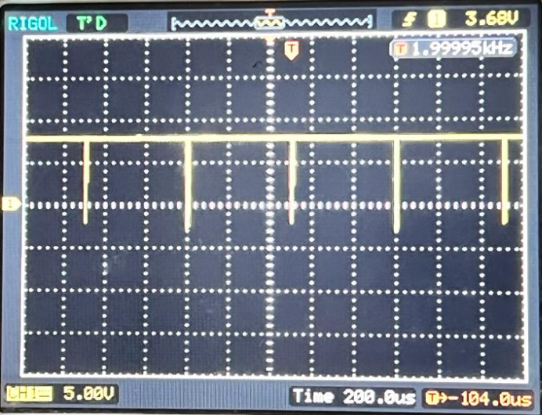

Square Wave – Fully Recitifed

# Conclusion

After performing this lab, we have achieved the following goals;

* Further familiarized ourselves with a fundamental electronic component; diode
* Examined the difference between voltage level markers and differential markers
* Performed full wave rectification using a bridge rectifier
* Calculated peak inverse voltage of the bridge rectifier