**Department of Electrical Engineering**

|  |  |
| --- | --- |
| **Faculty Member: ­­­­_______________** | **Dated: ________________** |
| **Semester:_____________** | **Section: ________________** |

**EE215: ELECTRONIC DEVICES AND CIRCUITS**

**Lab 04: Applications of Diode**

**(Full Wave Rectification)**

|  |  |  |  |  |
| --- | --- | --- | --- | --- |
| **PLO4/CLO4** | | **PLO5/CLO5** | **PLO8/CLO6** | **PLO9/CLO7** |
| **Name** | **Reg. No** | **Viva /Quiz / Lab Performance**  **5 marks** | **Analysis of data in Lab Report**  **5 marks** | **Modern Tool Usage**  **5 marks** | **Ethics and Safety**  **5 marks** | **Individual and Team Work**  **5 marks** |
|  |  |  |  |  |  |  |
|  |  |  |  |  |  |  |
|  |  |  |  |  |  |  |
|  |  |  |  |  |  |  |

# LABORATORY EXERCISE - 4

# Applications of Diode (Full wave Rectification)

**Objective:**

**Study the Applications of Diodes.**

1. The primary purpose of this lab is to develop a working knowledge of diode. Diodes can be used in variety of circuits for various applications one of which is rectifiers.

**Equipment and components**

1. The following component and test equipment is required.
2. PN Diode
3. Oscilloscope
4. Function Generator
5. Resistors
6. Power Supply

**The Experiment:**

1. The experiment is broken down into two exercises. Part I involves the simulation of the circuit on PSpice using Orcad-Capture module. The second part involves the practical setup of this circuit and making required measurements, tabulation and its analysis.

**Theory:**

The wide silver band on the diodes indicates the cathode side of the diode. A diode bridge is an arrangement of four (or more) diodes in a bridge circuit configuration that provides the same polarity of output for either polarity of input.

The main advantages of a full-wave bridge rectifier is that it has a smaller AC ripple value for a given load and a smaller reservoir or smoothing capacitor than an equivalent half-wave rectifier. Therefore, the fundamental frequency of the ripple voltage is twice that of the AC supply frequency (100Hz) where for the half-wave rectifier it is exactly equal to the supply frequency (50Hz).

***Full Wave Rectifier (Part A – Simulation I)***

***Circuit Diagram of Exercise A***

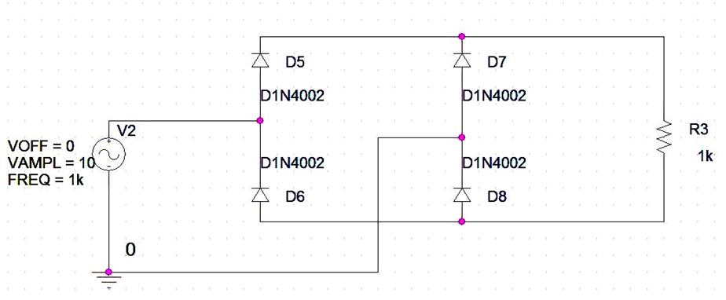

**Figure 1A_1 – Circuit Diagram for Full Wave Rectifier**

1. In the last lab exercise you experimented with half wave rectifier circuits. Now we will experiment with wave rectification.

**Procedure**

1. First draw the circuit as shown in figure 1A_1. Make sure that you have entered the correct values for the source VSIN.
2. We will perform a transient analysis and simulation profile should be made as shown in figure 1A_2. Just like previous experiments, students are encouraged to understand the change in graph obtained by changing various parameters of the simulation profile.
3. Plot the graph between Vin and Vout, which to be taken across the 1k ohm resistor (**hint:** use voltage differential markers, not voltage level markers). Save the graph and attach it with your lab report.
4. Observe the graph between ***Vin*** and ***Vout.***
5. Now use both the voltage differential marker and voltage level marker across the resistor and observe the difference. Plot both curves and include in your lab report.

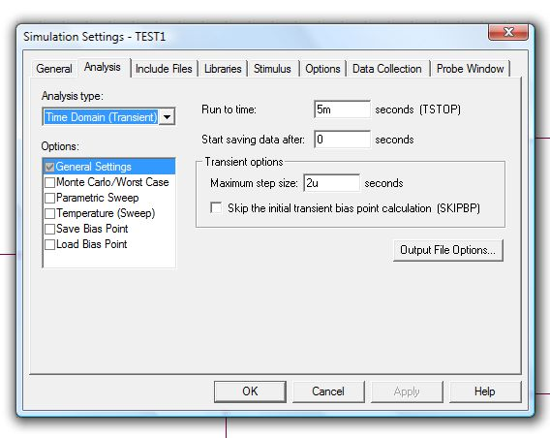

**Figure 1A_2 – Simulation Settings for Full Wave Rectifier**

***Full Wave Rectifier (Part B – Simulation)***

Repeat the experiment using a Transformer as shown in figure 1B_1, and the simulation profile given in figure 1A_2 (***Note the Frequency of the source is 60 Hz)***

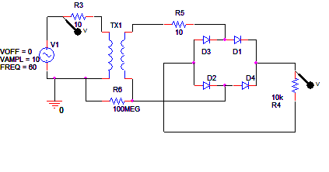

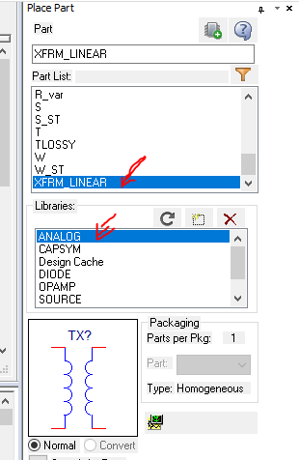

**Figure 1B_1 Full Wave Rectifier with Transformer**

**Tutorial link: PIV concept (watch this video)**

**https://www.youtube.com/watch?v=qRR-BVdnAWU&ab_channel=ECAcademy**

**Observations/Measurements:**

1. For the above two exercises answer the following questions in your report:
   1. Calculate the peak inverse voltage (PIV) of the rectifier. Include the calculations in your report.
   2. Do you observe the difference between peak voltages of the rectified wave and input signal? Measure the voltage and explain why the difference occurs?
   3. What difference do you observe between the graph obtained from “voltage differential marker” and “voltage level marker”? Explain why both the graphs are different from each other.
   4. Another technique used for full wave rectification is the use of centre tapped transformer. Explain which technique is better and why?

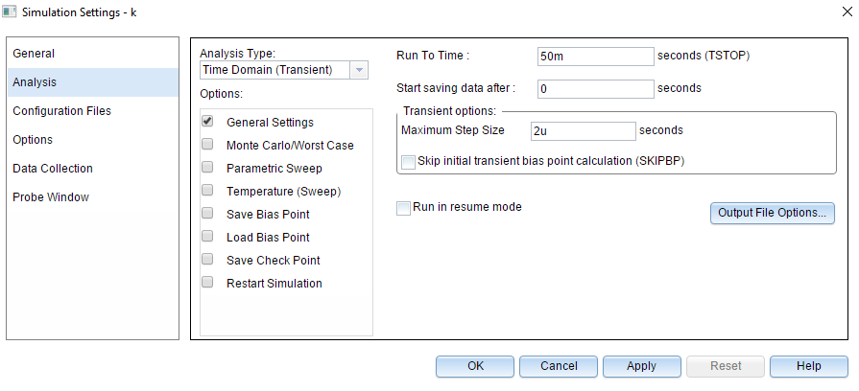

**Full Wave Rectifier (Part B – Implementation) – Part A only**

1. After circuit simulation, the next step involves practical implementation of the circuit.

**Procedure:**

1. Patch the circuit as shown in figure 1A_1.
2. Observe the waveforms of Vin and Vout on the oscilloscope. Save your results and include them in your lab report.
3. Measure the peak inverse voltage (PIV) of this practically implemented rectifier and compare the results obtained. Explain the differences, if any, in your lab report.
4. As you have observed in your graph, we do not still have a pure DC voltage. The rectified voltage is still pulsating. Can you think of any technique that can help you remove these pulses? (**Hint:** Take a look at your previous labs, you’ve done the procedure).
5. Try giving a square wave instead of a sine wave. What differences do you observe?

**Observations/Measurements:**

Answer the questions asked in 6(c), 6(d) and 6(e). Include them in your lab report.