**Department of Electrical Engineering**

|  |  |
| --- | --- |
| **Faculty Member: ­­­­_______________** | **Dated: ________________** |
| **Semester:_____________** | **Section: ________________** |

**EE215: ELECTRONIC DEVICES AND CIRCUITS**

**Lab 05: Applications of Diode (limiter circuits 1)**

|  |  |  |  |  |
| --- | --- | --- | --- | --- |
| **PLO4/CLO4** | | **PLO5/CLO5** | **PLO8/CLO6** | **PLO9/CLO7** |
| **Name** | **Reg. No** | **Viva /Quiz / Lab Performance**  **5 marks** | **Analysis of data in Lab Report**  **5 marks** | **Modern Tool Usage**  **5 marks** | **Ethics and Safety**  **5 marks** | **Individual and Team Work**  **5 marks** |
|  |  |  |  |  |  |  |
|  |  |  |  |  |  |  |
|  |  |  |  |  |  |  |
|  |  |  |  |  |  |  |

# LABORATORY EXERCISE -5

# Applications of Diode (limiter circuits 1)

**Objective:**

**Study the Applications of Diodes.**

The primary purpose of this lab is to develop a working knowledge of diode. Diodes can be used in variety of circuits for various applications such as clippers/clampers and voltage regulators.

**Equipment and components**

The following component and test equipment is required.

* PN Diode
* Oscilloscope
* Function Generator
* Resistors
* Capacitors
* Power Supply

**Theory:**

In [electronics](https://en.wikipedia.org/wiki/Electronics), a clipper is a device designed to prevent the output of a circuit from exceeding a predetermined voltage level without distorting the remaining part of the applied waveform.

A clipping circuit consists of linear elements like [resistors](https://en.wikipedia.org/wiki/Resistor) and non-linear elements like [junction diodes](https://en.wikipedia.org/wiki/Diode) or [transistors](https://en.wikipedia.org/wiki/Transistor), but it does not contain energy-storage elements like [capacitors](https://en.wikipedia.org/wiki/Capacitors). Clipping circuits are used to select for purposes of transmission, that part of a signal wave form which lies above or below a certain reference voltage level.

Thus a clipper circuit can remove certain portions of an arbitrary waveform near the positive or negative peaks. Clipping may be achieved either at one level or two levels.

**The Experiment:**

The experiment is broken down in four parts; each part involves simulation of the given circuit and then its practical implementation to observe the results.

**Before starting the lab, open this link and read about limiter circuit: https://www.theengineeringknowledge.com/diode-limiters-circuits/**

**Limiter Circuit (Part A – Simulation I)**

This exercise is on another application of diode, which is known as limiter. It serves the purpose of clipping off peaks and is also known as clipper. The first part of this exercise is simulation on

**Figure 2A_1 – Limiter Circuit**

**Set transient response profile by yourself and attach profile setting screenshot. Set run Time (at least two complete cycle should be visible) and also set step size (in milli or micro values)**

OrCad Capture Lite. Observe the following procedure for this part:

* 1. Draw the circuit as shown in figure 2A_1.
  2. You have to simulate the circuit by creating your own simulation profile (**Hint:** use transient analysis). Make sure the graph obtained is properly drawn. Take a curves and graphs of the simulation profile settings that you have done and attach it with your report.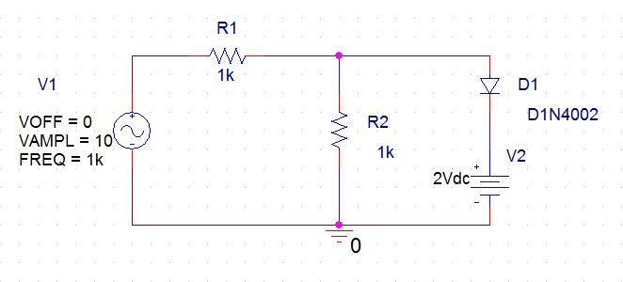
  3. Simulate the circuit and observe the waveforms b Vin and Vout. Vout is taken across the diode and voltage source. Please avoid the use of voltage differential markers.
  4. Simulate the circuit at different values of V2 (DC Source given in figure 2A_1). Observe the difference in waveforms.
  5. For the circuit given in Figure 2A_1, draw the transfer characteristic curve with Vout on y-axis and Vin on x-axis. This can be done by using DC Sweep simulation profile. It is left for the students to make the simulation profile settings themselves and observe the results.
  6. Attach the curves and graphs of the simulation profile settings that you use. Make sure proper settings have been done so that the curves are clearly visible and can be explained by you in the report/viva.

**Observations/Measurements:**

1. Answer the following questions:
2. What happens when you change the value of the DC source in the circuit? Explain.

Change in the DC Value of the source results in the change of where the circuit clips.

1. If value of DC source exceeds the peak value of VSIN what do you think should happen? Demonstrate by the help of a graph drawn in OrCad.

During +ive half cycle, in this case, the diode never turns on since VSIN is less than Voltage of DC Source + Voltage drop across Diode. While during negative half cycle diode acts as an open circuit.

1. Attach graphs at Vdc = 2V, 5V, 8V and 10V in your lab report. Explain the difference observed.

When we change the value from 2V up to 5V the clipping interval decreases. Further increase in V DC leads to clipping almost disappearing.

1. Explain the transfer characteristic curve of the limiter circuit in two to three lines in your lab report.
2. Attach the transfer characteristic curve taken at Vdc = 2V, 5V, 8V and 10V. What difference do you observe? Why do the differences occur?
3. Theoretically calculate the point where Vout becomes constant in the transfer characteristics curve? Compare it with the results obtained via simulations. Explain the difference if any.

**Limiter Circuit (Part B – Simulation II)**

1. In this part of the exercise, you have to simulate the circuit provided in figure 2A_1 but it should clip positive peak at +1.5V and negative peak at -0.2v. The procedure for doing the exercise the same as described in part A of exercise 2. You have to include the curves and graphs of your simulation settings and curves as asked in the procedure. From the Observations/Measurement section, please answer (d), (e), (f) and (g) parts.
2. Explain what differences do you observe with respect to the limiter in part A. Why do these differences occur?

**Limiter Circuit (Part C – Implementation)**

1. The following procedure should be adopted while practical implementation of the circuit given in figure 2A_1:
   1. Patch the circuit as shown in the figure.
   2. Try to observe the input and output curves on a dual channel oscilloscope. Save your results and add them to your report.