**Department of Electrical Engineering and   
Computer Science**

**Faculty Member:** Dr. Shakeel Alvi **Dated:** 31/04/2022

**Semester:** 4th **Section:** BEE 12C

**EE-215:** **Electronic Devices And Circuits**

Lab 6: BJT

**Group Members**

|  |  |  |  |  |
| --- | --- | --- | --- | --- |
| **PLO4/CLO4** | | **PLO5/CLO5** | **PLO8/CLO6** | **PLO9/CLO7** |
| **Name** | **Reg. No** | **Viva /Quiz / Lab Performance**  **5 marks** | **Analysis of Data in Lab Report**  **5 marks** | **Modern Tool Usage**  **5 marks** | **Ethics and Safety**  **5 marks** | **Individual and Team Work**  **5 marks** |
| **Danial Ahmad** | **331388** |  |  |  |  |  |
| **Muhammad Ahmed Mohsin** | **333060** |  |  |  |  |  |
| **Muhammad Umer** | **345834** |  |  |  |  |  |
|  |  |  |  |  |  |  |
|  |  |  |  |  |  |  |

# Laboratory Experiment # 6

## Objectives

* The primary purpose of this lab is to develop a working knowledge of Bipolar Junction Transistor (BJT). Transistors are current controlled devices which find applications in a vast array of circuits including but not limited to amplifiers, electronic switches, multipliers etc.
* First, the students will learn the method that is used to determine the type of the transistor and find out and label various terminals of the BJT.
* Second parts deals with the study the I-V characteristics of the BJT, and see how varying the parameters of the BJT affect them. For our implementation and simulation phase the 2N2222A transistor will be used which is one of the popular type of BJT around.

## Equipment

The following will be required in this lab experiment:

* 2N2222A Transistor
* DMM
* Oscilloscope
* Resistors
* Capacitors
* Power Supply
* PSpice Simulation Software

## Conduct of Lab

The students are required to work in groups of four; each student must attempt to understand and use the laboratoy set-up and conduct at least one or two parts of the requirement experimentation.The lab engineer will be available to assist the students. In case some aspect of the lab experiment is not understood the students are advised to seek help from the teacher, the lab attendent or the assigned Lab Engineer.

# Exercises

## Exercise 1: (BJT Type Identification)

In this part of the experiment you will be given a sample transistor and using the procedure below you are required to determine whether the transistor is an NPN or PNP transistor. You are also required to identify the terminals of the transistor.

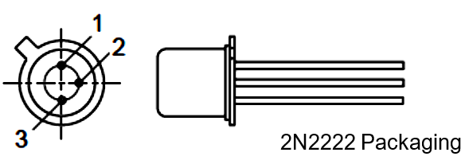

Figure 1

*Accomplish the following and explain your results:*

* **Tabulate your observations in the form of a table clearly showing the order of the connection of the probes to the terminals and the corresponding reading on the DMM.**

|  |  |  |  |
| --- | --- | --- | --- |
| **Terminal 1** | **Terminal 2** | **Terminal 3** | **V** |
| + | - |  | OL |
| - | + |  | 0.62 V |
| + |  | - | OL |
| - |  | + | OL |
|  | + | - | 0.6 V |
|  | - | + | OL |

* **Identify each of the terminals.**

1 – Emitter (E)

2 – Base (B)

3 – Collector(C)

* **Explain why the diode check reading for the collector base junction is lower than the emitter base junction?**

**Answer:** The emitter-base PN junction has a slightly greater forward voltage drop than the collector-base PN junction, because of heavier doping of the emitter semiconductor layer.

* **How will you determine whether the transistor is NPN or PNP type?**

**Answer:** We can determine whether the transistor is NPN or PNP through a multimeter;

1. **For NPN**: Connect +ive probe to the Base and the -ive probe to Emitter and the Collector; If it shows a voltage reading for both the cases, then our transistor is of NPN type.
2. **For PNP**: Connect -ive probe to the Base and the +ive probe to Emitter and the Collector; If it shows a voltage reading for both the cases, then our transistor is of NPN type.

## Exercise 2: Part A (Common Emitter I-V Characteristics of the BJT)

In this part the students will study the common emitter I-V characteristics of a BJT. In particular relationship between the collector current and the voltage that appears across the collector-emitter junction of the transistor will be observed. Further, the effect of various parameters like, saturation current, early voltage etc. on the transistor I-V characteristics will be studied.

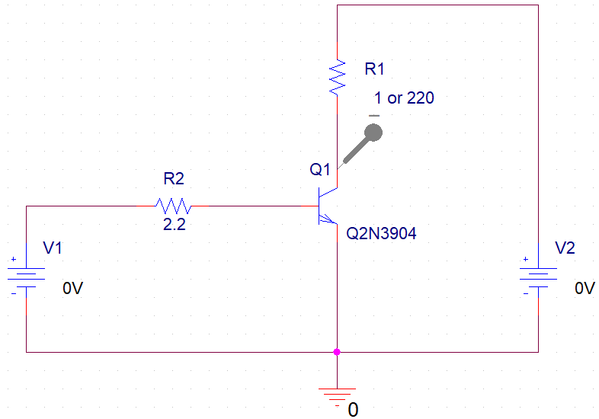

Figure 2

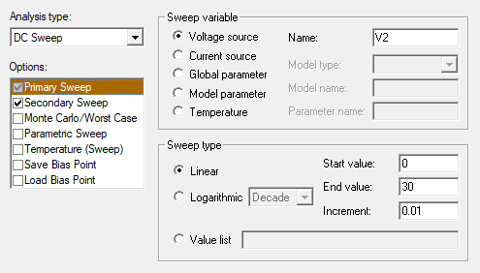

Simulation Settings: a

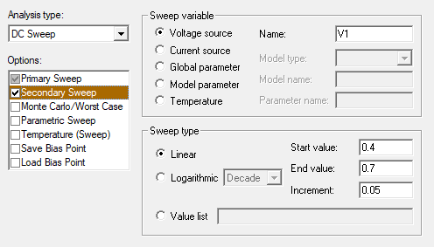

Simulation Settings: b

## R1: 1 Ohm

I – V Curve

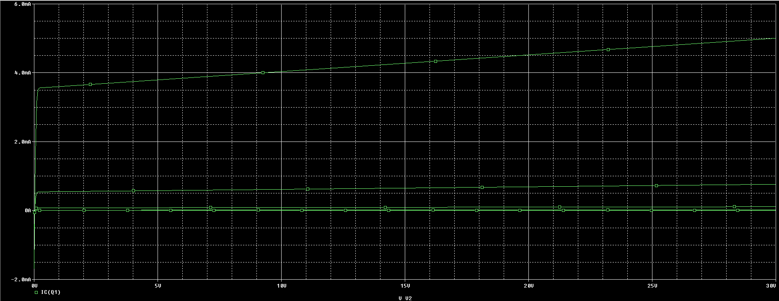

Modified I – V Curve

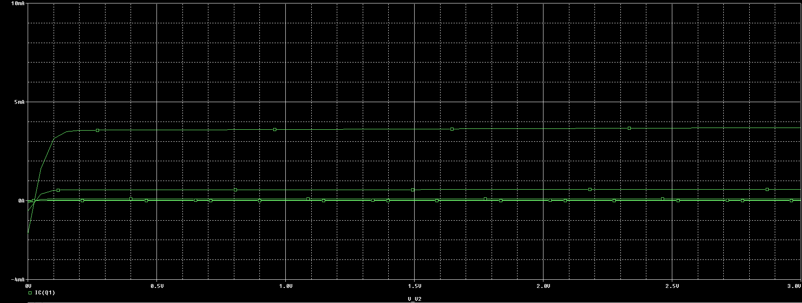

## R1: 220 Ohm

I – V Curve

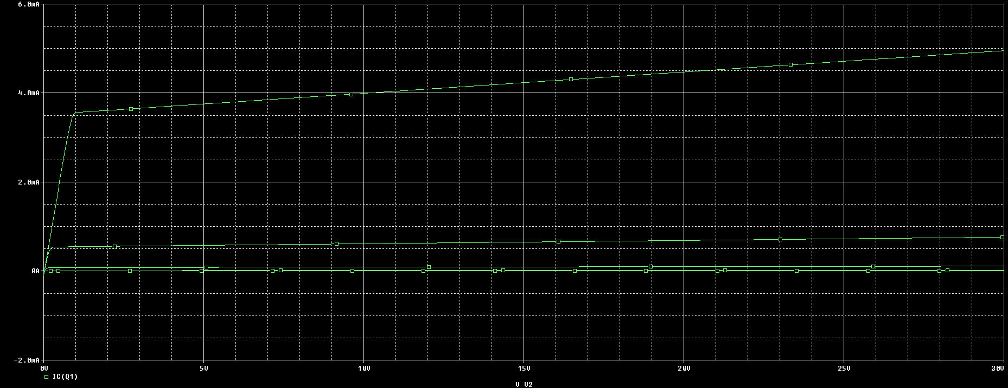

Modified I – V Curve

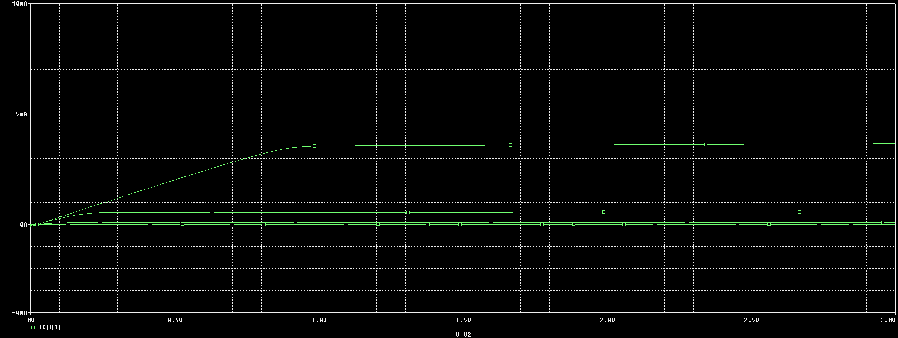

## Observations/Measurements

*Answer the following questions and include them in your report. Support your answers by mathematical equations where necessary.*

* **For each value of VBB, (in steps of 0.1V) calculate the value of the base current. Calculate the average value of β for each value of base current.**

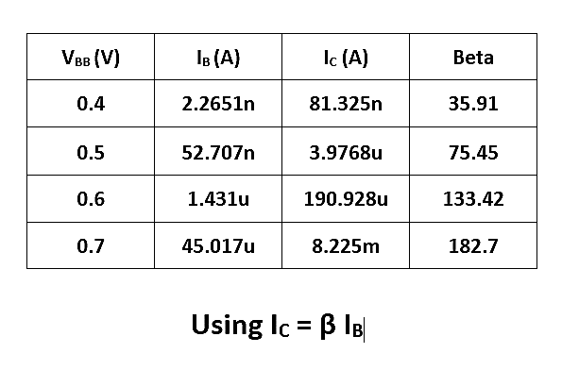

Figure 3

**Answer:** The trend suggests that the increase in VBB­ increases the value of base current which corresponds to a higher value of collector current given by the relation IC = x IB.

* **On the IC versus VCE plot, identify each region of operation of the transistor.**

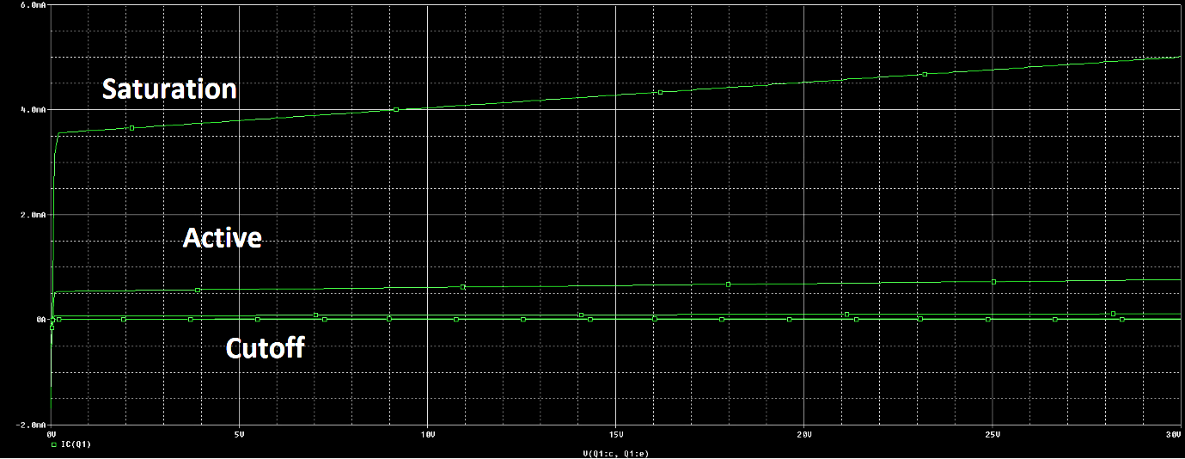

* **Why does the graph of the collector current have a considerable slope in the active region of the transistor? Explain.**

**Answer:** It is due to an effect known as early voltage effect. On increasing the voltage at the collector it is possible to increase the collector current. This is because on increasing the reverse biased collector voltage, the base width decreases since the collector depletion region penetrates more into the base region. Ideally, early voltage Va is infinite and IC doesn’t depend on collector-emitter voltage

* **Calculate the Early voltage of the transistor.**

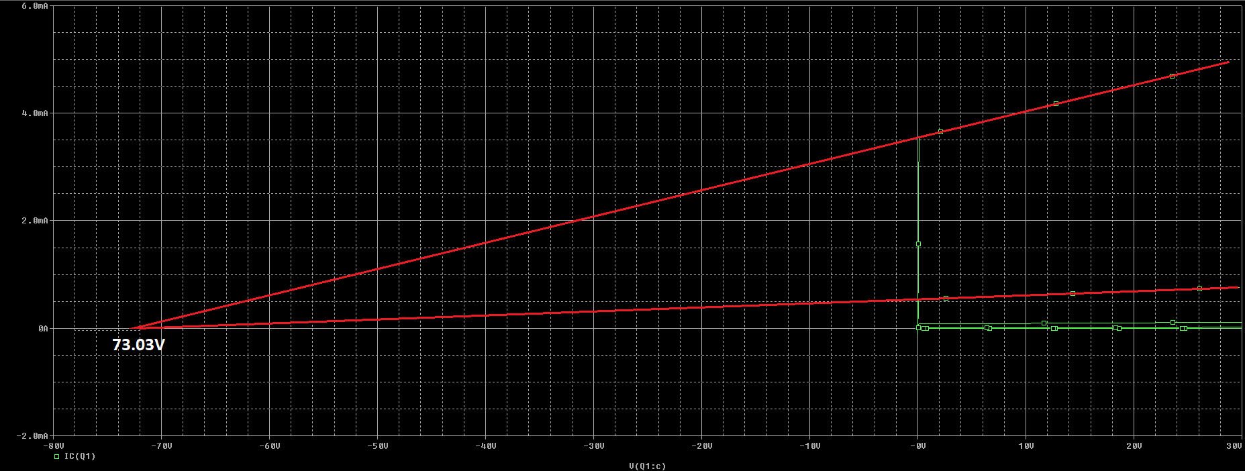

* **Now open the PSpice model (Right click on the part and select PSpice Model) of the transistor and compare the calculated value of Early voltage with the one specified in the model. Are they the same?**

**Answer:** Yes, the value obtained from graph is the same as given by PSpice model.

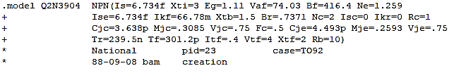

**Early Voltage (PSpice Model) = 74.03 V**

* **Try modifying the value of the Early Voltage specified in the PSpice Model and run the simulation again. Is there any effect on the I-V characteristics?**

**Answer:** Changing the early voltage to 1000 V, we see that the collector current does not depend on V­CE. The effect of VCE is completely eliminated at infinite early voltage.

* **Try modifying the value of the forward saturation current *Is* and run the simulation again. Do you expect any change in the characteristics? Is the plot according to your expectations?**

**Answer:** Since the collector current depends on saturation current by the relation:

We expected our curve to deviate a little from an almost straight line. The results obtained reinforces our expectations.

## Exercise 2: Part B (Common Emitter I-V Characteristics of the BJT)

This exercise involves the implementation of a circuit to test the I-V characteristic of a BJT which you have extensively studied through the simulation phase of the experiment.



## Observations/Measurements and Explanations

|  |  |  |  |
| --- | --- | --- | --- |
| **VBB** | **IB** | **IC** | **VCE** |
| 0.4V | 0.02 uA | 0.184 uA | 4.06 V |
| 0.5V | 0.07 uA | 0.18 uA | 5.07 V |
| 0.6V | 1.90 uA | 0.17 uA | 6.0 V |
| 0.7V | 33.08 uA | 0.18 uA | 7.03 V |

|  |  |  |  |
| --- | --- | --- | --- |
| **VCC** | **IB** | **IC** | **VCE** |
| 4 V | 0.02 uA | 0.18 uA | 4.83 V |
| 5 V | 0.01 uA | 4.60 uA | 5.134 V |
| 6 V | 0.03 uA | 0.20 mA | 5.89 V |
| 7 V | 0.07 uA | 103.4 mA | 7.134 V |

*Answer the following questions:*

* **Calculate the early voltage based on the IC-VCE graphs that you have obtained. Compare with the value that you have obtained from Simulation-I.**

**Answer:** A value of 71.37V is yielded for early voltage in the case of graphs obtained from implementing the circuit on hardware. It is very near to the values obtained from both the simulation and the ones defined in the Proteus Part Description, although certain discrepancies arise due to tolerance in actual hardware.

* **Try and change the values of the resistances and observe its effect on the IC-VCE curve. What changes do you observe? Is there any change in the slope of the graph in the active region? Comment in each case.**

**Answer:** In the active region, the slope of the IC curve remains near constant over a wide range of voltages, albeit, the value of resistance alters the shape, and thus the slope, of the graph considerably for saturation and cut-off regions.

# Conclusion

After performing this lab, we have achieved the following goals;

* Familiarized ourselves with one of the most important electronic element; a transistor
* Plotted the I-V Characteristic Curves of a BJT
* Identified different operating regions of a BJT and their different applications, i.e. as an amplifier or a switch.