# Department of Electrical Engineering

|  |  |
| --- | --- |
| **Faculty Member: ____________** | **Dated: _______________** |
| **Semester:_____________** | **Section: ________________** |

**EE215: ELECTRONIC DEVICES AND CIRCUITS**

**Lab 6: BJT**

**I-V characteristics and Type Identification**

|  |  |  |  |  |
| --- | --- | --- | --- | --- |
| **PLO4/CLO4** | | **PLO5/CLO5** | **PLO8/CLO6** | **PLO9/CLO7** |
| **Name** | **Reg. No** | **Viva /Quiz / Lab Performance**  **5 marks** | **Analysis of data in Lab Report**  **5 marks** | **Modern Tool Usage**  **5 marks** | **Ethics and Safety**  **5 marks** | **Individual and Team Work**  **5 marks** |
|  |  |  |  |  |  |  |
|  |  |  |  |  |  |  |
|  |  |  |  |  |  |  |
|  |  |  |  |  |  |  |

# LABORATORY EXERCISE-6

# BJT I-V Characteristics and type identification

**Objective: To study current-voltage characteristics of BJTs**

* The primary purpose of this lab is to develop a working knowledge of Bipolar Junction Transistor (BJT). Transistors are current controlled devices which find applications in a vast array of circuits including but not limited to amplifiers, electronic switches, multipliers etc.
* First, the students will learn the method that is used to determine the type of the transistor and find out and label various terminals of the BJT.
* Second parts deals with the study the I-V characteristics of the BJT, and see how varying the parameters of the BJT affect them. For our implementation and simulation phase the 2N2222A transistor will be used which is one of the popular type of BJT around.

**Required Resources**

The following components, test equipment and software would be required.

* 2N2222A Transistor
* DMM
* Oscilloscope
* Resistors
* Capacitors
* Power Supply
* PSpice Simulation Software.

**The Experiment**

The experiment is broken down in two exercises; one of the experiment is divided into two parts namely:simulation and implementation. You are required to observe and record the simulation/implementation results and answer the given questions. Include your answers in your lab reports.

**Exercise 1: BJT Type Identification (Implementation-I)**

In this part of the experiment you will be given a sample transistor and using the procedure below you are required to determine whether the transistor is an NPN or PNP transistor. You are also required to identify the terminals of the transistor.

**Procedure**

* Set your digital multi-meter to diode check mode.
* The physical packing and shape of 2N2222 transistor is shown in figure-1. Mark your terminals as 1, 2 and 3.
* Now, connect the probes of the multi-meter to any two terminals of the transistor and observe the readings. Interchange the positive and negative leads of the DMM and observe the new reading.
* Record your observations in the form of a table.
* The two terminals for which your DMM shows a high or out of range reading even after reversing the order of the probes are the collector and the emitter. The third terminal is obviously the base.
* The lower of the two “finite” readings that are measured correspond to the base-collector junction.
* To determine the type of transistor, you are required to use your previous knowledge of diodes and their biasing modes to determine whether the transistor is of NPN or PNP type.



2N2222 Packaging

**Figure 1 Physical packing of 2N2222**

**Observations/Measurements and Explanation:**

Accomplish the following and explain your results:

* + Tabulate your observations in the form of a table clearly showing the order of the connection of the probes to the terminals and the corresponding reading on the DMM.
  + Identify each of the terminals.
  + Explain why the diode check reading for the collector base junction is lower than the emitter base junction?
  + How will you determine whether the transistor is NPN or PNP type?

**Use these formulas to calculate values. You can take help from google.**

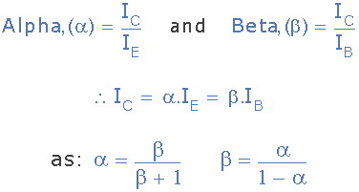

**Can take help:** [**https://www.youtube.com/watch?v=nCqQhqLTmxw**](https://www.youtube.com/watch?v=nCqQhqLTmxw)

**For simulation: use this BJT: Q2N3904 in EVAL library**

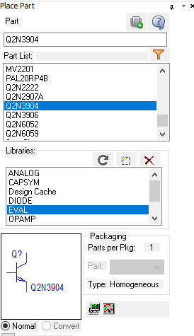

**Exercise 2 Part A:**

**Common Emitter I-V Characteristics of the BJT (Simulation-I)**

In this part the students will study the common emitter I-V characteristics of a BJT. In particular relationship between the collector current and the voltage that appears across the collector-emitter junction of the transistor will be observed. Further, the effect of various parameters like, saturation current, early voltage etc. on the transistor I-V characteristics will be studied.

**Procedure:**

* Using OrCad PSpice software, draw the circuit as shown in figure 2A.
* The test circuit in figure 2A is used to determine the dependence of the collector current on the base-emitter voltage as well as the voltage applied at the collector. The source VBB in figure 2A controls the amount of base-emitter voltage and the current that enters the base terminal and the source VCC controls the voltage that appears at the collector terminal.
* In the first simulation run, set the value of **R1** = 1Ω.
* Create an appropriate simulation profile and perform **DC Sweep Analysis**.
* In the **Primary Sweep** tab, specify the voltage source as VCC. Vary it from 0 to 30 V.
* Check the option for **Secondary Sweep** and specify the voltage source as VBB. Vary it from 0.4 to 0.7 V in steps of 0.05 V.
* Run the simulation and make use of axis variables and traces to get a graph between the collector current $i_{C}$ and $v_{CE}$. (Hint: The emitter is grounded so $v_{CE}$ is effectively equal to VC).
* Use Axis Setting Option to get different views of the V-I curve. Select different settings and save the graphs that depict the BJT graphs which are easily readable.
* Now do a second simulation run using **R1** = 220Ω. Repeat steps (4) to (8)
* Kindly make sure that your graph is neat, clear and labeled correctly.

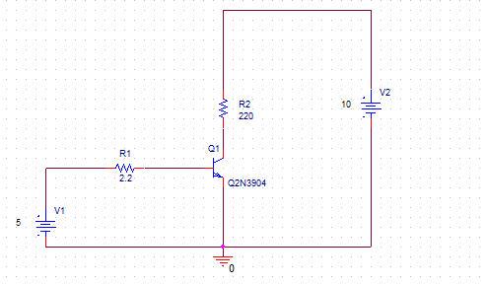

**Figure 2A Test Circuit for Common Emitter Characteristics of BJT**



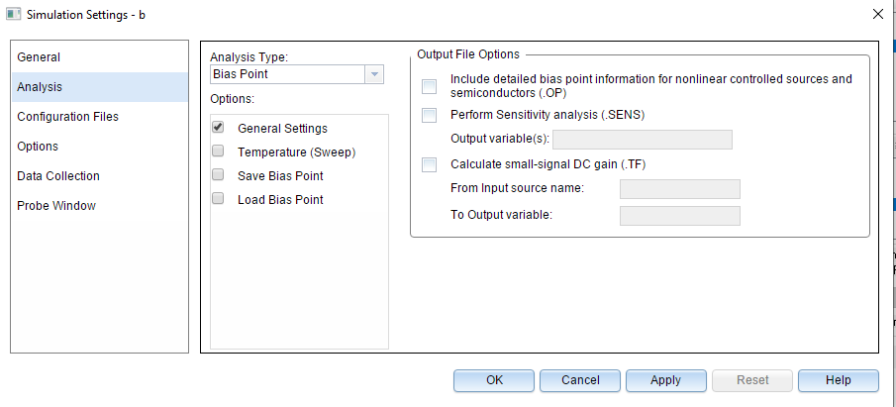

**Observations/Measurements**

Answer the following questions and include them in your report. Support your answers by mathematical equations where necessary.

* + For each value of VBB, (in steps of 0.1V) calculate the value of the base current.
  + Calculate the average value of β for each value of base current. Comment on and explain the trend that you observe.
  + On the IC versus VCE plot, identify each region of operation of the transistor.
  + Why does the graph of the collector current have a considerable slope in the active region of the transistor? Explain.
  + Calculate the **Early voltage** of the transistor using the plot that you have obtained.
  + Now open the PSpice model (Right click on the part and select PSpice Model) of the transistor and compare the calculated value of Early voltage with the one specified in the model. Are they the same?
  + Try modifying the value of the Early Voltage specified in the PSpice Model and run the simulation again. Is there any effect on the I-V characteristics?
  + Try modifying the value of the forward saturation current ***Is*** and run the simulation again. Do you expect any change in the characteristics? Is the plot according to your expectations?

**CAUTION: - Be sure to reset any changes you make in the SPICE models of the parts or your subsequent simulations will be affected.**

**Exercise 2 Part B:**

**Common Emitter I-V Characteristics of the BJT (Implementation-II)**

This exercise involves the implementation of a circuit to test the I-V characteristic of a BJT which you have extensively studied through the simulation phase of the experiment.

* + Patch the circuit as shown in figure 2B.
  + For a fixed value of VBB, vary VCC in steps of 1V and record the values of IB, IC and VCE. Take sufficient readings.
  + Change the value of VBB in steps of 0.1V and for each valve of VBB ,calculate and tabulate the values of β.
  + Plot the collector current versus collector emitter voltage using your data points in MS Excel and include it in your report



**Figure 2B – Circuit Diagram for Implementation-II**

**Observations/Measurements and Explanations**

Answer the following questions:

* Compare the graphs that you have obtained from Simulation-I and Implementation-II. Are they similar? If not, explain the differences.
* Calculate the early voltage based on the IC-VCE graphs that you have obtained. Compare with the value that you have obtained from Simulation-I.
* Try and change the values of the resistances and observe its effect on the IC-VCE curve. What changes do you observe? Is there any change in the slope of the graph in the active region? Comment in each case.