**Department of Electrical Engineering and   
Computer Science**

**Faculty Member:** Dr. Shakeel Alvi **Dated:** 4/04/2022

**Semester:** 4th **Section:** BEE 12C

**EE-215:** **Electronic Devices And Circuits**

Lab 7: Clamper and Voltage Multiplier

**Group Members**

|  |  |  |  |  |
| --- | --- | --- | --- | --- |
| **PLO4/CLO4** | | **PLO5/CLO5** | **PLO8/CLO6** | **PLO9/CLO7** |
| **Name** | **Reg. No** | **Viva /Quiz / Lab Performance**  **5 marks** | **Analysis of Data in Lab Report**  **5 marks** | **Modern Tool Usage**  **5 marks** | **Ethics and Safety**  **5 marks** | **Individual and Team Work**  **5 marks** |
| **Danial Ahmad** | **331388** |  |  |  |  |  |
| **Muhammad Ahmed Mohsin** | **333060** |  |  |  |  |  |
| **Muhammad Umer** | **345834** |  |  |  |  |  |
|  |  |  |  |  |  |  |
|  |  |  |  |  |  |  |

# Laboratory Experiment # 7

## Objectives

* The primary purpose of this lab is to develop additional practical knowledge of diodes. Diodes can be used in specialized circuits which include voltage limiters, level shifter or clampers, voltage multipliers especially voltage doubler or tripler circuits. In the previous lab, we looked at some applications of diode, now we will look at some more applications which would show the versatility of this simple two terminal device.

## Equipment

The following will be required in this lab experiment:

* 2N2222A Transistor
* DMM
* Oscilloscope
* Resistors
* Capacitors
* Power Supply
* PSpice Simulation Software

## Conduct of Lab

The students are required to work in groups of four; each student must attempt to understand and use the laboratoy set-up and conduct at least one or two parts of the requirement experimentation.The lab engineer will be available to assist the students. In case some aspect of the lab experiment is not understood the students are advised to seek help from the teacher, the lab attendent or the assigned Lab Engineer.

## The Experiment

The experiment is broken down in two exercises; each experiment is divided into two parts namely: implementation and simulation. You are required to observe and record the simulation/implementation results and answer the given questions. Include your answers in your lab reports

# Exercises

## Exercise 1: Clamping Circuits (Part A - Simulation I)

This exercise is to experiment with another application of diode, which is known as clamping. The clamping circuit is used to shift the average level of an input signal. This part of the exercise is simulation on OrCad Capture Lite.

Follow the steps given below:

* You have to simulate the circuit by creating your own simulation profile (**Hint:** use transient analysis). Make sure the graph obtained is properly drawn.
* Simulate the circuit and record the curves obtained.

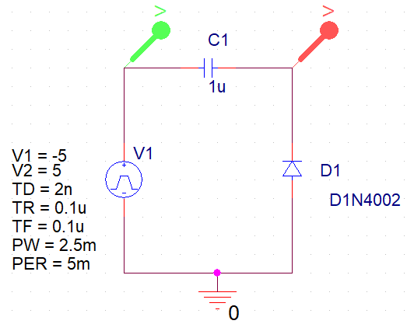

*Answer the following questions:*

1. **Record both and curves with respect to time, on the same graph sheet. Explain the working of the circuit with calculations.**

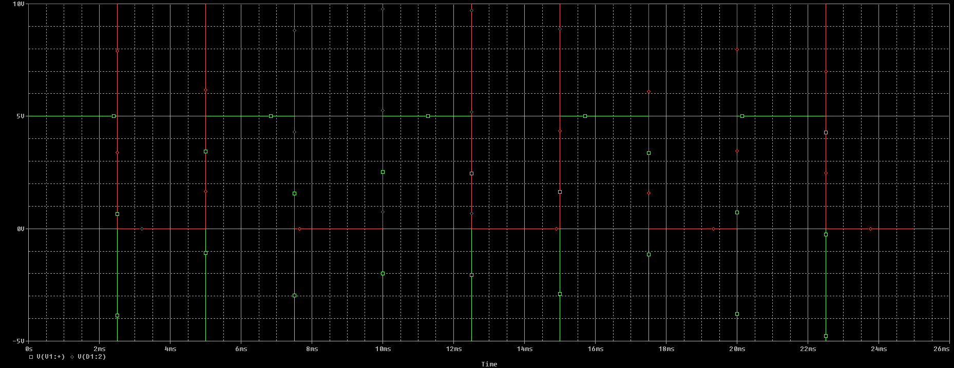

The concept behind a clamper circuit can be generalized to shifting of the DC level of an input signal. A capacitive element is used in pair with a diode in such a way that it allows for the capacitor to charge to the peak value of the input voltage in one half cycle, and allow minimum discharging in the other half cycle. This theory remains true for all clamper circuits.

1. **Will the capacitor discharge during the positive or negative cycles of the input? Explain.**

The capacitor does not discharge at all in this case as there is no resistive element in the circuit; the diode is either open or shorted out, providing no means of charges to impede themselves and discharge the capacitor.

**Implementation of Exercise 1: Part A – (VOUT vs. VIN)**

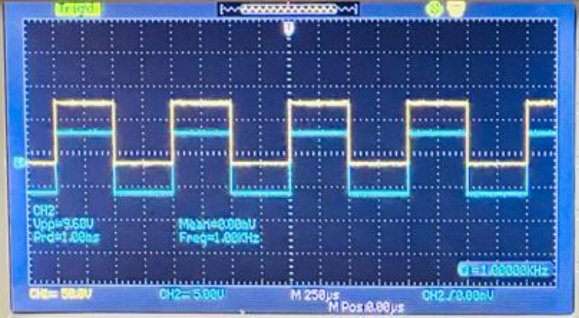

## Exercise 1: Clamping Circuits (Part B - Simulation II)

In this part we will observe modified clamper circuit as given in figure 2B. Draw this circuit in PSpice and make a suitable simulation profile setting.

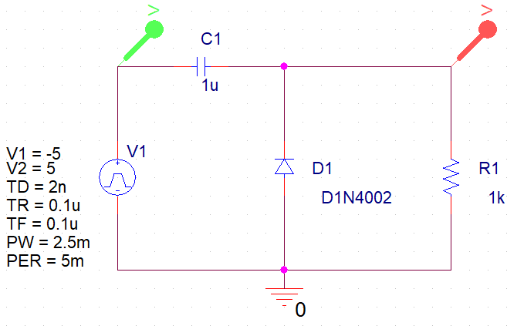

1. **Plot and record both VIN and VO w.r.t. time on the same graph.**

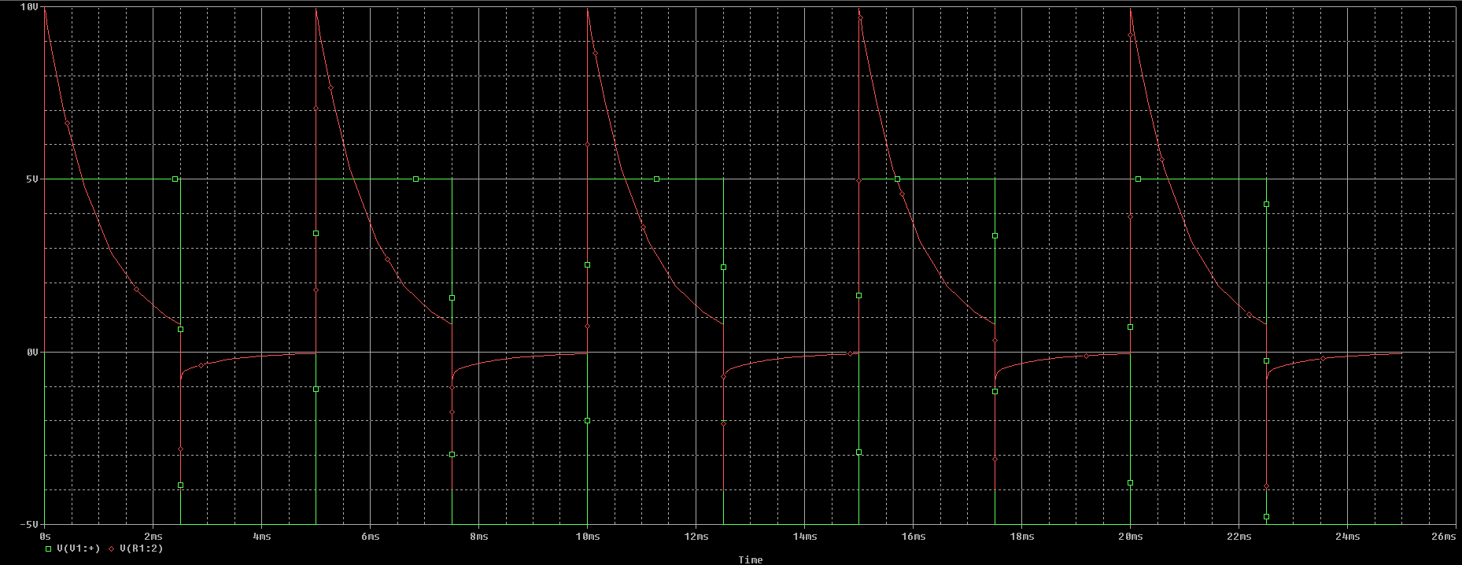

1. **What differences do you observe as compared to circuit in figure 2A? Why do you think these differences occur?**

Since the capacitor is now allowed to discharge through the resistive element in the +ive half cycle, we observe a discharge in the output waveform (*from 2Vm to almost near to zero*). Note that this is the case for a small RC constant. Had the value of RC constant been >> 10, we would observe a waveform similar to that obtained in the first figure, albeit in the positive direction. As an example, if the value of R is made to be 1 MEGA Ohm, the resultant waveform is:

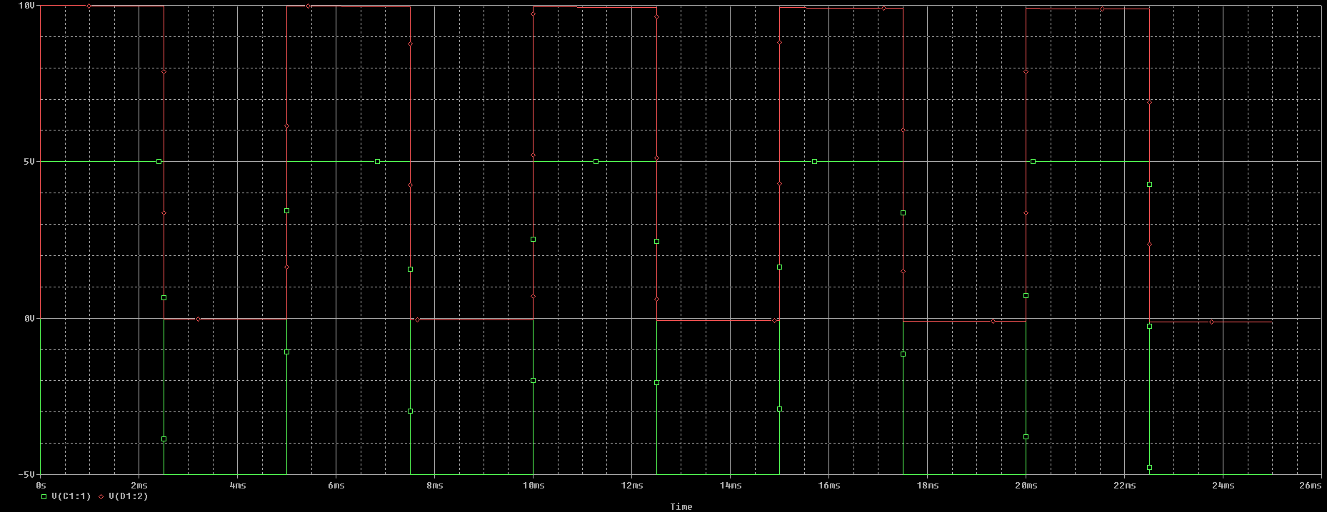

1. **Now change the value of PW to 1ms. Observe the waveform, what differences do you see? Explain with relevant calculations and equations.**

Altering the pulse width to a smaller value results in a smaller discharge of the capacitor in the +ive half cycle, keeping all parameters of the circuit constant. It can be rephrased as giving less time for the capacitor to discharge, i.e. reducing the value of in the equation .

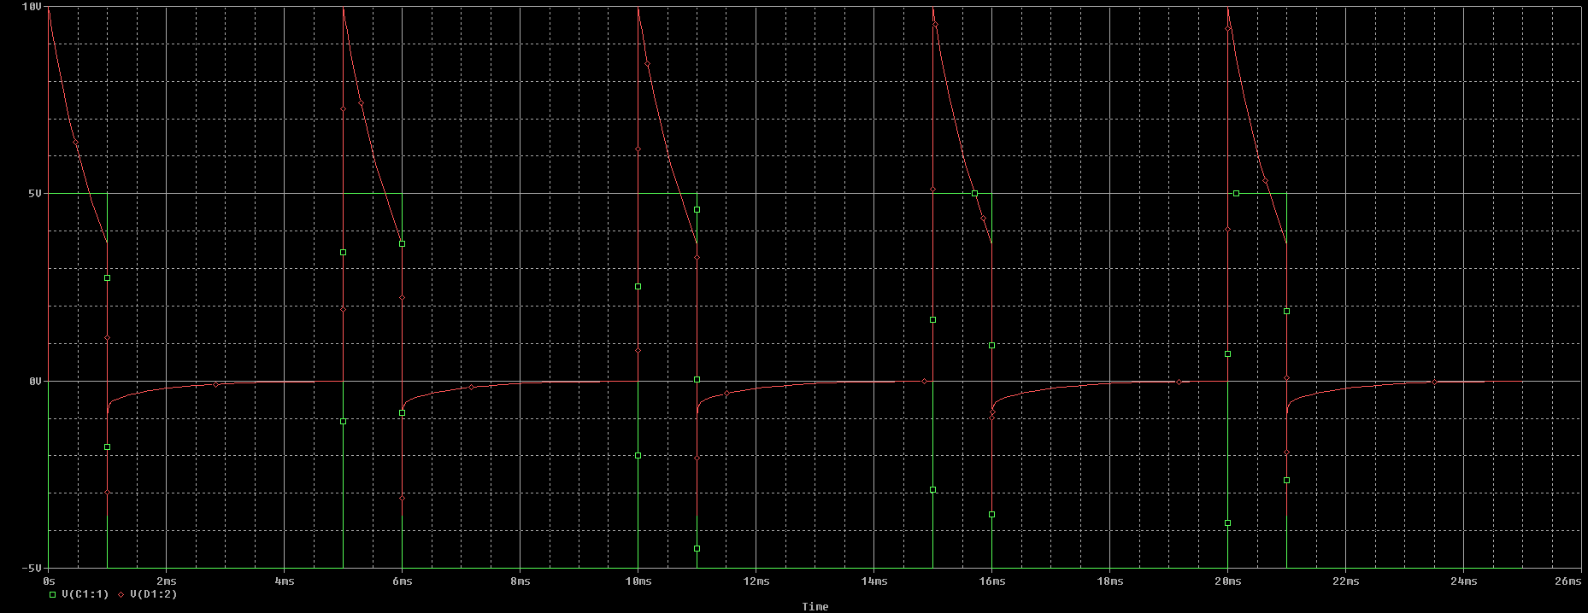

**Implementation of Exercise 1: Part B – (VOUT vs. VIN)**

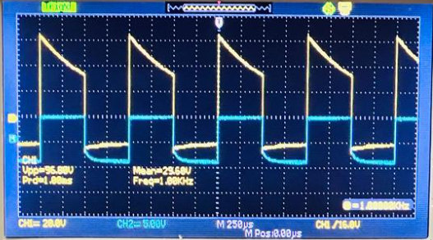

## Exercise 2: Voltage Doubler Circuit

The following procedure should be adopted while practical implementation of the circuit given below.

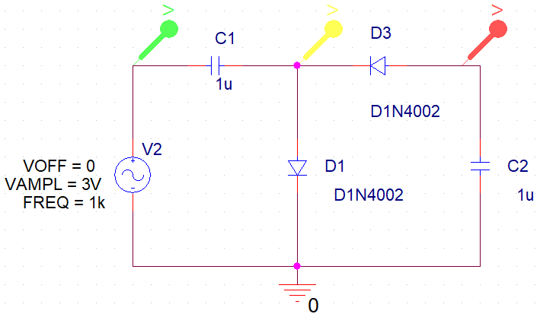

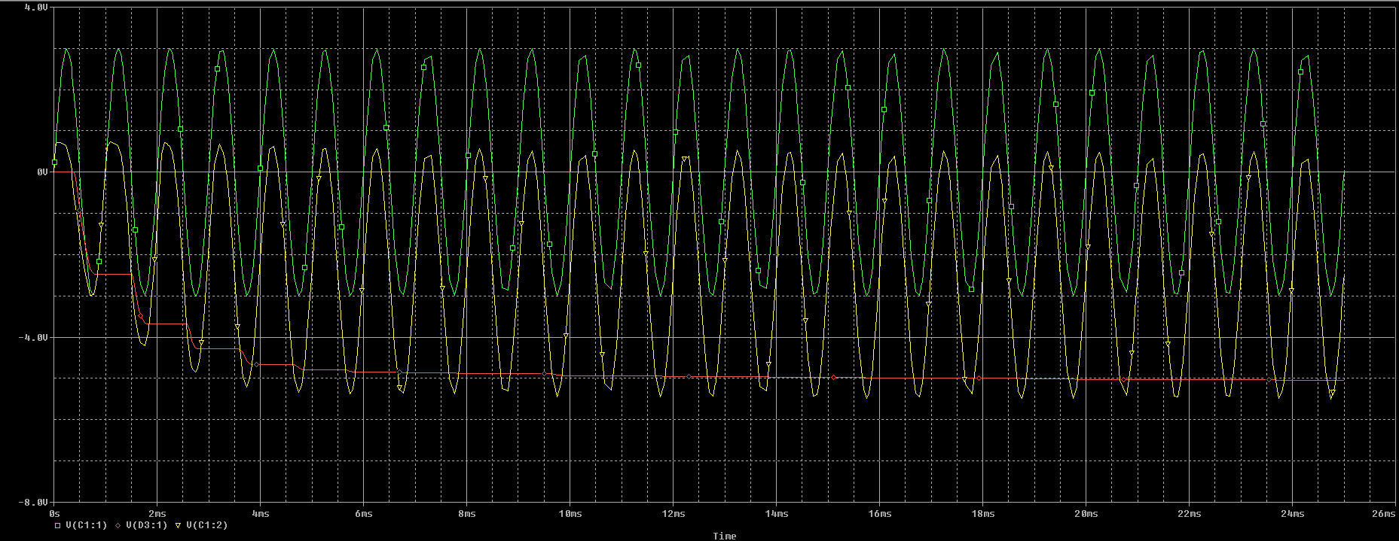

1. **On the bread board patch the circuit shown in the figure 3.**
2. **Derive the equations to explain how the voltage Doubler works.**

During the positive half cycle, diode D1 is reverse biased blocking the discharging of C1 while diode D2 is forward biased charging up capacitor C2. But because there is a voltage across capacitor C1 already equal to the peak input voltage, capacitor C2 charges to twice the peak voltage value of the input signal.

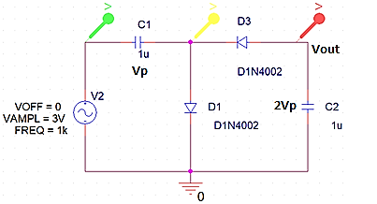

Voltage across C2 can be calculated as:

*Or in other words, the output voltage is double of that of input peak.*

## Exercise 3: Voltage Tripler Circuit (Simulation)

You have experimented with the voltage Doubler circuit in the previous exercise. Now it is required that you design a voltage Tripler circuit.

Use the circuit for the voltage Doubler and design a voltage Tripler. Your design should include the following:

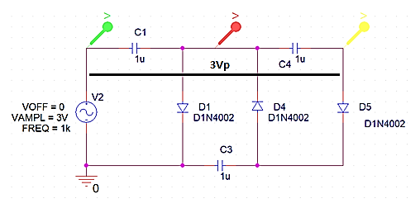

1. **Derive the mathematical relationships for the voltages in the circuit and draw the expected waveforms at different parts of the circuit.**

As with the previous voltage doubler, the diodes within the voltage tripler circuit charge and block the discharge of the capacitors depending upon the direction of the input half-cycle. Then 1Vp is dropped across C3 and 2Vp across C2 and as the two capacitors are in series, this results in the load seeing a voltage equivalent to 3Vp.

Where is the voltage drop across a diode (usually 0.7V).

1. **Attach your simulation profile and output curves showing the results of your design.**

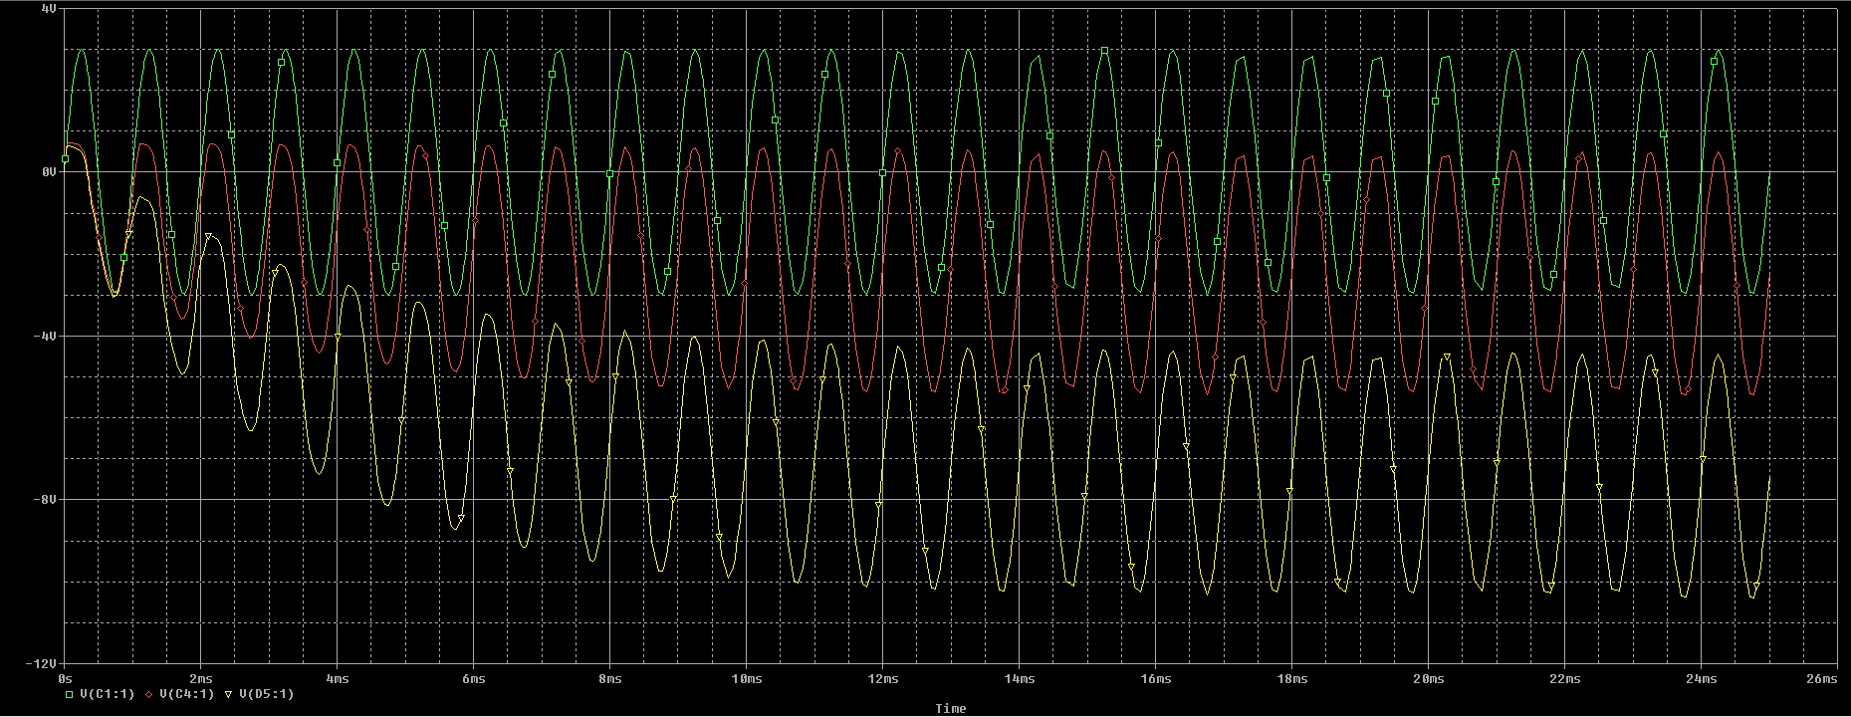

# Conclusion

After performing this lab, we have achieved the following goals;

* Further expanded on the theory of diodes
* Learned how to shift the DC level of a particular circuit through the use of diodes and capacitors
* Designed Voltage doubler and tripler circuits