**Department of Electrical Engineering**

|  |  |
| --- | --- |
| **Faculty Member: ­­­­_______________** | **Dated: ________________** |
| **Semester:_____________** | **Section: ________________** |

**EE215: ELECTRONIC DEVICES AND CIRCUITS**

**Lab 7: Clamper and Voltage Multiplier**

|  |  |  |  |  |
| --- | --- | --- | --- | --- |
| **PLO4/CLO4** | | **PLO5/CLO5** | **PLO8/CLO6** | **PLO9/CLO7** |
| **Name** | **Reg. No** | **Viva /Quiz / Lab Performance**  **5 marks** | **Analysis of data in Lab Report**  **5 marks** | **Modern Tool Usage**  **5 marks** | **Ethics and Safety**  **5 marks** | **Individual and Team Work**  **5 marks** |
|  |  |  |  |  |  |  |
|  |  |  |  |  |  |  |
|  |  |  |  |  |  |  |
|  |  |  |  |  |  |  |

# 

**Objective: To Study advanced applications of Diodes**

The primary purpose of this lab is to develop additional practical knowledge of diodes. Diodes can be used in specialized circuits which include voltage limiters, level shifter or clampers, voltage multipliers especially voltage doubler or tripler circuits. In the previous lab, we looked at some applications of diode, now we will look at some more applications which would show the versatility of this simple two terminal device.

**Required Resources**

The following components, test equipment and software would be required.

1. PN Diode
2. Oscilloscope
3. Function Generator
4. Resistors
5. Capacitors
6. Power Supply
7. PSpice Simulation Software.

**The Experiment**

The experiment is broken down in two exercises; each experiment is divided into two parts namely: implementation and simulation. You are required to observe and record the simulation/implementation results and answer the given questions. Include your answers in your lab reports.

**Exercise 1 Part A: Clamping Circuits (Simulation I)**

This exercise is to experiment with another application of diode, which is known as clamping. The clamping circuit is used to shift the average level of an input signal. This part of the exercise is simulation on OrCad Capture Lite. Follow the steps given below:

* Draw the circuit as shown in figure 2A.
* You have to simulate the circuit by creating your own simulation profile (**Hint:** use transient analysis). Make sure the graph obtained is properly drawn.
* Simulate the circuit and record the curves obtained.

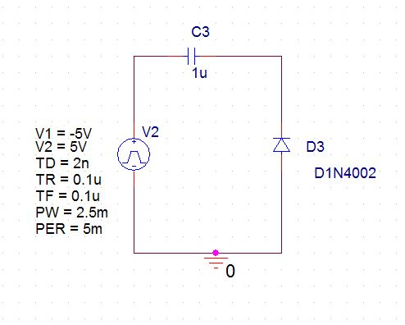

**Figure 2A – Circuit Diagram for Clamper Circuit I**

**Observations/Measurements and Explanations**

**Tutorial: Must Watch https://www.youtube.com/watch?v=7O3Hbkkt624&ab_channel=ALLABOUTELECTRONICS**

Answer the following questions:

* Record both Vin and Vout curves with respect to time, on the same graph sheet. Explain the working of the circuit with calculations.
* Will the capacitor discharge during the positive or negative cycles of the input? Explain.

**Exercise 1: Clamping Circuits (Part B – Simulation II)**

In this part we will observe modified clamper circuit as given in figure 2B. Draw this circuit in PSpice and make a suitable simulation profile setting. Simulate the circuit and answer the following question:

* 1. Plot and record both **Vin and Vo** w.r.t. time on the same graph and explain the working of the circuit.
  2. What differences do you observe as compared to circuit in figure 2A? Why do you think these differences occur?
  3. Now change the value of PW to 1ms. Observe the waveform, what differences do you see? Explain with relevant calculations and equations.

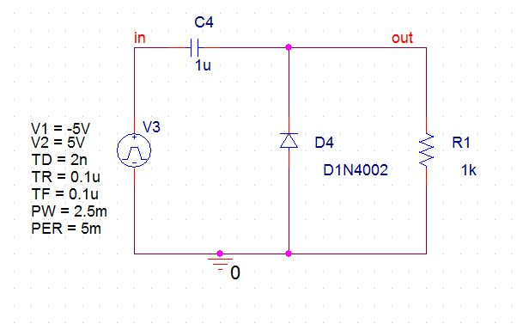



**Figure 2B – Circuit Diagram for Clamper Circuit II**

**Exercise 2: Voltage Doubler Circuit**

**Tutorial: Must Watch**

**https://www.youtube.com/watch?v=IqzA3-bgIIE&ab_channel=ALLABOUTELECTRONICS**

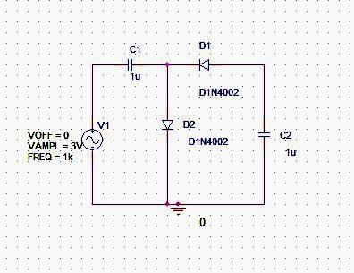

**Figure 3 – Circuit Diagram for Voltage Doubler**

**(Implementation)**

1. The following procedure should be adopted while practical implementation of the circuit given in figure 3:
   1. On the bread board patch the circuit shown in the figure 3.
   2. Observe first the input waveform and voltage across diode D2 on a dual channel oscilloscope. Save your results and add them to your report.
   3. Second observe the input waveform and output across capacitor C2 on a dual channel oscilloscope. Save your results and add them to your report.
   4. Derive the equations to explain how the voltage Doubler works.

**Exercise 3: Voltage Tripler Circuit (Part B – Simulation)**

1. You have experimented with the voltage Doubler circuit in the previous exercise. Now it is required that you design a voltage Tripler circuit.
2. Use the circuit for the voltage Doubler and design a voltage Tripler. Your design should include the following:
   1. Explain what additional components are used and why a particular circuit configuration was chosen.
   2. Derive the mathematical relationships for the voltages in the circuit and draw the expected waveforms at different parts of the circuit.
   3. Simulate the voltage Tripler circuit and verify that the designed circuit works as predicted.
   4. Attach your simulation profile and output curves showing the results of your design.