**Department of Electrical Engineering**

|  |  |
| --- | --- |
| **Faculty Member: Dr. Hammad Cheema** | **Dated: _______________** |
| **Semester:_____________** | **Section: ________________** |

**EE215: ELECTRONIC DEVICES AND CIRCUITS**

**Lab 8: Common Emitter Amplifier**

|  |  |  |  |  |
| --- | --- | --- | --- | --- |
| **PLO4/CLO4** | | **PLO5/CLO5** | **PLO8/CLO6** | **PLO9/CLO7** |
| **Name** | **Reg. No** | **Viva /Quiz / Lab Performance**  **5 marks** | **Analysis of data in Lab Report**  **5 marks** | **Modern Tool Usage**  **5 marks** | **Ethics and Safety**  **5 marks** | **Individual and Team Work**  **5 marks** |
|  |  |  |  |  |  |  |
|  |  |  |  |  |  |  |
|  |  |  |  |  |  |  |
|  |  |  |  |  |  |  |

# LABORATORY EXERCISE-8

# Common Emitter Amplifier

**Theory and Background**

The common-emitter transistor amplifier configuration is widely used. It provides large voltage gain (typically tens to hundreds) and provides moderate input and output impedance. The AC signal voltage gain is defined as

*AV=Voutput / Vinput*

Where Voutput and Vinput can both be rms, peak, or peak-peak values. The input impedance, Zi, is that of the amplifier (as seen by the input signal). The output impedance Zo, is that seen looking from the load into the output of amplifier.

For the voltage-divider DC bias configuration Figure 1, all DC bias voltages can be approximately determined without knowing the exact value of transistor beta. The transistors AC dynamic resistance **re**  can be calculated using

**re=26mV / IEQ mA (Eq.1)**

**Assuming that IEQ≈ICQ**

AC voltage gain : The AC voltage gain of a CE amplifier under no load can be calculated using

**Av= -Rc/ (RE+re)**

If **RE** is bypassed by a capacitor then RE=0 in the equation above therefore.

**Av= -Rc/ (re) (Eq.2)**

**Part 1: Calculations**

**Tutorial: https://www.youtube.com/watch?v=ZUXG9eZfSlw&ab_channel=TheOrganicChemistryTutor**

For the circuit in figure 1.

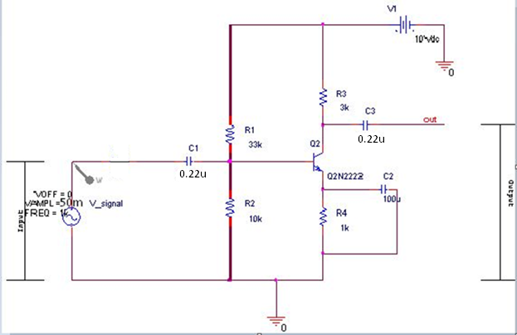

**Fig. 1: Common-Emitter amplifier (with input divider)**

1. Calculate the DC bias values for the circuit of figure 1. And Record them below.

VB(Calculated)=________________

VE(Calculated)=________________

VC(Calculated)=________________

IE(Calculated)=________________

1. Calculate **re** using Equation 1.

re(Calculated)=________________

1. Calculate the amplifier voltage gain for the bypassed emitter using Equation 2

Av(Calculated)=________________

**Part 2: Simulation**

1. Construct the circuit, shown in figure 1, in PSpice, Do not add the parts in dashed boxes initially.
2. Perform a bias point analysis and Record the values

VB(Simulated)=________________

VE(Simulated)=________________

VC(Simulated)=________________

IE(Simulated)=________________

1. Now add the parts in the dashed boxes and perform a transient analysis. Display both input and output waveforms and sketch them.
2. Calculate the gain from the waveforms and record the value

Av(Simulated)=________________

1. Comment on the proximity of the calculated and simulated values for part b and d

**Part 3: Implementation**

1. Patch the circuit in figure 1 on a breadboard ignoring the 50 Ohms resistor as it is used to simulate the internal resistance of signal source. **Do not** supply any AC voltage for the first part. Measure the resistances using handheld multimeter and note their values. (Keep in mind that the capacitors are polarized. Longer pin is positive and shorter pin is negative)
2. Measure the values of

VB(Measured)=________________

VE(Measured)=________________

VC(Measured)=________________

1. Using measured value of VE calculate IE i.e. VE (Measured)/ RE (measured)
2. Using results of Part C and equation 2, find out the **re**

**re( Practical):_________________**

1. Apply an AC signal V_signal=20mV, rms at frequency of 1KHz. Observe the output waveform on an oscilloscope and **sketch it**. Measure the resulting output voltage.

Voutput:______________________

1. Calculate the gain of the implemented circuit and record the value below.

**Av(measured):_______________________**

1. Compare all the values especially **re** and **Av** for all the parts (calculated, measured and simulated) and comment on their proximity