|  |  |
| --- | --- |
| E:\SEECS\Office Work\SEECS logo\01.jpg | **National University of Sciences & Technology (NUST)**  **School of Electrical Engineering and Computer Science (SEECS)**  **Department of Humanities** |

|  |  |  |  |
| --- | --- | --- | --- |
| Engineering Economics | | | |
| Student Name: |  | Semester: | 4th |
| Instructor | **Zainab Zeeshan** | **Class** | **BEE12 A B C D** |

**Demand & Supply Equilibrium**

## Case 1: D↑ = S↑

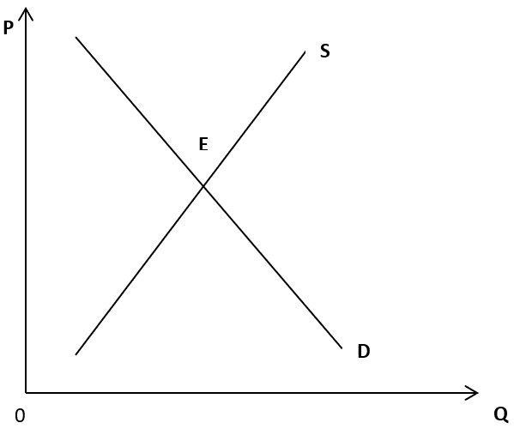

## Case 2: D↑ > S↑



## Case 3: D↑ < S↑



## Case 4: D↑ = S↓



## Case 5: D↑ > S↓



## Case 6: D↑ < S↓



## Case 7: D↓ = S↑



## Case 8: D↓ > S↑



## Case 9: D↓ < S↑



## Case 10: D↓ = S↓



## Case 11: D↓ > S↓



## Case 12: D↓ < S↓

