Basis of the Islamic Economic System: An In-Depth Analysis in Light of Modern Western Systems

Imran Haider, Class BEE 12C, CMS 332569   
Department of Electrical Engineering  
School of Electrical Engineering and Computer SciencesNational University of Science and Technology, Islamabad  
[ihaider.bee20seecs@*](mailto:ihaider.bee20seecs@*)

M. Ahmad Mohsin, Class BEE 12 C, CMS 333060  
Department of Electrical Engineering  
School of Electrical Engineering and Computer SciencesNational University of Science and Technology, Islamabad  
[mmohsin.bee20seecs@*](mailto:mmohsin.bee20seecs@*)

Danial Ahamd, Class BEE 12C, CMS 331388  
Department of Electrical Engineering  
School of Electrical Engineering and Computer SciencesNational University of Science and Technology, Islamabad  
[dahmad.bee20seecs@*](mailto:dahmad.bee20seecs@*)

Muhammad Umer, Class BEE 12 C, CMS 345834  
Department of Electrical Engineering  
School of Electrical Engineering and Computer SciencesNational University of Science and Technology, Islamabad  
[mumer.bee20seecs@*](mailto:mumer.bee20seecs@*)

Saad Bakhtiar, Class BEE 12C, CMS 341150   
Department of Electrical Engineering  
School of Electrical Engineering and Computer SciencesNational University of Science and Technology, Islamabad  
[sbakhtiar.bee20seecs@*](mailto:sbakhtiar.bee20seecs@*)

Tariq Umer, Class BEE 12 C, CMS 334943   
Department of Electrical Engineering  
School of Electrical Engineering and Computer SciencesNational University of Science and Technology, Islamabad  
tumar.bee20seecs@*

*Abstract—After the fall of communism, the market mechanism has become nearly universal. Conventional economic theories argue that this is natural because it is the best and the most efficient method for organizing economic affairs in society. Despite the immense market growth during the past half-century, the issues of inflation, poverty, and lack of resources in different areas of the world remain unresolved. Pride resulting from global dominance and spectacular scientific and technological developments led Europeans to believe that the West was the most advanced and developed of all societies. Other societies were primitive and underdeveloped. As these other societies matured and grew, they would follow the same stages that were followed by the West. This paper throws light on the havoc incurred by the present global market system based on modern capitalism and how the Islamic Economic System can be the solution to all these problems due to its globalized concept based on the equality and equity of mankind and complete submission to Allah’s will. The consequences of Consumerism on basic human psychology will also be discussed. This paper also throws light on a brief overview of the Economic policies of the state of Medina under the Prophet* صلى الله عليه وسلم *and Hazrat Umar bin Khattab, the second Caliph of Islam.*

*Keywords— Communism, Conventional Economic Theories, moment, Modern Capitalism, Consumerism, State of Medina.*

# Introduction

5th of April, Year 2022. We are living in the modern scientific era. According to western history, we are standing at the climax of what they call the **Enlightenment Project** [1], an extremely important element in the current thinking and psychology of Europeans undertaken by large numbers of European intellectuals, consequently the whole world. They thought that the application of the scientific method in all areas of human thought would lead to a radical improvement in the human condition. All social problems such as wars, famines, disease, and misery were due to traditions and superstition (that is, Christianity).  Opposing tradition, establishment, encouraging fresh and innovative ways of thinking, and subjecting all ideas to the iron test of reason would lead to the improvement of humans, and to ‘moral progress’. Since those who are in power are followed by the oppressed, in this age Western Psychology can be the **intellectual elite** of this era. This implies that understanding the core of the western economic system leads to the comprehension of the whole modern world of Economics. After the arrival of the age of enlightenment, there were a lot of philosophies that were introduced by different philosophers (modern word used for Prophets) of different times affecting the Economical perspective of people, nations, and governments. The most important ones are listed and explained as follows. [2]

# Capitalism

Capitalismis an economic system in which capital goods are owned by private individuals or enterprises. A market economy is one in which goods and services are produced based on supply and demand in the general market, rather than through central planning, as in a planned or command economy.

Free market or laissez-faire capitalism is the purest form of capitalism. Private individuals are unrestricted here and may decide where to invest, what to create or sell, and at what rates commodities and services are exchanged. There are no checks or regulations in place in a laissez-faire market. Unlike socialism or feudalism, which use centralized political techniques to organize economic decisions, capitalism uses decentralized and voluntary decision-making to plan economic decisions.

In the present times, most countries utilize a mixed capitalism system, in which the government regulates the industry and owns a portion of some businesses. [3]

## Profits and Losses

Profits are closely associated with the concept of private property. An individual only enters a voluntary exchange of private property when they believe the exchange benefits them in some psychic or material way. In such trades, each party gains extra subjective value, or profit, from the transaction.

Voluntary trade is the mechanism that drives activity in a capitalist system. The owners of resources compete with one another over consumers, who in turn, compete with other consumers over goods and services. All of this activity is built into the price system, which balances supply and demand to coordinate the distribution of resources.

A capitalist makes the greatest money by making the most effective use of capital assets while creating the highest-value item or service. Information regarding what is most valuable is communicated in this system by the pricing at which another individual freely purchases the capitalist's good or service. Profits indicate that fewer high-value inputs have been converted into higher-value outputs. When capital resources are not utilized efficiently and fewer useful outputs are produced, the capitalist suffers losses.

## Capitalism and Economic Growth

Capitalism has shown to be a highly successful vehicle for economic progress by providing incentives for entrepreneurs to reallocate resources away from unprofitable channels and into sectors where customers value them more highly.

Prior to the 18th and 19th centuries, rapid economic growth was mostly achieved by conquest and resource extraction from the victims of such conquests. This was a confined, zero-sum process in general. According to research, the average global per-capita income remained unchanged between the rise of agricultural cultures until around 1750, when the first Industrial Revolution began to take hold.

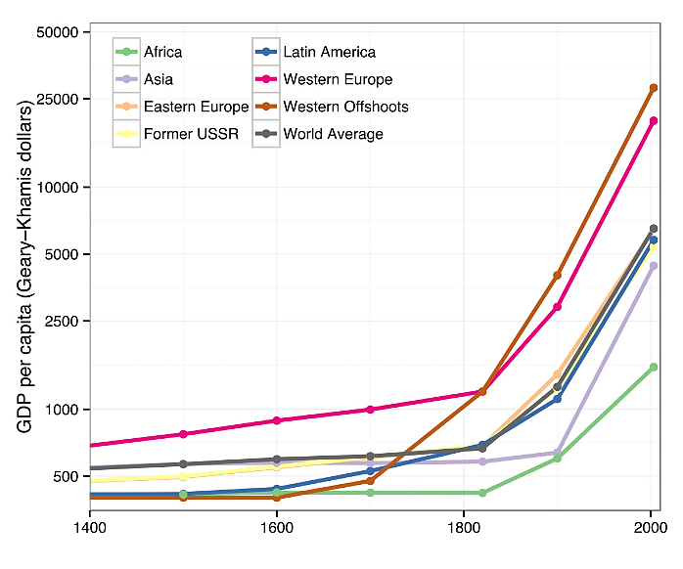

Figure 1 Global GDP Rise after 18th Century

Capitalist manufacturing systems have substantially increased output capacity in subsequent ages. More and better items become more affordable to a larger population, boosting living standards in previously unimaginable ways. As a result, practically all political philosophers and economists claim that capitalism is the most efficient and productive exchange system.

# Consumerism

Consumerism [4] is the idea that increasing the consumption of goods and services purchased in the market is always a desirable goal and that a person's wellbeing and happiness depend fundamentally on obtaining consumer goods and material possessions. In an economic sense, it is related to the Keynesian idea that [consumer spending](https://www.investopedia.com/terms/c/consumer-spending.asp) is the key driver of the economy and that encouraging consumers to spend is a major policy goal. From this point of view, consumerism is a positive phenomenon that fuels economic growth.

Proposed by Edward Bernays, consumerism refers to the tendency of people living in a [**capitalist**](https://www.investopedia.com/terms/c/capitalism.asp) economy to engage in a lifestyle of excessive materialism that revolves around reflexive, wasteful, or conspicuous overconsumption. In this sense, consumerism is widely understood to contribute to the destruction of traditional values and ways of life, consumer exploitation by big business, environmental degradation, and negative psychological effects.

Thorstein Veblen, for example, was a 19th-century economist and sociologist best known for coining the term “conspicuous consumption” in his book The Theory of the Leisure Class (1899). Conspicuous consumption is a means to show one's social status, especially when publicly displayed goods and services are too expensive for other members of the same class. This type of consumption is typically associated with the wealthy but can also apply to any economic class.

Following the Great Depression, consumerism was largely derided. However, with the U.S. economy kickstarted by World War II and the prosperity that followed at the end of the war, the use of the term in the mid-20th century began to have a positive connotation. During this time, consumerism emphasized the benefits that capitalism had to offer in terms of improving standards of living and an economic policy that prioritized the interests of consumers. These largely nostalgic meanings have since fallen out of general use.

## Advantages

Advocates of consumerism point to how consumer spending can drive an economy and lead to increased production of goods and services. As a result of higher consumer spending, a rise in GDP can occur. In the United States, signs of healthy consumer demand can be found in [consumer confidence](https://www.investopedia.com/terms/c/cci.asp) indicators, [retail sales](https://www.investopedia.com/terms/r/retail-sales.asp), and [personal consumption expenditures](https://www.investopedia.com/terms/p/pce.asp). Business owners, workers in the industry, and owners of raw resources can profit from sales of consumer goods either directly or through downstream buyers.

## Disadvantages

Consumerism is often criticized on cultural grounds. Some see that consumerism can lead to a materialistic society that neglects other values. Traditional modes of production and ways of life can be replaced by a focus on consuming ever more costly goods in larger quantities.

Consumerism is often associated with globalization in promoting the production and consumption of globally traded goods and brands, which can be incompatible with local cultures and patterns of economic activity. Consumerism can also create incentives for consumers to take on unsustainable debt levels that contribute to [**financial crises**](https://www.investopedia.com/terms/f/financial-crisis.asp) and [**recessions**](https://www.investopedia.com/terms/r/recession.asp).

Environmental problems are frequently associated with consumerism to the extent that consumer goods industries and the direct effects of consumption produce environmental [**externalities**](https://www.investopedia.com/terms/e/externality.asp). These can include pollution by producing industries, resource depletion due to widespread conspicuous consumption, and problems with waste disposal from excess consumer goods and packaging.

Lastly, consumerism is often criticized on psychological grounds. It is blamed for increasing status anxiety, where people experience stress associated with social status and a perceived need to "keep up with the Joneses" by increasing their consumption.

Psychological research has shown that people who organize their lives around consumerist goals, such as product acquisition, report poorer moods, greater unhappiness in relationships, and other psychological problems. Psychological experiments have shown that people exposed to consumerist values based on wealth, status, and material possessions display greater anxiety and depression.

# Communism

**Communism or socialism** [5] is a social and economic doctrine that calls for public rather than [**private ownership or control of property**](https://www.britannica.com/topic/private-property) and natural resources. According to the socialist view, individuals do not live or [work](https://www.britannica.com/topic/work-economics) in isolation but live in cooperation with one another. Furthermore, everything that people produce is in some sense a social product, and everyone who contributes to the production of a good is entitled to a share in it. Society, therefore, should own or at least control property for the benefit of all its members.

This [conviction](https://www.merriam-webster.com/dictionary/conviction) puts socialism in opposition to [**capitalism**](https://www.britannica.com/topic/capitalism), which is based on private ownership of the means of production and allows individual choices in a **free**[**market**](https://www.britannica.com/topic/market) to determine how goods and services are distributed. Socialists complain that capitalism necessarily leads to unfair and exploitative concentrations of wealth and power in the hands of the relative few who emerge victorious from the free-market competition—people who then use their wealth and power to reinforce their dominance in society. Because such people are rich, they may choose where and how to live, and their choices in turn limit the options of the poor. As a result, terms such as individual freedom and equality of opportunity may be meaningful for capitalists but can only ring [hollow](https://www.britannica.com/dictionary/hollow) for working people, who must do the capitalists’ bidding if they are to survive. As socialists see it, true freedom and true equality require social control of the resources that provide the basis for prosperity in any society. [**Karl Marx**](https://www.britannica.com/biography/Karl-Marx) and [**Friedrich Engels**](https://www.britannica.com/biography/Friedrich-Engels) made this point in the [**Manifesto of the Communist Party**](https://www.britannica.com/topic/The-Communist-Manifesto)**(1848)** when they proclaimed that in a socialist society “the condition for the free development of each is the free development of all.”

This fundamental conviction nevertheless leaves room for socialists to disagree among themselves regarding two key points. The first concerns the extent and the kind of property that society should own or control. Some socialists have thought that almost everything except personal items such as clothing should be public property; this is true, for example, of the society [envisioned](https://www.merriam-webster.com/dictionary/envisioned) by the English [humanist](https://www.britannica.com/topic/humanism) Sir [**Thomas More**](https://www.britannica.com/biography/Thomas-More-English-humanist-and-statesman) in his [***Utopia***](https://www.britannica.com/topic/Utopia-by-More) (1516). Other socialists, however, have been willing to accept or even welcome private ownership of farms, shops, and other small or medium-sized businesses.

The second disagreement concerns the way in which society is to exercise its control of property and other resources. In this case, the main camps consist of loosely defined groups of centralists and decentralists. On the centralist side are socialists who want to invest public control of the property in some central [authority](https://www.britannica.com/topic/authority), such as the state—or the state under the guidance of a [political party](https://www.britannica.com/topic/political-party), as was the case in the [**Soviet Union**](https://www.britannica.com/place/Soviet-Union). Those in the decentralist camp believe that decisions about the use of public property and resources should be made at the local, or lowest possible, level by the people who will be most directly affected by those decisions. This conflict has persisted throughout the history of socialism as a political movement.

Communism finds its roots in history all around the globe. Ranging from religion, theology, Christianity, and monastic orders. It was neither a religious upheaval nor a civil [war](https://www.britannica.com/topic/war) but a technological and economicthe **Industrial- Revolution** of the late 18th and early 19th centuries—that provided the impetus and inspiration for modern communism. This revolution, which achieved great gains in economic productivity at the expense of an increasingly miserable working class, encouraged Marx to think that the class struggles that dominated history was leading inevitably to a society in which prosperity would be shared by all through common ownership of the means of production.

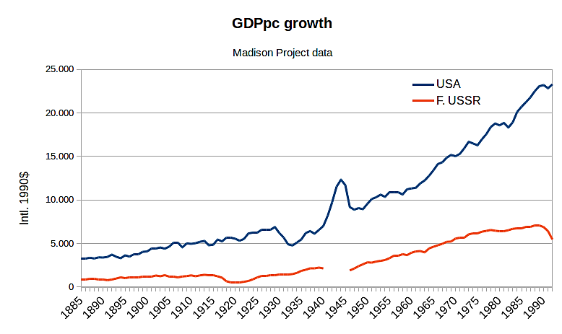

Figure 2 GDP Growth: Pro Communism vs. Pro Capitalism

# Islamic Economic System

Quran is the final love letter of Allah for His followers revealed to His last Prophet Hazrat Muhammad **صلى الله عليه**

**وسلم** 1400 years ago, explained and practiced by the Prophet himself and then further practiced by his companions, proving to be a complete code of conduct for the generations till the collapse of this universe.

The very confusion which must be cleared is why Islam is different from other religions. The simplest of answers can be that it is not just a religion because religion is nothing more than a collection of beliefs and rituals rather it is something more than that.

Allah commands in the Holy Quran,

**اَفَغَیۡرَ دِیۡنِ اللّٰہِ یَبۡغُوۡنَ وَ لَہٗۤ اَسۡلَمَ مَنۡ فِی السَّمٰوٰتِ وَ الۡاَرۡضِ طَوۡعًا وَّ کَرۡہًا وَّ اِلَیۡہِ یُرۡجَعُوۡنَ**

**“So is it other than the religion of Allah they desire, while to Him have submitted [all] those within the heavens and earth, willingly or by compulsion, and to Him, they will be returned”**

**Surat No. 3 Ayat NO. 83**

The Holy Quran has always used the word **دین** for Islam. In Arabic literature, this word is closer to what we call a **system** in the English language. So, one thing which should be clear at this point is that Islam is not just for an individual Muslim to practice rather it is for a society or a state to practice.

Before delving deep into the principles of Islamic Economy, Figure 3 shows the need and the benefits of the Islamic Economic system in lieu of Conventional Western economies, when implemented properly, free of any ill will.

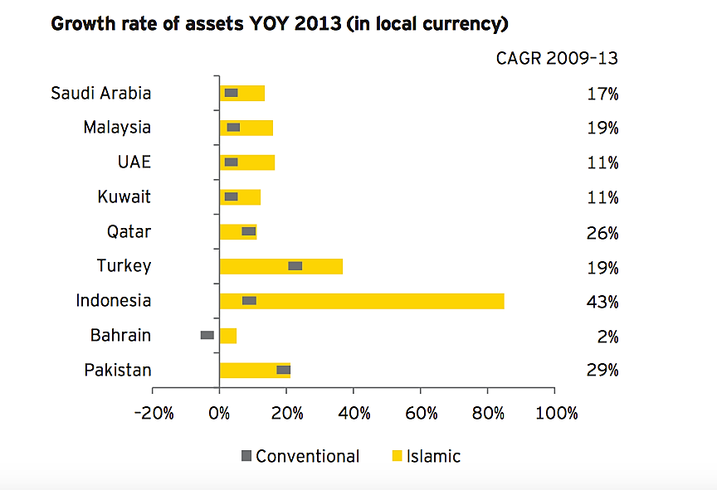

Figure 3 Conventional vs. Islamic Growth Rate of Assets

## The Islamic Ideology

To understand the economic system of Islam, it is very important to understand its basic ideology. This philosophy makes it clear how a Muslim should look at his wealth.

## Islam’s Perception of Money

Wealth is no doubt a blessing of the Almighty, He gives it to anyone he chooses. This is the Algorithm that Allah has designed, and we have to follow it, in fact, we are compelled to follow it. Allah explains this concept in the story of Hazrat Musa and Hazrat Khizr in Surat Al-Kahf, in which Hazrat Khizr exclaims three times that,

**فَوَجَدَا عَبۡدًا مِّنۡ عِبَادِنَاۤ اٰتَیۡنٰہُ رَحۡمَۃً مِّنۡ عِنۡدِنَا وَ عَلَّمۡنٰہُ مِنۡ لَّدُنَّا عِلۡمًا ﴿۶۵﴾**

**قَالَ لَہٗ مُوۡسٰی ہَلۡ اَتَّبِعُکَ عَلٰۤی اَنۡ تُعَلِّمَنِ مِمَّا عُلِّمۡتَ رُشۡدًا ﴿۶۶﴾**

**قَالَ اِنَّکَ لَنۡ تَسۡتَطِیۡعَ مَعِیَ صَبۡرًا ﴿۶۷﴾**

**وَ کَیۡفَ تَصۡبِرُ عَلٰی مَا لَمۡ تُحِطۡ بِہٖ خُبۡرًا ﴿۶۸﴾**

**“And there they found one of Our servants upon whom We had bestowed Our mercy and to whom We had imparted a special knowledge from Ourselves.** **Moses said to him: "May l follow you that you may teach me something of the wisdom which you have been taught?"** **He answered: "You will surely not be able to bear with me.** **For how you can patiently bear with something you cannot encompass in your knowledge?"**

**Surat No 18: سورة الكهف - Ayat No 68**

So now that we are clear that all of the money, we get is based on Allah’s will, a question may be asked what is the purpose of all that hard work that a person puts on?

Allah commands in the Holy Quran,

**وَ اَنۡ لَّیۡسَ لِلۡاِنۡسَانِ اِلَّا مَا سَعٰی ﴿ۙ۳۹﴾**

**“And that man shall have nothing but what he has striven for.”**

**Surat No 53: سورة النجم - Ayat No 39**

But Allah also says,

**قُلِ اللّٰہُمَّ مٰلِکَ الۡمُلۡکِ تُؤۡتِی الۡمُلۡکَ مَنۡ تَشَآءُ وَ تَنۡزِعُ الۡمُلۡکَ مِمَّنۡ تَشَآءُ ۫ وَ تُعِزُّ مَنۡ تَشَآءُ وَ تُذِلُّ مَنۡ تَشَآءُ ؕ بِیَدِکَ الۡخَیۡرُ ؕ اِنَّکَ عَلٰی کُلِّ شَیۡءٍ قَدِیۡرٌ ﴿۲۶﴾**

**“Say: 'O Allah Lord of all dominion! You bestow dominion on whomever You please and take away dominion from whomever You please and You exalt whom You please and abase whom You please. In Your Hand is all good. Surely You are All-Powerful.”**

**Surat No 3: سورة آل عمران - Ayat No 26**

So, if it was knowledge due to which a person could earn money, all the professors of this world would have been millionaires, if it was because of the skill, all the farmers would have been millionaires.

**“If any of those factors which you think is the determinant of money then money would have been indifferent hands altogether.”**

**Sahil Adeem (Podcast: Philosophy of Life)**

## Simplicity In Islam

The second principle that Allah has explained in the Holy Quran is the art of simplicity. Simple lifestyles and self-sufficiency are complementary virtues that have been praised in Islam. These contrast with the search for luxury and the theory of comparative advantage which militates against these virtues.

There is a hadith to the effect that “True richness is the contentment of the heart.” Being satisfied with whatever has been given to us by God is one of the elements of faith. These concepts are well illustrated in the following incident, reported in hadith in al- Bukhari’s Sahih (Volume 3, Book 43: Oppressions, Number 648):

**“I sat down and cast a glance at the room, and by Allah, I couldn’t see anything of importance but three hides. I said (to Allah’s Apostle) “Invoke Allah to make your followers prosperous for the Persians and the Byzantines have been made prosperous and given worldly luxuries, though they do not worship Allah?” The Prophet was leaning then (and on hearing my speech he sat straight) and said, “O Ibn Al-Khattab! Do you have any doubt (that the Hereafter is better than this world)? These people have been given rewards of their good deeds in this world only.” I asked the Prophet. “Please ask Allah’s forgiveness for me”.**

A question might be coming into the reader’s mind that Islam is against the happiness index. This leads us to a very important part, does money buy happiness?

## Money and Happiness

One thing which should be made very clear is that **money does not make you happy, making money makes you happy.** This is not a philosophical myth, there is scientific proof of this. Not only it is evident from scientific research, but also it is evident from the 95 percent of the billionaires who are taking **anti-depressant pills.**

For the historical perspective on this question, refer to the research article of Dr. Asad Zaman.

There is no doubt that making money is one of the most exciting things in this world, but adultery is also exciting, and gambling too is exciting. Exciting is not something because of which we are going to do anything.

**“دَّثَنَا أَبُو عَاصِمٍ، عَنِ ابْنِ جُرَيْجٍ، عَنْ عَطَاءٍ، قَالَ سَمِعْتُ ابْنَ عَبَّاسٍ ـ رضى الله عنهما ـ يَقُولُ سَمِعْتُ النَّبِيَّ صلى الله عليه وسلم يَقُولُ ‏ "‏ لَوْ كَانَ لاِبْنِ آدَمَ وَادِيَانِ مِنْ مَالٍ لاَبْتَغَى ثَالِثًا، وَلاَ يَمْلأُ جَوْفَ ابْنِ آدَمَ إِلاَّ التُّرَابُ، وَيَتُوبُ اللَّهُ عَلَى مَنْ تَابَ ‏"‏‏.‏**

**“Narrated Ibn `Abbas: I heard the Prophet saying, If the son of Adam (the human being) had two valleys of money, he would wish for a third, for nothing can fill the belly of Adam's son except dust, and Allah forgives him who repents to Him.”**

**Sahih Bukhari Vol. 7, 6436**

# Foundations of the Islamic Economic System

The Islamic economic system is based on the following key points which lay the very foundations of the system.

On the State level, in modern vocabulary, the Islamic Economic system is basically a **Controlled and Internally managed Capitalism. Capitalism** in the sense that,

1. Personal ownership is accepted up to a certain level.
2. But the concept of a free economy is not in Islam as, at a specific amount, giving zakat becomes obligatory.
3. The Islamic state rights the basic needs of its citizen.
4. A person’s money does not become a problem for the other person.

In a capitalistic society, a person with a lot of wealth becomes stronger than the law and stronger. At this very point, he starts to corrupt the fabric of society by taking the fate of the poor into his own hands. Islam is against this kind of mentality in which the rich become richer, and the poor become poorer.

John Perkins mentions the same issue in his book **The New Confessions of an Economic Hitman**. The consequences of the Economic War which was started after World War 2 is making the gap between the rich and the poor wider, which may result in a war between the rich and the poor.

## Economic System in the Reign of Umer

Once **Mahatma Gandhi** mentioned “**Abu Bucker (RA) & Umar Ibn Khattab (RA)**” They were leaders of vast empire, yet they lived a life of austerity.

Umar bin Khattab was a close friend of the Prophet Muhammad that did policies in Islamic economy, especially macroeconomy, and found wisdom way to manage property (country wealth) and made people benefit with three ways.

The three ways are as given:

1. Take the right way
2. Give accordance with their rights
3. Avoid from bad

The economic policies of Hazrat Umar Include:

1. Foreign exchange
2. Zakat

Zakat is one of the pillars of Islam and is obligatory for everyone (who fulfill certain conditions) to pay zakat. Indeed, zakat can purify man of avarice and love of extravagance to the property and is capable of nourishing properties of goodness in human hearts and expand their possessions.

Hazrat Umar laid the foundation for charity and philanthropy. Then Imam Malik said: “Interpretation of the words of Umar" cannot be grouped among those who split up "is if there are three people, everyone has forty goats, meaning everyone has forty goats, means any person who is required to issue a zakat goat, but when collecting alms dating, they gathered all their sheep so that they only released two goats alone.” "While interpretation of Umar said "cannot be separated from the assembly" is when there are two associates to buy a goat, they both had the lamb 200 goats, so each has 100 goats, then they should pay zakat three goats. But when it comes to tax collectors, they dissociate (split in two) so that each of them only zakat goat for each person, then Umar forbade things domain.

Hazrat Umer centralized the collection of zakat especially outside the Arab mainland.

## Ghanimah (Spoils of war)

Booty is the property confiscated from the Muslims of the army of infidels with the war path. Ghanimah the things seized by the Muslims from the infidel army; land, prisoners of war (men, women, children), and property that can be moved (horse, silver coins, swords, and so on).

The fundamental problem on the distribution of booty was taken by Hazrat Umer and is given as:

1. Shafi booty is selected by the head of state, this property cannot be divided
2. One-fifth of Shafi shared, assigned to Allah, His Messenger, Prophet relatives, the orphans, the needy, and Ibn Sabil (QS. Al-Anfal 41). After the Prophet's death, Abu Bakr stopped the Apostle and Prophet's kin, and replace it with the poor. Similarly, followed by Umar and distribute to the poor, needy, and Ibn Sabil.
3. Four-fifths were distributed to the soldiers who fought. Regarding the army, according to Umar, there are some conditions for the soldiers of Islam to get the booty among other things.

* It must be fought.
* It should be independent, Umar said, "a slave has no right to the top of the property part of the spoils of war if he took the fight with his master, but he took the fight on his own, then he got the part," and Umar in his "every slave who fought and not with his master, then give him the crate as a free man. "
* Harlequin, Umar did not share the booty with the soldiers who have not reached puberty.

The allocation of spoils (Ghanima) was ordained in the Quran as follows:

**“**And know that whatever you take as spoils in war, a fifth thereof is for Almighty Lord and for the Messenger and the kindred and the orphans and the needy and the wayfarer**”**

## Al-Fai

Fai is the booty left by the enemy. It is the property that is taken from the pagans and is not captured because of war. This Fai is divided into five sections and those sections areas:

1. To Allah and His Messenger
2. The Prophet’s Kin (Banu Hashim and Muttalib)
3. Orphans
4. The poor Ibnu Sabil
5. Four-fifths of the booty was distributed to those who join the battle.

## Kharaj

Another step taken under the government of Hazrat Umer was the introduction of Kharaj. Kharaj system is a system where the tax was imposed on the rulers in the newly conquered territories which generated a lot of revenue for the state. Tax on land must be issued considering the following three conditions:

1) The earth that their owners had converted to Islam, which is a kind of soil or earth is valid and belongs to their owners, and there should be no tax liability against him.

2) Earth peace, that every earth's covenant of peace with Muslim countries, so that they remain his property. Earth-like this tax must be issued, and the earth was still theirs. Once there is an agreement between the two parties Belak, then anyone can not reduce or add even a head of state though. Umar did not reduce the tax and added that he also believes tax was likened to the tribute, so when the owners converted to Islam, so they are not subject to tax or tribute again.

3) Conquered Earth, the Earth's population was conquered by the sharp sword, and the land is not distributed to those who are entitled to the booty, but the earth was still his. He never left the earth and was not distributed to the Muslims. He set the earth remains the property of those who inhabit the earth and were conquered by Muslim rulers. But Umar is only obliged to pay taxes only. And Umar forbade the conquered Muslim ruler to be traded. Umar has required the tax only on the ground that many seeds and fruits, a lot of results, and abounding in steadfast. And do not impose taxes on those who are poor and on land which is built into their homes.

## Jizya

Jizya is the annual tax that must be paid by the unbelievers either they are free, or they are slaves while living on the Islamic territory. Jizya system was also implemented where an annual individual tax would be placed on non-Muslims of the conquered territories to fund state expenditures for public safety and infrastructure projects

## Usyur

It is the money taken by the country from the merchants that pass through the country. standardization of customs imposed on merchants and their merchandise for passing through international boundaries within the caliphate. This generated extra much needed revenue for construction of roads and canals to promoted easier and safer trade routes, ultimately increasing trade and customs acquired form it.

## Bait-ul-Maal

Although Bait-up-Mal was a system existing before Hazrat Umar R.A reign it was he who centralized it into a proper financial institution whose job was to manage the states collected finances and distribute wealth among the needy to reduce poverty and create a proper welfare state. The Bait-ul-mal aided the Muslim and non-Muslim poor, needy, elderly, orphans, widows, and the disabled. Hazrat Umar R.A also introduced a child benefit and pensions for the children and the elderly bringing financial stability to all residents of the Caliphate. While he did all this, he kept an unspecified salary for himself mainly financing his family by his trade activities becoming a source of inspiration for many. He implemented a strong administered system where public workers and soldiers acquired a specified salary standardizing government worker office and creating a standing professional army financed by the state.

Other notable features include,

## **Infrastructure Projects & Free Trade**

During his reign Hazrat Umar bin Khattab R.A started many public infrastructure projects to facilitate easier trade and communication between the new provinces. The aim was to consolidate the gains made and develop a connected system of roads and canals to facilitate residents and merchants easy commute for trade or travel purposes. New and protected roads were developed all over the caliphate to encourage trade activities for merchants from far lands resulting in an economic boom through the exchange of goods and production. Meanwhile, canals were built on many important locations such as along the banks of the river Neil or Tigress to facilitate canal-based trade where massive amounts of cargo sailed through far lands with ease previously inaccessible. The canals also provided waterways for agriculture on previously uncultivable barren lands ultimately increasing the food supply grown from a surplus of farms. Meanwhile, food storage and disaster management infrastructure projects all over the caliphate were carried out to store the prerecorded amount of grain in case of a famine which ended up saving a hundred thousand people during the great famine of 638 CE.

Another big aspect of economic success was free trade which merchants benefited from all over the caliphate. As sales tax was not a system in Islam to encourage commerce it wasn’t implemented resulting in the massive growth of trade activities as the caliphate expanded ore and more. This attracted many foreigners non-Muslims to the lands who wished for their businesses to grow resulting in more economic activities within the caliphate. In the end, all these policies by Hazrat Umar R.T made a proper welfare state where poverty was visually eradicated to the point it got difficult to find people who needed Zakat assistance.

# The Caliph’s Personnel Sympathy

Caliph Umar RA's sense of justice does not seem to have been merely theoretical. Indeed, there are many accounts of his being a **true**man of the people, patrolling the streets in person to see the state of the population under his responsibility. Once he was crying profusely stating that if a baby calf gets lost/orphaned on the riverbanks of Tigris as the ruler he will be answerable to Almighty Lord as he ruled with just and was responsible for his people's welfare as well as for every living animal within his region. no account says that one day, Caliph ‘Umar RA in the presence of a man named Aslam noticed a campfire outside the city of Medina. As they approached the fire, they saw a woman with some young children screaming. The Caliph greeted the woman and asked if he was allowed to approach her. The woman returned the greeting and replied: “Bring us some good or leave us alone.” The Caliph then asked her what had happened to the children. She told him that nightfall and cold had overtaken them, and that hunger was making her children cry. She had a pot set up over the fire to which the Caliph asked what was in it. She told him there was **water** for her children. Not recognizing the Caliph, she added: “I ask God to judge between us and ‘Umar!” The Caliph replied: “God have mercy upon you, how can ‘Umar knows anything about you?” To this, she replied: “He is in authority over us, and yet he neglects us**.”**

The Caliph was famed for his sense of personal responsibility for everyone under his care. Visibly shaken, the Caliph left with Aslam and went to the flour store from where he took out a measure and put a ball of fat into it. When the Caliph started carrying all this, Aslam proposed to carry it on his behalf. But ‘Umar RA insisted and said: “Will you carry my burden for me on the Day of Resurrection? He thus took all the food and they rushed to get back to the woman. The Caliph gave her the food and began to cook the bread with her. Once it was made, he told her to feed her children until they were satisfied. Gratefully she said: “God give you a good reward. You have done better in this matter than the Commander of the Faithful!”. Keeping his identity hidden, ‘Umara RA replied: “Speak well of him, for when you come to the Commander of the Faithful, you will find me there, God willing**”**. After slightly stepping away from her, Aslam said to him that they should leave now as he has other things to do. But the Caliph remained silent until he saw that the children had fallen asleep. After praising God, he turned to Aslam and said: “Hunger kept them awake and made them cry. I did not want to leave until I could see them doing what I see now!**”** (Al-Tabari).

# Conclusion

In summary, we can see that in communism, everyone gets what they need and there is no concentration of wealth among a few, but there is less economic flexibility, which leads to citizens lacking drive. Individual achievement is appreciated, and people are given incentives to work hard in a capitalist system. At the same time, capitalism has the potential to widen the income and wealth divide, exposing workers to exploitation.

On the other hand, in an Islamic economic system, the concept of money is that it defines the relative worth of goods and services. It is more of a medium of exchange than a source of value. Money cannot be sold or purchased on credit; thus, people are less interested with money and more concerned with the products. This improves product quality and introduces healthy competition into the market. It is also to be noted that fundamentally, an Islamic economic system does not differ much from mixed-economy non-Islamic ones, however, by the virtue of divine revelations and order of God.

In conclusion, all economic systems have advantages and disadvantages, and the proper implementation of any one of these economic systems can eliminate many of the difficulties that the economy faces today. And this is precisely why a proper infrastructure backed by Islamic economic system is bound to succeed as proved through history; reason being that divine revelations throughout the Quran intervenes and does not let a person that has been bestowed a powerful position be led astray, such as corruption, tax evasion, etc.

# References

|  |  |
| --- | --- |
| [1] | <https://pakistaniaat.org/index.php/pak/article/view/30/30> |
| [2] | <https://asadzaman.net/the-dark-side-of-the-enlightenment-project/> |
| [3] | <https://www.britannica.com/topic/capitalism> |
| [4] | <https://www.investopedia.com/terms/c/consumerism.asp> |
| [5] | <https://en.wikipedia.org/wiki/Consumerism> |
| [6] | <https://www.britannica.com/topic/communism/Marxian-communism> |
| [7] | <https://asadzaman.net/can-money-buy-happiness/> |
| [8] | <https://youtu.be/ZtUQFdfKiow> |
| [9] | <https://www.amazon.com/New-Confessions-Economic-Hit-Man/dp/1626566747> |
| [10] | <https://www.amazon.com/Sapiens-Humankind-Yuval-Noah-Harari-ebook/dp/B00ICN066A> |
| [11] | <https://www.amazon.com/Lost-Islamic-History-Reclaiming-Civilisation-ebook/dp/B07B5391YM> |
| [12] | <https://books.google.com.pk/books/about/Arab_Administration.html?id=VOZ5nQEACAAJ&redir_esc=y> |

*seecs.edu.pk