Report

## Introduction

We developed a six bit microprocessor using different hardware components and using the basic knowledge of digital logic design and microprocessor systems.

We used different hardware components like 2 – 1 4 bit MUX, 3 bit registers, an ALU unit to perform arithmetic operations such as addition and subtraction, Arduino for power supply and seven segment display and a program counter 74163 (4 bit program counter). Another special use case of Arduino in our particular circuit is of Instruction Decoding; we utilized the On-Chip ROM of Arduino, organized as 4096 x 8 bits, to store the flash program.

## Features Implemented

Our basic microprocessor can perform arithmetic operations of addition and subtraction through the Arithmetic logic unit. We also can output a multiplication table of a small number on the display.

Moreover, there is a program counter (74163 4 bit counter) to count the number of instructions executed. Although we give the clock through the Arduino by controlling its frequency, but we also developed a separate circuit to provide the clock using NE555 timer IC.

## Flowchart

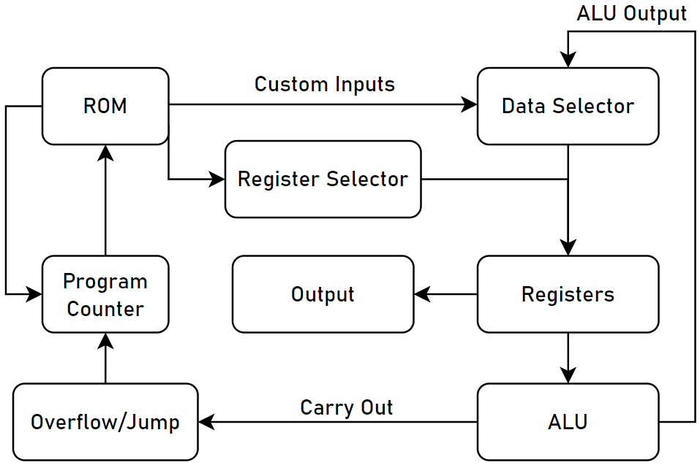

## Simulation

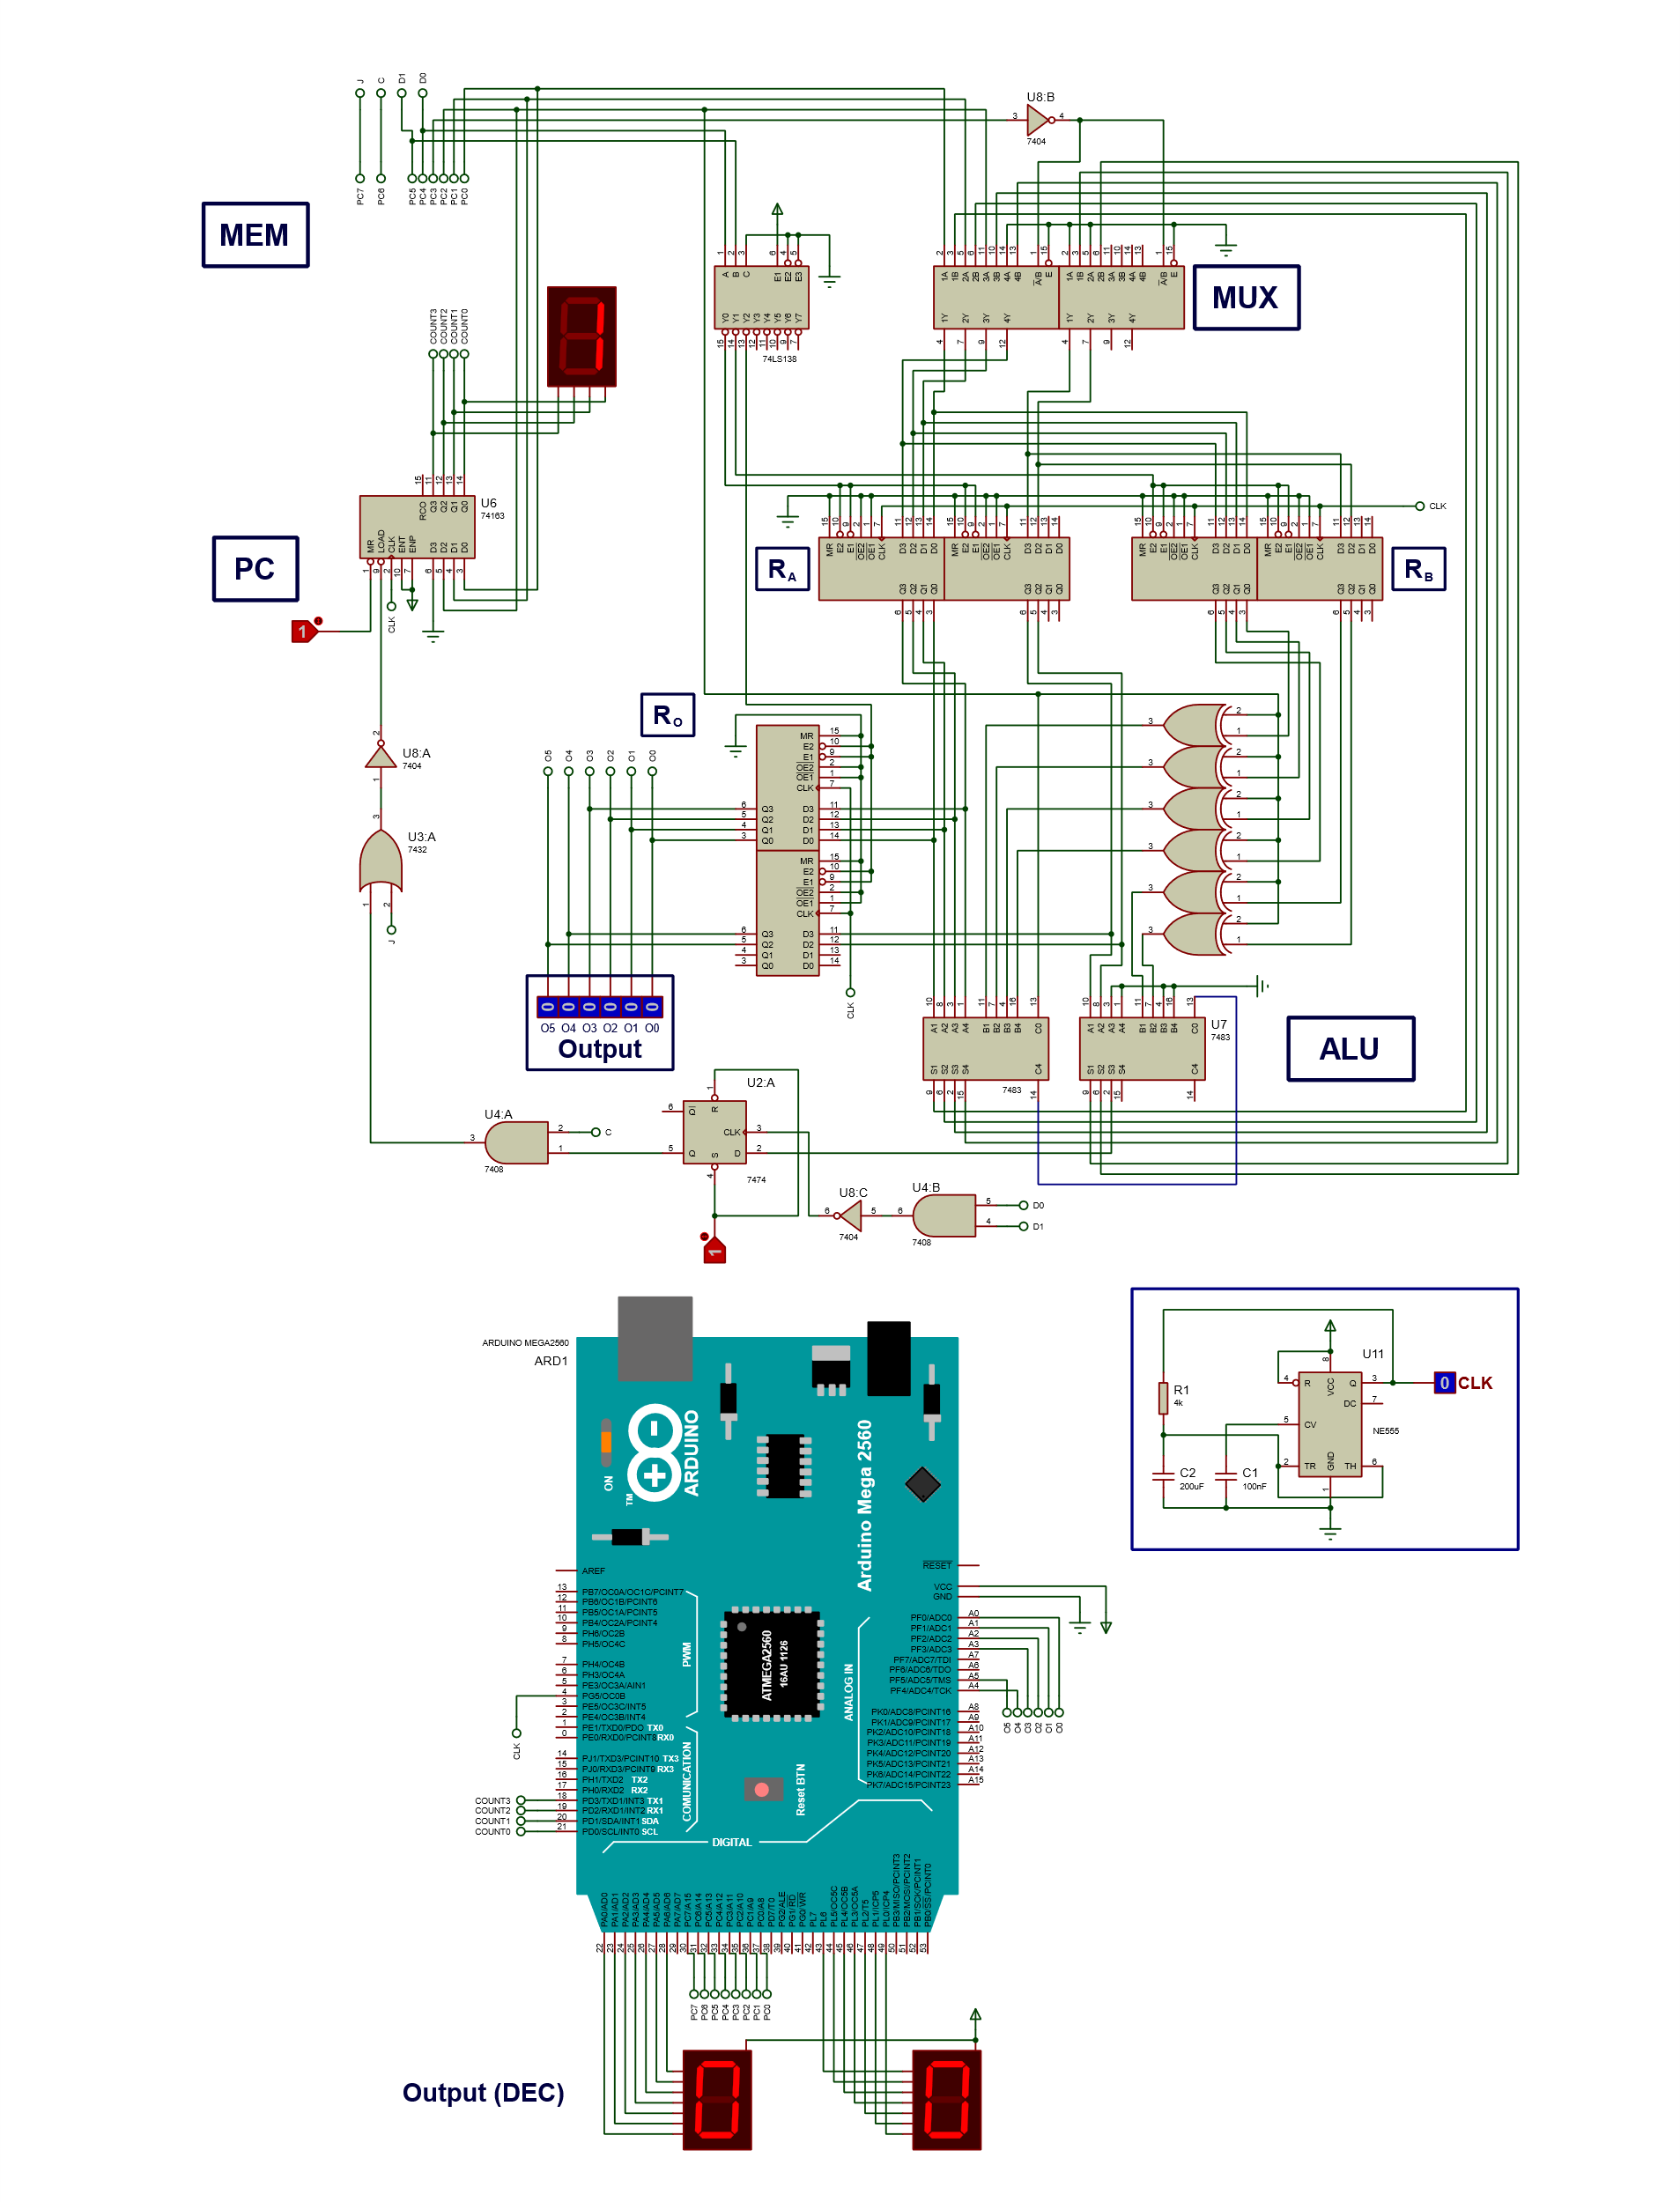

## Conclusion

In this assignment we develop skills on hardware as well as software and learn to implement the basic knowledge to develop a microprocessor from scratch. We programmed a microprocessor that can perform addition (4 bit and 2 bit adders cascaded), subtraction and after every instruction the 4 bit program counter counts. We also learnt the use of Arduino and we used seven segment display through Arduino. Moreover, we also understood the basic working of ROM (XLS 2864) and how to burn it and check the status of different pins to see the flow of instructions from the rom to the microprocessor.