**Department of Electrical Engineering and   
Computer Science**

**Faculty Member:** Dr. Arbab Latif  **Dated:** 31/01/2022

**Semester:** 4th **Section:** BEE 12C

**EE-222: Microprocessor Systems**

Lab 0: Introduction to AVR Programming

Group Members

|  |  |  |  |  |
| --- | --- | --- | --- | --- |
| **Name** | **Reg. No** | **Report**  **Marks / 10** | **Viva**  **Marks / 5** | **Total**  **Marks / 15** |
| Danial Ahmad | 331388 |  |  |  |
| Muhammad Umer | 345834 |  |  |  |
|  |  |  |  |  |
|  |  |  |  |  |

# Experiment

# Intro to AVR Programming

## Objectives

1. Familiarization with Atmel Studio
2. Getting introduced to AVR Microcontrollers
3. Simulating assembly codes for AVR ATmega16A
4. Burning HEX files into ATmega16A using SUPERPRO

## Equipment

Software

* *Atmel Studio*
* *Universal Programmer (SUPERPRO)*

Hardware

* *LEDs*
* *Digital Trainer Kit*
* *ATmega16A Microcontroller Unit*

## Introduction

Atmel Studio IDE is a free development environment for programming Atmel MCUs, sourced by Microchip Technology Inc. It provides us with the means to simulate assembly language codes on specific Microcontrollers and provides an easy and intuitive way of producing .HEX files, which are what makes burning the code on the hardware possible.

In this specific lab, we have implemented a code designed to count from 0x00 to 0xFF whilst its output gets displayed on 8 LEDs (of the trainer kit). The code contains two nested loops: the outer loop (toggler) increments the count with each iteration, while the inner loop (idle loop) simply iterates for a long time doing nothing, thereby acting as a time – delay, without which it would be hard to verify the functionality of our code practically.

In the latter half of this lab, we will utilize the .HEX file produces as a byproduct of debugging this simulation, located within the project directory. A Universal Programmer, in our case, SUPERPRO, will be utilized to burn this file onto our MCU effectively.

## Assembly Code

**; Former Half**

**; Lab1.asm**

**;**

**; Created: 07/02/2022 6:21:55 pm**

**; Author : Muhammad Umer and Danial Ahmad**

**;**

**; initial constants**

**ldi R16, 0xFF**

**ldi R17, 0xFF**

**; set DDRB as output**

**out DDRA, R17**

**; code to toggle LEDs**

**toggler:**

**subi R16, 0xFF**

**out PORTA, R16**

**rjmp idle_loop**

**; delay loop**

**idle_loop :**

**ldi R19, 0xFF**

**ldi R20, 0x0F**

**ldi R21, 0x01**

**idle_loop_0 :**

**idle_loop_1 :**

**idle_loop_2 :**

**dec R19**

**brne idle_loop_2**

**dec R20**

**brne idle_loop_1**

**dec R21**

**brne idle_loop_0**

**rjmp toggler**

## Debug Screenshots

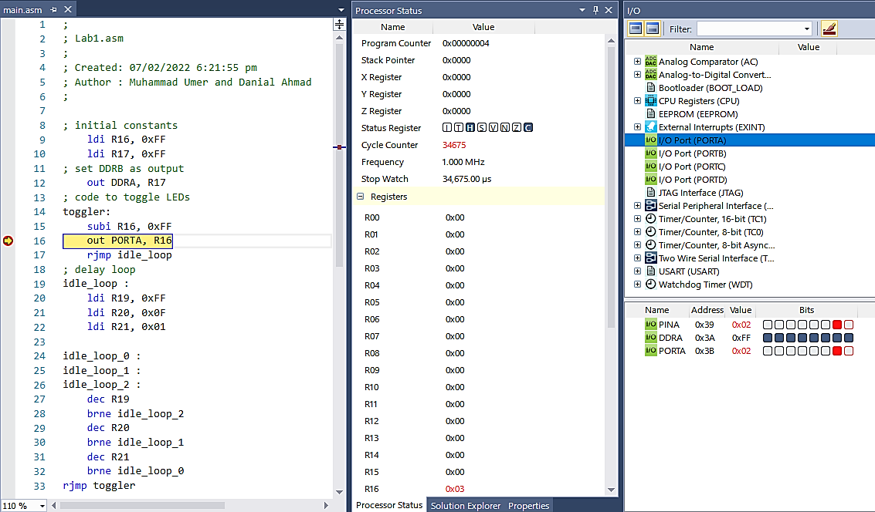

***Iteration 3***

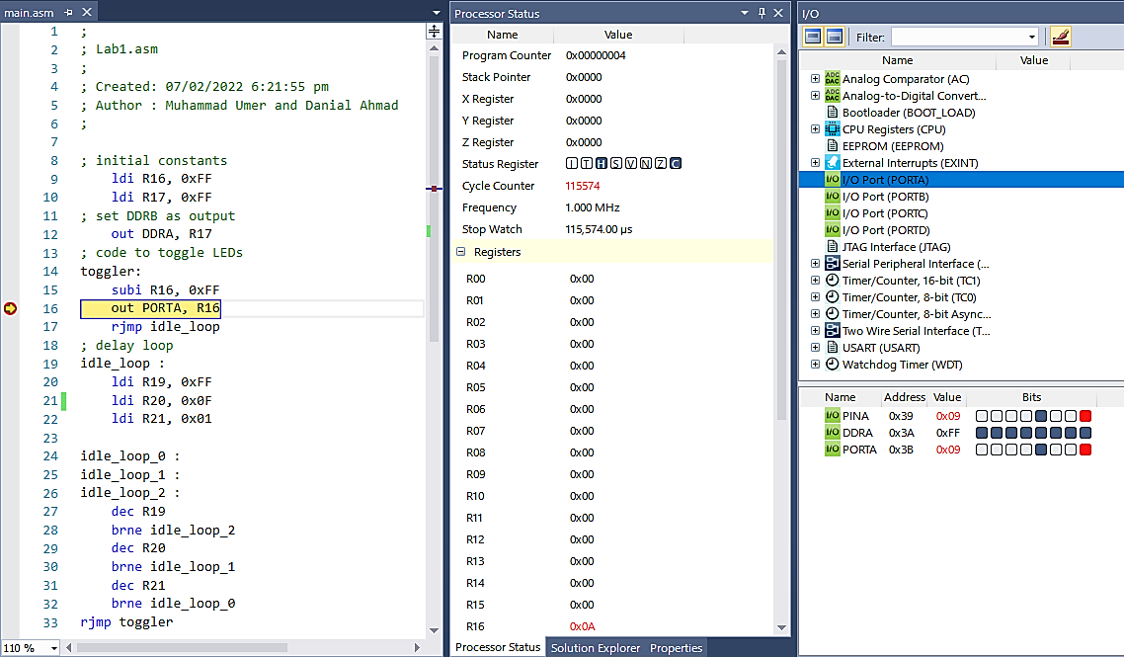

***Iteration 11***

## Simulation Derivations – Tabular Data

## Iteration 1

|  |  |  |  |  |  |  |  |  |
| --- | --- | --- | --- | --- | --- | --- | --- | --- |
| **Cycle Counter** | I | T | H | S | V | N | Z | C |
| 0 | 0 | 0 | 0 | 0 | 0 | 1 | 0 |
| **Cycles** | 4 | | | | | | | |
| **Time** | 4 µs | | | | | | | |
| **R16** | 0x00 | | | | | | | |
| **PORTA** | 0 | 0 | 0 | 0 | 0 | 0 | 0 | 0 |

## Iteration 2

|  |  |  |  |  |  |  |  |  |
| --- | --- | --- | --- | --- | --- | --- | --- | --- |
| **Cycle Counter** | I | T | H | S | V | N | Z | C |
| 0 | 0 | 1 | 0 | 0 | 0 | 0 | 1 |
| **Cycles** | 11561 – 4 = 11557 | | | | | | | |
| **Time** | 11557 µs | | | | | | | |
| **R16** | 0x01 | | | | | | | |
| **PORTA** | 0 | 0 | 0 | 0 | 0 | 0 | 0 | 0 |

## Iteration 3

|  |  |  |  |  |  |  |  |  |
| --- | --- | --- | --- | --- | --- | --- | --- | --- |
| **Cycle Counter** | I | T | H | S | V | N | Z | C |
| 0 | 0 | 1 | 0 | 0 | 0 | 0 | 1 |
| **Cycles** | 23118 – 11561 = 11557 | | | | | | | |
| **Time** | 11557 µs | | | | | | | |
| **R16** | 0x02 | | | | | | | |
| **PORTA** | 0 | 0 | 0 | 0 | 0 | 0 | 0 | 1 |

## Iteration 4

|  |  |  |  |  |  |  |  |  |
| --- | --- | --- | --- | --- | --- | --- | --- | --- |
| **Cycle Counter** | I | T | H | S | V | N | Z | C |
| 0 | 0 | 1 | 0 | 0 | 0 | 0 | 1 |
| **Cycles** | 34675 – 23118 = 11557 | | | | | | | |
| **Time** | 11557µs | | | | | | | |
| **R16** | 0x03 | | | | | | | |
| **PORTA** | 0 | 0 | 0 | 0 | 0 | 0 | 1 | 0 |

## Iteration 5

|  |  |  |  |  |  |  |  |  |
| --- | --- | --- | --- | --- | --- | --- | --- | --- |
| **Cycle Counter** | I | T | H | S | V | N | Z | C |
| 0 | 0 | 1 | 0 | 0 | 0 | 0 | 1 |
| **Cycles** | 46232 – 34675 = 11557 | | | | | | | |
| **Time** | 11557 µs | | | | | | | |
| **R16** | 0x04 | | | | | | | |
| **PORTA** | 0 | 0 | 0 | 0 | 0 | 0 | 1 | 1 |

## Iteration 6

|  |  |  |  |  |  |  |  |  |
| --- | --- | --- | --- | --- | --- | --- | --- | --- |
| **Cycle Counter** | I | T | H | S | V | N | Z | C |
| 0 | 0 | 1 | 0 | 0 | 0 | 0 | 1 |
| **Cycles** | 57789 – 46232 = 11557 | | | | | | | |
| **Time** | 11557 µs | | | | | | | |
| **R16** | 0x05 | | | | | | | |
| **PORTA** | 0 | 0 | 0 | 0 | 0 | 1 | 0 | 0 |

## Iteration 7

|  |  |  |  |  |  |  |  |  |
| --- | --- | --- | --- | --- | --- | --- | --- | --- |
| **Cycle Counter** | I | T | H | S | V | N | Z | C |
| 0 | 0 | 1 | 0 | 0 | 0 | 0 | 1 |
| **Cycles** | 69346 – 57789 = 11557 | | | | | | | |
| **Time** | 11557 µs | | | | | | | |
| **R16** | 0x06 | | | | | | | |
| **PORTA** | 0 | 0 | 0 | 0 | 0 | 1 | 0 | 1 |

## Iteration 8

|  |  |  |  |  |  |  |  |  |
| --- | --- | --- | --- | --- | --- | --- | --- | --- |
| **Cycle Counter** | I | T | H | S | V | N | Z | C |
| 0 | 0 | 1 | 0 | 0 | 0 | 0 | 1 |
| **Cycles** | 80903 – 69346 = 11557 | | | | | | | |
| **Time** | 11557 µs | | | | | | | |
| **R16** | 0x07 | | | | | | | |
| **PORTA** | 0 | 0 | 0 | 0 | 0 | 1 | 1 | 0 |

## Iteration 8

|  |  |  |  |  |  |  |  |  |
| --- | --- | --- | --- | --- | --- | --- | --- | --- |
| **Cycle Counter** | I | T | H | S | V | N | Z | C |
| 0 | 0 | 1 | 0 | 0 | 0 | 0 | 1 |
| **Cycles** | 92460 – 80903 = 11557 | | | | | | | |
| **Time** | 11557 µs | | | | | | | |
| **R16** | 0x08 | | | | | | | |
| **PORTA** | 0 | 0 | 0 | 0 | 0 | 1 | 1 | 1 |

## Iteration 10

|  |  |  |  |  |  |  |  |  |
| --- | --- | --- | --- | --- | --- | --- | --- | --- |
| **Cycle Counter** | I | T | H | S | V | N | Z | C |
| 0 | 0 | 1 | 0 | 0 | 0 | 0 | 1 |
| **Cycles** | 104017 – 92460 =11557 | | | | | | | |
| **Time** | 11557 µs | | | | | | | |
| **R16** | 0x09 | | | | | | | |
| **PORTA** | 0 | 0 | 0 | 0 | 1 | 0 | 0 | 0 |

## Iteration 11

|  |  |  |  |  |  |  |  |  |
| --- | --- | --- | --- | --- | --- | --- | --- | --- |
| **Cycle Counter** | I | T | H | S | V | N | Z | C |
| 0 | 0 | 1 | 0 | 0 | 0 | 0 | 1 |
| **Cycles** | 115574 – 104017 = 11557 | | | | | | | |
| **Time** | 11557 µs | | | | | | | |
| **R16** | 0x0A | | | | | | | |
| **PORTA** | 0 | 0 | 0 | 0 | 1 | 0 | 0 | 1 |

## Iteration 12

|  |  |  |  |  |  |  |  |  |
| --- | --- | --- | --- | --- | --- | --- | --- | --- |
| **Cycle Counter** | I | T | H | S | V | N | Z | C |
| 0 | 0 | 1 | 0 | 0 | 0 | 0 | 1 |
| **Cycles** | 127131 – 115574 = 11557 | | | | | | | |
| **Time** | 11557 µs | | | | | | | |
| **R16** | 0x0B | | | | | | | |
| **PORTA** | 0 | 0 | 0 | 0 | 1 | 0 | 1 | 0 |

## Iteration 13

|  |  |  |  |  |  |  |  |  |
| --- | --- | --- | --- | --- | --- | --- | --- | --- |
| **Cycle Counter** | I | T | H | S | V | N | Z | C |
| 0 | 0 | 1 | 0 | 0 | 0 | 0 | 1 |
| **Cycles** | 138688 – 127131 = 11557 | | | | | | | |
| **Time** | 11557 µs | | | | | | | |
| **R16** | 0x0C | | | | | | | |
| **PORTA** | 0 | 0 | 0 | 0 | 1 | 0 | 1 | 1 |

## Iteration 14

|  |  |  |  |  |  |  |  |  |
| --- | --- | --- | --- | --- | --- | --- | --- | --- |
| **Cycle Counter** | I | T | H | S | V | N | Z | C |
| 0 | 0 | 1 | 0 | 0 | 0 | 0 | 1 |
| **Cycles** | 150245 – 138688 = 11557 | | | | | | | |
| **Time** | 11557 µs | | | | | | | |
| **R16** | 0x0D | | | | | | | |
| **PORTA** | 0 | 0 | 0 | 0 | 1 | 1 | 0 | 0 |

## Iteration 15

|  |  |  |  |  |  |  |  |  |
| --- | --- | --- | --- | --- | --- | --- | --- | --- |
| **Cycle Counter** | I | T | H | S | V | N | Z | C |
| 0 | 0 | 1 | 0 | 0 | 0 | 0 | 1 |
| **Cycles** | 161802 – 150245 = 11557 | | | | | | | |
| **Time** | 11557 µs | | | | | | | |
| **R16** | 0x0E | | | | | | | |
| **PORTA** | 0 | 0 | 0 | 0 | 1 | 1 | 0 | 1 |

## Iteration 16

|  |  |  |  |  |  |  |  |  |
| --- | --- | --- | --- | --- | --- | --- | --- | --- |
| **Cycle Counter** | I | T | H | S | V | N | Z | C |
| 0 | 0 | 1 | 0 | 0 | 0 | 0 | 1 |
| **Cycles** | 173359 – 161802 = 11557 | | | | | | | |
| **Time** | 11557 µs | | | | | | | |
| **R16** | 0x0F | | | | | | | |
| **PORTA** | 0 | 0 | 0 | 0 | 1 | 1 | 1 | 0 |

## Iteration 17

|  |  |  |  |  |  |  |  |  |
| --- | --- | --- | --- | --- | --- | --- | --- | --- |
| **Cycle Counter** | I | T | H | S | V | N | Z | C |
| 0 | 0 | 0 | 0 | 0 | 0 | 0 | 1 |
| **Cycles** | 184916 – 173359 = 11557 | | | | | | | |
| **Time** | 11557 µs | | | | | | | |
| **R16** | 0x10 | | | | | | | |
| **PORTA** | 0 | 0 | 0 | 0 | 1 | 1 | 1 | 1 |

## Iteration 18

|  |  |  |  |  |  |  |  |  |
| --- | --- | --- | --- | --- | --- | --- | --- | --- |
| **Cycle Counter** | I | T | H | S | V | N | Z | C |
| 0 | 0 | 1 | 0 | 0 | 0 | 0 | 1 |
| **Cycles** | 196473 – 184916 = 11557 | | | | | | | |
| **Time** | 11557 µs | | | | | | | |
| **R16** | 0x11 | | | | | | | |
| **PORTA** | 0 | 0 | 0 | 1 | 0 | 0 | 0 | 0 |

## Iteration 19

|  |  |  |  |  |  |  |  |  |
| --- | --- | --- | --- | --- | --- | --- | --- | --- |
| **Cycle Counter** | I | T | H | S | V | N | Z | C |
| 0 | 0 | 1 | 0 | 0 | 0 | 0 | 1 |
| **Cycles** | 208030 – 196473 = 11557 | | | | | | | |
| **Time** | 11557 µs | | | | | | | |
| **R16** | 0x12 | | | | | | | |
| **PORTA** | 0 | 0 | 0 | 1 | 0 | 0 | 0 | 1 |

## Iteration 20

|  |  |  |  |  |  |  |  |  |
| --- | --- | --- | --- | --- | --- | --- | --- | --- |
| **Cycle Counter** | I | T | H | S | V | N | Z | C |
| 0 | 0 | 1 | 0 | 0 | 0 | 0 | 1 |
| **Cycles** | 219587 – 208030 = 11557 | | | | | | | |
| **Time** | 11557 µs | | | | | | | |
| **R16** | 0x13 | | | | | | | |
| **PORTA** | 0 | 0 | 0 | 1 | 0 | 0 | 1 | 0 |

## Simulation Derivations – Observations

* From this tabular data, and by looking at the results of the first 20 iterations, we can conclusively say that our assembly code essentially acts as a binary up counter, as the value of R16 increments by 1 after each iteration.
* PORTA provides 8 – bit positions for the binary representation of the counter.
* Apart from the first iteration taking lesser time per cycle due to the addition of breakpoint, all the other iterations took a constant amount of time as a loop was being repeated on each ‘continue’ of the debugger.

## Conclusion

After the conduction of this lab, we have familiarized ourselves with the Atmel Studio Development Environment and learnt how to simulate assembly language codes, albeit without going much into the detail of the code itself. Upon making inferences on the output, we deduce that our code counts from 0x00 to 0xFF, *(00000000 to 11111111 in binary)*. We also tabulated different values, namely, status register, time taken, cycles for iteration, register R16, and I/O PORTA for the first 20 iterations.