**Department of Electrical Engineering and   
Computer Science**

**Faculty Member:** Dr. Arbab Latif  **Dated:** 11/04/2022

**Semester:** 4th **Section:** BEE 12C

**EE-222: Microprocessor Systems**

Lab 9: Voltmeter Design

Group Members

|  |  |  |  |  |
| --- | --- | --- | --- | --- |
| **Name** | **Reg. No** | **Report**  **Marks / 10** | **Viva**  **Marks / 5** | **Total**  **Marks / 15** |
| Danial Ahmad | 331388 |  |  |  |
| Muhammad Umer | 345834 |  |  |  |
|  |  |  |  |  |
|  |  |  |  |  |

# Experiment

## Objectives

1. Solve daily life problems through microcontroller.
2. Develop a voltmeter using ADC.
3. Propose your engineering solution to the problem.

## Equipment

Software

* *Atmel Studio*

Hardware

* ATmega16A Microcontroller Unit
* Universal Programmer
* Seven Segment Display
* Resistance 47Ω
* LEDs (may use from trainer kit)
* USB-TTL Converter.

## Introduction

 Atmel Studio IDE is a free development environment for programming Atmel MCUs, sourced by Microchip Technology Inc. It provides us with the means to simulate assembly language codes on specific Microcontrollers and provides an easy and intuitive way of producing .HEX files, which are what makes burning the code on the hardware possible.

In this specific lab, we familiarize ourselves with the on-chip Analog to Digital converters of the ATmega16A. The ability to convert analog signals to discrete time signals is an integral part of any communication device; it allows us to interface a lot more with our microcontroller than just logical ICs and LEDs. We utilized this concept to design a Voltmeter, the specifications and the code of which are attached herewith.

# Lab Tasks

## Task A

Design a (0-5V range) digital voltmeter using ATmega16 ADC channel zero and display your readings on a 2-digit (units and a decimal point digit) seven segment display.For example 3.4 should be displayed as:

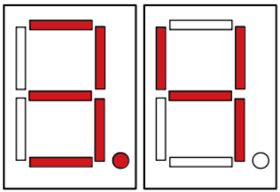

**#include <avr/io.h>**

**#include <math.h>**

**char SevenSegment(char number);**

**float num = 0;**

**float temp_fp = 0;**

**int dec = 0;**

**int fp = 0;**

**// initialize adc**

**void adc_init()**

**{**

**// AREF = AVcc**

**ADMUX = (1<<REFS0);**

**// ADC Enable and prescaler of 8**

**// 1000000/8 = 125000**

**ADCSRA = (1<<ADEN)|(1<<ADPS1)|(1<<ADPS0);**

**}**

**// read adc value**

***uint16_t* adc_read()**

**{**

**// start single conversion**

**// write '1' to ADSC**

**ADCSRA |= (1<<ADSC);**

**// wait for conversion to complete**

**// ADSC becomes '0' again**

**// till then, run loop continuously**

**while(ADCSRA & (1<<ADSC));**

**return ADC;**

**}**

**void split(float num)**

**{**

**num = num * 4.88e-3;**

**num = *roundf*(num * 10.0f)/10.0f;**

**dec = (int)num;**

**temp_fp = (num - dec)*10;**

**fp = temp_fp;**

**}**

**int main(void)**

**{**

**DDRC = 0xFF;**

**DDRD = 0xFF;**

**PORTC = 0x00;**

**PORTD = 0x00;**

**adc_init();**

**/* Replace with your application code */**

**while (1)**

**{**

**adc_read();**

**num = ADC;**

**split(num);**

**PORTC = SevenSegment(dec);**

**PORTD = SevenSegment(fp);**

**}**

**}**

**// ------- BCD - 7 Segment Decoder -------**

**char SevenSegment(char number)**

**{**

**if (number == 0) return 0x01;**

**else if (number == 1) return 0x4F;**

**else if (number == 2) return 0x12;**

**else if (number == 3) return 0x06;**

**else if (number == 4) return 0x4C;**

**else if (number == 5) return 0x24;**

**else if (number == 6) return 0x20;**

**else if (number == 7) return 0x0F;**

**else if (number == 8) return 0x00;**

**else if (number == 9) return 0x0C;**

**else return 0xFF;**

**}**



Voltmeter for - 5V to + 5V Sine Wave

## Task B

Build the given three circuits using all same resistances and measure Vx using the voltmeter you made. Also calculate Vx theoretically using circuit analysis techniques and compare results. Include the images of readings from your voltmeter and the calculations in your lab report.

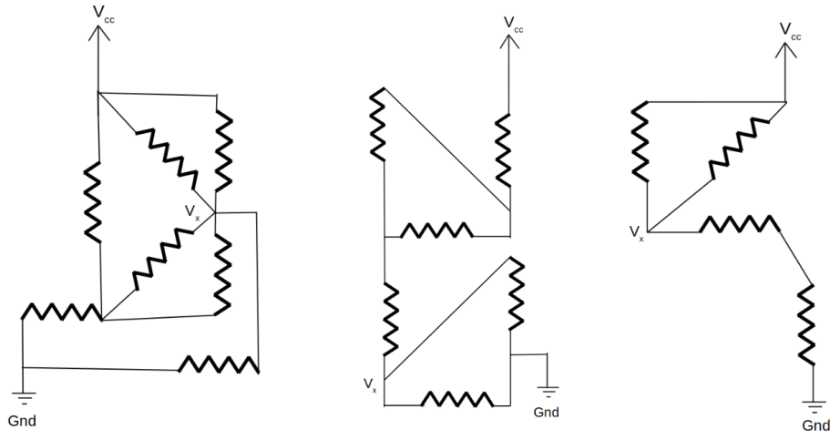

As any specific resistance isn’t specified, we assume it to be a default value of 10k Ohms. These resistance combinations divide a 5V DC voltage across different nodes, and we are required to find the voltage at Vx.

**Leftmost Circuit**

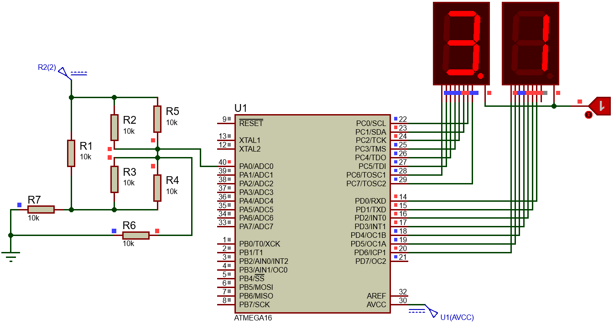

**Theoretical Calculations:** Replacing the parallel resistors with an equivalent of $5kΩ$, we have a circuit with three loops;

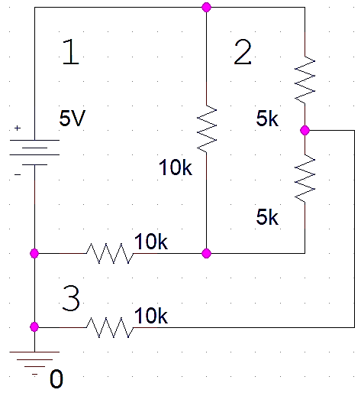

Through mesh analysis, the current in each loop is:

$$I_{1}=593.8 μA, I_{2}=375 μA, I_{3}=312.5 μA$$

Using Ohms law in the resistor of Loop 3:

$$I_{3}=312.5 μA=\frac{V_{x}}{10k}=3.125 V$$

**Middle Circuit**

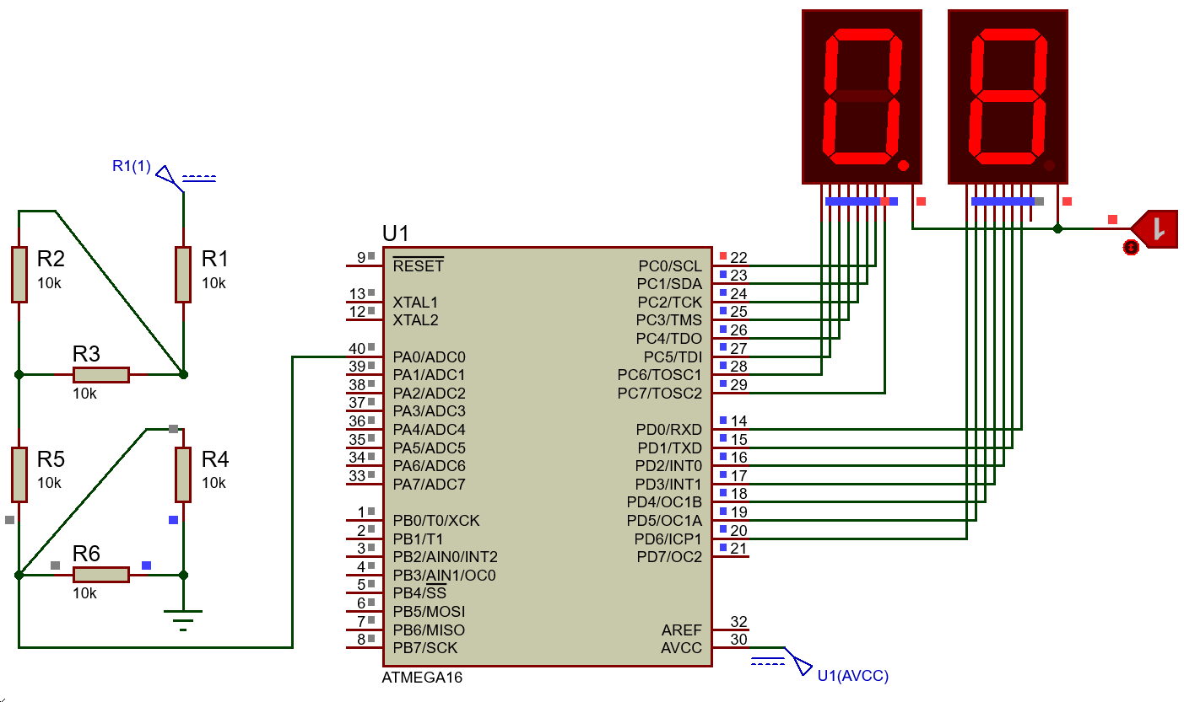

**Theoretical Calculations:** The upper half combination of resistor can be replaced with an equilvalent resistance of;

While the lower half just beside $V_{x}$ can be replaced with;

$$R_{eq_{lower}}=5 kΩ$$

We can then find $V_{x}$ (across the lower half) through Voltage Divider formula:

$$Vx=5×\frac{5k}{25k+5k}=0.833 V$$

**Rightmost Circuit**

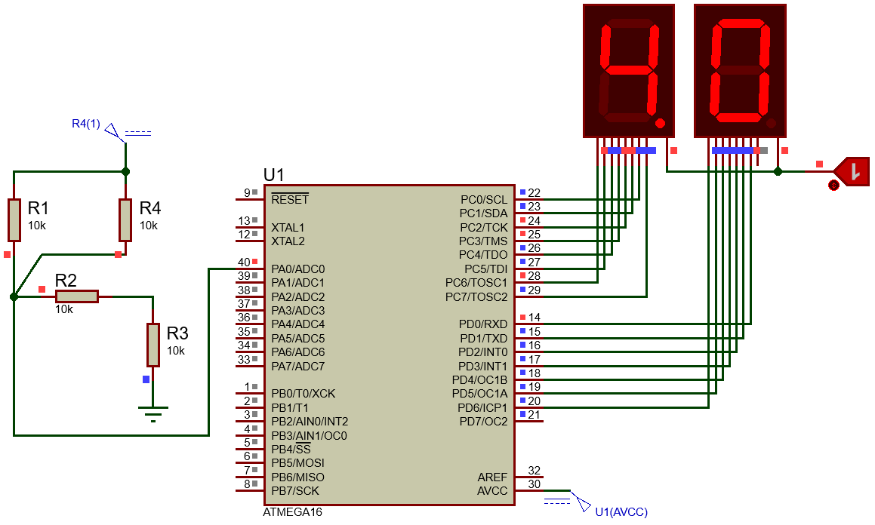

**Theoretical Calculations:** The upper half combination of resistor can be replaced with an equilvalent resistance of;

While the lower half just beside $V_{x}$ can be replaced with;

$$R_{eq_{lower}}=10k+10k=20 kΩ$$

We can then find $V_{x}$ (across the lower half) through Voltage Divider formula:

$$Vx=5×\frac{20k}{5k+20k}=4 V$$

## Conclusion

After the conduction of this lab, we have learnt how to utilize the Analog to Digital converter residing within the ATmega16A by means of different registers associated with it. We also designed a simple 0 – 5 V ranged Voltmeter and found the potential at a node connected to several resistors. The results obtained from the custom-designed Voltmeter aligned with the results obtained through simulation and theoretical calculations.