

**EE-222: Microprocessor Systems**

**Project Proposal**

**Web-Controlled  
Multifunctional Car**



**Group Members**

|  |  |
| --- | --- |
| **Name** | **Reg. No** |
| Muhammad Ahmed Mohsin | 333060 |
| Muhammad Umer | 345834 |
| Tariq Umar | 334943 |

# Abstract

In this project, we aim to develop a Web-Controlled Multifunctional Car. We hope to implement features such as line following, obstacle detection etc. along with some specfialized features such as camera, light sensors and speakers. All of this will be implemented with AT MEGA16 as the heart of our project.

Other hardware components will include NodeMCU (ESP8266 Wifi-Module) along with L293D Motor Driver. Moreover, we also aim to develop a mobile app or a website to control the car. Our objective is to develop skills to use microprocessor to implement advanced functions on hardware. This will give us an insight on how to implement the theoretical knowledge on hardware and what are the difficulties faced during the process. We can further extend our functionality from detection to identification in order to make our car as an information gathering device over a long-ranged WiFi network.

# Block Diagram

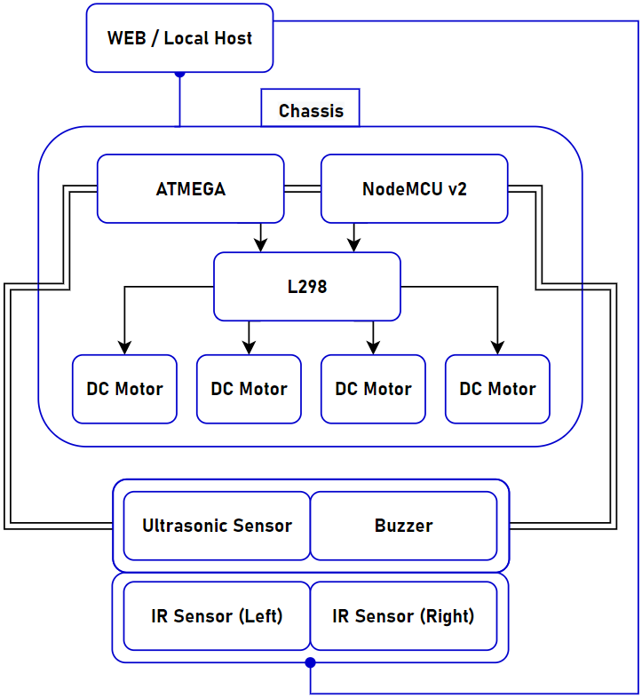

|  |
| --- |
| **Functionality** |
| Line Following |
| Web – Controlled Movement |
| Obstacle Detection & Avoidance |
| Buzzing Selectively |

|  |
| --- |
| **Components** |
| AT MEGA16A |
| NodeMCU V2 (ESP8266) |
| 2 x L298N Motor Driver / L293D Motor Driver |
| 4 x DC Motors |
| 12V Battery |
| Breadboards |
| Car Chassis |
| Speaker |
| Light Sensors |

|  |
| --- |
| **Relevant Industries** |
| LRRC Robotics |
| IoT (Internet of Things) |
| Information Nodes |