**Assignment #02 (Electrical Machines (EE-260)) (CLO3)**

**(To be submitted by 31st Oct 2022)**

**Note:** Please use standard A-4 size paper for the assignment and leave reasonable margins on the top bottom left & right.

**Question #01**

A 2300-V, 1000-kVA, 0.8-PF-Iagging, 60-Hz, two-pole, Y-connected synchronous generator has a synchronous reactance of 1.1 ohm and an armature resistance of 0.15 ohm. At 60 Hz, its friction and windage losses are 24 kW, and its core losses are 18 kW. The field circuit has a dc voltage of 200 V, and the maximum IF is 10 A. The resistance of the field circuit is adjustable over the range from 20 to 200 ohm. The OCC of this generator is shown in Figure 1.

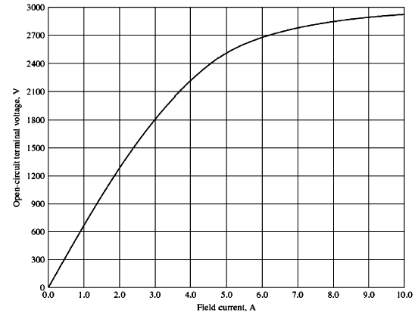

Fig-1

1. Evaluate field current that is required to make VT equal to 2300 V when the generator is running at no load?
2. Evaluate the internal generated voltage of this machine at rated conditions?

(c) How much field current is required to make VT equal to 2300 V when the generator is running at rated conditions?

(d) Solve for the power and torque must the generator's prime mover be capable of supplying?

**Question #02**

Assume that the field current of the generator in question 1 has been adjusted so that it supplies rated voltage when loaded with rated current at unity power factor.

(a) Evaluate the torque angle  of the generator when supplying rated current at unity power factor?

(b) When this generator is running at full load with unity power factor, Analyze how close is it to the static stability limit of the machine?

**Also Solve Examples 5.2, 5.3 and end Problems 5.3, 5.4 as your Homework. (4th edition chapman book)**