# Department of Electrical Engineering

|  |  |
| --- | --- |
| **Faculty Member:____________________** | **Dated: ________________** |
| **Semester:__________________________** | **Section: ________________** |

**EE 260: Electro Mechanical System**

**Lab10: Squirrel Cage Induction Motor Characteristics**

|  |  |  |  |  |
| --- | --- | --- | --- | --- |
| **Name** | **Reg. No** | **Report Marks / 10** | **Viva Marks / 5** | **Total/15** |
|  |  |  |  |  |
|  |  |  |  |  |
|  |  |  |  |  |
|  |  |  |  |  |

**Lab10: Squirrel Cage Induction Motor Characteristics / P4**

**Objectives:**

**Conduct an experiment:**

Using Data Acquisition Interface (DAI):

* Demonstrate the operating characteristics of a three-phase induction motor using the Four-Pole Squirrel-Cage Induction Motor module.
* To study the effects of varying the input line voltage on the induction motor characteristic.

**Equipment:**

|  |  |  |  |
| --- | --- | --- | --- |
| **S No.** | **Description** | **Module No.** | **Quantity** |
| 1 | Four Pole Squirrel – Cage Induction Motor | EMS 8221 | 1 |
| 2 | Data Acquisition Interface (DAI) | EMS 9061 | 1 |
| 3 | Prime Mover/ Dynamometer | EMS 8960 | 1 |
| 4 | Resistive load | EMS 8311 | 1 |
| 5 | Connecting Leads Set | EMS 8941 | 1 |
| 6 | Timing Belt | EMS 8942 | 1 |
| 7 | Power Supply | EMS 8821 | 1 |

Table 1

**Discussion:**

The simplest and the most widely used rotor for induction motors is the squirrel cage rotor. The squirrel cage induction motor consists of a laminated iron core which is slotted lengthwise around its periphery. Solid bars of copper or aluminum are tightly pressed or embedded into the rotor slots. At both ends of the rotor, short circuiting rings are welded or brazed to the bars to make a solid structure. The short circuited bars, because their resistance is much less than the core, do not have to be specially insulated from the core.

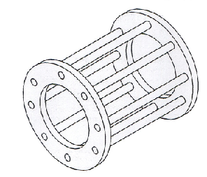

Figure 1- Squirrel cage rotor

The rotor has relatively large inductive reactance (XL) with respect to its resistance (R). Under these conditions the rotor current will lag the rotor voltage and the power factor in the circuit will be low.

One of the ways of creating a rotating electromagnet is to connect a three-phase power source to a stator made of three electromagnets A, B, and C, that are placed at 1200 to one another as shown in Figure 2.

When sine-wave currents phase shifted of 1200 to each other, like those shown in Figure 3

, flow in stator electromagnets A, B,and C, a magnetic field that rotates very regularly is obtained.

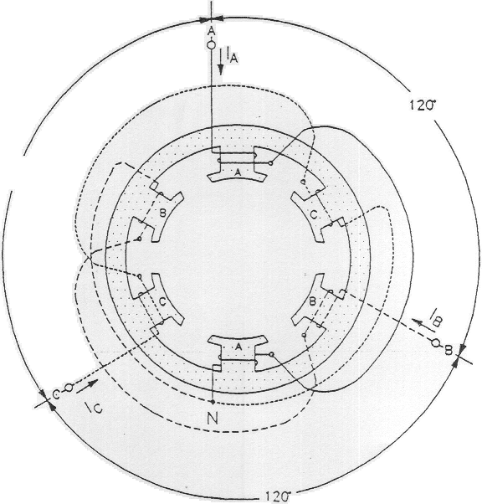

Figure 2

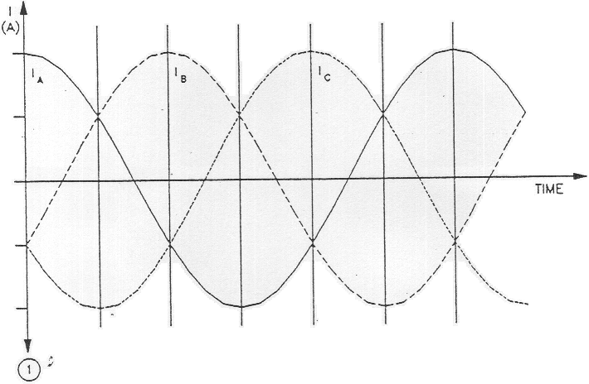

Figure 3

Figure 4, illustrates the magnetic field created by stator electromagnets A, B, and C at instants numbered 1 to 6 in Figure 3. Notice that the magnetic lines of force exit at the north pole of each electromagnet and enter at the South Pole. As can be seen, the magnetic field rotates clockwise.

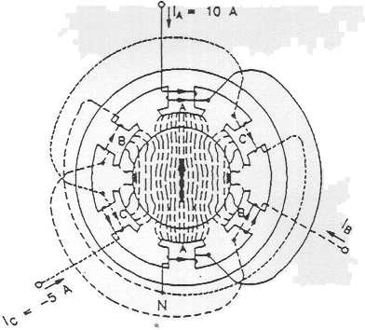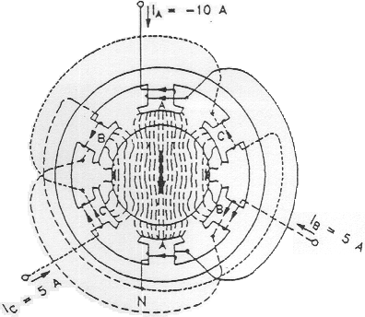

14

Figure 4

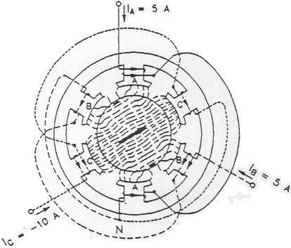 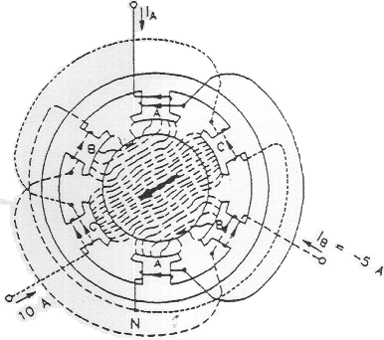

25

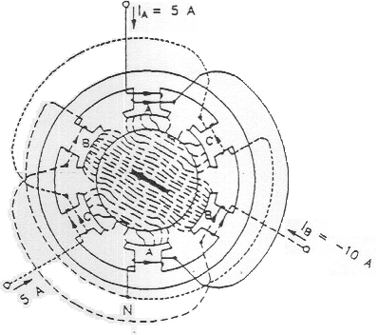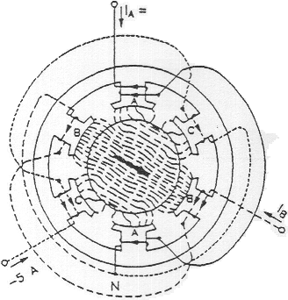

3 6

Figure 4

The use of sine-wave currents produces a magnetic field that rotates regularly and whose strength does not vary over time. The speed of the rotating magnetic field is known as the synchronous speed (ns and is proportional to the frequency of the ac power source. A rotating magnetic field can also be obtained using other combinations of sine-wave currents that are phase-shifted with respect to each other, but three-phase sine-wave currents are used more frequently.

When a squirrel-cage rotor is placed inside a rotating magnetic field, it is pulled around in the same direction as the rotating field. Interchanging the power connections to two of the stator windings (interchanging A with B for example) interchanges two of the three currents and reverses the phase sequence. This causes the rotating field to reverse direction. As a result, the direction of rotation of the motor is also reversed.

One can easily deduce that the torque produced by squirrel-cage induction motor increases as the difference in speed between the rotating magnetic field and the rotor increases. The difference in speed between the two is called slip. A plot of the speed versus torque characteristic for a squirrel-cage induction motor gives a curve similar to that shown in Figure 5. As can be seen, the motor speed (rotor speed) is always lower than the synchronous speed ns because slip is necessary for the motor to develop torque. The synchronous speed for the Lab-Volt motors is 1800 r/min for 60-Hz power, and 1500 r/min for 50-Hz power.

s = (nsynch – nm) / nsynch) x 100 %

Where:

nsynch = Synchronous speed = (120 x fe) / P, P: number of poles.

nm = Rotor speed.

s = Slip.

The rotor frequency (fr )= s fe

Where:

fe : Electrical frequency.

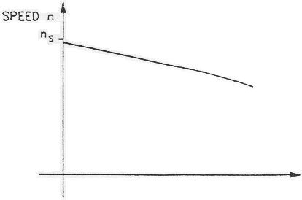τ (N.m)

Figure 5

The speed versus torque characteristic of the squirrel-cage induction motor is very similar to that obtained for a separately excited dc motor. However, the currents induced in the squirrel-cage rotor must change direction more and more rapidly as the slip increases. In other words, the frequency of the currents induced in the rotor increases as the slip increases, since the rotor is made up of iron and coils of wire, it has an inductance that opposes rapid changes in current. As a result, the currents induced in the rotor are no longer directly proportional to the slip of the motor. This affects the speed versus torque characteristic as shown in figure 6.

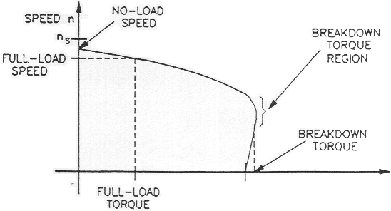τ (N.m)

Figure 6

As the curve shows, the no-load speed is slightly less than the synchronous speed ns, but as the load torque increases, motor speed decreases. For the nominal value of motor torque (full-load torque) corresponds a nominal operating speed (full-load speed). Further increases in load torque leads to a point of instability, called breakdown torque, after which both motor speed and output torque decrease. The torque value at zero speed, called locked-rotor torque, is often less than the breakdown torque. At start-up, and at low speed, motor current is very high and the amount of power that is consumed is higher than during normal operation.

Another characteristic of three-phase squirrel-cage induction motors is the fact that they always draw reactive power from the ac power source. The reactive power even exceeds the active power when the squirrel-cage induction motor rotates without load. The reactive power is necessary to create the magnetic field in the machine in the same way that an inductor needs reactive power to create the magnetic field surrounding the inductor.

As shown in figure 7 both locked rotor torque and the breakdown torque decrease greatly when the motor voltage is reduced. In practice, the torque decreases by factor equal to the square of the reduction factor of the motor voltage.

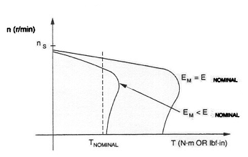

Figure 7

The efficiency of induction motor (ή) = Pout / Pin x 100 %

While Pout = τ ω

Where:

ω : Mechanical speed (rotor speed).  
 τ : Induced torque.

**Procedure:**

In the first part of the exercise, you will set up the equipment in the Workstation, connect the equipment as shown in Figure 8, and make the appropriate settings on the Prime Mover *I* Dynamometer.

In the second part of the exercise, you will apply the nominal line voltage to the squirrel-cage induction motor, note the motor direction of rotation, and measure the motor no-load speed. You will then increase the mechanical load applied to the squirrel-cage induction motor by steps. For each step, you will record in the data table various electrical and mechanical parameters related to the motor. You will then use this data to plot various graphs and determine many of the characteristics of the squirrel-cage induction motor.

In the third part of the exercise, you will interchange two of the leads that supply power to the squirrel-cage induction motor and observe if this affects the direction of rotation.

1. Install the Power Supply, Prime Mover / Dynamometer, Four-Pole Squirrel-Cage Induction Motor (Wye configuration), and Data Acquisition Interface {DAI) modules in the EMS workstation.
2. Mechanically couple the Prime Mover / Dynamometer to the Four-Pole Squirrel-Cage Induction Motor.
3. On the 'Power Supply, make sure the main power switch is set to the O (off) position, and the voltage control knob is turned fully counterclockwise.
4. Ensure that the flat cable from the computer is connected to the DAI module.
5. Connect the LOW POWER Inputs of the DAI and Prime Mover / Dynamometer modules to the 24 Vac output of the power supply. On the Power Supply, set the 24 V - AC power switch to the I (on) position
6. Start the Metering application. In the metering window open the set up.

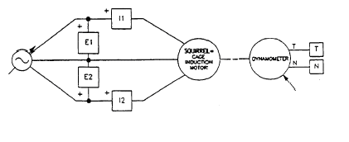

Figure 8

1. Set the Prime Mover / Dynamometer controls as follows:
   * MODE switch, DYN
   * LOAD CONTROL MODE switch MAN
   * LOAD CONTROL knob MIN (Fully ccw)
   * DISPLAY switch TORQUE (T)

**Characteristics of a Squirrel-Cage Induction Motor:**

1. Turn on the Power Supply and set the voltage control knob so that the line voltage indicated by meter E1 is equal to 400 line-voltage of the squirrel-cage induction motor.
2. What is the direction of rotation of the squirrel-cage induction motor?
3. Record in the following blank space the motor speed indicated by meter N inthe Metering window.

n = …………………….. r/min

1. Is the no-load speed almost equal to the speed of the rotating magnetic field (synchronous speed) given in the Discussion?

YES NO

1. In the Metering window, make sure that the torque correction function of meter T is selected. Meter T indicates the output torque of the squirrel- cage induction motor.

On the Prime Mover / Dynamometer, adjust the LOAD CONTROL knob so that the mechanical power developed by the squirrel-cage induction motor (indicated by meter Pm in the Metering window) is equal to 175 W (nominal motor output power).

1. Record the nominal speed, torque, and line current of the squirrel-cage induction motor in the following blank spaces. The line current is

nNOM = r/min

TNOM = N.m (lbf.in)

INOM = A

On the Prime Mover / Dynamometer, turn the LOAD CONTROL knob fully counterclockwise. The torque indicated on the Prime Mover / Dynamometer display should be 0 N.m (0 Ibf.in).

1. Record the motor line voltage ELINE line current ILINE active power P, reactive power Q, speed n, output mechanical power Pm and output torque T (indicated by meters E1, I1, C, A, N, Pm and T, respectively) in the data table and table 2.
2. On the Prime Mover *I* Dynamometer, adjust the LOAD CONTROL knob so that the torque indicated on the module display increases by 0.3 N.m (3.0 Ibf.in) increments up to 1.8 N.m (15.0 Ibf.in). For each torque setting, record the data in the data table and table 2.
3. On the Prime Mover / Dynamometer, carefully adjust the LOAD CONTROL knob so that the torque indicated on the module display increases by 0.1 N.m (1.0 Ibf.in) increments until the motor speed starts to decrease fairly rapidly (breakdown torque region). For each additional torque setting, record the data in the data table. Once the motor speed has stabilized, record the data in the data table and table 2

|  |  |  |  |  |  |  |  |  |
| --- | --- | --- | --- | --- | --- | --- | --- | --- |
| **Eline**  **V** | **Iline**  **A** | **Pin**  **w** | **Q**  **VAR** | **n**  **rpm** | **Pm**  **w** | **τ**  **N.m** | **η**  **%** | **s**  **%** |
| **400** |  |  |  |  |  | **0** |  |  |
|  |  |  |  |  |  | **0.3** |  |  |
|  |  |  |  |  |  | **0.6** |  |  |
|  |  |  |  |  |  | **0.9** |  |  |
|  |  |  |  |  |  | **1.2** |  |  |
|  |  |  |  |  |  | **1.5** |  |  |
|  |  |  |  |  |  | **1.8** |  |  |
|  |  |  |  |  |  | **1.9** |  |  |
|  |  |  |  |  |  | **2.0** |  |  |
|  |  |  |  |  |  | **2.1** |  |  |
|  |  |  |  |  |  | **2.2** |  |  |

Table 2

1. When all data has been recorded, set the LOAD CONTROL knob on the Prime Mover / Dynamometer to the MIN. position (fully CCW), turn the voltage control knob fully counterclockwise, and turn off the Power Supply.

In the data table window, confirm that the data has been stored, edit the table so as to keep only the values of the motor line voltage ELINE line current ILINE active power P, reactive power Q, speed n, output mechanical power Pm and output torque T (data in columns E1, I1, C, A, N, Pm and T, respectively). Then calculate and record the efficiency (η) and the slip(s) in table 2.

1. Does the motor line current indicated in column I1 increase as the mechanical load applied to the squirrel-cage induction motor increases?

YES NO

1. In the Graph window, make the appropriate settings to obtain a graph of the motor- speed (obtained from meter N) as a function of the motor-torque (obtained from meter N, name the x-axis as squirrel-Cage Induction-Motor Torque, name the y-axis as Squirrel-Cage Induction-Motor Speed, and print the graph.
2. Briefly describe how the speed varies as the mechanical load applied to the squirrel-cage induction increases i.e., as the motor torque increase.
3. Indicate on the graph the nominal speed and torque of the squirrel cage induction motor measured previously.

Using the graph,

* Determine the breakdown torque of the squirrel cage induction motor:

T BREAKDOWN = N.m (lbf.in)

* Determine the minimum-speed torque. This torque is a good approximation of the locked-rotor torque of the squirrel-cage induction motor

T LOCKED ROTOR = N.m (lbf.in)

1. Compare the breakdown torque and locked-rotor torque with the nominal torque of the squirrel-cage induction motor.
2. In the Graph window, make the appropriate settings to obtain a graph of the motor active (P) and reactive (Q) powers (obtained from meters C and A, respectively) as a function of the motor speed (obtained from meter N) using the data recorded previously in the data table, name the x-axis as Squirrel-Cage Induction-Motor Speed, name the y-axis as Squirrel-Cage Induction Motor Active and Reactive Powers, and print the graph.

* Does graph confirm that the squirrel-cage induction motor always draws reactive power from the ac power source?
* Does graph confirm that the squirrel-cage induction motor draws more electrical power from the ac power source as it drives a heavier load?
  + Observe that when the squirrel-cage induction motor rotates without load, the reactive power exceeds the active power. What does this reveal?

1. In the Graph window, make the appropriate settings to obtain a graph of the motor line current ILINE (obtained from meter I1) as a function of the motor speed (obtained from meter N) using the data recorded previously in the data table. Name the x-axis as Squirrel-Cage Induction-Motor Speed, name the y-axis as Squirrel-Cage Induction-Motor Line Current, and print the graph. How does the line current vary as the motor speed decreases?
2. Indicate on graph the nominal line current of the squirrel-cage induction motor measured previously.
3. How many times greater than the nominal line current is the starting line current (use the line current measured at minimum speed as the starting current)?
4. Adjust the line voltage Eline to 300 volts then repeat from step 14 to step 26 but on the Prime Mover / Dynamometer, carefully adjust the LOAD CONTROL knob so that the torque indicated on the module display increases by 0.1 N.m (1.0 Ibf.in) increments take the increment in the load torque.

|  |  |  |  |  |  |  |  |  |
| --- | --- | --- | --- | --- | --- | --- | --- | --- |
| **Eline**  **V** | **Iline**  **A** | **Pin**  **w** | **Q**  **VAR** | **n**  **rpm** | **Pm**  **w** | **τ**  **N.m** | **η**  **%** | **s**  **%** |
| **300** |  |  |  |  |  | **0** |  |  |
|  |  |  |  |  |  | **0.1** |  |  |
|  |  |  |  |  |  | **0.2** |  |  |
|  |  |  |  |  |  | **0.3** |  |  |
|  |  |  |  |  |  | **0.4** |  |  |
|  |  |  |  |  |  | **0.5** |  |  |
|  |  |  |  |  |  | **0.6** |  |  |
|  |  |  |  |  |  | **0.7** |  |  |
|  |  |  |  |  |  | **0.8** |  |  |
|  |  |  |  |  |  | **0.9** |  |  |
|  |  |  |  |  |  | **1.0** |  |  |
|  |  |  |  |  |  | **1.1** |  |  |
|  |  |  |  |  |  | **1.2** |  |  |

Table 3

1. On the Four-Pole Squirrel-Cage Induction Motor, interchange any two of the three leads connected to- the stator windings.

Turn on the Power Supply and set the voltage control knob so that the line voltage indicated by meter E1 is approximately equal to the nominal line voltage of the squirrel-cage induction motor. What is the direction of rotation of the squirrel-cage induction motor?

1. Does the squirrel-cage induction motor rotate opposite to the direction noted previously in this exercise?
2. Turn the voltage control knob fully counterclockwise and turn off the Power Supply.
3. Set the 24 V - AC power switch to the 0 (off) position and remove all leads and cables.

**Note:**

Submit a Formal and group Laboratory Report.