**Department of Electrical Engineering and   
Computer Science**

**Faculty Member:** Ms. Neelma Naz  **Dated:** 16/12/2022

**Semester:** 5th **Section:** BEE 12C

**EE-260:** **Electrical Machines**

Lab 11: Shunt and Series DC Motor Characteristics

Group Members

|  |  |  |  |  |  |  |  |
| --- | --- | --- | --- | --- | --- | --- | --- |
|  |  | | **PLO4/**  **CLO5** | **PLO4/**  **CLO5** | **PLO5/ CLO6** | **PLO8/ CLO7** | **PLO9/ CLO8** |
| **Name** | | **Reg. No** | **Viva / Quiz / Lab Performance** | **Analysis of data in Lab Report** | **Modern Tool Usage** | **Ethics and Safety** | **Individual and Teamwork** |
|  | |  | **5 Marks** | **5 Marks** | **5 Marks** | **5 Marks** | **5 Marks** |
| Danial Ahmad | | 331388 |  |  |  |  |  |
| Hassan Rizwan | | 335753 |  |  |  |  |  |
| Muhammad Umer | | 345834 |  |  |  |  |  |
| Syeda Fatima Zahra | | 334379 |  |  |  |  |  |

**Table of Contents**

3 Shunt and Series DC Motor Characteristics 3

3.1 Objectives 3

3.2 Equipment 3

3.3 Introduction 3

3.4 Lab Instructions 3

4 Lab Tasks 4

4.1 Shunt Connected 4

4.2 Series Connected 6

5 Conclusion 7

**Table of Figures**

Figure 1 4

Figure 2 6

# Shunt and Series DC Motor Characteristics

## Objectives

* To learn the basic motor wiring connection
* To observe the operating characteristics of shunt and series connected motors
* To study the torque vs speed characteristics of a shunt and series motors
* To calculate the efficiency of the shunt and series DC motors
* To observe the effect of varying the input voltage on the speed of the DC shunt motor

## Equipment

Hardware

* LabVolt Proprietary Toolkit

Software

* *LVDAC*



## Introduction

Direct current motors are unsurpassed for variable speed applications, and for applications with severe torque requirements. Uncounted millions of fractional horsepower DC motors are used by transportation industries in automobiles, trains and aircraft where they drive fans, blowers for air conditioners, heaters and defrosters; they operate windshield wipers, raise, lower seats and windows. One of their most useful functions is for the starting of gasoline and diesel engines in autos, trucks, buses and boats.

## Lab Instructions

All questions should be answered precisely to get maximum credit. Lab report must ensure following items:

* Lab objectives
* Results (Graphs/Tables) duly commented and discussed
* Conclusion

# Lab Tasks

## Shunt Connected

1. Set up the circuit in Figure 1.

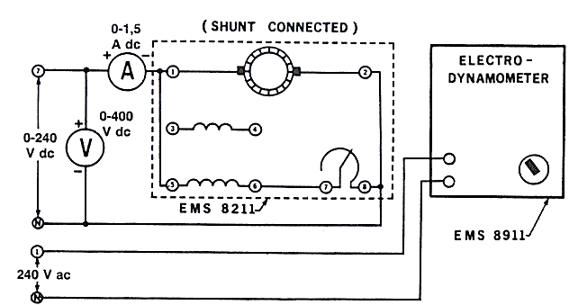

Figure

1. Notice that the motor is wired for shunt field operation and is connected to the variable DC output of the power supply (terminals 7 and N).
2. Couple the electrodynamometer to the DC motor / generator with the timing belt.
3. Set the shunt rheostat control knob to its full CW position (for maximum shunt field excitation).
4. Set the electrodynamometer control knob to its CCW position (to provide minimum starting load for the DC motor).
5. Adjust the shunt filed rheostat for no load motor speed of 1500 rpm as indicated by metering application. Make sure the voltmeter connected across the input of your circuit indicates exactly 220 V DC.
6. Measure and record in table 2 the line current as indicated by the DC ammeter for motor speed 1500 rpm.
7. Apply a load to the DC motor / generator by varying the electrodynamometer control knob until the scale marker on the stator housing indicates 0.35 Nm.
8. Measure and record the line current and the motor speed in table 2.
9. Repeat for each of the torque values listed in table 1 while maintaining a constant 220 V DC.

Table

|  |  |  |  |  |  |
| --- | --- | --- | --- | --- | --- |
| E  V | Speed  rpm | Torque  N.m | Pin  w | Pout  w | η |
| 220.2 | 1402.8 | **0.35** | 155.6 | 26.33 | 16.93 |
| 220 | 1383.2 | **0.4** | 162.2 | 29.14 | 17.97 |
| 219.7 | 1333.2 | **0.6** | 197 | 42.32 | 21.49 |
| 219.1 | 1290.6 | **0.8** | 233.9 | 55.49 | 23.73 |
| 218.9 | 1260.8 | **1.0** | 267.6 | 67.03 | 25.05 |
| 218.5 | 1230.2 | **1.2** | 303.4 | 77.72 | 25.61 |
| 218.3 | 1217.4 | 1.3 | 323.1 | 83.45 | 25.83 |



1. Set the electrodynamometer control knob to its CW position.
2. Turn on the power supply and gradually increase the DC voltage until the motor is drawing 1.5 A of line current. The motor should turn slowly or not at all.
3. Measure and record the DC voltage and torque developed

**E = 46.87 V τ = 0.504 N.m**

1. The line current in the previous step is limited only by the equivalent DC resistance of the shunt wound motor. Calculate the value of DC resistance via R= V/I = 31.24 $Ω$
2. Calculate the value of the starting current if the full line voltage (220 V DC) were applied to the shunt wound motor via I= V/R

**Starting current = 7.04 A**

1. Adjust the input DC voltage to 100 V DC.
2. Set the load on the electrodynamometer to 0.6 N.m and this load will be constant.
3. Set the shunt rheostat control knob to its full CW position (for maximum shunt field excitation).
4. Measure and record in table 2 the input voltage.
5. Increase the speed at 100 rpm by varying the input voltage then record in table 2 the input voltage
6. Repeat step b, with equal step size, until reach the input voltage 220 V DC.

Table

|  |  |  |
| --- | --- | --- |
| τ  N.m | Voltage  V | Speed  rpm |
| 0.6 | 98.38 | 579.6 |
| 0.6 | 124.6 | 683.8 |
| 0.6 | 155 | 785.8 |
| 0.6 | 182.8 | 876.4 |
| 0.6 | 215.7 | 986.6 |

## Series Connected

1. Connect the circuit in Figure 2.

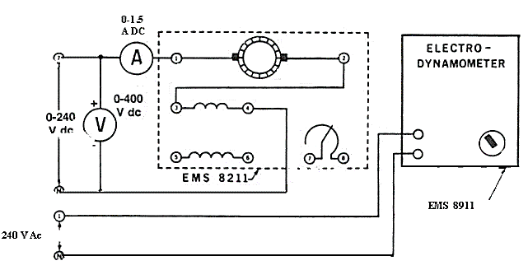

Figure

1. Couple the electrodynamometer to the DC motor / generator with the timing belt.
2. Set the electrodynamometer control knob to its mid-range position (to provide a starting load for the DC motor).
3. Turn on the power supply. Gradually increase the DC voltage until the motor starts to run. **Note the direction of rotation: if it is not CW, turn off the power supply and interchange the series field connection.**
4. Adjust the variable voltage for exactly 220 V DC as indicated by the voltmeter.
5. Adjust the loading of your DC series motor by varying the electrodynamometer control knob until the scale marked on the stator housing indicates 1.6 Nm.
6. Measure the line current and the motor speed. Record these values in table 3.

Table

|  |  |  |  |  |  |  |
| --- | --- | --- | --- | --- | --- | --- |
| E  V | I  A | Speed  rpm | Torque  N.m | Pin  w | Pout  w | η |
| 221.1 | 1.104 | 1298.8 | **1.0** | 245.9 | 68.47 | 27.84 |
| 220.9 | 1.209 | 1231.4 | **1.2** | 269.1 | 77.13 | 28.67 |
| 220.4 | 1.33 | 1163.2 | **1.4** | 295 | 85.41 | 28.95 |
| 220 | 1.451 | 1101.2 | **1.6** | 321.3 | 93.46 | 29.09 |
| 219.8 | 1.498 | 1079 | **1.7** | 331.3 | 96.28 | 29.06 |
| 219.7 | 1.556 | 1055.8 | 1.8 | 343.9 | 99.91 | 29.05 |

1. Calculate and record in table 4 Pin, Pout and the efficiency for the series DC motor.
2. Draw the motor speed characteristic curve, values from table 3.



1. Set the electrodynamometer control knob to its full CW position.
2. Turn on the power supply and gradually increase the DC voltage until the motor is drawing 1.5 A of line current. The motor should turn slowly.
3. Measure and record the DC voltage and torque developed.

**E = 80.51 V τ = 1.724 N.m**

1. The line current in previous step is limited only by the equivalent DC resistance of the series motor
2. Calculate the value of the starting current if the full line voltage (220 V DC) were applied to the series wound motor.

**Starting current = 4.09 A**

# Conclusion

After the conduction of this lab, we have familiarized ourselves with self-excited DC motors and the two most common configurations; series connected, and shunt connected. We observed the linear motor characteristics of the shunt motor against an increasing load and observed the almost-quadratic characteristics of the series motor against an increasing load. From our experiments, we also deduce that a series motor should never be operated in a unloaded condition as the starting torque offered by the series motor is much greater than other alternatives, and can potentially damage the equipment.