|  |  |
| --- | --- |
| **Semester:__________________________** | **Section: ________________** |

**EE 260: Electro Mechanical System**

**Lab11: Shunt and Series Dc Motor Characteristics**

|  |  |  |  |  |
| --- | --- | --- | --- | --- |
| **Name** | **Reg. No** | **Report Marks / 10** | **Viva Marks / 5** | **Total/15** |
|  |  |  |  |  |
|  |  |  |  |  |
|  |  |  |  |  |
|  |  |  |  |  |

**Lab11: Shunt and Series Dc Motor Characteristics / P4**

**Objectives:**

**Conduct an experiment:**

* To learn the basic motor wiring connection.
* To observe the operating characteristics of shunt and series connected motors.
* To study the torque vs speed characteristics of a shunt and series motors.
* To calculate the efficiency of the shunt and series Dc motors.
* To observe the effect of varying the input voltage on the speed of the Dc shunt motor.

**Equipment:**

|  |  |  |  |
| --- | --- | --- | --- |
| **Sno.** | **Description** | **Module No.** | **Quantity** |
| 1 | Dc motor / generator | 8211 | 1 |
| 2 | Dc voltmeter / ammeter | 8412 | 1 |
| 3 | Power supply | 8821 | 1 |
| 5 | Electrodynamometer | 8911 | 1 |
| 6 | Timing belt | 8942 | 1 |
| 7 | Connection leads | 8941 |  |

Table 1

**Discussion:**

Direct current motors are unsurpassed for variable speed applications, and for applications with severe torque requirements. Uncounted millions of fractional horsepower Dc motors are used by transportation industries in automobiles, trains and aircraft where they drive fans, blowers for air conditioners, heaters and defrosters; they operate windshield wipers, raise, lower seats and windows. One of their most useful functions is for the starting of gasoline and diesel engines in autos, trucks, buses and boats.

The Dc motor contains a stator and a rotor, the later commonly called an armature. The stator contains one or more windings per pole to setting up the magnetic field.

The armature and its winding are located in the path of this magnetic field and when the armature winding carries a current, a torque is developed causing the motor to turn.

**Shunt Dc motor:**

Dc shunt motor is a motor whose field circuit gets its power directly across the armature terminals of the motor as shown in figure 1.

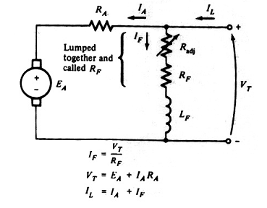

Figure 1- Dc shunt motor.

The speed of any Dc motor depends mainly on its armature voltage and the strength of the magnetic field. The speed tends to drop with load increasing on the motor due to the resistance of the armature winding. The following figure shows the speed-torque curve:

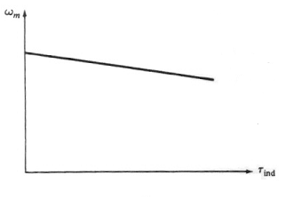

Figure 2- Torque-speed characteristic for Dc shunt motor.

Just like most energy conversion devices, the Dc shunt motor in not 100% efficient. In other words, all of the electric power which is supplied to the motor is not converted into mechanical power. The power difference between the input and the output is dissipated in form of heat, and constitutes what are known as the losses of the machine. These losses increase with load.

η = Pout/Pin

Where:

Pout = (2 x Л x n x τ)/ 60

Pin = Vin x Iin

**Series Dc motor:**

A series motor is a Dc motor whose field windings consists of few turns connected in series with the armature circuit. Figure 3 shows the Dc series motor equivalent circuit

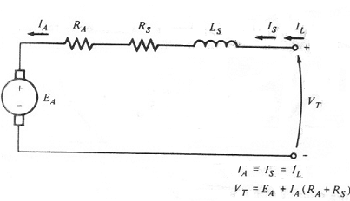

Figure 3- DC series motor.

In series motor the magnetic field produced by the same current which flows through the armature winding, with the result that the magnetic field weak when the load is light and strong when the load is heavy. Consequently the speed of the series connected motor is entirely determined by load current. The speed is low at heavy loads, and very high at no load. In fact if the series motor operated at no load it will run so fast which will damage the motor.

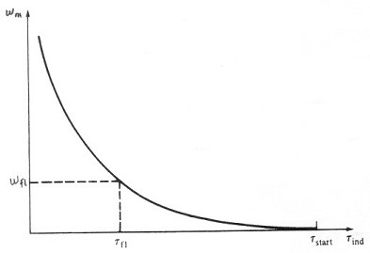

Figure 4- Torque-speed characteristics for Dc series motor.

The torque (τ = k x ф x IA) of any motor depends on the product of armature current and the magnetic field. For series connected motor this relationship implies that the torque will be very large for high armature currents, such as occur during start up. The series motor is adapted to start large heavy loads.

**Procedure:**

**Warring: high voltages are presented in this laboratory experiment! Do not make any connections with the power on! The power should be turned off after completing each individual measurement!**

**Shunt motor:**

1. Using your power supply, Dc motor / generator, Dc voltmeter / ammeter and electrodynamometer set up the circuit in figure 5.

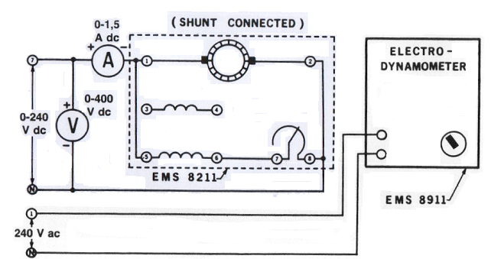

Figure 5- Shunt motor.

Notice that the motor is wired for shunt field operation and is connected to the variable Dc output of the power supply (terminals 7 and N).

Couple the electrodynamometer to the Dc motor / generator with the timing belt.

1. Set the shunt rheostat control knob at its full cw position (for maximum shunt field excitation).
2. Set the electrodynamometer control knob at its ccw position (to provide minimum starting load for the Dc motor).
3. Turn on the power supply. Adjust the variable input to 220 V Dc as indicated by the voltmeter. **Note the direction of rotation: if it is not cw turn off the power supply and interchange the shunt field connection.**
4. a. Adjust the shunt filed rheostat for no load motor speed of 1500 rpm as indicated by metering application. Make sure the voltmeter connected across the input of your circuit indicates exactly 220 V Dc.

b. Measure and record in table 2 the line current as indicated by the Dc ammeter for motor speed 1500 rpm.

c. Apply a load to the Dc motor / generator by varying the electrodynamometer control knob until the scale marker on the stator housing indicates 0.35 Nm. (readjust the power supply, if necessary to maintain exactly 220 V Dc).

d. Measure and record the line current and the motor speed in table 2.

e. Repeat for each of the torque values listed in table 2 while maintaining a constant 220 V Dc.

f. Return the voltage to zero and turn off the power supply.

|  |  |  |  |  |  |  |
| --- | --- | --- | --- | --- | --- | --- |
| **E**  **V** | **I**  **A** | **Speed**  **rpm** | **Torque**  **N.m** | **Pin**  **w** | **Pout**  **w** | **η** |
| **220** |  |  | **0.35** |  |  |  |
|  |  |  | **0.4** |  |  |  |
|  |  |  | **0.6** |  |  |  |
|  |  |  | **0.8** |  |  |  |
|  |  |  | **1.0** |  |  |  |
|  |  |  | **1.2** |  |  |  |
|  |  |  | **1.3** |  |  |  |

Table 2

1. Calculate and record in table 2 Pin, Pout and the efficiency for the shunt Dc motor.
2. Draw the motor speed characteristic curve, values from table 2.
3. a. Set the electrodynamometer control knob at its cw position( to provide the maximum starting load for the shunt wound motor)

b. Turn on the power supply and gradually increase the dc voltage until the motor is drawing 1.5 A of line current. The motor should turn slowly or not at all.

c. Measure and record the Dc voltage and torque developed

E = ………………. V τ = ………………... N.m

d. Return the voltage to zero and turn off the power supply

1. a. The line current in step 8 is limited only by the equivalent DC resistance of the shunt wound motor. Calculate the value of DC resistance via R= V/I =_______________

b. Calculate the value of the starting current if the full line voltage (220 V Dc) were applied to the shunt wound motor via I= V/R

Starting current = ……………… A

1. a. Adjust the input DC voltage to 100 V DC.

b. Set the load on the electrodynamometer to 0.6 N.m and this load will be constant.

c. Set the shunt rheostat control knob at its full cw position (for maximum shunt field excitation).

1. a. Measure and record in table 3 the input voltage.

b. Increase the speed at 100 rpm by varying the input voltage then record in table 3 the input voltage

c. Repeat step 11.b, with equal step size, until reach the input voltage 220 V Dc.

|  |  |  |
| --- | --- | --- |
| **τ**  **N.m** | **Voltage**  **V** | **Speed**  **rpm** |
| **0.6** | **100** |  |
| **0.6** |  |  |
| **0.6** |  |  |
| **0.6** |  |  |
| **0.6** |  |  |
| **0.6** |  |  |
| **0.6** | **220** |  |

Table 3

**Series motor:**

1. Connect the circuit in figure 6.

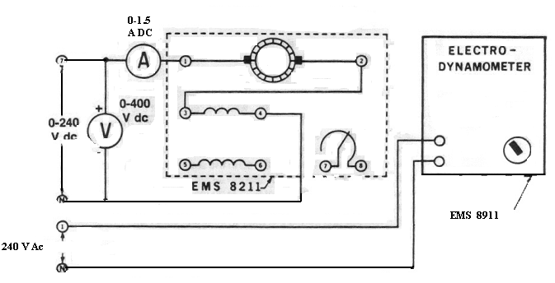

Figure 6- Series Motor.

Notice that the motor is wired for series field operation and is connected to the variable Dc output of the power supply (terminals 7 and N).

Couple the electrodynamometer to the Dc motor / generator with the timing belt.

1. Set the electrodynamometer control knob at its mid-range position (to provide a starting load for the Dc motor).

**Note: Start motor only when initial load is applied on series motor, otherwise, it can be dangerous.**

1. a. Turn on the power supply. Gradually increase the DC voltage until the motor starts to run. **Note the direction of rotation: if it is not cw turn off the power supply and interchange the series field connection.**

b. Adjust the variable voltage for exactly 220 V DC as indicated by the voltmeter.

1. a. adjusts the loading of your DC series motor by varying the electrodynamometer control knob until the scaled marked on the stator housing indicates 1.6 Nm. (Readjust the power supply if necessary to maintain the exactly 220 V Dc).

b. Measure the line current and the motor speed. Record these values in table 4

c. Repeat for each of torque values listed in the table while maintaining a constant 220 V DC input.

d. Return the voltage to zero and turn off the power supply.

|  |  |  |  |  |  |  |
| --- | --- | --- | --- | --- | --- | --- |
| **E**  **V** | **I**  **A** | **Speed**  **rpm** | **Torque**  **N.m** | **Pin**  **w** | **Pout**  **w** | **η** |
| **220** |  |  | **1.0** |  |  |  |
| **220** |  |  | **1.2** |  |  |  |
| **220** |  |  | **1.4** |  |  |  |
| **220** |  |  | **1.6** |  |  |  |
| **220** |  |  | **1.7** |  |  |  |
| **220** |  |  | **1.8** |  |  |  |

Table 4

1. Calculate and record in table 4 Pin, Pout and the efficiency for the series Dc motor.
2. Draw the motor speed characteristic curve, values from table 4
3. a. Set the electrodynamometer control knob at its full cw position( to provide the maximum starting load for the series wound motor)

b. Turn on the power supply and gradually increase the DC voltage until the motor is drawing 1.5 A of line current. The motor should turn slowly.

c. Measure and record the DC voltage and torque developed

E = ………………. V τ = ………………... N.m

d. Return the voltage to zero and turn off the power supply

1. a. The line current in step 18 is limited only by the equivalent DC resistance of the series motor

b. Calculate the value of the starting current if the full line voltage (220 V Dc) were applied to the series wound motor

Starting current = ……………… A

**Note**:

1. Submit group Laboratory Report.