**Department of Electrical Engineering and   
Computer Science**

**Faculty Member:** Ms. Neelma Naz  **Dated:** 23/09/2022

**Semester:** 5th **Section:** BEE 12C

**EE-260:** **Electrical Machines**

Lab 2: Single Phase Transformers

Group Members

|  |  |  |  |  |  |  |  |
| --- | --- | --- | --- | --- | --- | --- | --- |
|  |  | | **PLO4/**  **CLO5** | **PLO4/**  **CLO5** | **PLO5/ CLO6** | **PLO8/ CLO7** | **PLO9/ CLO8** |
| **Name** | | **Reg. No** | **Viva / Quiz / Lab Performance** | **Analysis of data in Lab Report** | **Modern Tool Usage** | **Ethics and Safety** | **Individual and Teamwork** |
|  | |  | **5 Marks** | **5 Marks** | **5 Marks** | **5 Marks** | **5 Marks** |
| Danial Ahmad | | 331388 |  |  |  |  |  |
| Hassan Rizwan | | 335753 |  |  |  |  |  |
| Muhammad Umer | | 345834 |  |  |  |  |  |
| Syeda Fatima Zahra | | 334379 |  |  |  |  |  |

**Table of Contents**

3 Single Phase Transformers 3

3.1 Objectives 3

3.2 Equipment 3

3.3 Introduction 3

3.4 Lab Instructions 3

4 Lab Tasks 4

4.1 Transformer Core Saturation 4

4.1.1 Discussion 4

4.1.2 Connection setup 4

4.1.3 Results & Readings 5

4.2 Transformer Polarity 6

4.2.1 Discussion 6

4.2.2 Connection setup 7

4.2.3 Procedure 7

5 Conclusion 10

**Table of Figures**

Figure 4.1.1.a Saturation Curve 4

Figure 4.1.2.a Connections 5

Figure 4.1.3.a Excitation Curve 5

Figure 4.2.1.a Polarity Determination - DC Method (Left), AC Method (Right) 6

Figure 4.2.2.a Initial Connections 7

Figure 4.2.3.a Step 1 7

Figure 4.2.3.b Step 4 8

Figure 4.2.3.c Step 7 9

Figure 4.2.3.d Step 9 9

# Single Phase Transformers

## Objectives

* To learn the effects of core saturation
* Learn how to determine transformer polarity

## Equipment

Hardware

* LabVolt Proprietary Toolkit

Software

* *LVDAC*



## Introduction

Single-phase transformers use only one phase of electricity. These transformers are widely used in low voltage appliances such as electronic devices, many of which are found in households. Single-phase transformers cost less and are easily switched on or off depending on load demand, as compared to three-phase transformers. These transformers undergo core saturation, which occurs when a transformer is not large enough for a specific application. Their usage also involves knowing the polarity of the transformer.

## Lab Instructions

All questions should be answered precisely to get maximum credit. Lab report must ensure following items:

* Lab objectives
* Results (Graphs/Tables) duly commented and discussed
* Conclusion

# Lab Tasks

Transformer Core Saturation

### Discussion

When transformer is connected to power supply, the exciting current, which is directly related to the alternating magnetic flux, increases in direct proportion to the applied voltage until core saturation sets in. This occurs when the applied voltage exceeds the rated value of the primary, and then the linear relationship between the primary voltage and the exciting current breaks down. The curve of primary voltage versus exciting current flattens and smaller increases in primary voltage led to larger increases in exciting current, as demonstrated in the following graph.

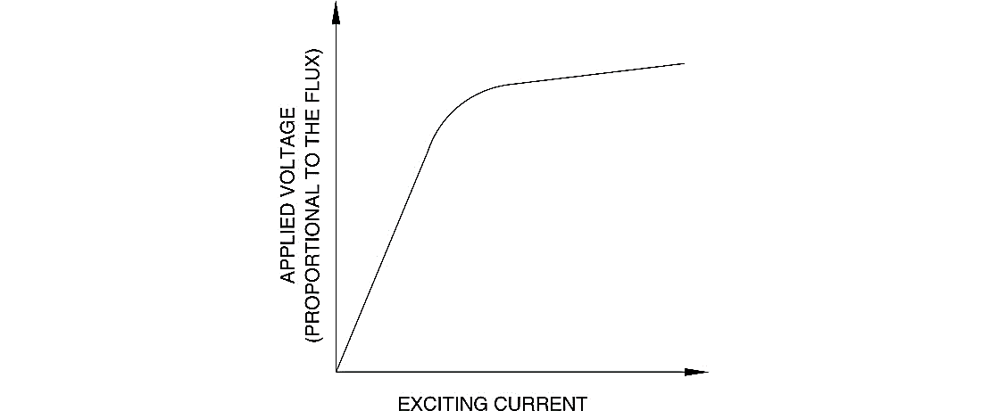

Figure . Saturation Curve

### Connection setup

Set up the transformer circuit shown in Figure 4.1.1-a. It will be used to show how exciting current is affected when the transformer core becomes saturated. Since the exciting current is so small, the corresponding voltage across a sense resistor R, ER, will be used to illustrate its variation. Connect the transformer primary terminals to Power Supply terminals 4 and 5 through sense resistor R. Connect meter inputs E1, E2, and E3 to measure the transformer voltages, ER, EPRI, ESEC, respectively. Connect meter input I1 to measure the primary current, IPRI.

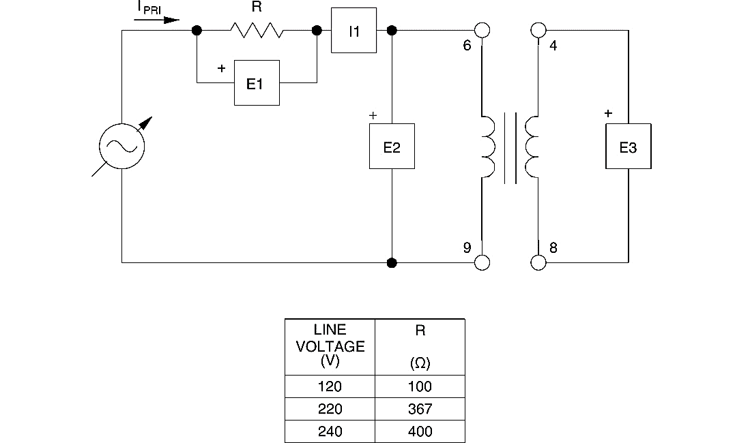

Figure . Connections

### Results & Readings

1. Display the *Graph* window, select E1 (ER) as the X-axis parameter, and E2 (EPRI) as the Y-axis parameter. Make sure the line graph format and the linear scale are selected. Observe the curve of primary voltage versus exciting current, represented by E1.

|  |  |  |  |
| --- | --- | --- | --- |
| M1-E1 | M2-E2 | M3-E3 | M7-I1 |
| AC | **AC** | **AC** | **AC** |
| V | **V** | **V** | **A** |
| 2.135 | 20.77 | 9.608 | 0.011 |
| 3.177 | 41.31 | 19.1 | 0.014 |
| 4.051 | 60.5 | 27.99 | 0.015 |
| 4.971 | 80.71 | 37.31 | 0.017 |
| 5.969 | 98.48 | 45.55 | 0.02 |
| 6.703 | 109 | 50.45 | 0.021 |



Figure . Excitation Curve

1. Does the exciting current increase more rapidly after the rated voltage is exceeded?

**Answer:** Yes, as the input voltage exceeds the rated voltage, the transformer core approaches a state of saturation, where any increase in the terminal voltage above normal greatly increases the exciting current.

1. Does the curve illustrate that the transformer core becomes saturated?

**Answer:** Yes, as the slope of the curve starts approaching → 0, it implies that the transformer core has become saturated. Although Figure 4.1.3.a Excitation Curve only slightly shows this effect, one can always take more readings to illustrate it better.

1. Review the measured data to determine how the primary-to-secondary voltage ratio was affected when the transformer core became saturated.

**Answer:** From the columns E2 and E3, the voltages across the transformer windings, we deduce that the turn ratio $a=\frac{N_{p}}{N_{s}}=\frac{V_{p}}{V_{s}}$ tends to decrease as the slope decreases, i.e., the transformer core enters saturation.

## Transformer Polarity

### Discussion

There are two methods to determine the polarity of transformer, the AC method and the DC method. For this lab, we only proceed with the AC method; with the AC source method, an AC voltage is connected to the primary winding which is temporarily connected in series with the secondary. The voltage across the series combination will be less than the applied voltage if the two terminals that are interconnected have the same polarity. If the voltage is greater, the interconnected terminals have opposite polarities. Figure 2.3 illustrates both methods of determining transformer polarity.

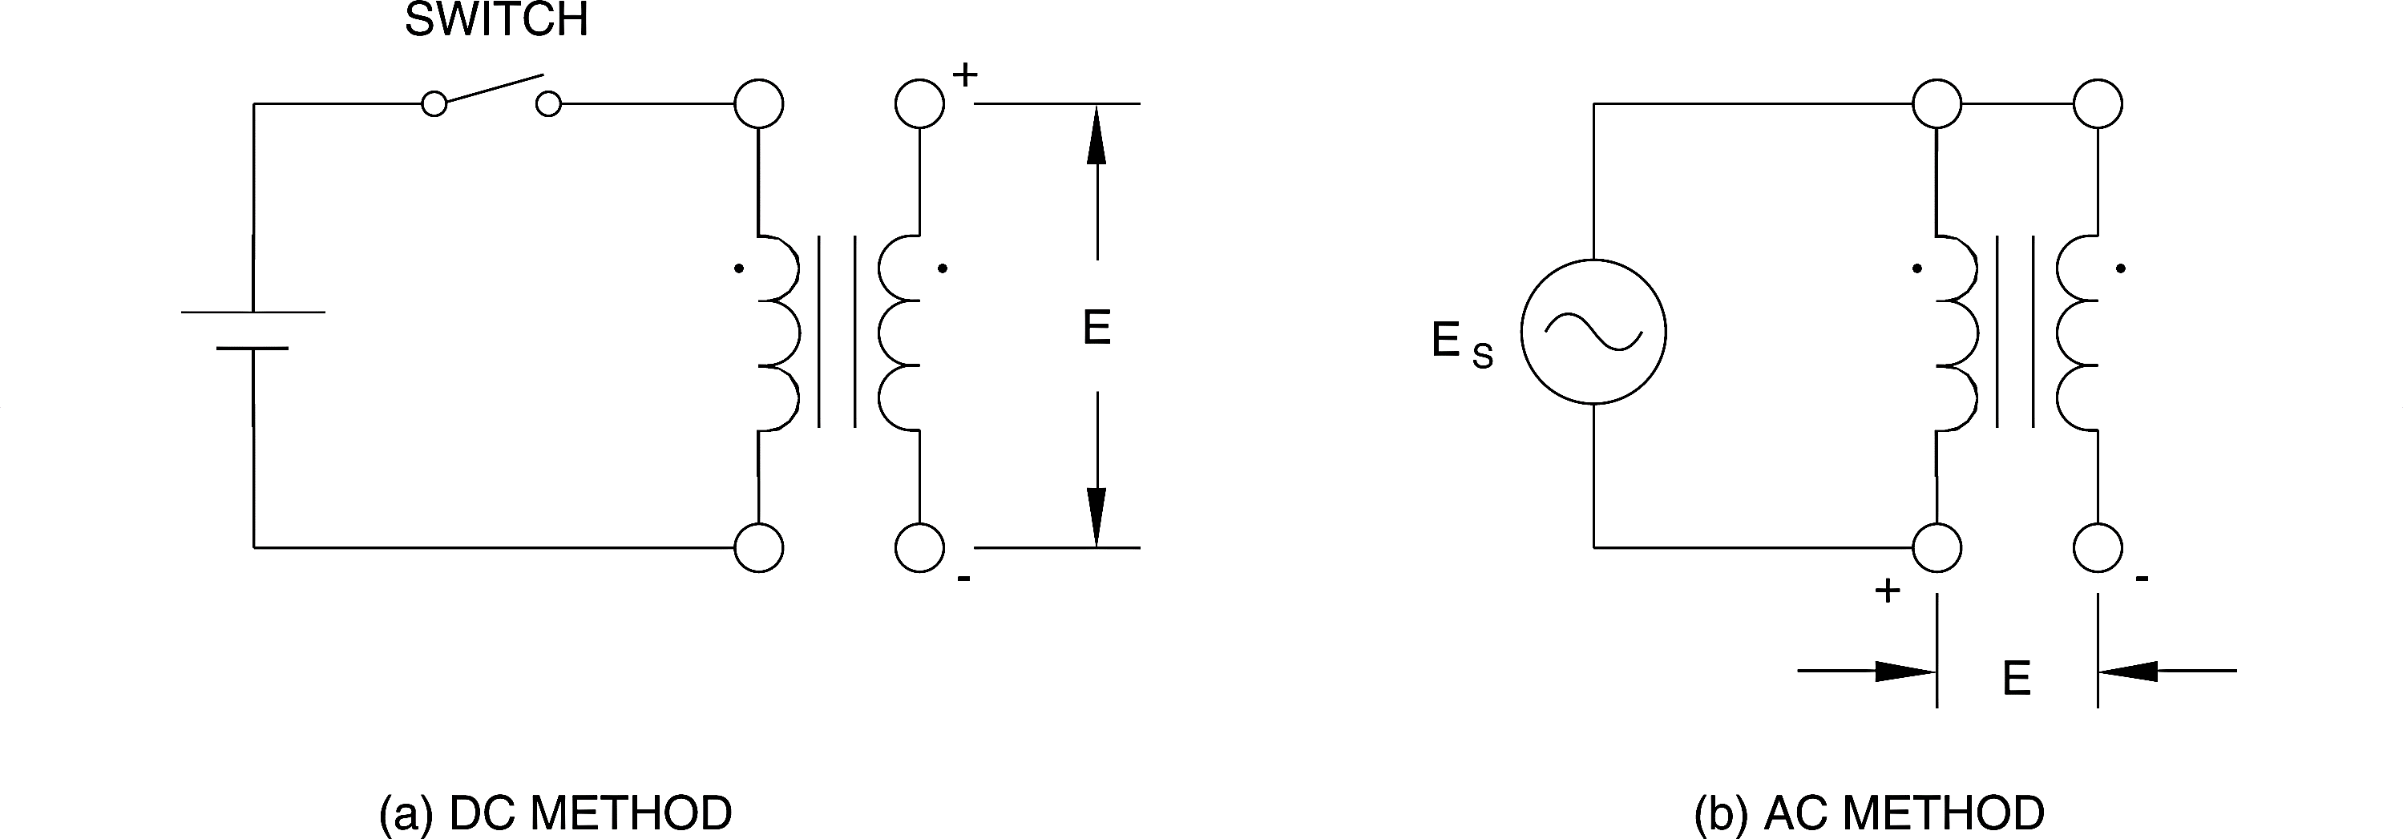

Figure . Polarity Determination - DC Method (Left), AC Method (Right)

### Connection setup

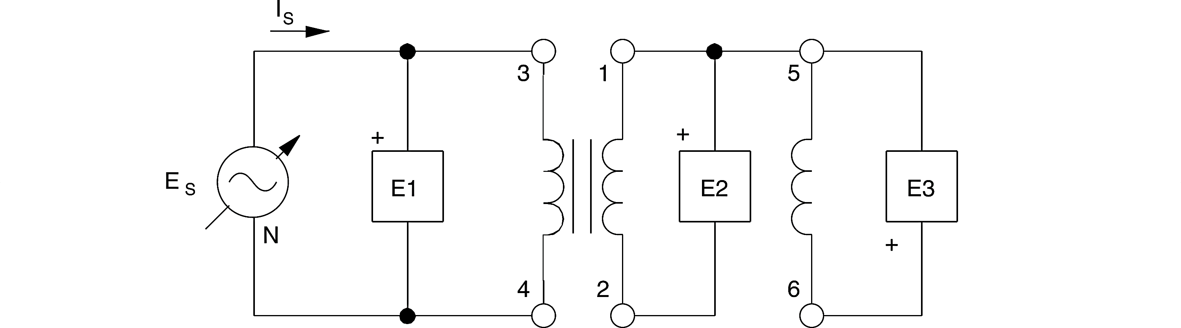

Figure . Initial Connections

### Procedure

1. Turn on the power and adjust the voltage control to set ES at exactly 50% of the rated voltage for winding 3-4. *Note that the rated voltage is the sum of the intermediate winding voltages between terminals 3 and 4.* Measure and record the voltages at transformer windings 1-2, 5-6, and 2-6. Note that E2-6 is obtained by using the metering function E2 + E3.

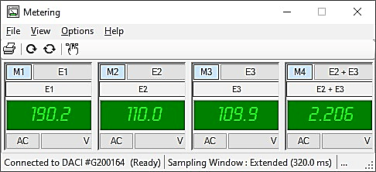

Figure . Step 1

1. Are the windings connected in series-aiding, or series-opposing?

**Answer:** The windings are connected in a series-opposing fashion, as it implies that polarities are the same at the dot on each of the winding, resulting in a subtractive polarity.

1. Return the voltage control to zero and turn off the Power Supply. Disconnect terminals 1 and 5 and connect terminals 1 and 6 together. Reverse connections to meter input E3. If this new connection is series-aiding, what will be the value of E2-5 when the same voltage of step 6 is applied to winding 3-4?

**Answer:** After swapping the terminals 5 and 6, the windings are now connected in a series-aiding fashion, implying that polarities are different at the dot on each of the winding, resulting in an additive polarity. From step 1, E2 = 110.0, E3 = 109.9 → E2+E3 = 219.9

1. Select setup configuration file *ES17-5.dai*. Turn on the power and once again set ES at exactly 50% of the rated voltage for winding 3-4. Measure and record the voltages at transformer windings 1-2, 5-6, and 2-5 indicated on the meters. Note that E2-5 is obtained by using the metering function E2 + E3.

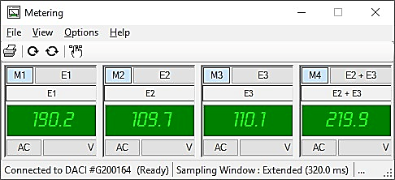

Figure . Step 4

1. Is the value obtained for E2-5 the same as predicted in step 3?

**Answer:** Yes, the value obtained theoretically in step 3 is the same as that measured in step 4.

1. Return the voltage control to zero, turn off the power supply and remove the connection between terminals 1 and 6. What are the two voltages which can be obtained across the series combination of windings 3-4 and 1-2 when the same voltage as that in step 4 is applied to winding 3-4?

**Answer:** E2, from the previous parts, measures out to be 110 V; Two voltages which can be obtained across the series combination of the windings 3-4 and 1-2 are,

*Additive Polarity: 190+E2 = 190+110 = 300 V*

*Subtractive Polarity: 190-E2 = 190-110 = 80 V*

, where 190 is the applied voltage.

1. Connect terminals 1 and 4 together, turn on the power and set ES at exactly 50% of the rated voltage for winding 3-4. Select setup configuration file *ES17-6.dai*. Measure and record the voltages at transformer windings 1-2 and 2-3 using meter inputs E2 and E3.

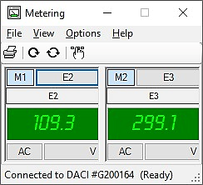

Figure . Step 7

1. Return the voltage control to zero and turn off the power supply. Disconnect terminals 1 and 4 and connect terminals 1 and 3 together. Interchange the connections at input E2 of the data acquisition module.
2. Turn on the power and set ES at exactly 50% of the rated voltage for winding 3-4. Select setup configuration file *ES17-7.dai*. Measure and record the voltage at transformer winding 2-4.

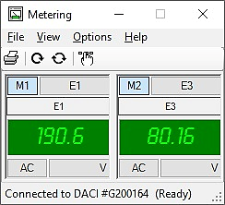

Figure . Step 9

1. How do the results of steps 7 and 9 compare with the predictions in step 6?

**Answer:** The measured values match those of theoretical ones, with minor differences that arise due to internal tolerances of real components.

1. Which sets of terminals have the same polarity, 1 and 3, 2 and 4, 1 and 4, or 2 and 3?

**1-3:** Same polarities (+ +); *result in subtractive polarity of 80 V*

**2-4:** Same polarities (- -); *result in subtractive polarity of 80 V*

**1-4:** Different polarities (+ -); *result in additive polarity of 300 V*

**2-3:** Different polarities (- +); *result in additive polarity of 300 V*

# Conclusion

The completion of this lab enabled us to expand our theoretical and practical knowledge of single-phase transformers. We learned the concept behind how a core of a transformer is saturated and what its implications are on exciting current. Also, we learnt how the polarity of a transformer can be determined using the AC source method. Performing these experiments on hardware and observing our measurements on LVDAC, we were able to transparently observe exactly how the concepts unfold on hardware equipment. Analyzing the measurements obtained, discovering correlations between values, and answering the review questions helped in solidifying the concepts and learnings.