**Department of Electrical Engineering**

**Faculty Member: ____________________ Dated: ________________**

**Semester: __________________________ Section: ________________**

**EE-260: Electrical Machines**

**Lab 2: Single Phase Transformers (Part-a)   
Transformer core saturation and Transformer Polarity**

|  |  |  |  |  |  |  |
| --- | --- | --- | --- | --- | --- | --- |
|  |  | **PLO4/**  **CLO5** | **PLO4/**  **CLO5** | **PLO5/ CLO6** | **PLO8/ CLO7** | **PLO9/ CLO8** |
| **Name** | **Reg. No** | **Viva / Quiz / Lab Performance** | **Analysis of data in Lab Report** | **Modern Tool Usage** | **Ethics and Safety** | **Individual and Team Work** |
|  |  | **5 Marks** | **5 Marks** | **5 Marks** | **5 Marks** | **5 Marks** |
|  |  |  |  |  |  |  |
|  |  |  |  |  |  |  |
|  |  |  |  |  |  |  |
|  |  |  |  |  |  |  |

Lab 2: Single Phase Transformers

# Part – (a): Transformer Core Saturation

## Exercise objective

When you have completed this exercise, you will be familiar with effect of core saturation.

**Equipment required:**

Refer to the Equipment Utilization Chart in Appendix C to obtain the list of equipment required for this exercise.

## Discussion

When transformer is connected to power supply, the exciting current, which is directly related to the alternating magnetic flux, increases in direct proportion to the applied voltage until core saturation sets in. This occurs when the applied voltage exceeds the rated value of the primary, and then the linear relationship between the primary voltage and the exciting current breaks down. The curve of primary voltage versus exciting current flattens and smaller increases in primary voltage lead to larger increases in exciting current as shown in Figure 2.1. The exciting current is only a few mill amperes in the EMS Single-Phase Transformer module, and generally its value is a small percentage of the nominal current of a transformer.

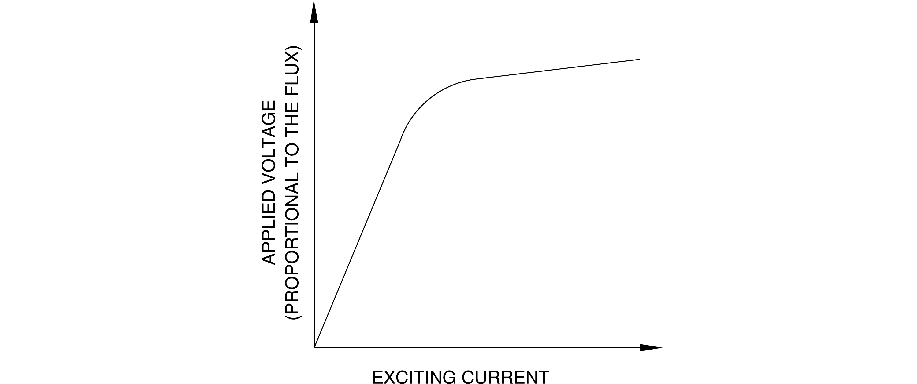

**Figure 2.1 Saturation Curve of a Transformer**

**Procedure:**

***CAUTION!***

***High voltages are present in this laboratory exercise! Do not make or modify any banana jack connections with the power on unless otherwise specified!***

1. Install the power supply, Data Acquisition Interface (DAI), resistive load, inductive load and, capacitive load, and Single phase transformer module in the EMS workstation.
2. Make sure that the main switch of the power supply is set to 0 (OFF) position and the voltage control knob is turned fully CCW. Ensure the power supply is connected to a three-phase wall receptacle.
3. Ensure that the DAI LOW POWER INPUT is connected to the main power supply and the USB port cable from the computer is connected to the DAI.
4. 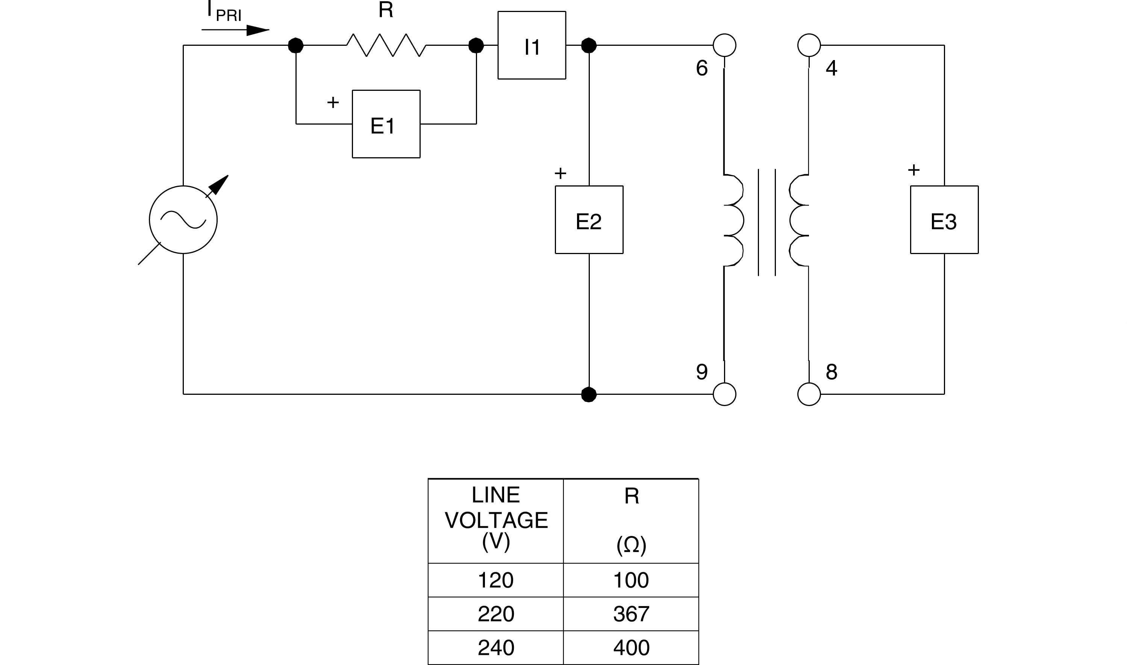Set up the transformer circuit shown in Figure 2.2. It will be used to show how exciting current is affected when the transformer core becomes saturated. Since the exciting current is so small, the corresponding voltage across a sense resistor R, ER, will be used to illustrate its variation. Connect the transformer primary terminals to Power Supply terminals 4 and 5 through sense resistor R. Connect meter inputs E1, E2, and E3 to measure the transformer voltages, ER, EPRI, ESEC, respectively. Connect meter input I1 to measure the primary current, IPRI.

**Figure 2.2 Effect of Core Saturation on Exciting Current**

1. Set the 24V – AC power switch to 1 (ON) position. Display the *Metering* application*.*

## CAUTION!

**Do not leave high currents circulate through the transformer primary coil over a long period of time. Take all your measurements requiring a primary current higher than the transformer coil nominal value within two minutes. Let the transformer cool down for 15 minutes after the Power Supply is turned off.**

1. Turn on the power and use the output voltage control to obtain values for EPRI (E2) equally spaced at about 10% (20v) intervals over the complete control knob range. At each voltage adjustment, click the *Record Data* button to enter the measurements in the *Data Table*.
2. When all data values have been recorded, rotate the voltage control fully CCW, and turn off the Power Supply.
3. Display the *Graph* window, select E1 (ER) as the X-axis parameter, and E2 (EPRI) as the Y-axis parameter. Make sure the line graph format and the linear scale are selected. Observe the curve of primary voltage versus exciting current, represented by E1.

*Paste your screenshots here*

1. Does the exciting current increase more rapidly after the rated voltage is exceeded?

**a)** Yes **b)** No

1. Does the curve illustrate that the transformer core becomes saturated?

**a)** Yes **b)** No

1. Review the measured data to determine how the primary-to-secondary voltage ratio was affected when the transformer core became saturated.
2. Ensure that the Power Supply is turned off, the voltage control is fully CCW, and remove all leads and cables.

## Conclusion

**Lab 2: The Single Phase Transformer**

**Part – (b): Transformer Polarity**

## Exercise objective

When you have completed this exercise, you will be able to determine and use transformer polarities to properly connect separate windings so that the voltages add (series-aiding) or subtract (series-opposing).

## Discussion

There are two methods for determining the polarity of a transformer, one using a dc source, the other an ac source. In the dc method, a dc voltmeter is connected across the secondary winding and a small dc voltage is applied to the primary. The direction in which the voltmeter pointer deflects when power is turned on will indicate the polarity of the secondary winding. The pointer will deflect to the right if the secondary winding terminal to which the voltmeter positive probe is connected has the same polarity as the primary winding terminal to which the positive side of the source is connected. If it deflects to the left, the primary and secondary terminals have opposite polarities. With the ac source method, an ac voltage is connected to the primary winding which is temporarily connected in series with the secondary. The voltage across the series combination will be less than the applied voltage if the two terminals that are interconnected have the same polarity. If the voltage is greater, the interconnected terminals have opposite polarities. Figure 2.3 illustrates both methods of determining transformer polarity.

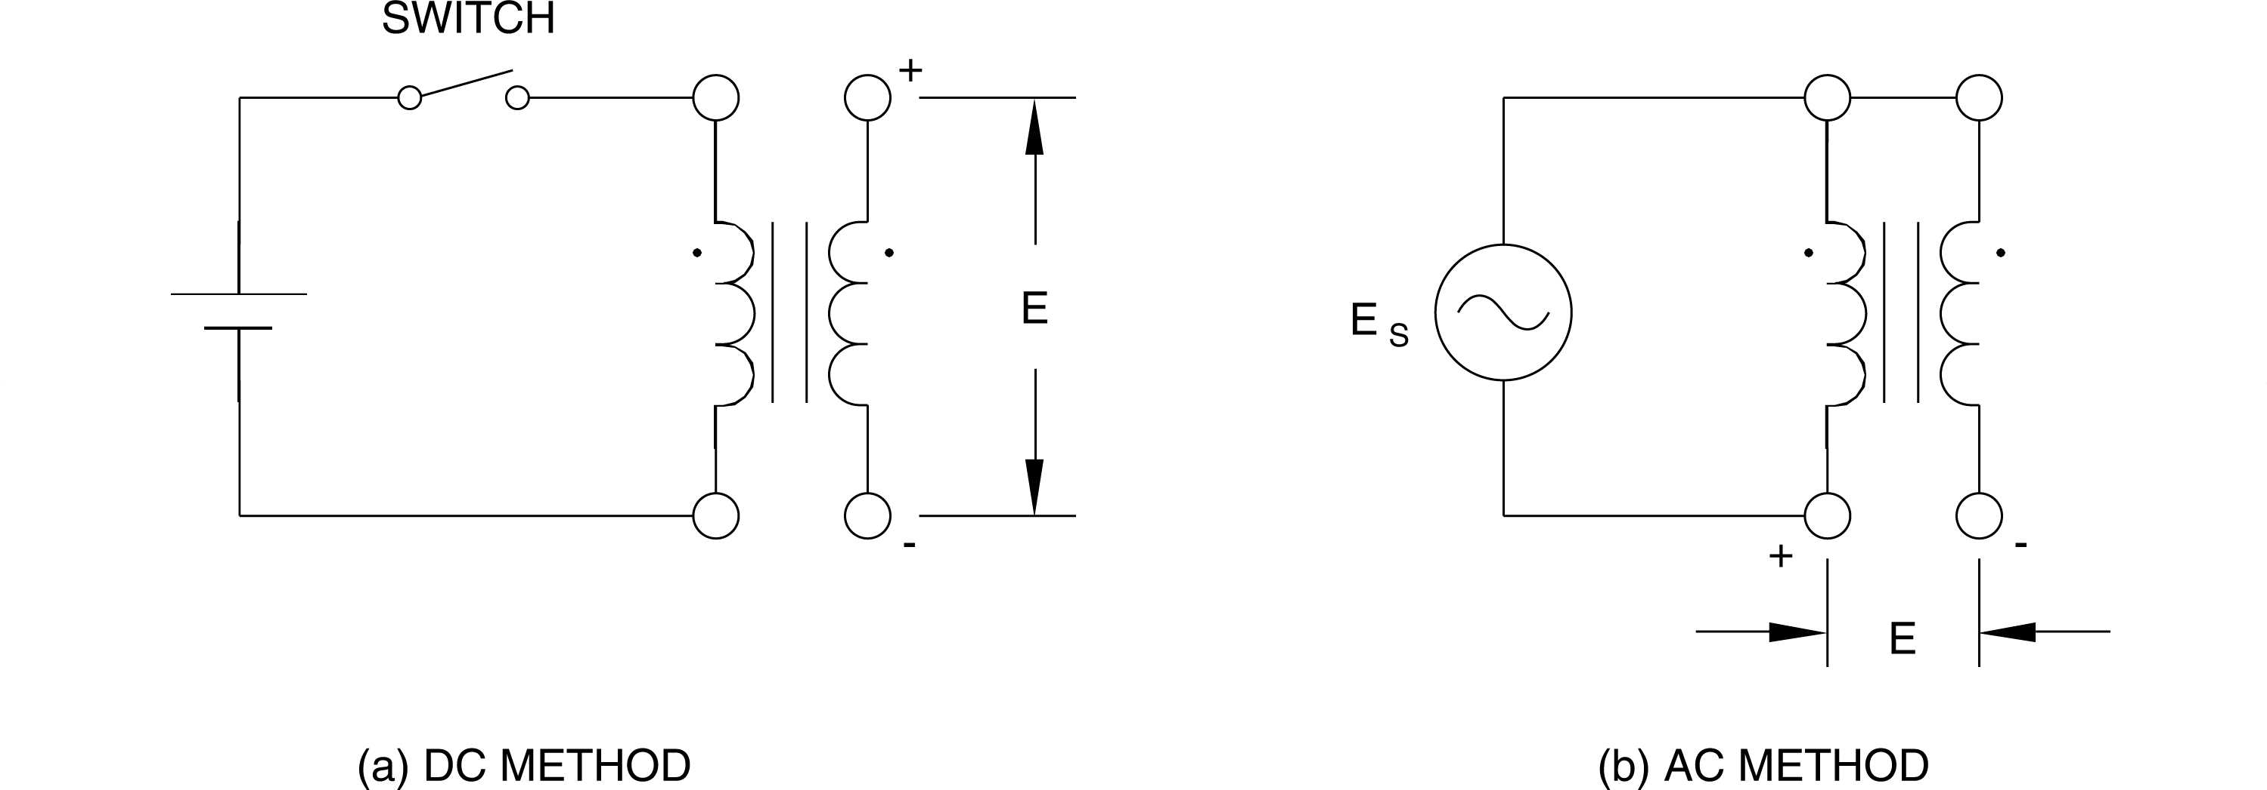

**Figure 2.3 Methods for Determining Transformer Polarity**

## Equipment required

Refer to the Equipment Utilization Chart in Appendix C to obtain the list of equipment required for this exercise.

## Procedure

**CAUTION!**

**High voltages are present in this laboratory exercise! Do not make or modify any banana jack connections with the power on unless otherwise specified!**

1. Install the Power Supply, data acquisition module, and Single-Phase Transformer module in the EMS Workstation.
2. Make sure that the main switch of the Power Supply is set to the O (OFF) position, and the voltage control knob is turned fully ccw. Set the voltmeter select switch to the 4-N position, and then ensure the Power Supply is connected to a three-phase wall receptacle.
3. Ensure that the POWER INPUT of the data acquisition module is connected to the main Power Supply, and ensure the USB port cable from the computer is connected to the data acquisition module. Set the 24 V - AC power switch to the 1 (ON) position.
4. Display the *Metering* application.
5. Set up the transformer circuit in Figure 2.4, and connect terminals 1 and 5 together as shown. Note that the ac input power in this circuit is connected at winding 3-4.

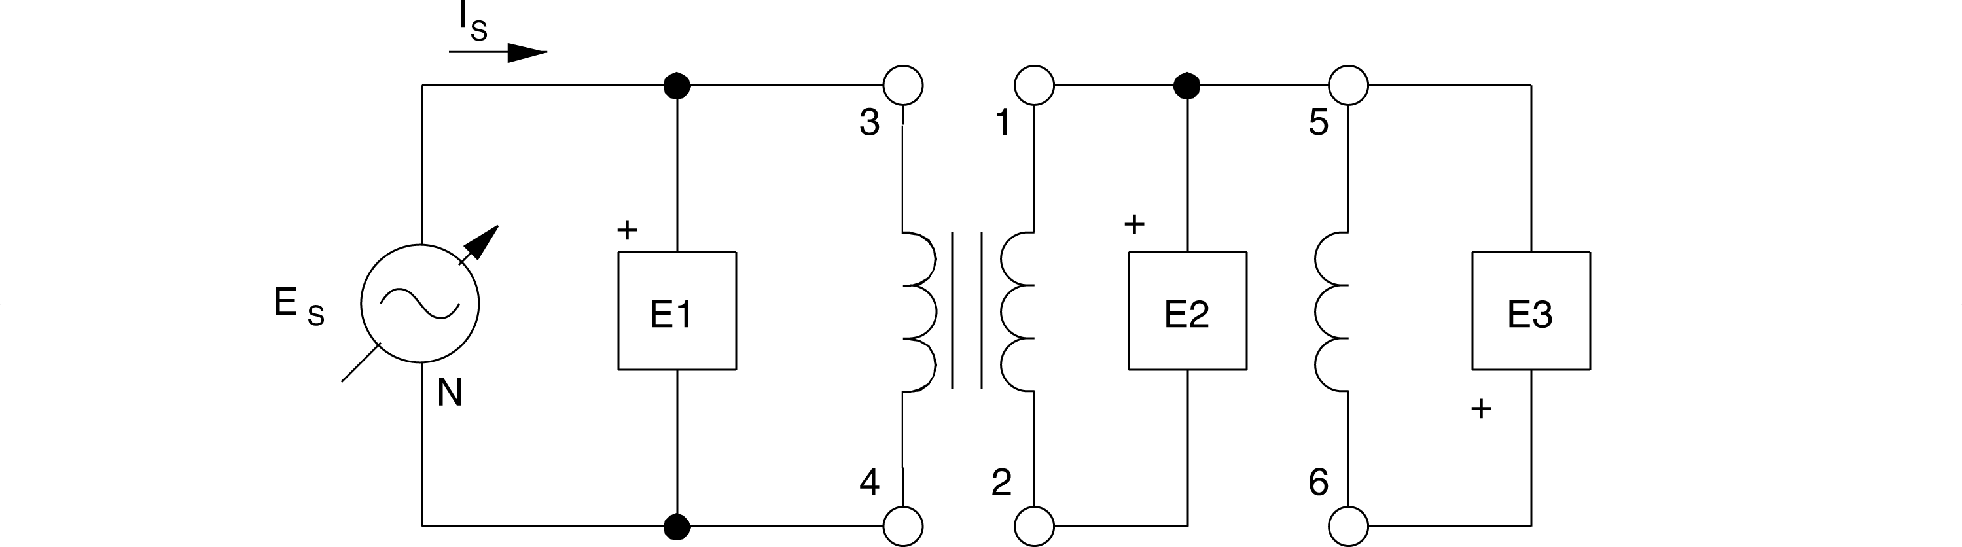

**Figure 2.4 Transformer Windings Connected in Series**

1. Turn on the power and adjust the voltage control to set ES at exactly 50% of the rated voltage for winding 3-4. *Note that the rated voltage is the sum of the intermediate winding voltages between terminals 3 and 4.* Measure and record the voltages at transformer windings 1-2, 5-6, and 2-6. Note that E2-6 is obtained by using the metering function E2 + E3.

E1-2 ' V E5-6 ' V E2-6 ' V

1. Are the windings connected in series-aiding, or series-opposing?

**Note:** *The voltage measured between terminals 2 and 6 is normally around zero volts, meaning that the windings are connected so that the voltages subtract from each other. Transformer polarity can be determined in this manner because the voltage across two interconnected windings will be less than the applied voltage when the interconnected terminals have the same polarity.*

1. Return the voltage control to zero and turn off the Power Supply. Disconnect terminals 1 and 5, and connect terminals 1 and 6 together. Reverse connections to meter input E3. If this new connection is series-aiding, what will be the value of E2-5 when the same voltage of step 6 is applied to winding 3-4?
2. Select setup configuration file *ES17-5.dai*. Turn on the power and once again set ES at exactly 50% of the rated voltage for winding 3-4. Measure and record the voltages at transformer windings 1-2, 5-6, and 2-5 indicated on the meters. Note that E2-5 is obtained by using the metering function E2 + E3.

E1-2 ' V E5-6 ' V E2-5 ' V

1. Is the value obtained for E2-5 the same as predicted in step 8?

**a)** Yes **b)** No

1. Return the voltage control to zero, turn off the power supply and remove the connection between terminals 1 and 6. What are the two voltages which can be obtained across the series combination of windings 3-4 and 1-2 when the same voltage as that in step 9 is applied to winding 3-4?
2. Connect terminals 1 and 4 together, turn on the power and set ES at exactly 50% of the rated voltage for winding 3-4. Select setup configuration file *ES17-6.dai*. Measure and record the voltages at transformer windings 1-2 and 2-3 using meter inputs E2 and E3.

E1-2 = V E2-3 = _________ V

1. Return the voltage control to zero and turn off the power supply. Disconnect terminals 1 and 4, and connect terminals 1 and 3 together. Interchange the connections at input E2 of the data acquisition module.
2. Turn on the power and set ES at exactly 50% of the rated voltage for winding 3-4. Select setup configuration file *ES17-7.dai*. Measure and record the voltage at transformer winding 2-4.

E2-4 = ____________V

1. How do the results of steps 12 and 14 compare with the predictions in step 11?
2. Which sets of terminals have the same polarity, 1 and 3, 2 and 4, 1 and 4, or 2 and 3?
3. Ensure that the Power Supply is turned off, the voltage control is fully CCW, and remove all leads and cables.

## Conclusion