**Department of Electrical Engineering and   
Computer Science**

**Faculty Member:** Ms. Neelma Naz  **Dated:** 23/09/2022

**Semester:** 5th **Section:** BEE 12C

**EE-260:** **Electrical Machines**

Lab 3: Single Phase Transformers

Group Members

|  |  |  |  |  |  |  |  |
| --- | --- | --- | --- | --- | --- | --- | --- |
|  |  | | **PLO4/**  **CLO5** | **PLO4/**  **CLO5** | **PLO5/ CLO6** | **PLO8/ CLO7** | **PLO9/ CLO8** |
| **Name** | | **Reg. No** | **Viva / Quiz / Lab Performance** | **Analysis of data in Lab Report** | **Modern Tool Usage** | **Ethics and Safety** | **Individual and Teamwork** |
|  | |  | **5 Marks** | **5 Marks** | **5 Marks** | **5 Marks** | **5 Marks** |
| Danial Ahmad | | 331388 |  |  |  |  |  |
| Hassan Rizwan | | 335753 |  |  |  |  |  |
| Muhammad Umer | | 345834 |  |  |  |  |  |
| Syeda Fatima Zahra | | 334379 |  |  |  |  |  |

**Table of Contents**

3 Single Phase Transformers 3

3.1 Objectives 3

3.2 Equipment 3

3.3 Introduction 3

3.4 Lab Instructions 3

4 Lab Tasks 4

4.1 Eddy Currents and Laminated Cores 4

4.1.1 Connection setup 4

4.1.2 Procedure 4

4.2 Hysteresis Loss in Transformer Core 7

4.2.1 Connection setup 7

4.2.2 Procedure 7

5 Conclusion 11

**Table of Figures**

Figure 3.4.1 Connections 4

Figure 3.4.2 Vertical Bars 5

Figure 3.4.3 Magnetic Circuit 6

Figure 3.4.4 Connections 7

Figure 3.4.5 Hysteresis Loop 9

Figure 3.4.6 Traced Step 5 9

Figure 3.4.7 Traced Step 10 11

# Single Phase Transformers

## Objectives

* FamiliarIze students with eddy current and hysteresis loss
* To learn how to use a flux meter and display a dynamic hysteresis loop on the oscilloscope
* To measure and compare in different types of cores.
* To display excitation current of a core on a virtual oscilloscope

## Equipment

Hardware

* LabVolt Proprietary Toolkit

Software

* *LVDAC*



## Introduction

Eddy current loss us caused due to the induction of eddy current in the core and conductors held in magnetic field. Hysteresis loss occurs in the core of an electric machine. Eddy current loss occurs in the core, conductor and body of an electric machine. The use of different cores has different effects on the eddy current and hysteresis losses. A way to reduce eddy current losses in the transformer is to make the core by stacking thin sheets together. This will decrease the eddy current and hence the losses made by it too.

## Lab Instructions

All questions should be answered precisely to get maximum credit. Lab report must ensure following items:

* Lab objectives
* Results (Graphs/Tables) duly commented and discussed
* Conclusion

# Lab Tasks

Eddy Currents and Laminated Cores

### Connection setup

Set up the circuit as shown in Figure 3.4.4 Connections. Tighten the screws in order to minimize the air gaps.

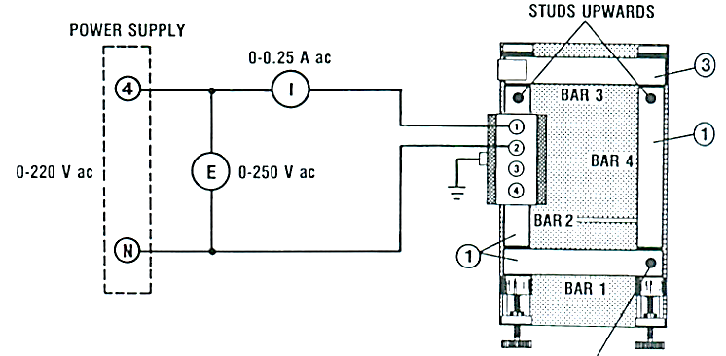

Figure . Connections

### Procedure

1. Turn on the power and adjust voltage E to 55 V ac. Measure the value of current I and keep the circuit in operation for 5 minutes. At the end of this period, again measure the value of current I and observe the temperature of the four bars, by hand. After this period, fill the following table.

|  |  |  |  |  |  |  |
| --- | --- | --- | --- | --- | --- | --- |
| **Time** | **E** | **I** | **Temperature** | | | |
| Min | Vac | Aac | Bar1 | Bar2 | Bar3 | Bar4 |
| 0 | 55 | 0.644 | *Cool* | *Cool* | *Cool* | *Cool* |
| 5 | 55 | 0.637 | *Cool* | *Cool* | *Cool* | *Cool* |

1. Set up the circuit again using the 133 mm solid soft Steel Bar (Item 6) instead of a laminated bar. Tighten the screws in order to minimize the air gaps in the magnetic circuit. Turn on the power and adjust voltage E to 55 V ac. Measure the value of the current I and keep the circuit in operation for 5 minutes. After this period, fill the following table.

|  |  |  |  |  |  |  |
| --- | --- | --- | --- | --- | --- | --- |
| **Time** | **E** | **I** | **Temperature** | | | |
| Min | Vac | Aac | Bar1 | Bar2 | Bar3 | Bar4 |
| 0 | 55 | 0.644 | *Cool* | *Cool* | *Cool* | *Cool* |
| 5 | 55 | 0.637 | Cool | Cool | Cool | Warm |

1. After the 5-minute test, explain any difference in the temperature of the bars.

**Answer:** The temperature of the laminated bars has remained the same. However, the steel bar has increased in temperature and has become relatively hotter. It is due to the large eddy currents flowing in the steel bar as compared to the laminated bars.

1. Why is the exciting current much greater in this step than in step 2?

**Answer:** The eddy currents induced in the steel bar are large as compared to those in the laminated bars. The eddy currents will flow in a direction so as to weaken the flux created by the primary winding (Lenz’s law). Consequently, the current in the primary coil required to produce the magnetic flux density is increased as shown by the current values obtained in tables of step 1 and step 2.

1. Set up the circuit again, but in this circuit, two bars are mounted vertically. Tighten the screws in order to minimize the air gaps in the magnetic circuit. Make sure terminal 1 of the coil is nearest the left bar, as shown.

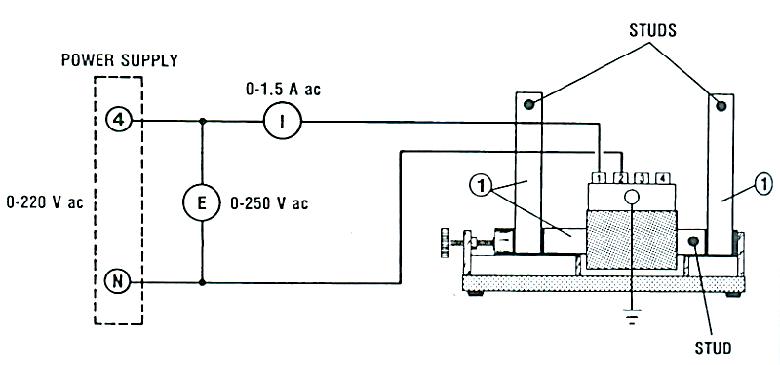

Figure . Vertical Bars

1. Turn on the power and adjust voltage E to 55V ac. Measure the value of I.

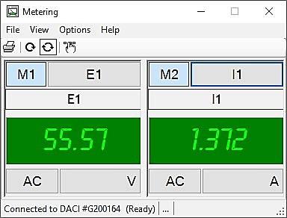

1. Why is current I greater now than it was in the previous step?

**Answer:** As the reluctance of air is many times high than that of a magnetic material due to its relative permittivity being equal to 1, the production of magnetic flux density in air requires much more energy as compared to its production in the steel bar used in step 2. Therefore, a larger current is required from the AC source

1. Place the Aluminum ring over the right bar and observe what happens. Describe what happens.

**Answer:** Due to flux passing though the magnetic core, an emf is induced and consequently, eddy currents in the aluminum ring, which in turn induces an emf that opposes the cause (i.e., flux in the core) producing it (Lenz’s law). This produces a repulsive force (Similar Poles – North – North / South - South) between the ring and the magnetic core producing the flux which causes the ring to float.

1. Let the ring float for about 1 minute and observe that it becomes quite hot. Why does it heat up?

**Answer:** It heats up due to the eddy currents flowing through it as a result of the emf induced in it by the changing magnetic flux of the magnetic core.

1. Measure the value of current I with and without the ring, while keeping E at 55 V ac.
2. Why is current I larger when the ring is in place?

**Answer:** Current is larger as more of it is being drawn from the AC source for the production of magnetic flux density in the magnetic core because to the formation of eddy currents in the aluminum ring which tend to oppose / weaken the flux due to the primary winding (Lenz’s Law).

1. Complete the magnetic circuit using the 178 mm Laminated and observe the behavior of the aluminum ring around the right bar.

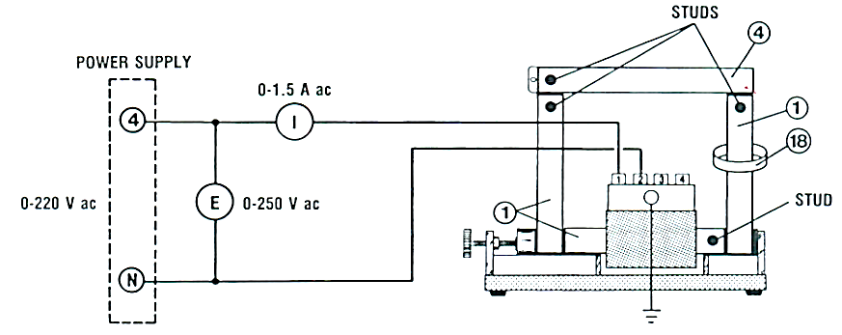

Figure . Magnetic Circuit

1. Describe what happens to the ring.

**Answer:** As the reluctance of the magnetic circuit is decreased due to the addition of laminated bar, more flux is produced in the magnetic core which in turn causes more eddy currents in the ring and a larger repulsive force is observed as the ring is now floating close to the top end of bar 1 instead of the lower half which was the case when the magnetic circuit was not complete.

1. Open the magnetic circuit by removing the 178 mm Laminated bar for a moment place the ring over the bar, then close the magnetic circuit. Observe what happens.

**Answer:** The bar experiences a larger repulsive force when the circuit is closed as compared to when it is open. The ring moves up along bar 1 when the circuit is closed and moves down when it is open.

1. Is there a force of repulsion or attraction between the ring and the coil?

**Answer:** There is a repulsive force between the ring and the coil due to the formation of the same magnetic poles (Lenz’s Law).

Hysteresis Loss in Transformer Core

### Connection setup

Set up the circuit as shown in Figure 3.4.4 Connections. Tighten the screws in order to minimize the air gaps. Set the oscilloscope to DC input mode and the X-Y mode. Select the 0-1000 µWb peak scale on the flux meter.

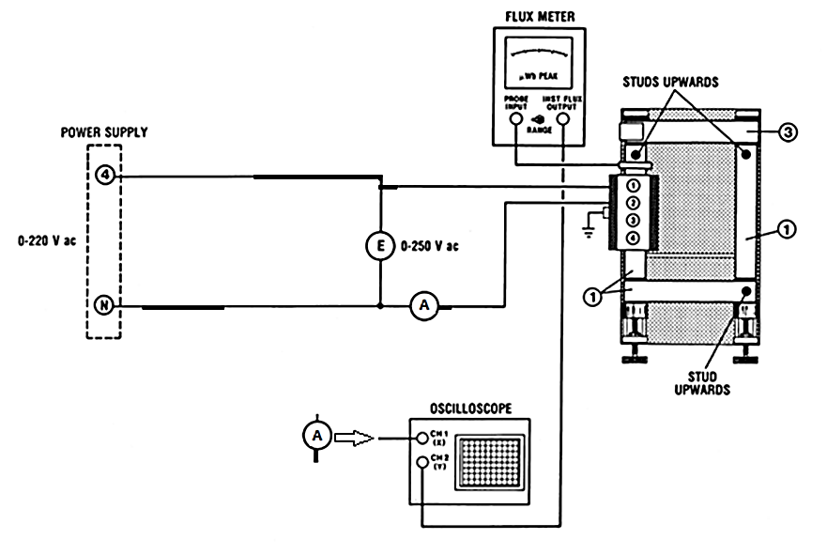

Figure . Connections

### Procedure

1. Apply power and raise voltage E gradually until it is equal to 55Vac. Observe the display on the oscilloscope. If the loop is reversed from that shown in Figure 3.9, turn off the power and turn the search coil.

Apply voltage E to each value shown in Table 3.4‑1 Results. For each value of E, measure both A (X-axis on the oscilloscope display) and V2 max (Y-axis). Then calculate the corresponding maximum values of flux ϕ. Note that the sensitivity of the flux meter (instantaneous flux output) is 1 mV/µW.

In Table 3.4‑1 Results, calculate the theoretical values of the ϕ max using the formula:

Therefore:

Table ‑ Results

|  |  |  |  |  |
| --- | --- | --- | --- | --- |
| **E** | **Φ max\*** | **V max\*\*** | **I max \*\*** | **Φ max\*\*** |
| V ac | µWb | mV | A | µWb |
| 20 | 150 | 140 | 0.37 | 140 |
| 40 | 300 | 280 | 0.71 | 280 |
| 60 | 450 | 420 | 1.09 | 420 |
| 80 | 600 | 560 | 1.53 | 560 |
| 85 | 638 | 600 | 1.67 | 600 |

*\* Theoretical Value*

*\*\* Measured Value*

1. Compare the measured values of the flux ϕ max with the theoretical values.

**Answer:** The measured values of flux are close to the theoretical values. We can clearly observe that they are somewhat different. However, this is not a very considerable change, so we can state that these values are valid.

1. How does the current I max and the flux ϕ max change as the applied voltage E increases?

**Answer:** The max current and flux were originally steadily increasing with the applied voltage. The relationship initially seemed to be directly proportional. However, due to the core entering saturation, the incremental change decreased gradually.

1. Observe how the hysteresis loop changes shape as voltage E is varied. Note that its area increases with increasing voltage. What does this indicate about the change in core loss as the flux increases?

**Answer:** At higher voltages, flux would be higher. And hence, as flux increases, the size of the loop increases, which means that core loss would be higher

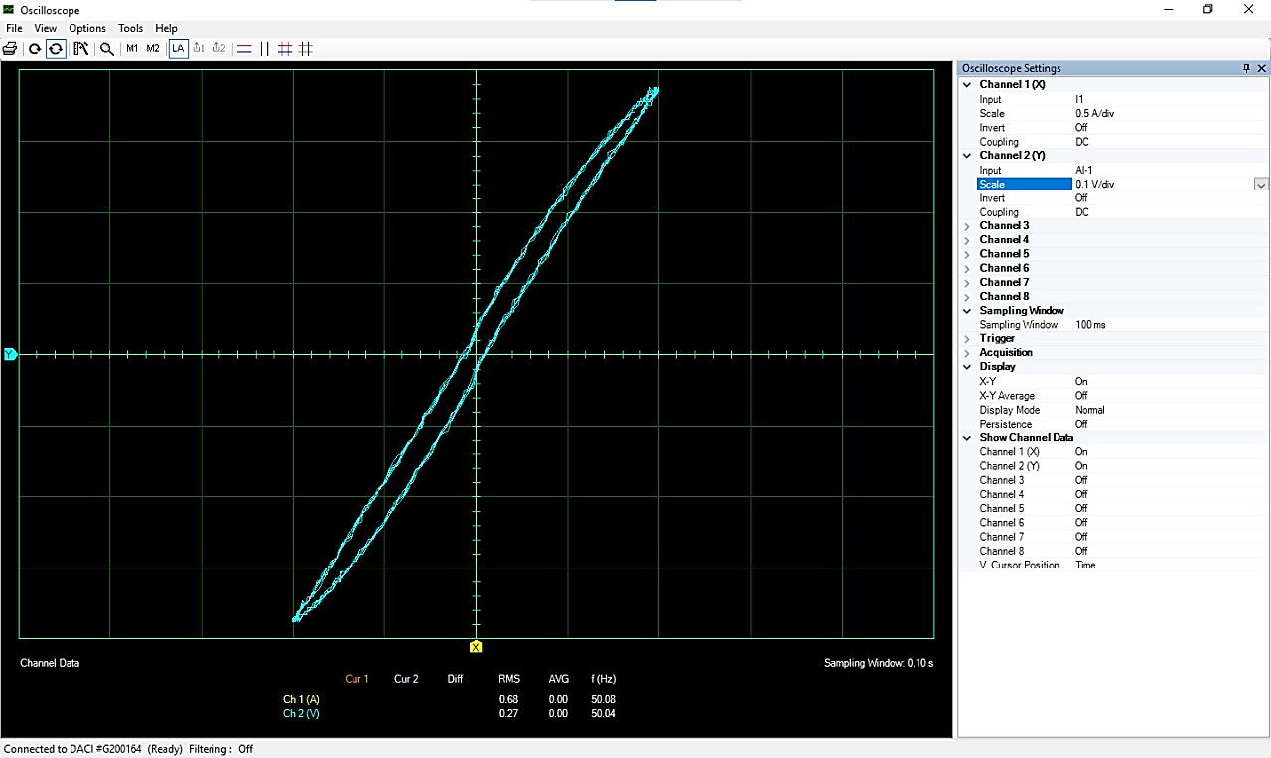

Figure . Hysteresis Loop

1. Calculate the area of the loop in V2. (Follow the procedure)

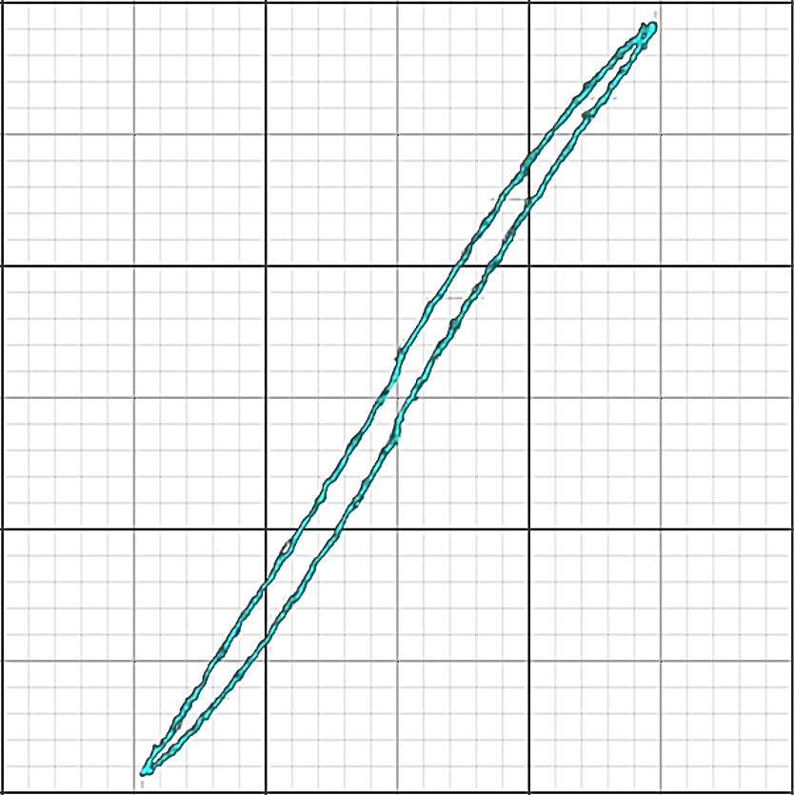

Figure . Traced Step 5

Number of square divisions in the loop = **(45/25) = 1.80**

Area of each square division = X-scale on the oscilloscope * Y-scale

**= 0.5 V/DIV * 0.1 V/DIV**

**= 0.05 V2/DIV2**

Area of loop = number of square divisions x area of each square division

Area of loop = **0.09 V2**

1. Calculate the area A of the loop in weber-amperes.

A = Area of loop in V2 / (sensitivity of current sensor * sensitivity of flux meter)

A = Area of loop in V2 / (1 V/A x 1000 V/Wb)

A = **90WbA**

1. Calculate the core loss.

Number of turns on coil A, N = **600**

Frequency of the source, f = **50 Hz**

Core loss, PL = A. N. F = **2.70 W**

1. Using a short lead, loop it around the bar without the coil and short-circuit the lead on itself. Observe that the hysteresis loop becomes broader.
2. Replace the right laminated bar without coil by the solid soft Steel Bar. Apply power and raise the voltage E to 10V. Observe the display on the oscilloscope. Measure A and V max and calculate the corresponding maximum values of I max and flux ϕ max.

I = **0.291 A**

Vmax = **70 mV**

Φmax = **70 Wb**

1. Paste the screenshot of the hysteresis loop below when E=10 V.

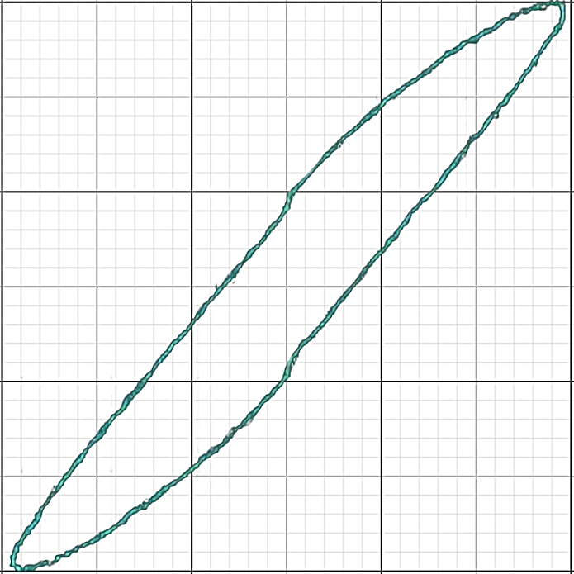

Figure . Traced Step 10

1. Calculate the core loss, using the same procedure as outlined in step 7.

PL = **9 W**

1. Why is core loss in step 11 much greater than that in step 7?

**Answer:** This is because this time we have a steel bar involved in step 10. Steel is a better conductor, and hence, the eddy currents in steel would be much greater than the currents in the laminated bar

# Conclusion

In this lab we learned about eddy currents and hysteresis losses. We further learned on how to plot those hysteresis losses using an oscilloscope at LVDAC. We performed practical experiments in single phase transformers using different types of materials as cores, and we concluded that having a different material as a core effects the eddy currents and hysteresis losses produced. Using the graph plotted by LVDAC, we learned how to calculate the losses using the graph, and concluded that at higher voltages, the current losses are higher. We also learned how to handle cores and single phase transformers by performing hardware on them and were also taught the safety precautions that are to be taken before performing any such experiments.