**Department of Electrical Engineering**

**Faculty Member: ____________________ Dated: ________________**

**Semester: __________________________ Section: ________________**

**EE-260: Electrical Machines**

**Lab 3: Single Phase Transformers (Part-b)**

**Eddy Currents and Laminated Cores**

|  |  |  |  |  |  |  |
| --- | --- | --- | --- | --- | --- | --- |
|  |  | **PLO4/**  **CLO5** | **PLO4/**  **CLO5** | **PLO5/**  **CLO6** | **PLO8/**  **CLO7** | **PLO9/**  **CLO8** |
| **Name** | **Reg. No** | **Viva / Quiz / Lab Performance** | **Analysis of data in Lab Report** | **Modern Tool Usage** | **Ethics and Safety** | **Individual and Team Work** |
|  |  | **5 Marks** | **5 Marks** | **5 Marks** | **5 Marks** | **5 Marks** |
|  |  |  |  |  |  |  |
|  |  |  |  |  |  |  |
|  |  |  |  |  |  |  |
|  |  |  |  |  |  |  |

**Lab3: Part - 1**

**Eddy Currents and Laminated Cores**

## Exercise objective

When you have completed this exercise, you will be familiar with Eddy current and hysteresis loss.

**Equipment required:**

Refer to the Equipment Utilization Chart in Appendix C to obtain the list of equipment required for this exercise.

**Discussion:**

An alternating magnetic field is always surrounded by an alternating electric field, as shown in Figure 1. This is the basis of Faraday's law of electromagnetic induction. If an electron happens to be in the alternating electric field, it will move first in one direction, then in the other, following the lines of force of the electric field.

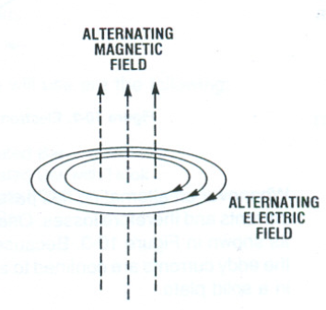

Figure 3.1 Relationship between magnetic and electric fields

If the alternating magnetic field goes through a metallic plate, as shown in Figure 2, the alternating electric field will act on the free electrons inside the plate, causing them to oscillate back and forth. But, any electron flow is actually an electric current. It follows that an alternating current flows in the plate, causing it to heat up. The current follows a circular path, flowing back and forth throughout the whole body of the plate. It moves in the same way that water in a bucket swishes back and forth when it is stirred one way, then the other. That is why the current in the plate is called an eddy current. It is also called Foucault current.

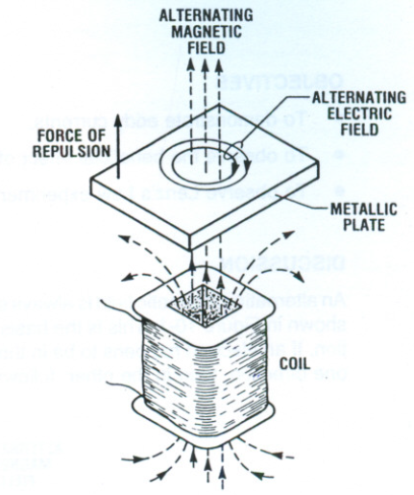

Figure 3.2 Electromagnetic Induction in a metallic plate

Whenever an alternating flux passes through a solid metal plate, it produces eddy currents and therefore losses. One way to reduce the losses is to laminate the plate as shown in Figure 3.

Because the laminations are insulated from each other, the eddy currents are confined to smaller area, and so they are much smaller than in a solid plate.

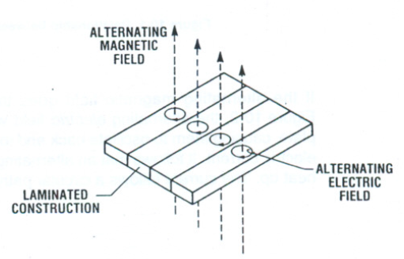

Figure 3.3 Electromagnetic Induction in a laminated construction

It is particularly important to laminate the iron core of a transformer, because it carries a large alternating magnetic flux. Most transformer laminations are about 0.35 mm thick and they are covered with a very thin varnish or oxide insulation.

For the same reason, the iron cores of ac motors and generators have to be laminated.

According to Lenz's Law, eddy currents in a metallic object flow in such a direction as to oppose the change of flux through the object. As a result, the magnetic field created by the eddy currents acts in opposition to the magnetic field that produced the eddy currents in the first place. In Figure 2 this produces a force of repulsion between the object and the coil that creates the flux. Thus the object tends to push away from the flux-producing coil. We will observe this phenomenon in this experiment.

**Procedure:**

1. ****Set up the circuit as shown in Figure 3.4. Tighten the screws in order to minimize the air gaps in the magnetic circuit.

**CAUTION!**

**High voltages are present in this experiment. Do not make any connections with the power ON. Be sure to connect each ground terminal (green) on the components to the power supply ground.**

1. Turn on the power and adjust voltage E to 55 V ac. Measure the value of current I and keep the circuit in operation for 5 minutes. At the end of this period, again measure the value of current I and observe the temperature of the four bars, by hand. State whether the temperature is cool, slightly warm, or hot.

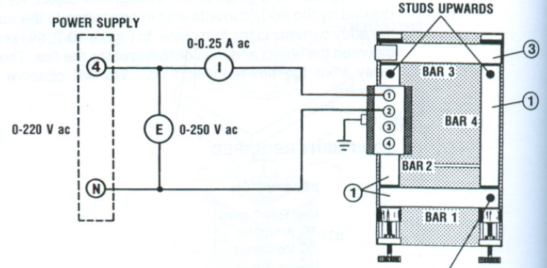

Figure 3.4 Circuit used for the observation of the effects of a laminated construction on electromagnetic induction

1. Complete Table 3.1. Turn off the power.

|  |  |  |  |  |  |  |
| --- | --- | --- | --- | --- | --- | --- |
| **TIME** | **E** | **I** | **TEMPERATURE** | | | |
| min | V ac | A ac | BAR1 | BAR2 | BAR3 | BAR4 |
| 0 | 55 |  |  |  |  |  |
| 5 | 55 |  |  |  |  |  |

Table 3.1

1. Set up the circuit of Figure 5 using the 133 mm solid soft Steel Bar (Item 6) instead of a laminated bar. Tighten the screws in order to minimize the air gaps in the magnetic circuit.
2. Turn on the power and adjust voltage E to 55 V ac. Measure the value of the current I and keep the circuit in operation for 5 minutes. At the end of this period, again measure the value of the current I and observe the temperature of the bars, by hand. State whether the temperature is hot, slightly warm, or hot.

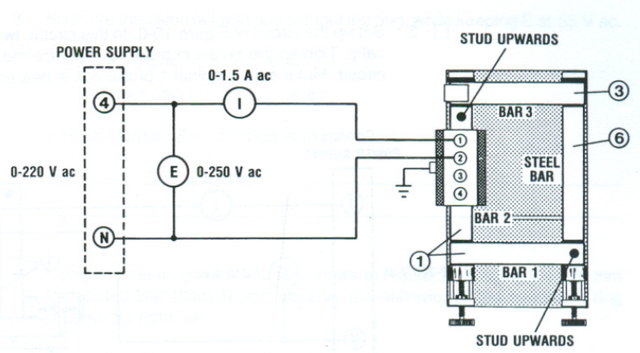

Figure 3.5 Circuit used to observe the effect of a solid steel bar on electromagnetic induction

1. Complete Table 3.2

Turn off the power.

|  |  |  |  |  |  |  |
| --- | --- | --- | --- | --- | --- | --- |
| **TIME** | **E** | **I** | **TEMPERATURE** | | | |
| min | V ac | A ac | BAR1 | BAR2 | BAR3 | BAR4 |
| 0 | 55 |  |  |  |  |  |
| 5 | 55 |  |  |  |  |  |

Table 3.2

1. After the 5-minute test, explain any difference in the temperature of the bars.
2. Why is the exciting current much greater in this step than in step 2?
3. Set up the circuit of Figure 3.6. In this circuit, two bars are mounted vertically. Tighten the screws in order to minimize the air gaps in the magnetic circuit. Make sure terminal 1 of the coil is nearest the left bar, as shown.

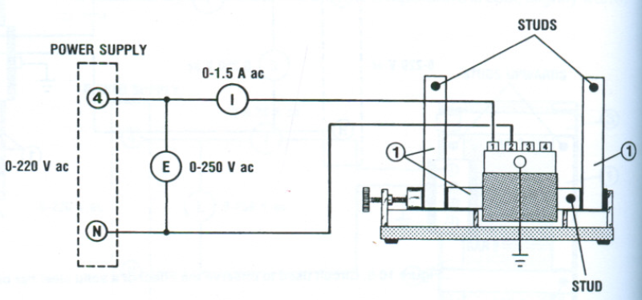

Figure 3.6 Circuit used to measure the effects of eddy currents in a metallic ring

1. Turn on the power and adjust voltage E to 55V ac. Measure the value of I.

I= _____________ A (ac).

1. Why is current I greater now than it was in step 2?
2. Place the Aluminum ring (Item 18) over the right bar and observe what happens. Describe what happens.

**CAUTION!** 

**The aluminum ring can become *very* hot.**

1. Let the ring float for about 1 minute and observe that it becomes quite hot. Why does it heat up?
2. Measure the value of current I with and without the ring, while keeping E at 55 V ac.

I with ring= __________________ A ac

I without ring= __________________ A ac

1. Why is current I larger when the ring is in place?
2. Complete the magnetic circuit as shown in Figure 3.7, using the 178 mm Laminated Bar (Item 4) and observe the behavior of the aluminum ring around the right bar.

Describe what happens to the ring.

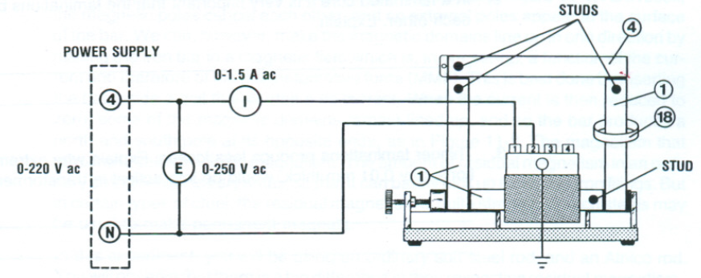

Figure 3.7 Circuit used to observe the effects of eddy currents in a metallic ring

1. Open the magnetic circuit by removing the 178 mm Laminated bar (Item 4) for a moment place the ring over the bar, then close the magnetic circuit. Observe what happens.

Is there a force of repulsion or attraction between the ring and the coil?

**Note:**  Because of the way the coil is wound, the force in this step will be relatively weak.

1. Ensure that the Power Supply is turned off, the voltage control is fully CCW, and remove all leads and cables.

## Conclusion:

**Lab3: Single Phase Transformers (Part-b)**

**Hysteresis Loss is Transformer Core**

## Exercise objectives:

**Conduct an experiment:**

* To learn how to use a flux meter and display a dynamic hysteresis loop on the oscilloscope.
* To measure and compare in different types of cores.
* To display excitation current of a core on a virtual oscilloscope.

## Equipment required

Refer to the Equipment Utilization Chart in Appendix C to obtain the list of equipment required for this exercise.

**Discussion:**

Consider a coil having N turns connected to an ac source E. It draws and ac current which produces an alternating flux ϕ in an iron core (see Figure 3.8). If the instantaneous flux ϕ is plotted against the instantaneous current I, we obtain a closed loop whose general shape is shown in Figure 3.9. This is called a dynamic hysteresis loop.

The hysteresis loop shows two values of the flux for each value of the current; one when the current is increasing, the other when it is decreasing.

**Note:** Usually this type of loop represents the variations of the magnetic flux density B against the magnetic field strength. H.

The hysteresis loop is usually formed by static magnetization curves. However, this term may also be loosely used to refer to the loop formed by dynamic magnetization curves.

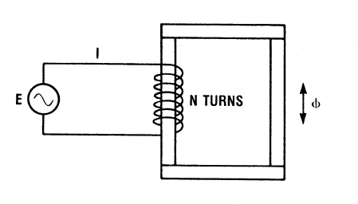

Figure 3.8 AC Source connected to a coil of N turns

This type of hysteresis loop gives an indication of the core loss (also called iron loss). This loss is composed of both the hysteresis loss and the eddy current loss in the iron core. It can be shown that the area of the loop (in Weber-Amperes) is equal to the core loss in joules per cycle per turn of the coil. Therefore the total core loss, PL is given by the equation:

**PL=A. N. F**

Where

PL is the total core loss, in watts

A is the area of the hysteresis loop, in Wb-A

N is the number of turns on the coil that produces the flux

F is the frequency of the source, in hertz

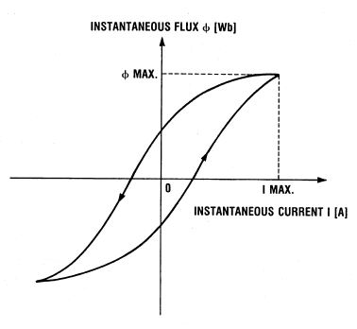

Figure 3.9 Hysteresis Loop

The hysteresis loop can be displayed in the screen of the oscilloscope provided that the current I and the flux ϕ are first converted into equivalent instantaneous voltages. This can be done using the current sensor and the flux meter. In the current sensor, the current is transduced into a voltage V1 (see Figure 3.10). A search coil S is used with the flux meter to sample the flux and a special integrating circuit T in the flux meter makes the output voltage V2 proportional to the instantaneous flux. Ammeter reading Ais applied to the horizontal axis (X) and voltage V2 is applied to the vertical (Y) axis of the oscilloscope. The area of the resulting loop can be measured by photographing it or by copying it using tracing paper.

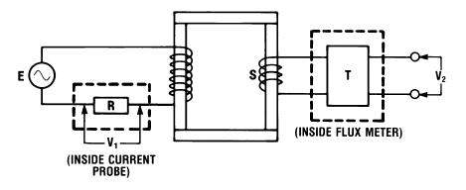

Figure 3.10 using the current probe and the flux meter

The Lab-Volt Flux Meter has a PROBE INPUT for the search coil to measure the flux. The output (Instantaneous flux output) gives a voltage proportional to the instantaneous flux.

It should be noted that in the hysteresis loop obtained in this exercise, the intercept on the horizontal axis is not a measure of the coercive force and the intercept on the vertical axis is not a measure of the remnant magnetism as in a regular hysteresis loop.

**Procedure:**

1. Set up the circuit as shown in Figure 3.11. Tighten the screws in order to minimize the air gaps. Set the oscilloscope to DC input mode and the X-Y mode. Select the 0-1000 µWb peak scale on the flux meter.

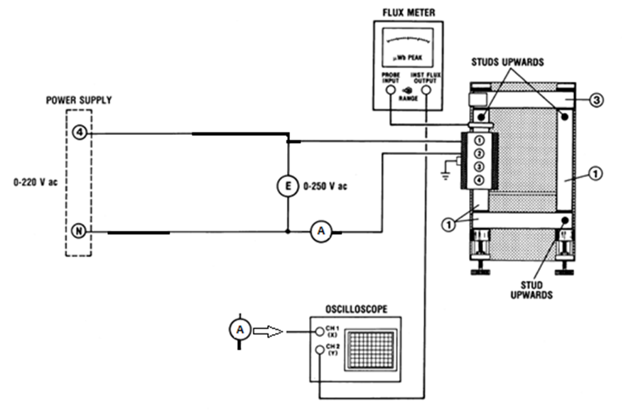

Figure 3.11 Circuit used to observe the hysteresis loop.



**CAUTION!**

**High voltages are present in this experiment. Do not make any connections with the power ON. Be sure to connect each ground terminal (green) on the components to the power supply ground.**

1. Apply power and raise voltage E gradually until it is equal to 55Vac. Observe the display on the oscilloscope. If the loop is reversed from that shown in Figure 3.9, turn off the power and turn the search coil.

Apply voltage E to each value shown in Table 3. For each value of E, measure both A (X-axis on the oscilloscope display) and V2 max (Y-axis). Then calculate the corresponding maximum values of flux ϕ. Note that the sensitivity of the flux meter (instantaneous flux output) is 1 mV/µW.

In Table 3.1, calculate the theoretical values of the ϕ max using the formula:

Φmax= E/ (4.44 f. N).

Therefore:

Φ max (µWb) = V2 max (mV)

|  |  |  |  |  |
| --- | --- | --- | --- | --- |
| **E** | **Φ max\*** | **V max\*\*** | **I max \*\*** | **Φ max\*\*** |
| V ac | µWb | mV | A | µWb |
| 20 |  |  |  |  |
| 40 |  |  |  |  |
| 60 |  |  |  |  |
| 80 |  |  |  |  |
| 85 |  |  |  |  |

Table 3.1

* *Theoretical Value*

*\*\* Measured Value*

1. Compare the measured values of the flux ϕ max with the theoretical values.
2. How do the current I max and the flux ϕ max change as the applied voltage E increases?
3. Observe how the hysteresis loop changes shape as voltage E is varied. Note that its area increases with increasing voltage.

What does this indicate about the change in core loss as the flux increases?

1. Paste screenshot below of the hysteresis loop displayed on the screen, when E=10V.
2. Calculate the area of the loop in V2 , using the following procedure:

Number of square divisions in the loop= _______

(Count the number of small squares inside the loop, and divide by 25.)

1. Area of each square division = X-scale on the oscilloscope * Y-scale

= __________ V/DIV * ___________ V/DIV

=___________ V2/DIV2

1. Area of loop = number of square divisions x area of each square division

Area of loop = ____________ V2

1. Calculate the area A of the loop in weber-amperes:

A= Area of loop in V2 / (sensitivity of current sensor in V/A x sensitivity of flux meter in V/Wb)

A= Area of loop in V2 / (1 V/A x 1000 V/Wb)

A=________ Wb. A

1. Calculate the core loss:

Number of turns on coil A, N=________

Frequency of the source, f=__________ Hz

Core loss, PL=A. N. F=__________W

1. Using a short lead, loop it around the bar without the coil and short-circuit the lead on itself. Observe that the hysteresis loop becomes broader.

Turn off the power.

1. Replace the right laminated bar without coil in Figure 3.11 by the solid soft Steel Bar (Item 16).
2. Apply power and raise the voltage E to 10V. Observe the display on the oscilloscope. Measure A and V max and calculate the corresponding maximum values of I max and flux ϕ max.

Q5) Fill in the following details:

I = ________ A

V max = ________ V

Φ max = ________ µWb

1. Paste the screenshot of the hysteresis loop below when E=10 V.
2. Calculate the core loss, using the same procedure as outlined in step 11. PL=__________W

Turn off the power.

1. Why is core loss in step 14 much greater than that in step 11?

## Conclusion: