**Department of Electrical Engineering and   
Computer Science**

**Faculty Member:** Ms. Neelma Naz  **Dated:** 7/10/2022

**Semester:** 5th **Section:** BEE 12C

**EE-260:** **Electrical Machines**

Lab 4: Open Circuit and Short Circuit Tests

Group Members

|  |  |  |  |  |  |  |  |
| --- | --- | --- | --- | --- | --- | --- | --- |
|  |  | | **PLO4/**  **CLO5** | **PLO4/**  **CLO5** | **PLO5/ CLO6** | **PLO8/ CLO7** | **PLO9/ CLO8** |
| **Name** | | **Reg. No** | **Viva / Quiz / Lab Performance** | **Analysis of data in Lab Report** | **Modern Tool Usage** | **Ethics and Safety** | **Individual and Teamwork** |
|  | |  | **5 Marks** | **5 Marks** | **5 Marks** | **5 Marks** | **5 Marks** |
| Danial Ahmad | | 331388 |  |  |  |  |  |
| Hassan Rizwan | | 335753 |  |  |  |  |  |
| Muhammad Umer | | 345834 |  |  |  |  |  |
| Syeda Fatima Zahra | | 334379 |  |  |  |  |  |

**Table of Contents**

3 Single Phase Transformers 3

3.1 Objectives 3

3.2 Equipment 3

3.3 Introduction 3

3.4 Lab Instructions 3

4 Lab Tasks 4

4.1 Open Circuit Test 4

4.1.1 Connection setup 4

4.1.2 Procedure 4

4.2 Short Circuit Test 5

4.2.1 Connection setup 5

4.2.2 Procedure 5

5 Conclusion 6

**Table of Figures**

Figure 3.4.1 Connections 4

Figure 3.4.2 Connections 5

# Single Phase Transformers

## Objectives

* Conduct an experiment to learn how to calculate transformer internal losses using open and short circuit tests

## Equipment

Hardware

* LabVolt Proprietary Toolkit

Software

* *LVDAC*



## Introduction

In real life, we don’t have ideal transformers, and real-life transformers have internal resistances and eddy currents, which means power is lost in order to overcome them.

Open circuit test or no-load test on a transformer is performed to determine 'no load loss (core loss)' and 'no load current I0. Open circuit test gives core losses of transformer and shunt parameters of the equivalent circuit. On the other hand, the short circuit test gives copper losses of transformer and approximate equivalent resistance and reactance of the transformer.

## Lab Instructions

All questions should be answered precisely to get maximum credit. Lab report must ensure following items:

* Lab objectives
* Results (Graphs/Tables) duly commented and discussed
* Conclusion

# Lab Tasks

Open Circuit Test

### Connection setup

Set up the circuit as shown in Figure 3.4.1 Connections.

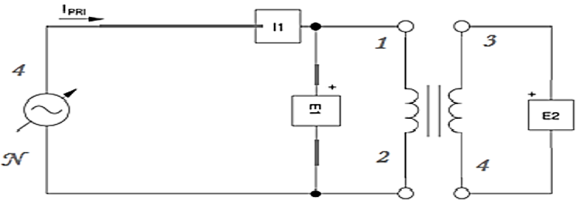

Figure 3.4.1 Connections

### Procedure

1. Connect the circuit as shown in Figure 3.4.1 Connections. Make sure that the low voltage side of the transformer corresponds to the left side of the connection diagram. A wattmeter should be used in metering window of the software.

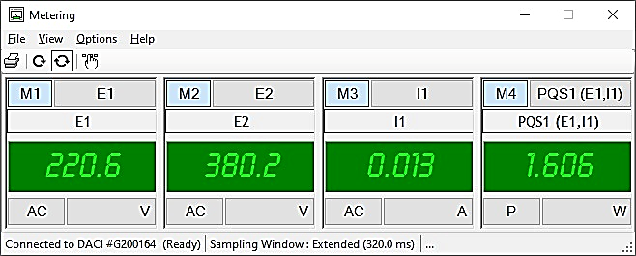

1. Measure and record the values for E1, E2, and I1and P1.

|  |  |
| --- | --- |
| E1 | 220.6 V |
| E2 | 380.2 V |
| I1 | 13 mA |
| P1 | 1.606 W |

1. Using the equations below find out the values for the excitation branch components.

Real Power = POC = = **1.606 $W$**

Power Factor = $cos⁡(θ)$ = **0.560**

Admittance = Y = |Y| <  =

Y = $\frac{1}{R_{P}}-j\frac{1}{X_{P}}=3.3×10^{-5} – j4.88×10^{-5} Ω$

$$R_{P}= 30.3 kΩ$$

$$X_{P}=20.4 kΩ$$

Short Circuit Test

### Connection setup

Set up the circuit as shown in Figure 3.4.2 Connections.

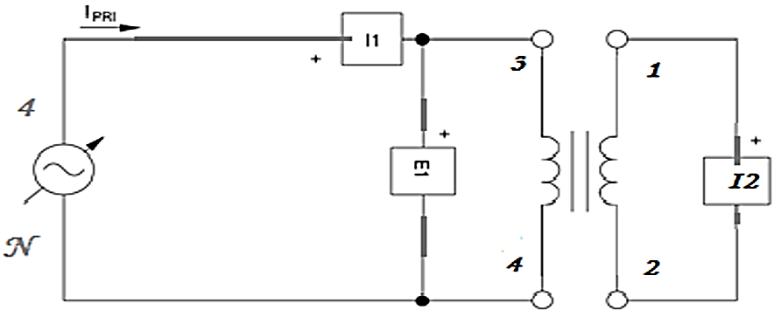

Figure 3.4.2 Connections

### Procedure

1. Connect the circuit as shown in Figure 3.4.1 Connections. Make sure that the low voltage side of the transformer corresponds to the left side of the connection diagram. A wattmeter should be used in metering window of the software.

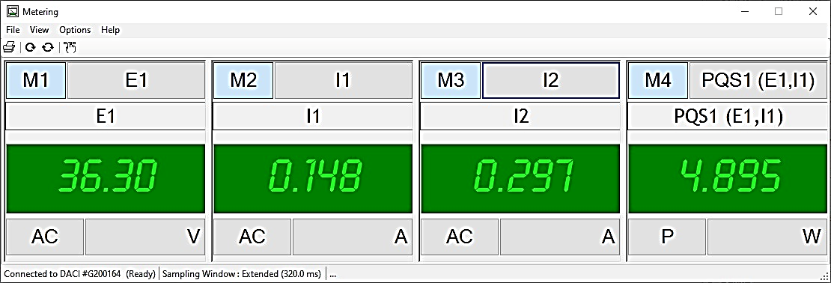

1. Turn the main power switch to on position and slowly increase the voltage. You will observe that currents I1 and I2 will rise very rapidly as compared to open circuit test.   
   Make sure that the currents I1 and I2 does not exceed he rated current of the winding you are using (i.e., 0.15 A) no matter what the voltage is
2. Measure and record the values for E1, E2, and I1and P1.

|  |  |
| --- | --- |
| E1 | 36.30 V |
| E2 | 0.148 V |
| I1 | 297 mA |
| P1 | 4.895 W |

1. Using the following equations, calculate the required series branch parameters.

Real Power = PSC =

Power Factor = $cos⁡(θ)$ = **0.911**

Admittance = Z = |Z| <  =

Z = $R_{S}+jX_{S}=223.4-j101.1 Ω$

$$R_{S}= 223.4 Ω$$

$$X_{S}=101.1 Ω$$

# Conclusion

In this lab we performed the open circuit and the short circuit test and noted down the values of voltage or current. Using these values, we calculated the power which was lost due to core losses and copper losses. We now know that using the open circuit test, we find the core losses of the transformer, and using the short circuit test, we find the copper losses of the transformer. We learned that real life transformers are not ideal and have some internal resistance and hence our power input is not the power output since some of it is lost in overcoming the copper losses and core losses. We measured the values using Lab-volt and so we got more familiar with the software side along with the hardware.