**Department of Electrical Engineering**

**Faculty Member: ____________________ Dated: ________________**

**Semester: __________________________ Section: ________________**

**EE-260: Electrical Machines**

**Lab 4: Transformer internal losses (part c)**

**Open Circuit and Short circuit tests**

|  |  |  |  |  |  |  |
| --- | --- | --- | --- | --- | --- | --- |
|  |  | **PLO4/**  **CLO5** | **PLO4/**  **CLO5** | **PLO5/ CLO6** | **PLO8/ CLO7** | **PLO9/ CLO8** |
| **Name** | **Reg. No** | **Viva / Quiz / Lab Performance** | **Analysis of data in Lab Report** | **Modern Tool Usage** | **Ethics and Safety** | **Individual and Team Work** |
|  |  | **5 Marks** | **5 Marks** | **5 Marks** | **5 Marks** | **5 Marks** |
|  |  |  |  |  |  |  |
|  |  |  |  |  |  |  |
|  |  |  |  |  |  |  |
|  |  |  |  |  |  |  |

**Lab 4: Transformer Open Circuit and Short circuit tests**

**Objectives:**

Conduct an experiment to learn how to calculate transformer internal losses using open and short circuit tests.

**Equipment required:**

Refer to the Equipment Utilization Chart in Appendix C to obtain the list of equipment required for this exercise.

**Background:**

A power transformer is usually employed for the purpose of converting power, at a ﬁxed frequency, from one voltage to another. If it is used for converting power from a high voltage to a low voltage, it is called a step-down transformer. The conversion efficiency of a power transformer is extremely high and almost all of the input power is supplied as output power at the secondary winding.

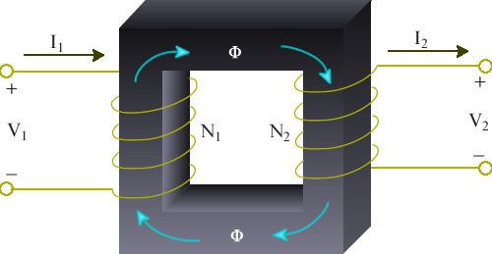

**Figure 4.1 Ideal Transformer**

Consider a magnetic core as shown in ﬁgure 4.1, carrying primary and secondary windings having N1and N2turns, respectively. When a sinusoidal voltage is applied to the primary winding, a ﬂux Φ will exist in the core which links both the primary and secondary windings, inducing the RMS voltages

*V1 = 4 .44f N1 Φ in the primary winding* **(4.1)**

*V2 = 4.44fN2 Φ in the secondary winding* **(4.2)**

The transformer is said to have a transformation ratio:

Formula 3.3

**(4.3)**

**Equivalent Circuit:**

The transformer may be represented by the equivalent circuit shown in figure 4.2. The parameters may be referred to either the primary or the secondary side. The series resistances *R1*and *R2*represent the copper loss in the resistance of the two windings. The series reactances *X1* and *X2*are leakage inductances, and account for the fact that some of the flux established by one of the windings does not fully couple the other winding. These reactances would be zero if there were perfect coupling between the two transformer windings.

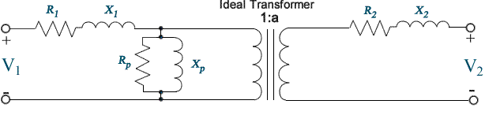**Figure 4.2: Equivalent circuit of a transformer**

The shunt resistance *RP* accounts for the core losses (due to hysteresis and eddy currents) of the transformer. The shunt inductance *XP* is representative of the inductances of the two windings and would be infinite in an ideal transformer if the number of turns of the two windings were to be infinite.

The Knowledge of the equivalent circuit parameters permits the calculation of transformer efficiency and of voltage regulation without the need to conduct actual load tests. But experimental data must first be obtained in order to determine those parameters.

It will be confirmed at the conclusion of the first two parts of this experiment that the impedances of the series branch of the transformer equivalent circuit are substantially smaller than the impedances of the parallel branch. Because of this large discrepancy in the magnitudes of the elements we can redraw the equivalent circuit shown in figure 4.2 into that shown in figure 4.3. The errors introduced into calculations using figure 4.3 in place of figure 4.2 are quite insignificant. Furthermore, the large difference in the magnitudes of the transformer parameters allows for the determination of the elements in the series branch using one set of measurements and the elements in the parallel branch using another set of measurements.

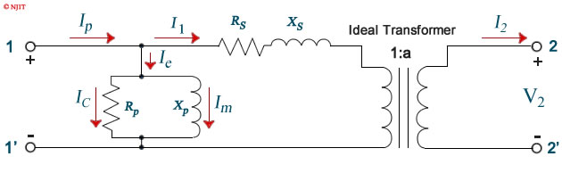**Figure 4.3: Simplified equivalent circuit of a transformer**

**Open Circuit Test:**

The open circuit test is used to determine the values of the shunt branch of the equivalent circuit *RP*and *XP*. We can see from figure 4.3 that with the secondary winding left open, the only part of the equivalent circuit that affects our measurement is the parallel branch. The impedance of the parallel branch is usually very high but appears lower when referred to the low voltage side. This test is therefore performed on the low voltage side of the transformer terminals 1 − 1' in ﬁgure 4.3 to increase the current drawn by the parallel branch to a readily measurable level. Besides, the rated voltage on the low voltage side is lower and therefore more manageable.

****Procedure:**

***CAUTION!***

***High voltages are present in this laboratory exercise! Do not make or modify any banana jack connections with the power on unless otherwise specified and do not leave high currents circulate through the transformer primary coil over a long period of time. Take all your measurements requiring a primary current at maximum transformer coil nominal value within two minutes. Let the transformer cool down for 15 minutes after the Power Supply is turned off.***

1. Connect the circuit as shown in ﬁgure 4.4. Make sure that the low voltage side of the transformer corresponds to the left side of the connection diagram. A wattmeter should be used in metering window of the software.

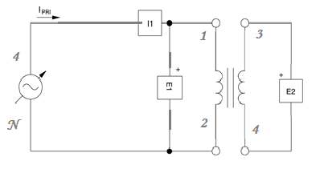

**Figure 4.4: Open Circuit Test**

1. Slowly increase the voltage keeping in check the excitation current flowing through the winding, up to the rated voltage of the winding used (i.e. 220v).
2. Measure and record the values for E1, E2, and I1and P1.

E1:______; E2:_______, I1:_______; P1:_______.

1. Using the equations below find out the values for the excitation branch components.

**Real Power** = POC = E1 * I1* Cos θ

**Power Factor** = Cos θ = 0.585.

**Admittance** = Y= |Y| < -θ = < -cos-1 PF

Y=G – j B: (Where G= Conductance & B = Susceptance)

Or Y= $\frac{1}{Rp}$– - j $\frac{1}{Xp}$; = 3.45e-5 – j 4.79e-5

So by calculations:

RP= 28.9 k $Ω$. XP = 20.8 k $Ω$.

**Short Circuit Test:**

The short circuit test is used to determine the values *RS* and *XS* of the series branch of the equivalent circuit. These impedances are usually very low, but appear higher in value when referred to the high voltage side. This test is consequently performed on high voltage side of the transformer (terminals 2 − 2ʹ in ﬁgure 4.3) in order to keep the current drawn by these impedances at a manageable level.

****Procedure:**

***CAUTION!***

***High voltages are present in this laboratory exercise! Do not make or modify any banana jack connections with the power on unless otherwise specified and do not leave high currents circulate through the transformer primary coil over a long period of time. Take all your measurements requiring a primary current at maximum transformer coil nominal value within two minutes. Let the transformer cool down for 15 minutes after the Power Supply is turned off.***

1. Connect the circuit as shown in ﬁgure 4.4. Make sure that the high voltage side of the transformer corresponds to the left side of the connection diagram. A wattmeter should be used in metering window of the software.

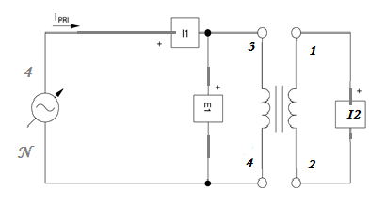

**Figure 4.4: Short Circuit Test**

1. Make sure that the variable knob of the power supply is at minimum voltage level, i.e. fully counter clockwise at 0% level before turning main power switch to on position.
2. Turn the main power switch to on position and slowly increase he voltage. You will observe that currents I1 and I2 will rise very rapidly as compared to open circuit test.   
   Make sure that the currents I1 and I2 does not exceed he rated current of the winding you are using (i.e. 0.15 A) no matter what the voltage is.
3. Special care must be taken that current should not exceed the rated value and voltage must never be turned on to 100%. The desired rated current will be achieved at almost 5 to 10% of total rated voltage. Also the experiment should be done in less than 1 to 2 minute time period and voltage should be reduced to zero and turn main power switch off.
4. Measure and record the values for E1, I1, and I2and P1.

E1:______; I1:_______, I2:_______; P1:_______.

1. Using the following equations, calculate the required series branch parameters.

**Real Power** = PSC = E1 * I1* Cos θ

**Power Factor** = Cos θ = 0.911 .

**Impedance** = Z= |Z| < θ = < cos-1 PF = 223.4 + j101.1

Or Z=RS + j XS: (Where RS= Series resistance & XS = Series reactance)

So by calculations:

RS= 223.4 XS = 101.1

**Conclusion:**