**Department of Electrical Engineering and   
Computer Science**

**Faculty Member:** Ms. Neelma Naz  **Dated:** 14/10/2022

**Semester:** 5th **Section:** BEE 12C

**EE-260:** **Electrical Machines**

Lab 5: Autotransformers and Transformers Voltage Regulation

Group Members

|  |  |  |  |  |  |  |  |
| --- | --- | --- | --- | --- | --- | --- | --- |
|  |  | | **PLO4/**  **CLO5** | **PLO4/**  **CLO5** | **PLO5/ CLO6** | **PLO8/ CLO7** | **PLO9/ CLO8** |
| **Name** | | **Reg. No** | **Viva / Quiz / Lab Performance** | **Analysis of data in Lab Report** | **Modern Tool Usage** | **Ethics and Safety** | **Individual and Teamwork** |
|  | |  | **5 Marks** | **5 Marks** | **5 Marks** | **5 Marks** | **5 Marks** |
| Danial Ahmad | | 331388 |  |  |  |  |  |
| Hassan Rizwan | | 335753 |  |  |  |  |  |
| Muhammad Umer | | 345834 |  |  |  |  |  |
| Syeda Fatima Zahra | | 334379 |  |  |  |  |  |

**Table of Contents**

3 Autotransformers 3

3.1 Objectives 3

3.2 Equipment 3

3.3 Introduction 3

3.4 Lab Instructions 3

4 Lab Tasks 4

4.1 The Autotransformer 4

4.1.1 Procedure 4

4.2 Transformer Voltage Regulation 7

4.2.1 Connection setup 7

4.2.2 Load Table 7

4.2.3 Procedure 7

5 Conclusion 10

**Table of Figures**

Figure 3.4.1 Connections 4

Figure 3.4.2 Connections 5

Figure 3.4.3 Connections 7

# Autotransformers

## Objectives

* Familiarize yourself with voltage and current characteristics of an autotransformer
* Determine the voltage regulation of a transformer with varying loads

## Equipment

Hardware

* LabVolt Proprietary Toolkit

Software

* *LVDAC*



## Introduction

This lab introduces the concept of autotransformers and voltage regulation. We study in-depth the autotransformers, their configurations, step-up and step-down, and the voltage and current characteristics. The autotransformer contains only a single winding that serves the use of both primary and secondary. For stepping up the voltage, a part of the winding acts as secondary while the entire winding acts as the secondary. For stepping down, the entire winding acts as primary. By connecting various loads against the autotransformer, we study the current voltage characteristics, as well as the apparent power level of the transformer. In the second part, we observe how the transformer behaves against varying loads, and their effect on voltage regulation.

## Lab Instructions

All questions should be answered precisely to get maximum credit. Lab report must ensure following items:

* Lab objectives
* Results (Graphs/Tables) duly commented and discussed
* Conclusion

# Lab Tasks

The Autotransformer

### Procedure

1. Display the *Metering* application. Set up the autotransformer circuit shown in Figure 3.4.1 Connections. Connect meter inputs E1 and I1 as shown and use meter inputs E2 and I2 to measure the secondary voltage and current. Note that winding 5-6 is connected as the primary, and that center-tap terminal 9 and terminal 6 act as the secondary winding.

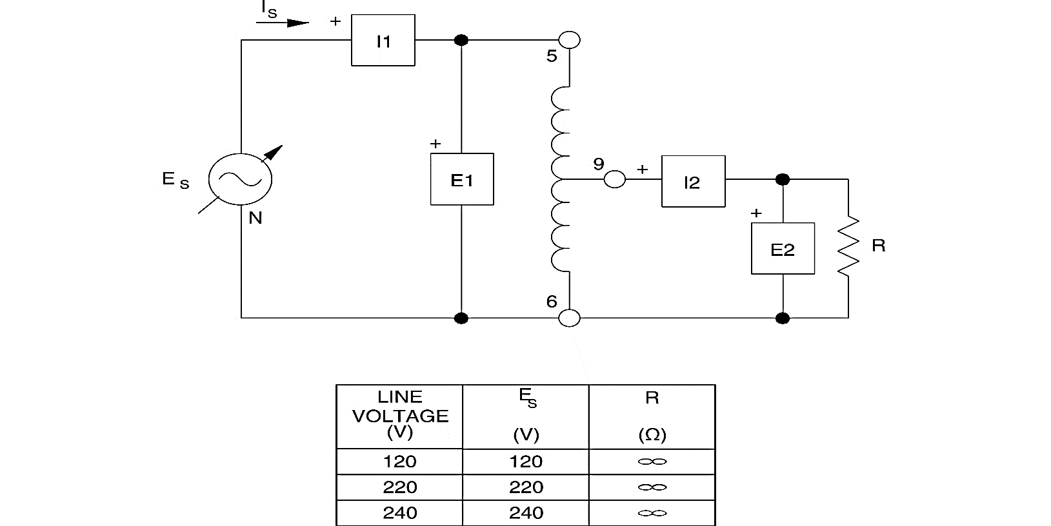

Figure . Connections

1. Measure and record EPRI, IPRI, ESEC, ISEC, as well as the primary and secondary apparent powers SPRI and SSEC. After recording the measurements, rotate the voltage control fully CCW and turn off the power.

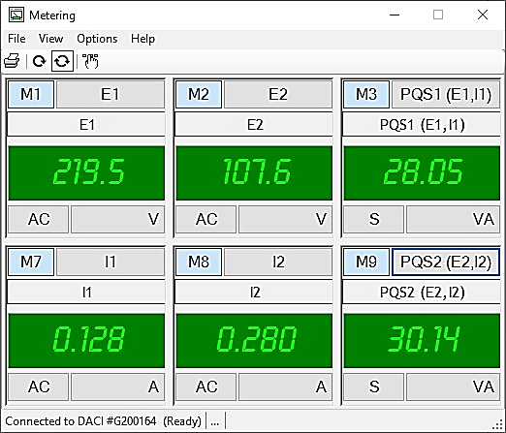

|  |  |  |
| --- | --- | --- |
| IPRI = 0.128 A | EPRI = 219.5 V | SPRI = 28.05 VA |
| ISEC = 0.280 A | **ESEC** = 107.6 V | **SSEC** = 30.14 VA |

1. Compare the values of SPRI and SSEC. Are they approximately the same, except for a small difference caused by copper and core losses?

|  |  |  |  |
| --- | --- | --- | --- |
| ✓ | Yes |  | No |

1. Using the measured values in step 2, calculate the apparent power for both the primary and secondary circuits.

**SPRI = EPRI x IPRI**= 30.346 VA

**SSEC** = 26.215 VA

1. Are the calculated results approximately the same as the measured values of SPRI and SSEC?

|  |  |  |  |
| --- | --- | --- | --- |
| ✓ | Yes |  | No |

1. Is the autotransformer connected in a step-up, or a step-down configuration?

**Answer:** The autotransformer is connected in a step-down configuration.

1. Compare the ratio of primary to secondary current. Does it agree with the inverse of the turn’s ratio?

IPRI/ISEC =, 1/a = Ns/Np =

|  |  |  |  |
| --- | --- | --- | --- |
| ✓ | Yes |  | No |

1. Set up the autotransformer circuit shown in Figure 3.4.2 Connections. Connect meter inputs E1 and I1 as shown and use meter inputs E2 and I2 to measure the secondary voltage and current. Note that winding 9-6 is now connected as the primary, and the terminals 5 and 6 are used for the secondary winding.

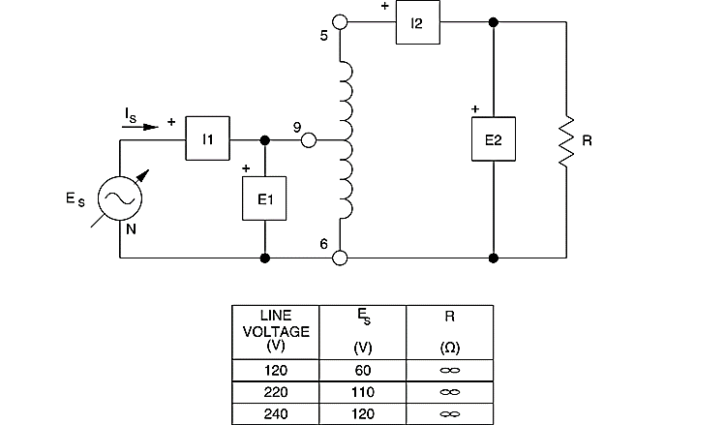

Figure . Connections

1. Measure and record EPRI, IPRI, ISEC, ESEC, SPRI, SSEC. After recording the measurements, rotate the voltage control fully CCW and turn off the power.

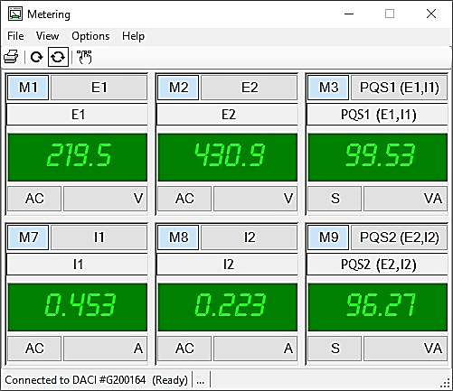

|  |  |  |
| --- | --- | --- |
| IPRI = 0.453 A | EPRI = 219.5 V | SPRI = 99.53 VA |
| ISEC = 0.223 A | **ESEC** = 430.9 V | **SSEC** = 96.27 VA |

1. Compare the values of SPRI and SSEC. Are they approximately the same, except for a small difference caused by copper and core losses?

|  |  |  |  |
| --- | --- | --- | --- |
| ✓ | Yes |  | No |

1. Calculate the apparent power for both the primary and secondary circuits.

**SPRI = EPRI x IPRI**= 24.525 VA

**SSEC** = 21.463 VA

1. Are the calculated results approximately the same as the measured values of SPRI and SSEC?

|  |  |  |  |
| --- | --- | --- | --- |
| ✓ | Yes |  | No |

1. Is the autotransformer connected in a step-up, or a step-down configuration?

**Answer:** The autotransformer is connected in a step-up configuration.

1. Compare the ratio of primary to secondary current. Does it agree with the inverse of the turn’s ratio?

IPRI/ISEC =, 1/a = Ns/Np =

Transformer Voltage Regulation

### Connection setup

Set up the circuit as shown in Figure 3.4.3 Connections.

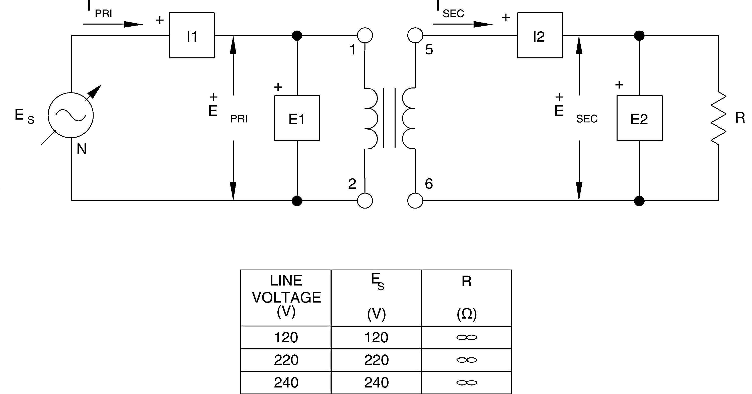

Figure . Connections

### Load Table

|  |  |  |  |  |  |
| --- | --- | --- | --- | --- | --- |
| Line Voltage | R, XL, XC | R, XL, XC | R, XL, XC | R, XL, XC | R, XL, XC |
| V | **Ω** | **Ω** | **Ω** | **Ω** | Ω |
| 120 | 1200 | 600 | 400 | 300 | 240 |
| 220 | 4400 | 2200 | 1467 | 1100 | 880 |
| 240 | 4800 | 2400 | 1600 | 1200 | 960 |

### Procedure

1. Adjust the switches on the Resistive Load module to successively obtain the resistance values given in the load table. For each resistance value, record the measurements.

|  |  |  |  |  |
| --- | --- | --- | --- | --- |
| R | M1-E1 | M2-E2 | M3-I1 | M4-I2 |
|  | AC | AC | AC | AC |
| ohm | V | V | A | A |
| 0 | 220.3 | 219.7 | 0.012 | 0.007 |
| 880 | 220.4 | 202.5 | 0.232 | 0.261 |
| 1100 | 219.9 | 205.5 | 0.188 | 0.21 |
| 1467 | 220.1 | 208.8 | 0.149 | 0.165 |
| 2200 | 220.2 | 212.4 | 0.103 | 0.112 |
| 4400 | 220.4 | 216.2 | 0.058 | 0.059 |

1. Display the *Graph* window, select E2 (ESEC) as the Y-axis parameter, and I2 (ISEC) as the X-axis parameter. What happens to the secondary voltage as the resistive load increases, i.e., load resistance decreases?

**Answer:** From the following graph, we can observe that the secondary voltage decreases as the current increases (load resistance decreases), implying a positive voltage regulation.



1. Calculate the voltage regulation using the no-load and full-load output voltages.

VR = $\frac{V_{nl}-V_{fl}}{V_{fl}}*100\%$

VR = $\frac{220.4-202.5}{202.5}*100\%$ = $8.839\%$

1. Adjust the switches on the Inductive Load module to successively obtain the reactance values given in the load table. For each reactance value, record the measurements.

|  |  |  |  |  |
| --- | --- | --- | --- | --- |
| I | M1-E1 | M2-E2 | M3-I1 | M4-I2 |
|  | AC | AC | AC | AC |
| H | V | V | A | A |
| 0 | 219.3 | 218.7 | 0.012 | 0.007 |
| 880 | 219.1 | 193.9 | 0.234 | 0.263 |
| 1100 | 219.2 | 198.4 | 0.192 | 0.216 |
| 1467 | 219.1 | 203.7 | 0.144 | 0.159 |
| 2200 | 219.2 | 208.7 | 0.099 | 0.106 |
| 4400 | 219.3 | 213.2 | 0.059 | 0.059 |

1. Display the *Graph* window, select E2 (ESEC) as the Y-axis parameter, and I2 (ISEC) as the X-axis parameter. How does the secondary voltage vary as the inductive load increases?

**Answer:** From the following graph, we can observe that the secondary voltage decreases as the current increases (load inductance decreases), implying a positive voltage regulation.



1. Adjust the switches on the Capacitive Load module to successively obtain the reactance values given in load table. For each reactance value, record the measurements.

|  |  |  |  |  |
| --- | --- | --- | --- | --- |
| C | M1-E1 | M2-E2 | M3-I1 | M4-I2 |
|  | AC | AC | AC | AC |
| F | V | V | A | A |
| 0 | 220.3 | 219.6 | 0.013 | 0.007 |
| 880 | 219.7 | 245.2 | 0.275 | 0.326 |
| 1100 | 219.7 | 239.4 | 0.211 | 0.252 |
| 1467 | 219.7 | 234.6 | 0.16 | 0.192 |
| 2200 | 219.7 | 229.8 | 0.111 | 0.135 |
| 4400 | 219.7 | 224.5 | 0.053 | 0.068 |

1. Display the *Graph* window, select E2 (ESEC) as the Y-axis parameter, and I2 (ISEC) as the X-axis parameter. How does the secondary voltage vary as the capacitive load increases?

**Answer:** From the following graph, we can observe that the secondary voltage increases as the current increases (load capacitance decreases), implying a negative voltage regulation.



1. What differences do you observe between the three load curves?

**Answer:** From the three load curves, we can deduce that the voltage across the secondary winding decreases for the case of inductive and resistive loads, whereas in capacitive loads, it increases. An increase in secondary voltage with increase in load implies a negative voltage regulation and vice versa. We should also note that although inductive and resistive load show similar voltage regulation characteristics, an inductive load exhibits a higher voltage regulation as the secondary voltage drops at a faster rate.

# Conclusion

In this lab, we practically implemented an autotransformer and observed the current voltage characteristics of the step-up and step-down configuration. We calculated the apparent power for both configurations. We also studied the effects of connecting varying power factors loads on the voltage regulation of the transformer. We observed that the secondary voltage decreased for inductive and resistive loads but increased for inductive loads.