**Department of Electrical Engineering**

**Faculty Member: ____________________ Dated: ________________**

**Semester: __________________________ Section: ________________**

**EE-260: Electrical Machines**

**Lab 5 – Autotransformers and Transformers Voltage Regulation**

|  |  |  |  |  |  |  |
| --- | --- | --- | --- | --- | --- | --- |
|  |  | **PLO4/**  **CLO5** | **PLO4/**  **CLO5** | **PLO5/ CLO6** | **PLO8/ CLO7** | **PLO9/ CLO8** |
| **Name** | **Reg. No** | **Viva / Quiz / Lab Performance** | **Analysis of data in Lab Report** | **Modern Tool Usage** | **Ethics and Safety** | **Individual and Team Work** |
|  |  | **5 Marks** | **5 Marks** | **5 Marks** | **5 Marks** | **5 Marks** |
|  |  |  |  |  |  |  |
|  |  |  |  |  |  |  |
|  |  |  |  |  |  |  |
|  |  |  |  |  |  |  |

**Lab5-Part-1: The Autotransformer**

## EXERCISE OBJECTIVE

When you have completed this exercise, you will be familiar with voltage and current characteristics of an autotransformer and you will be able to connect a standard transformer as an autotransformer in step-up and step-down configurations.

## DISCUSSION

The autotransformer is a special type of transformer with only one winding which serves as both the primary and secondary. When the autotransformer is used to step-up the voltage, only one part of the single winding acts as the primary, while the complete winding serves as the secondary. However, when the autotransformer is used to step-down the voltage, primary and secondary use is reversed. The whole winding is connected for use as the primary and only a part serves as the secondary. Figure 5.1 shows the autotransformer connections necessary for step-up and step- down operation.

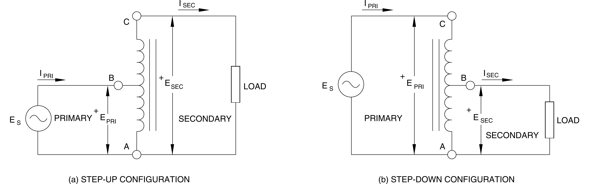

**Figure 5.1 Autotransformer connections (a) Step-Up Configuration; (b) Step-Down Configuration**

Autotransformer operation is basically the same as a standard two-winding transformer. Power is transferred from the primary to the secondary by a changing magnetic flux. The amount of increase or decrease in the voltage depends on the turn’s ratio between the primary and the secondary. To determine the turn’s ratio of the autotransformer, each winding is considered as separate even though some turns are common to both the primary and the secondary. Voltages and currents can be found using two simple equations:

**EPRI x IPRI = ESEC x ISEC,**





The autotransformer has a great advantage over a conventional transformer: it can operate at an apparent power level that is twice that of a conventional transformer of the same size. Furthermore, the autotransformer is somewhat more efficient than transformers with separate windings because it has smaller copper and iron losses. It is used mainly when small increases or decreases are required in the secondary voltage. For example, to boost a power line voltage and compensate for losses caused by long transmission lines, or to reduce the starting voltage of a motor, thus holding down its starting current within reasonable values. One major disadvantage of an autotransformer is the lack of electrical isolation between the primary and secondary windings since the windings are not separate. Also, it is generally unadvisable to use an autotransformer as a large-ratio step-down device because the high-voltage primary voltage would be placed across the low-voltage load if the low-voltage section of the winding became defective and opened up.

## EQUIPMENT REQUIRED

Refer to the Equipment Utilization Chart in Appendix C to obtain the list of equipment required for this exercise.

## PROCEDURE

**CAUTION!**

**High voltages are present in this laboratory exercise! Do not make or modify any banana jack connections with the power on unless otherwise specified!**

1. Install the Power Supply, data acquisition module, Resistive Load, and Single-Phase Transformer modules in the EMS Workstation.
2. Make sure that the main switch of the Power Supply is set to the O (OFF) position, and the voltage control knob is turned fully ccw. Set the voltmeter select switch to the 4-N position, and then ensure the Power Supply is connected to a three-phase wall receptacle.
3. Ensure that the POWER INPUT of the data acquisition module is connected to the main Power Supply, and ensure the USB port cable from the computer is connected to the data acquisition module. Set the 24 V - AC power switch to the 1 (ON) position.
4. Display the *Metering* application. Set up the autotransformer circuit shown in Figure 5.2. Connect meter inputs E1 and I1 as shown, and use meter inputs E2 and I2 to measure the secondary voltage and current. Note that winding 5-6 is connected as the primary, and that center-tap terminal 9 and terminal 6 act as the secondary winding.

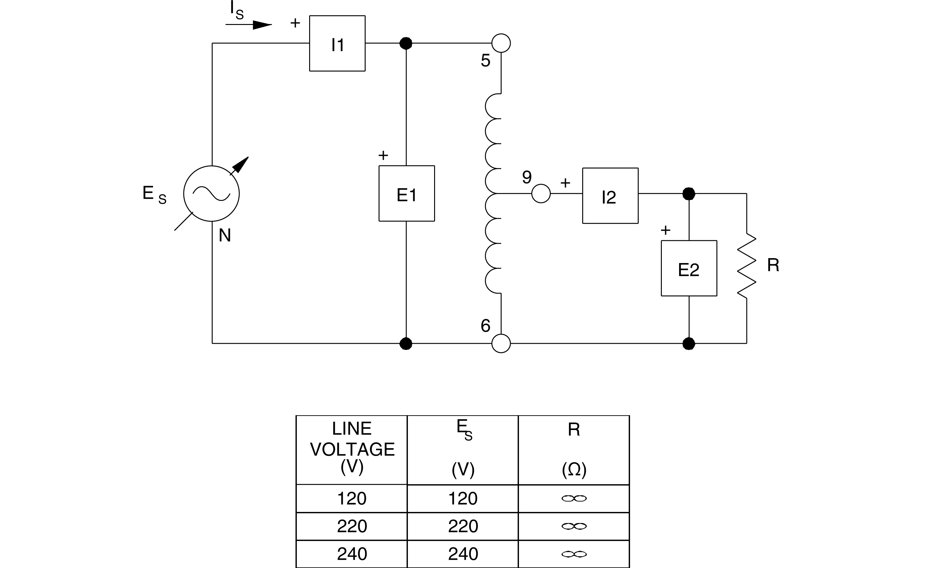

**Figure 5.2 Autotransformer Circuit to Decrease Secondary Voltage**

1. Set the Resistive Load module to obtain the value of R given in Table 5.1.

|  |  |
| --- | --- |
| **LINE VOLTAGE** | **R** |
| **V** | **Ω** |
| 120 | 120 |
| 220 | 440 |
| 240 | 480 |

**Table 5.1 Value of Resistor R**

1. Measure and record EPRI, IPRI, ESEC, ISEC, as well as the primary and secondary apparent powers SPRI and SSEC. After recording the measurements, rotate the voltage control fully CCW and turn off the power.

|  |  |  |
| --- | --- | --- |
| EPRI = V | IPRI = A | ISEC = A |
| ESEC = V | SPRI = _______VA | SSEC = _______VA |

1. Compare the values of SPRI and SSEC. Are they approximately the same, except for a small difference caused by copper and core losses?

G Yes G No

1. Using the measured values in step 7, calculate the apparent power for both the primary and secondary circuits.

SPRI = EPRI x IPRI VA, SSEC = ESEC x ISEC VA

1. Are the calculated results approximately the same as the measured values of SPRI and SSEC?

G Yes G No

1. Is the autotransformer connected in a step-up, or a step-down configuration?
2. Compare the ratio of primary to secondary current. Does it agree with the inverse of the turn’s ratio?

G Yes G No

1. Set up the autotransformer circuit shown in Figure 5.3. Connect meter inputs E1 and I1 as shown, and use meter inputs E2 and I2 to measure the secondary voltage and current. Note that winding 9-6 is now connected as the primary, and the terminals 5 and 6 are used for the secondary winding.

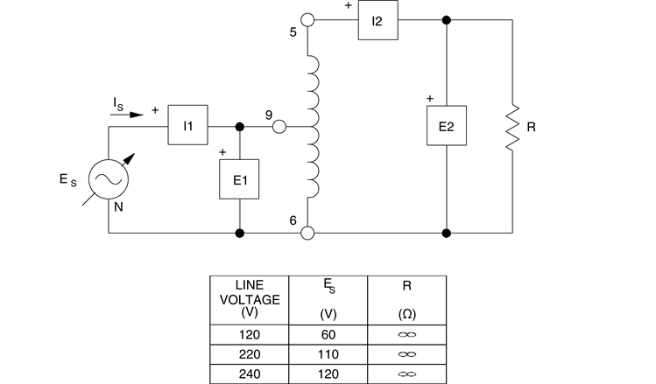

**Figure 5.3 Autotransformer Circuit to Increase Secondary Voltage**

1. Ensure that all of the Resistive Load module switches are open, and turn on the main power. Adjust the voltage control to obtain the value of ES given in Figure 5.3. This is the rated voltage for winding 9-6.
2. Set the Resistive Load module to obtain the value of R given in Table 5.2.

|  |  |
| --- | --- |
| **LINE VOLTAGE** | **R** |
| **V** | **Ω** |
| 120 | 600 |
| 220 | 2 200 |
| 240 | 2 400 |

**Table 5.2 Value of Resistor**

1. Measure and record EPRI, IPRI, ISEC, ESEC, SPRI, SSEC. After recording the measurements, rotate the voltage control fully ccw and turn off the power.

|  |  |  |
| --- | --- | --- |
| EPRI = V | IPRI = A | ISEC = A |
| ESEC = V | SPRI = VA | SSEC = VA |

1. Compare the values of SPRI and SSEC. Are they approximately the same, except for a small difference caused by copper and core losses?

G Yes G No

1. Using the measured values in step 15, calculate the apparent power for both the primary and secondary circuits.

SPRI = EPRI x IPRI = VA SSEC = ESEC x ISEC = VA

1. Are the calculated results approximately the same as the measured values of SPRI and SSEC?

G Yes G No

1. Is the autotransformer connected in a step-up, or a step-down configuration?
2. Compare the ratio of primary to secondary current. Does it agree with the inverse of the turn’s ratio?

G Yes G No

1. Ensure that the Power Supply is turned off, the voltage control is fully CCW, and remove all leads and cables.

## CONCLUSION:

**Lab5-Part-2: Transformer Voltage Regulation**

## EXERCISE OBJECTIVE

When you have completed this exercise, you will be able to determine the voltage regulation of a transformer with varying loads, and discuss capacitive and inductive loading on transformer regulation. Voltage and current measurements will be used to produce load regulation curves.

## DISCUSSION

The load on a large power transformer in a sub-station will vary from a very small value in the early hours of the morning to a very high value during the heavy peaks of maximum industrial and commercial activity. The transformer secondary voltage will vary somewhat with the load, and because motors, incandescent lamps, and heating devices are all quite sensitive to voltage changes, transformer regulation is of considerable importance. The secondary voltage also depends upon whether the power factor of the load is leading, lagging, or unity. Therefore, it should be known how the transformer will behave (its voltage regulation) when connected to a capacitive, an inductive, or a resistive load. Transformer voltage regulation in percent is determined with the following formula:



Where ENL is the no-load secondary voltage EFL is the full-load secondary voltage

The result (a percentage value) obtained gives an indication of transformer behavior under load. The smaller the voltage regulation percentage, the smaller is the secondary voltage variation with load, and the better the voltage regulation. Note that ENL is measured with the secondary winding open while EFL is measured when nominal current flows in the secondary winding.

Several factors affect a transformer's operation. The resistance and inductive reactance of its windings because internal voltage drops that vary with the amount of current flowing in the windings. If the secondary is lightly loaded, current through the winding resistance and reactance is small and the internal voltage drops are not significant. As the load increases, current and internal voltage drops also increase. If a transformer was perfectly ideal, its windings would have neither resistance nor inductive reactance to cause voltage drops. Such a transformer would have perfect regulation under all load conditions and the secondary voltage would remain absolutely constant. But practical transformers coils are made of real wire, and thereby, have resistance and inductive reactance. Therefore, the primary and secondary windings have an overall resistance R, and an overall reactance X. The simplified equivalent circuit of a practical transformer with a 1:1 turn’s ratio can be approximated by the circuit shown in Figure 5.4. The actual transformer terminals are P1, P2 on the primary side, and S1, S2 on the secondary side.

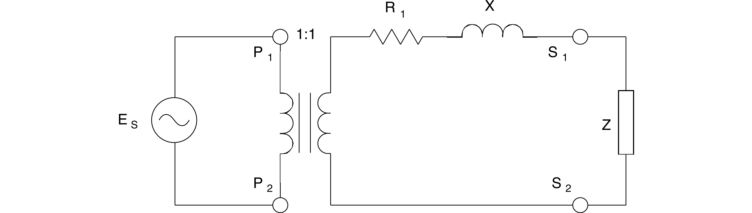

**Figure 5.4 Simplified Equivalent Circuit of a Practical Transformer**

In this equivalent circuit, the practical transformer is shown to be made up of an ideal transformer in series with impedance consisting of R and X that represents the imperfections of the transformer. When a load (Z) is connected to the secondary winding terminals (terminals S1 and S2), a series ac circuit consisting of the secondary winding of the ideal transformer, R, X, and Z is obtained. Analysis of this series ac circuit shows that when the load is either resistive or inductive, the load voltage decreases continuously as the load increases (as the secondary current increases). Furthermore, when the load is capacitive, the load voltage increases to a maximum as the load increases from zero (no load condition), and then, the load voltage decreases as the load continues to increase.

## EQUIPMENT REQUIRED

Refer to the Equipment Utilization Chart in Appendix C to obtain the list of equipment required for this exercise.

## PROCEDURE

**CAUTION!**

**High voltages are present in this laboratory exercise! Do not make or modify any banana jack connections with the power on unless otherwise specified!**

1. Install the Power Supply, data acquisition module, Single-Phase Transformer, Resistive Load, Capacitive Load, and Inductive Load modules in the EMS Workstation.
2. Make sure that the main switch of the Power Supply is set to the O (OFF) position, and the voltage control knob is turned fully ccw. Set the voltmeter select switch to the 4-N position, and then ensure the Power Supply is connected to a three-phase wall receptacle.
3. Ensure that the POWER INPUT of the data acquisition module is connected to the main Power Supply, and ensure the USB port cable from the computer is connected to the data acquisition module. Set the 24 V - AC power switch to the 1 (ON) position.
4. Display the *Metering* application.
5. Set up the transformer loading circuit shown in Figure 5.5. Ensure that all switches on the Resistive, Capacitive, and Inductive Load modules are open, and connect meter inputs E1, E2, I1, and I2 as shown in the figure. Different load values will be used to examine how the secondary (load) voltage changes as transformer loading changes.

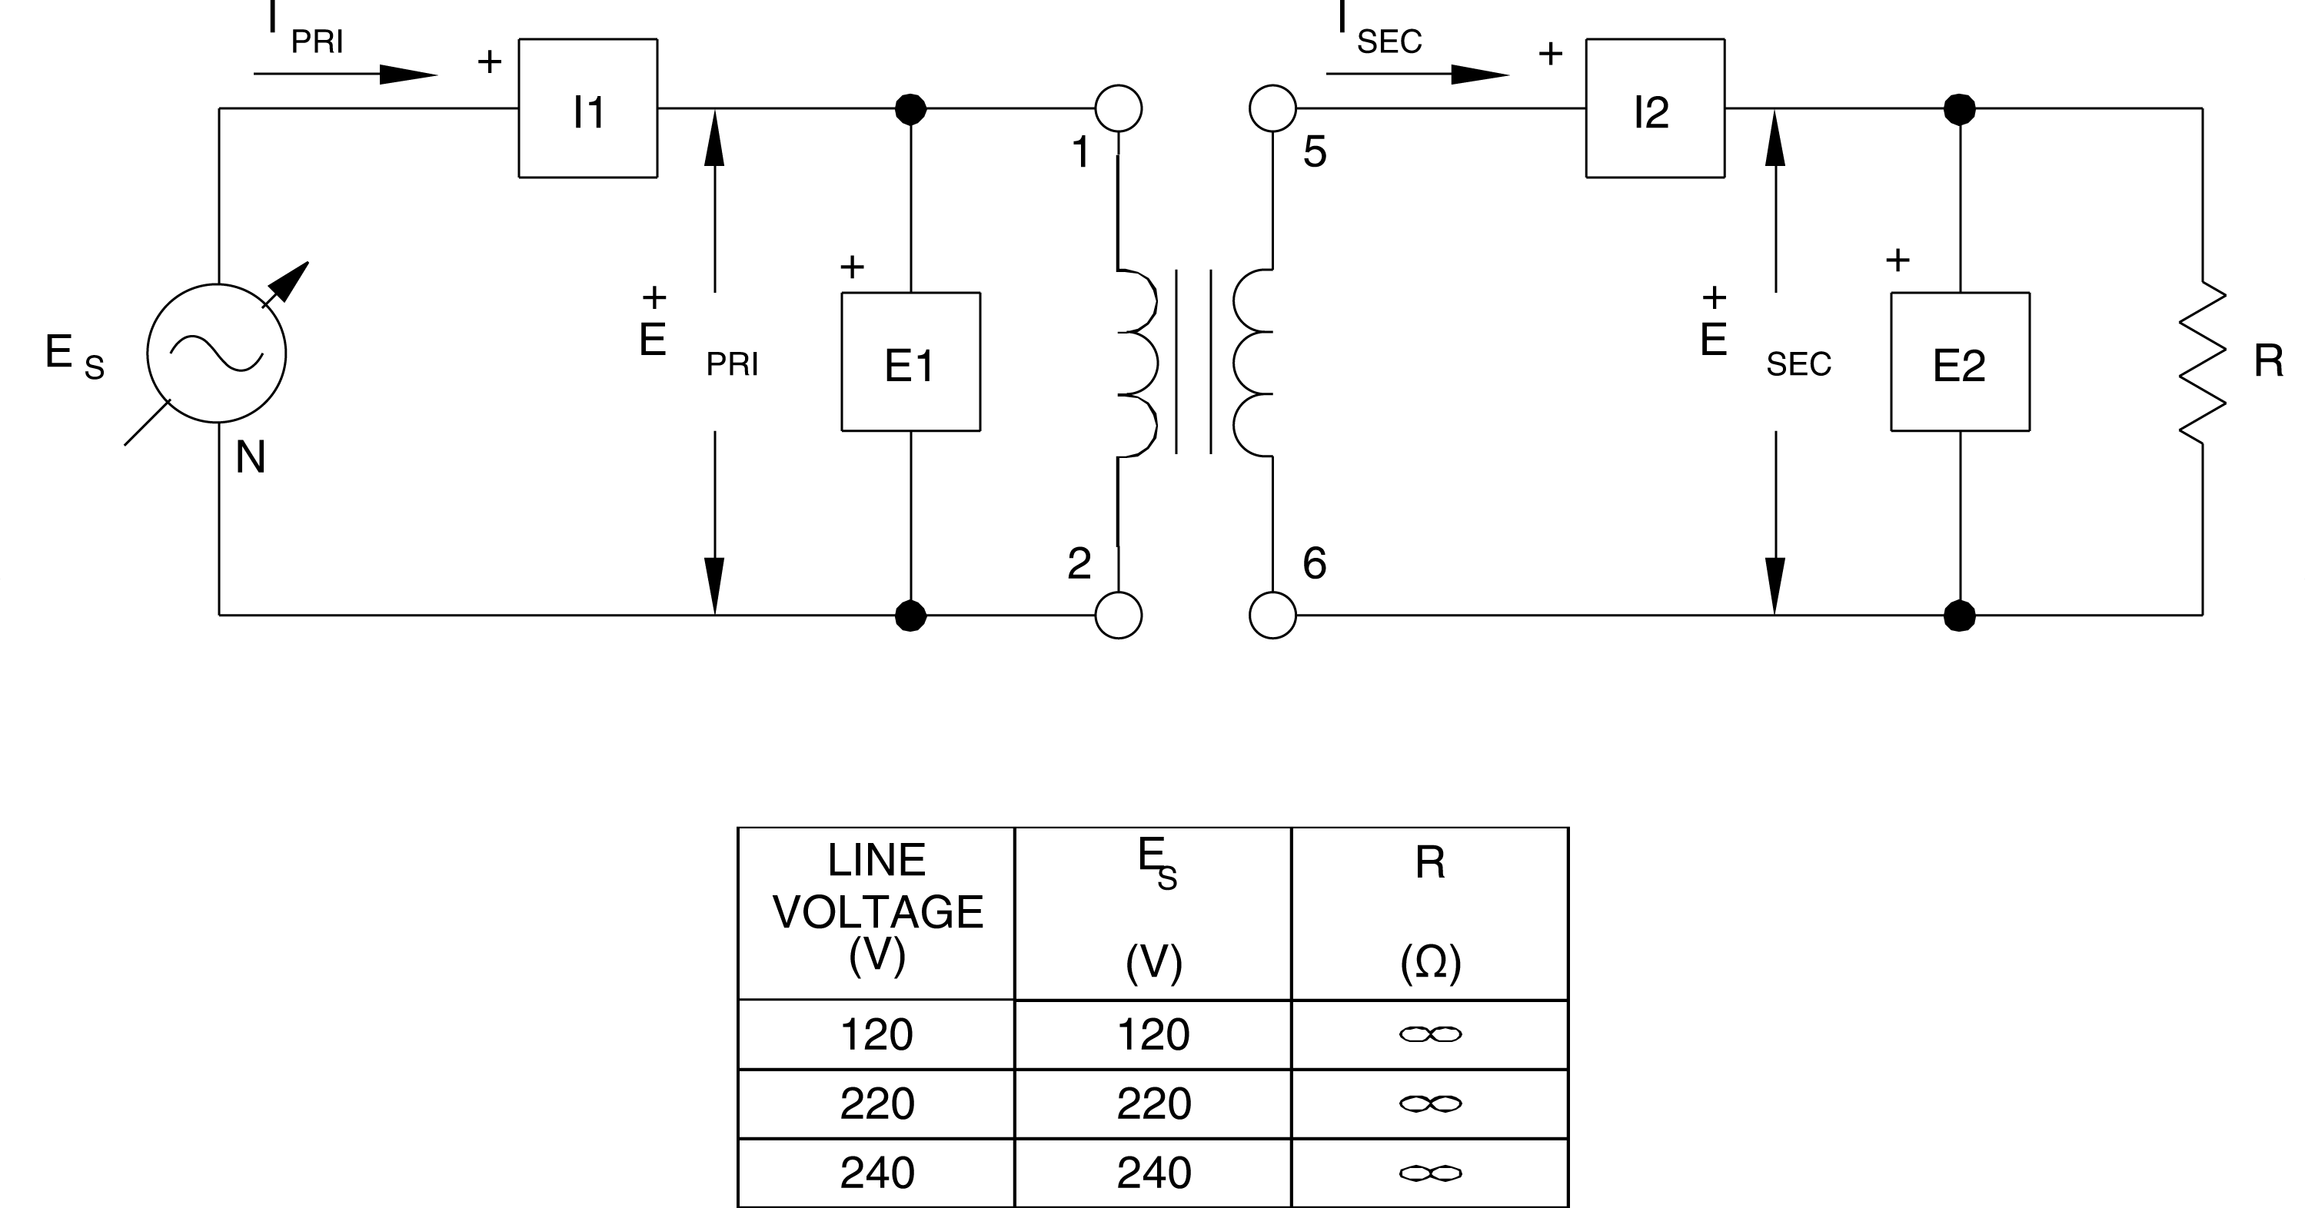

**Figure 5.5 Transformers with a Variable Load**

1. Turn on the main Power Supply and adjust the main voltage control to obtain the value of ES given in Figure 5.5. With no load on the transformer (all switches open on the load module), click the *Record Data* button to enter the measurements for EPRI, IPRI, ESEC, and ISEC in the *Data Table*.
2. Adjust the switches on the Resistive Load module to successively obtain the resistance values given in Table 5.3. For each resistance value, record the measurements as in step 6. When all data values have been recorded, rotate the voltage control fully CCW, and turn off the Power Supply.

|  |  |  |  |  |  |
| --- | --- | --- | --- | --- | --- |
| **LINE VOLTAGE** | **R, XL, XC** | **R, XL, XC** | **R, XL, XC** | **R, XL, XC** | **R, XL, XC** |
| **V** | **Ω** | **Ω** | **Ω** | **Ω** | **Ω** |
| 120 | 1 200 | 600 | 400 | 300 | 240 |
| 220 | 4 400 | 2 200 | 1467 | 1 100 | 880 |
| 240 | 4 800 | 2 400 | 1600 | 1 200 | 960 |

**Table 5.3 Values for R, XL, and XC.**

1. Display the *Graph* window, select E2 (ESEC) as the Y-axis parameter, and I2 (ISEC) as the X-axis parameter. Make sure the line graph format and the linear scale are selected. Observe the curve of secondary voltage versus current. What happens to the secondary voltage as the resistive load increases, i.e. load resistance decreases?

**Note:** *To make it easier to compare the curves obtained with different loads, hard copies of the graphs in steps 8, 13, and 17 can be printed using the Print button on the Tool Bar.*

1. Calculate the voltage regulation using the no-load and full-load output voltages.







1. Use the Clear Data Table button in the *Data Table* window to clear the data, and then replace the Resistive Load module in the circuit of Figure 5.5 with the Inductive Load module.
2. Turn on the main Power Supply and adjust the main voltage control to obtain the value of ES given in Figure 5.5. With no load on the transformer (all switches open on the load module), click the *Record Data* button to enter the measurements for EPRI, IPRI, ESEC, and ISEC in the *Data Table*.
3. Adjust the switches on the Inductive Load module to successively obtain the reactance values given in Table 5.3. For each reactance value, record the measurements as in step 11. When all data values have been recorded, rotate the voltage control fully CCW, and turn off the Power Supply.
4. Display the *Graph* window, select E2 (ESEC) as the Y-axis parameter, and I2 (ISEC) as the X-axis parameter. Make sure the line graph format and the linear scale are selected. Observe the curve of secondary voltage versus current. How does the secondary voltage vary as the inductive load increases?
5. Use the Clear Data Table button in the *Data Table* window to clear the data, and then replace the Inductive Load module in the circuit of Figure 5.5 with the Capacitive Load module.
6. Turn on the main Power Supply and adjust the main voltage control to obtain the value of ES given in Figure 5.5. With no load on the transformer (all switches open on the load module), click the *Record Data* button to enter the measurements for EPRI, IPRI, ESEC, and ISEC in the *Data Table*.
7. Adjust the switches on the Capacitive Load module to successively obtain the reactance values given in Table 5.3. For each reactance value, record the measurements as in step 15. When all data values have been recorded, rotate the voltage control fully CCW, and turn off the Power Supply.
8. Display the *Graph* window, select E2 (ESEC) as the Y-axis parameter, and I2 (ISEC) as the X-axis parameter. Make sure the line graph format and the linear scale are selected. Observe the curve of secondary voltage versus current. How does the secondary voltage vary as the capacitive load increases?
9. What differences do you observe between the three load curves?
10. Ensure that the Power Supply is turned off, the voltage control is fully CCW, and remove all leads and cables.

## CONCLUSION