**Department of Electrical Engineering and   
Computer Science**

**Faculty Member:** Ms. Neelma Naz  **Dated:** 21/10/2022

**Semester:** 5th **Section:** BEE 12C

**EE-260:** **Electrical Machines**

Lab 6: Three Phase Transformer Connections and Operations

(Part A)

Group Members

|  |  |  |  |  |  |  |  |
| --- | --- | --- | --- | --- | --- | --- | --- |
|  |  | | **PLO4/**  **CLO5** | **PLO4/**  **CLO5** | **PLO5/ CLO6** | **PLO8/ CLO7** | **PLO9/ CLO8** |
| **Name** | | **Reg. No** | **Viva / Quiz / Lab Performance** | **Analysis of data in Lab Report** | **Modern Tool Usage** | **Ethics and Safety** | **Individual and Teamwork** |
|  | |  | **5 Marks** | **5 Marks** | **5 Marks** | **5 Marks** | **5 Marks** |
| Danial Ahmad | | 331388 |  |  |  |  |  |
| Hassan Rizwan | | 335753 |  |  |  |  |  |
| Muhammad Umer | | 345834 |  |  |  |  |  |
| Syeda Fatima Zahra | | 334379 |  |  |  |  |  |

**Table of Contents**

3 Three Phase Transformer Connections 3

3.1 Objectives 3

3.2 Equipment 3

3.3 Introduction 3

3.4 Lab Instructions 3

4 Lab Tasks 4

4.1 Procedure 4

5 Conclusion 7

**Table of Figures**

Figure 4.1.1 Connections Delta – Delta 4

Figure 4.1.2 Connections Wye – Wye 6

# Three Phase Transformer Connections

## Objectives

When you have completed this exercise, you will be able to connect three-phase transformers in delta-delta and wye-wye configurations. You will measure winding voltages to verify that the secondary windings are connected with the proper phase relationships, and you will verify that the voltage within a delta equals zero before the delta is closed.

## Equipment

Hardware

* LabVolt Proprietary Toolkit

Software

* *LVDAC*



## Introduction

A three-phase transformer is made of three sets of primary and secondary windings, each set wound around one leg of an iron core assembly. Essentially it looks like three single-phase transformers sharing a joined core. hose sets of primary and secondary windings will be connected in either Δ or Y configurations to form a complete unit. The various combinations of ways that these windings can be connected together it will be the focus of this and the following lab. Whether the winding sets share a common core assembly, or each winding pair is a separate transformer, the winding connection options are the same. We aim to verify the theoretical relationships between line voltages and line currents on the secondary and primary side of the three phase transformers by practically implementing them.

## Lab Instructions

All questions should be answered precisely to get maximum credit. Lab report must ensure following items:

* Lab objectives
* Results (Graphs/Tables) duly commented and discussed
* Conclusion

# Lab Tasks

## Procedure

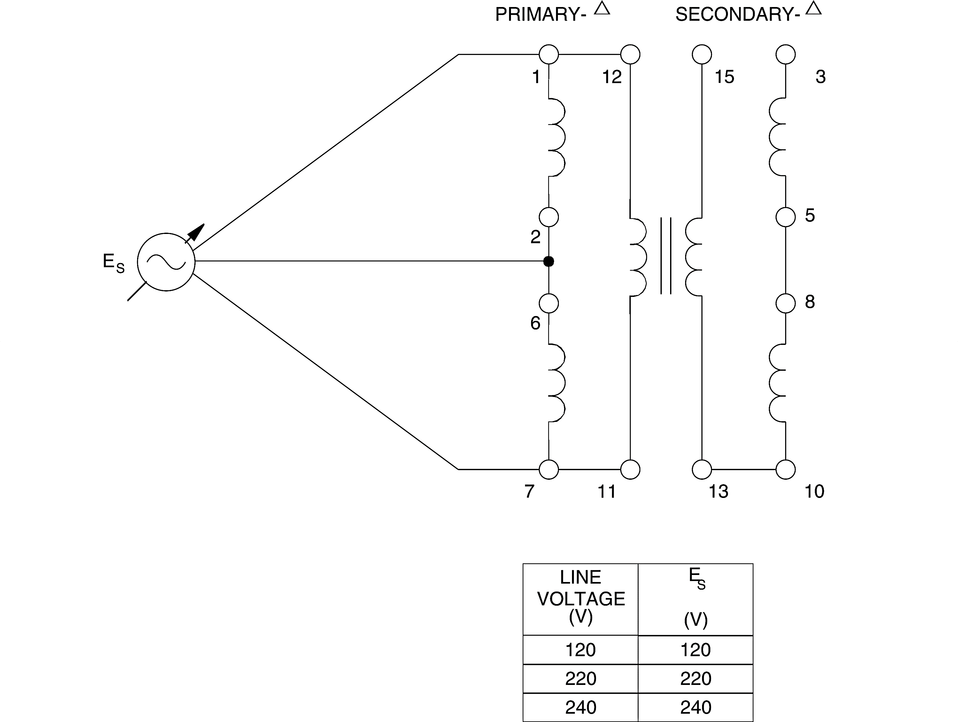

Figure . Connections Delta – Delta

1. Connect the Three-Phase Transformer module in the delta-delta configuration shown in Figure 4.1.1. Make sure before setting up connections that all the windings are connected in series aiding configuration i.e., opposite polarities are connected together.
2. Turn on the power and adjust the voltage control to obtain the line-to-line voltage ES given in Figure 4.1.1. Use meter input E1 to measure the winding voltages and record the results. After recording the measurements, rotate the voltage control fully CCW and then turn off the power.

|  |  |  |
| --- | --- | --- |
| E1-2 = 219.4 V | E1-7 = 219.5 V | E1-12 = 0 V |
| E3-5 = 218.9 V | **E3-10** = 218.9 V | **E3-15** = 0 V |

1. Do the measurements confirm that the secondary windings are connected with the proper phase relationships?

|  |  |  |  |
| --- | --- | --- | --- |
| ✓ | Yes |  | No |

1. Are the voltages within the secondary delta equal to zero, thus confirming that it is safe to close the delta?

|  |  |  |  |
| --- | --- | --- | --- |
| ✓ | Yes |  | No |

1. When the winding connections are confirmed to be correct, close the delta on the secondary side of the transformer. Connect meter inputs E1, E2, and E3 to measure the line voltages at the secondary. Turn on the power and adjust the voltage control to obtain the same value of ES used in step 6.
2. Is the sum of the three line voltages indicated by the meter E1 + E2 + E3 approximately equal to zero?

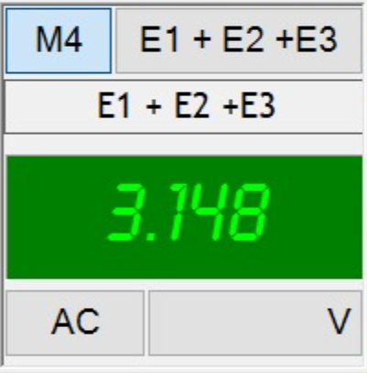

|  |  |  |  |
| --- | --- | --- | --- |
| ✓ | Yes |  | No |

1. Observe the voltage phasors on the *Phasor Analyzer*. Does the display confirm they are equal with a 120 phase shift between each of them?

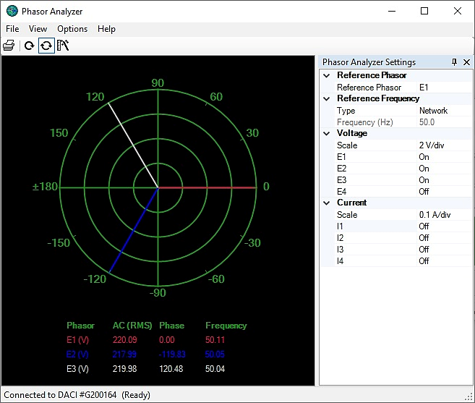

|  |  |  |  |
| --- | --- | --- | --- |
| ✓ | Yes |  | No |

1. Turn off the power. Connect meter input E2 to measure line voltage E1-2 on the primary side. Turn on the power and adjust the voltage control voltage to obtain the same value of ES used in step 6. Compare the voltage phasor of E1-2 on the primary side with that of E3-5 on the secondary side. Does the *Phasor Analyzer* display show that the voltages are equal and in phase, except for possibly a small difference due to transformer reactance?

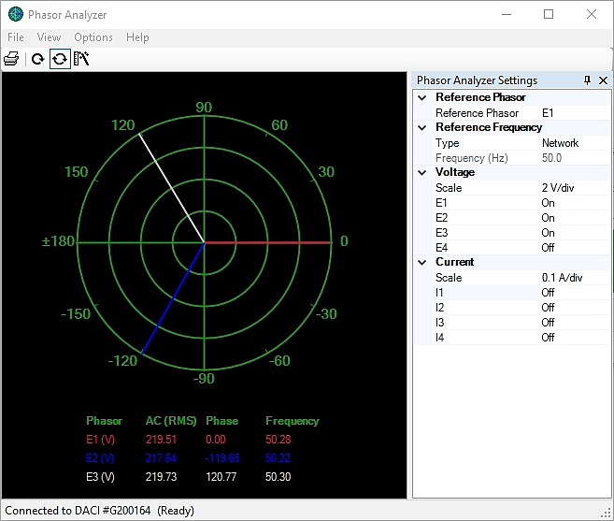

|  |  |  |  |
| --- | --- | --- | --- |
| ✓ | Yes |  | No |

1. Connect the Three-Phase Transformer module in the wye-wye configuration shown in Figure 6.6.

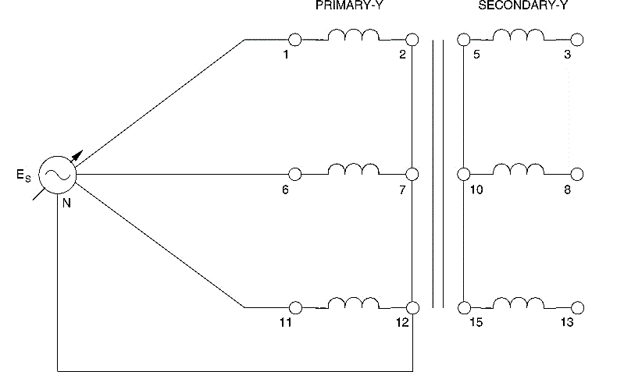

Figure . Connections Wye – Wye

1. Turn on the power and adjust the voltage control to obtain the value of ES used in previous step. Use meter input E1 to measure the winding voltages and record the results. After recording the measurements, rotate the voltage control fully CCW and then turn off the power.

|  |  |  |
| --- | --- | --- |
| E1-6 = 219.7 V | E1-11 = 219.7 V | E6-11 = 219.7 V |
| E1-2 = 126.5 V | **E6-7** = 126.4 V | **E11-12** = 126.5 V |
| E3-8 = 218.7 V | **E3-13** = 218.6 V | **E8-13** = 218.6 V |
| E3-5 = 126.4 V | **E8-10** = 126.4 V | **E13-15** = 126.5 V |

1. Do the measurements confirm that the secondary windings are connected with the proper phase relationships?

|  |  |  |  |
| --- | --- | --- | --- |
| ✓ | Yes |  | No |

1. Are the line-to-line voltages on the primary and secondary sides of the transformer times greater than the line-to-neutral values?

|  |  |  |  |
| --- | --- | --- | --- |
| ✓ | Yes |  | No |

1. Is the sum of the three phase voltages indicated by the meter E1 + E2 + E3 approximately equal to zero?

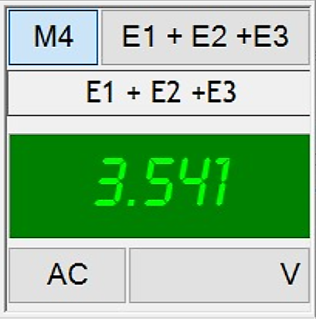

|  |  |  |  |
| --- | --- | --- | --- |
| ✓ | Yes |  | No |

1. Observe the voltage phasors on the *Phasor Analyzer*. Does the display confirm they are equal with a 120 phase shift between each of them?

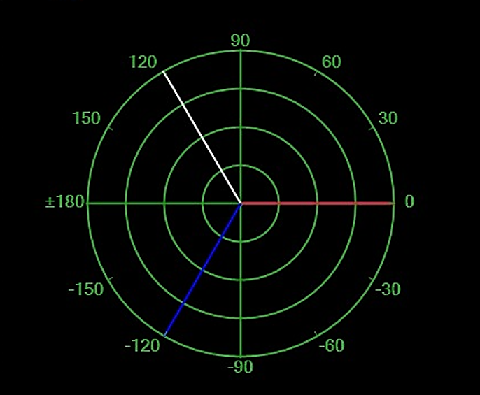

|  |  |  |  |
| --- | --- | --- | --- |
| ✓ | Yes |  | No |

1. Turn off the power without modifying the setting of the voltage control. Connect meter input E2 to measure phase voltage E1-2 on the primary side. Turn on the power and compare the voltage phasor of E1-2 on the primary side with that of E3-5 on the secondary side. Does the *Phasor Analyzer* display show that the voltages are equal and in phase, except for possibly a small difference due to transformer reactance?



|  |  |  |  |
| --- | --- | --- | --- |
| ✓ | Yes |  | No |

# Conclusion

In this lab, we familiarized ourselves with the three-phase transformer. We came to know of different configurations of three-phase transformers, namely, delta-delta, wye-wye, delta-wye and wye-delta. Two of which (delta-delta, wye-wye) we implemented in this part of the lab. We verified our known theoretical relationships between the line voltages and line currents, and we also verified the angles between the phasors.