**Department of Electrical Engineering**

**Faculty Member: ____________________ Dated: ________________**

**Semester: __________________________ Section: ________________**

**EE-260: Electrical Machines**

**Lab 6: Three Phase Transformer Connections and Operations (part a)**

|  |  |  |  |  |  |  |
| --- | --- | --- | --- | --- | --- | --- |
|  |  | **PLO4/**  **CLO5** | **PLO4/**  **CLO5** | **PLO5/ CLO6** | **PLO8/ CLO7** | **PLO9/ CLO8** |
| **Name** | **Reg. No** | **Viva / Quiz / Lab Performance** | **Analysis of data in Lab Report** | **Modern Tool Usage** | **Ethics and Safety** | **Individual and Team Work** |
|  |  | **5 Marks** | **5 Marks** | **5 Marks** | **5 Marks** | **5 Marks** |
|  |  |  |  |  |  |  |
|  |  |  |  |  |  |  |
|  |  |  |  |  |  |  |
|  |  |  |  |  |  |  |

**Lab 6: Three Phase Transformer Connections and Operations**

**Delta – Delta and Wye – Wye Connections**

## EXERCISE OBJECTIVE

When you have completed this exercise, you will be able to connect three-phase transformers in delta-delta and wye-wye configurations. You will measure winding voltages to verify that the secondary windings are connected with the proper phase relationships, and you will verify that the voltage within a delta equals zero before the delta is closed.

## DISCUSSION

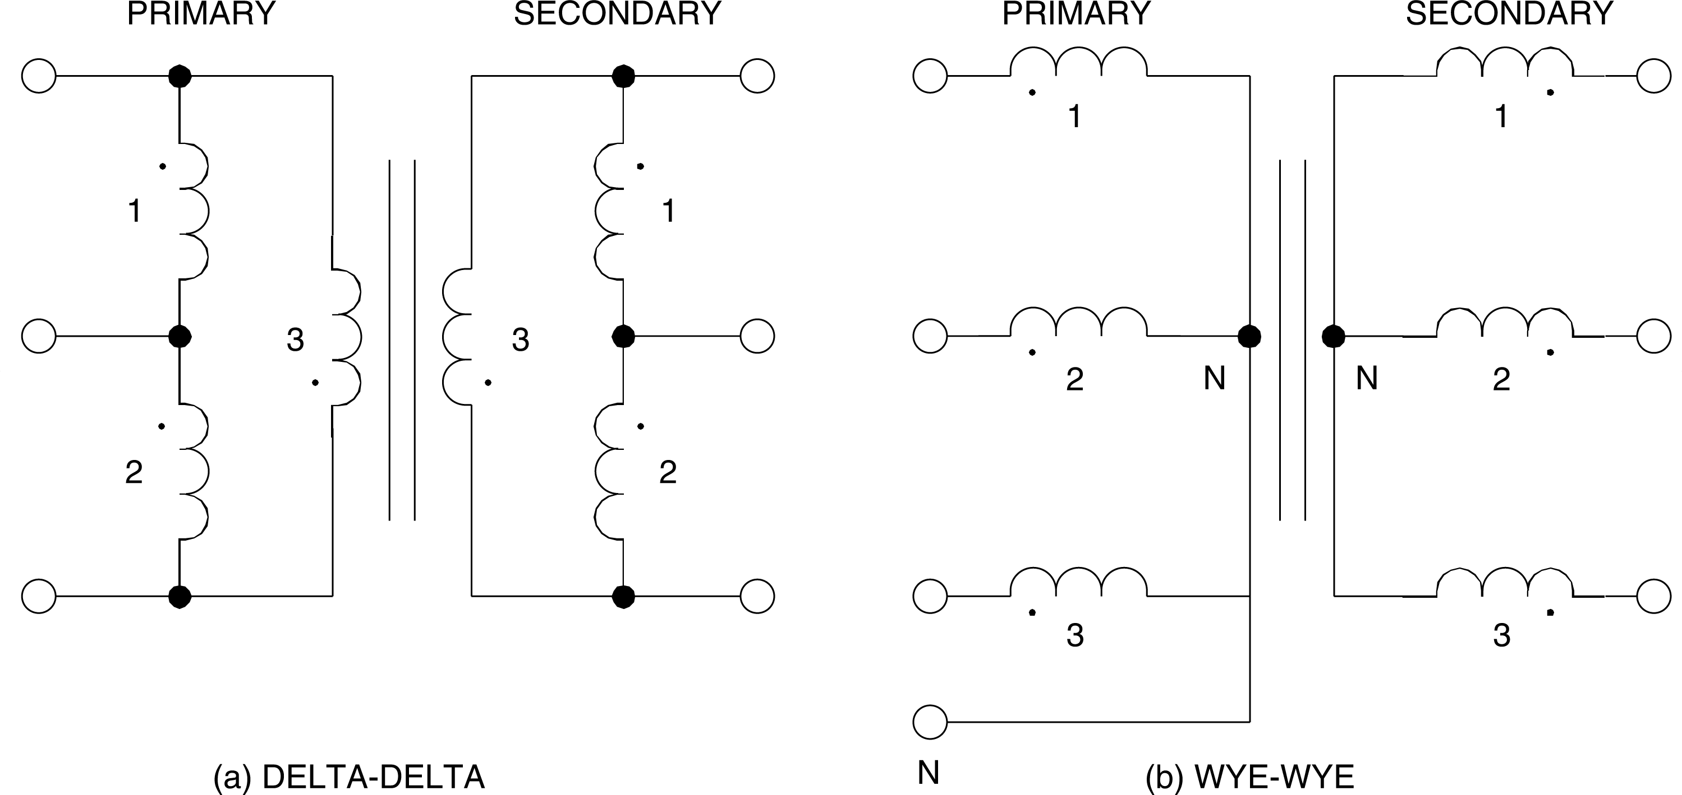There are four common ways of connecting transformer windings to form a three-phase transformer are: delta-delta, wye-wye, delta-wye, and wye-delta, as shown in Figures 6.1 and 6.2. In order to set up a wye connection, first connect the three components (windings) together at a common point for interconnection with the neutral wire, and then connect the other end of each component in turn to the three line wires. To set up a delta connection, connect the first component in series with the second, the second in series with the third, and the third in series with the first to close the delta loop. The three line wires are then separately connected to each of the junction nodes in the delta loop.

**Figure 6.1 Delta-Delta and Wye-Wye Connections**

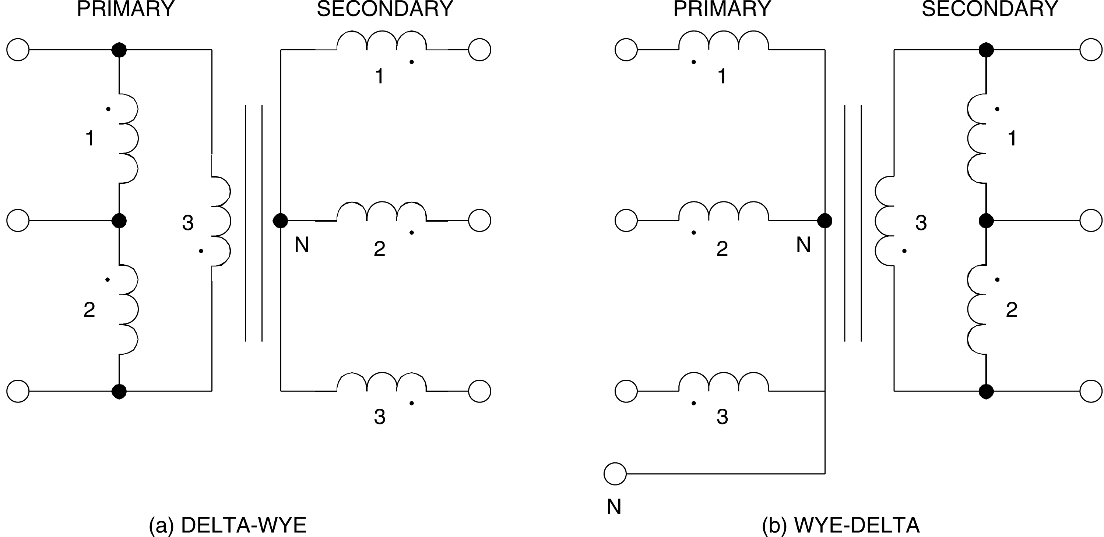

**Figure 6.2 Delta-Wye and Wye-Delta Connections**

Before a three-phase transformer is put into service, the phase relationships must be verified. For a wye configuration, the line voltages at the secondary windings must all be √3 times greater than the corresponding phase voltages. If not, winding connections must be reversed. To verify that phase relationships are correct for a wye configuration, the voltage between two windings (EAB) is measured as shown in Figure 6.3 (a) to confirm that it is √3 times greater than the line-to-neutral voltage across either winding (for example EAN). The voltages between the third winding and the others (EBC and ECA) are then measured to confirm that they are also √3 times greater than the phase voltage (EAN), as shown in Figure 6.3(b).

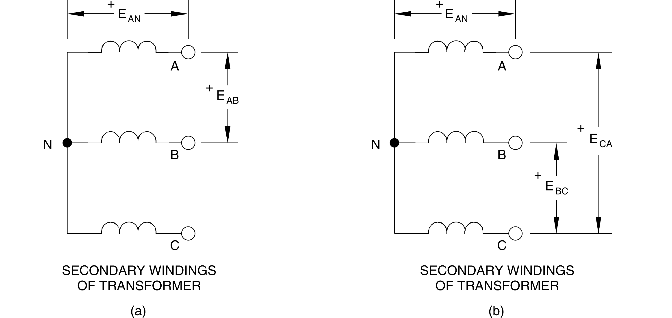 **Figure 6.3 Confirming Phase Relationships in a Wye-Connected Secondary**

For a delta configuration, the line voltages at the secondary windings must all be equal. If not, winding connections must be reversed. To verify that phase relationships are correct for a delta configuration, the voltage across two series- connected windings (ECA) is measured as shown in Figure 6.4 (a) to confirm that it equals the voltage across either winding (EAB and EBC). The third winding is then connected in series, and the voltage across the series combination of the three windings is measured to confirm that it is zero before the delta is closed, as shown in Figure 6.4 (b). This is extremely important for a delta configuration, because a very high short-circuit current will flow if the voltage within the delta is not equal to zero when it is closed.

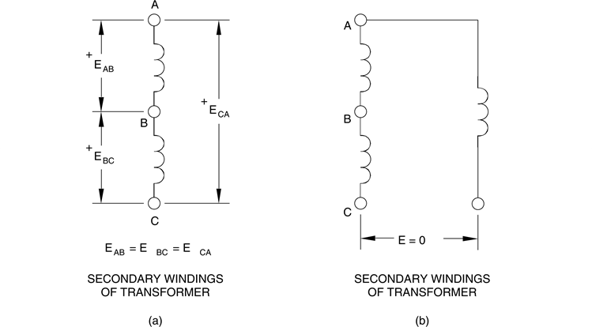

**Figure 6.4 Confirming that the Delta Voltage Equals Zero**

## EQUIPMENT REQUIRED

Refer to the Equipment Utilization Chart in Appendix C to obtain the list of equipment required for this exercise.

## PROCEDURE

**CAUTION!**

**High voltages are present in this laboratory exercise! Do not make or modify any banana jack connections with the power on unless otherwise specified!**

1. Install the Power Supply, data acquisition module, and Three-Phase Transformer module in the EMS Workstation.
2. Make sure that the main switch of the Power Supply is set to the O (OFF) position, and the voltage control knob is turned fully ccw. Set the voltmeter select switch to the 4-5 position, and then ensure the Power Supply is connected to a three-phase wall receptacle.
3. Ensure that the POWER INPUT of the data acquisition module is connected to the main Power Supply, and ensure the USB port cable from the computer is connected to the data acquisition module. Set the 24 V - AC power switch to the 1 (ON) position.
4. Display the *Metering* application.
5. Connect the Three-Phase Transformer module in the delta-delta configuration shown in Figure 6.5. Make sure before setting up connections that all the windings are connected in series aiding configuration i.e. opposite polarities are connected together.



**CAUTION!**

**Do not close the delta on the secondary side of the transformer until the voltages are verified.**

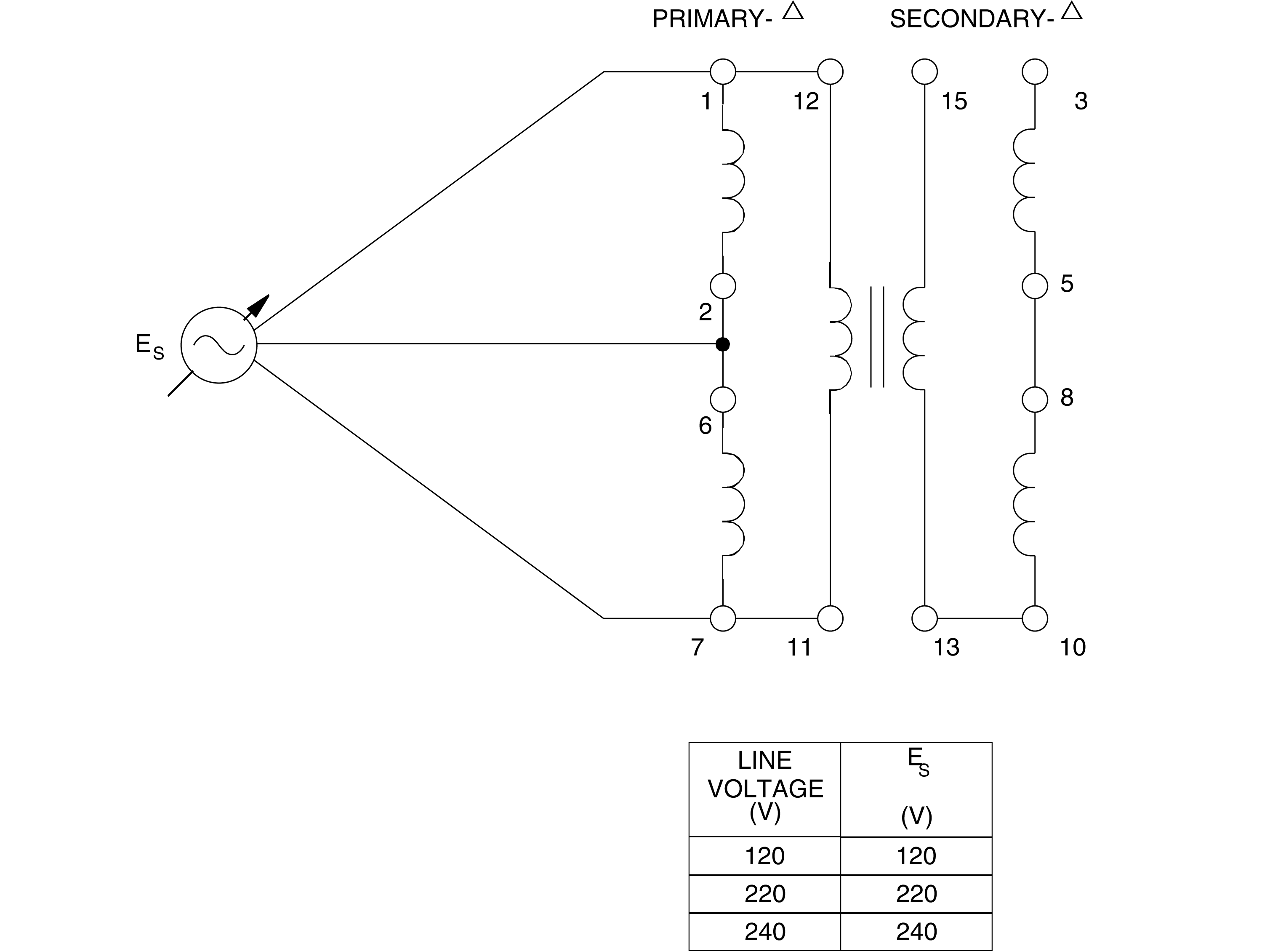

**Figure 6.5 Three-Phase Transformer Connected in Delta-Delta**

1. Turn on the power and adjust the voltage control to obtain the line-to-line voltage ES given in Figure 6.5. Use meter input E1 to measure the winding voltages and record the results. After recording the measurements, rotate the voltage control fully CCW and then turn off the power.

**Note:** *When measuring the various voltages, turn off the Power Supply before modifying the connections of the meter input E1 to the circuit.*

|  |  |  |
| --- | --- | --- |
| E1-2 = V | E1-7 = V | E1-12 = V |
| E3-5 = V | E3-10 = ___V | E3-15 = V |

1. Do the measurements confirm that the secondary windings are connected with the proper phase relationships?

G Yes G No

1. Are the voltages within the secondary delta equal to zero, thus confirming that it is safe to close the delta?

G Yes G No

**Note:** *The value of E3-15 will not be exactly zero volts because of small imbalances in the three-phase line voltages. If it is more than 5 V, the winding connections have to be checked carefully.*

1. When the winding connections are confirmed to be correct, close the delta on the secondary side of the transformer. Connect meter inputs E1, E2, and E3 to measure the line voltages at the secondary. Turn on the power and adjust the voltage control to obtain the same value of ES used in step 6. Note that the transformer is connected using the 1:1 ratio, so the primary and secondary voltages should be equal.
2. Is the sum of the three line voltages indicated by the meter E1 + E2 + E3 approximately equal to zero?

G Yes G No

1. Observe the voltage phasors on the *Phasor Analyzer*. Does the display confirm they are equal with a 120® phase shift between each of them?

G Yes G No

1. Turn off the power. Connect meter input E2 to measure line voltage E1-2 on the primary side. Turn on the power and adjust the voltage control voltage to obtain the same value of ES used in step 6. Compare the voltage phasor of E1-2 on the primary side with that of E3-5 on the secondary side. Does the *Phasor Analyzer* display show that the voltages are equal and in phase, except for possibly a small difference due to transformer reactance?

G Yes G No

1. Turn off the power and connect the Three-Phase Transformer module in the wye-wye configuration shown in Figure 6.6.

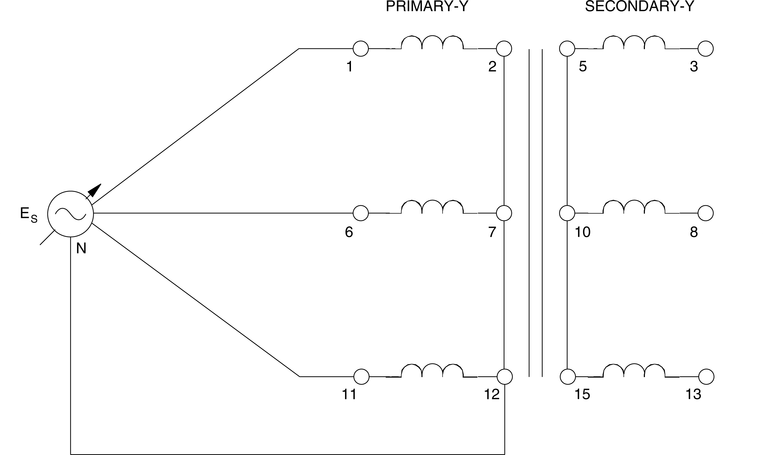

**Figure 6.6 Three-Phase Transformer Connected in Wye-Wye**

1. Turn on the power and adjust the voltage control to obtain the value of ES used in step 6. Use meter input E1 to measure the winding voltages and record the results. After recording the measurements, rotate the voltage control fully CCW and then turn off the power.

**Note:** *When measuring the various voltages, turn off the Power Supply before modifying the connections of meter input E1 to the circuit.*

|  |  |  |
| --- | --- | --- |
| E1-6 = V | E1-11 = V | E6-11 = V |
| E1-2 = V | E6-7 = _ V | E11-12 = V |
| E3-8 = V | E3-13 = V | E8-13 = ______V |
| E3-5 = V | E8-10 = V | E13-15 = V |

1. Do the measurements confirm that the secondary windings are connected with the proper phase relationships?

G Yes G No

1. Are the line-to-line voltages on the primary and secondary sides of the transformer √3 times greater than the line-to-neutral values?

G Yes G No

1. Connect meter inputs E1, E2, and E3 to measure phase voltages E3-5, E8-10, and E13-15 at the secondary. Turn on the power and adjust ES at about the same value as used previously.
2. Is the sum of the three phase voltages indicated by the meter E1 + E2 + E3 approximately equal to zero?

G Yes G No

1. Observe the voltage phasors on the *Phasor Analyzer*. Does the display confirm they are equal with a 120® phase shift between each of them?

G Yes G No

1. Turn off the power without modifying the setting of the voltage control. Connect meter input E2 to measure phase voltage E1-2 on the primary side. Turn on the power and compare the voltage phasor of E1-2 on the primary side with that of E3-5 on the secondary side. Does the *Phasor Analyzer* display show that the voltages are equal and in phase, except for possibly a small difference due to transformer reactance?

G Yes G No

1. Ensure that the Power Supply is turned off, the voltage control is fully CCW, and remove all leads and cables.

## CONCLUSION