**Department of Electrical Engineering and   
Computer Science**

**Faculty Member:** Ms. Neelma Naz  **Dated:** 28/10/2022

**Semester:** 5th **Section:** BEE 12C

**EE-260:** **Electrical Machines**

Lab 7: Three Phase Transformer Connections and Operations

(Part B)

Group Members

|  |  |  |  |  |  |  |  |
| --- | --- | --- | --- | --- | --- | --- | --- |
|  |  | | **PLO4/**  **CLO5** | **PLO4/**  **CLO5** | **PLO5/ CLO6** | **PLO8/ CLO7** | **PLO9/ CLO8** |
| **Name** | | **Reg. No** | **Viva / Quiz / Lab Performance** | **Analysis of data in Lab Report** | **Modern Tool Usage** | **Ethics and Safety** | **Individual and Teamwork** |
|  | |  | **5 Marks** | **5 Marks** | **5 Marks** | **5 Marks** | **5 Marks** |
| Danial Ahmad | | 331388 |  |  |  |  |  |
| Hassan Rizwan | | 335753 |  |  |  |  |  |
| Muhammad Umer | | 345834 |  |  |  |  |  |
| Syeda Fatima Zahra | | 334379 |  |  |  |  |  |

**Table of Contents**

3 Three Phase Transformer Connections 3

3.1 Objectives 3

3.2 Equipment 3

3.3 Introduction 3

3.4 Lab Instructions 3

4 Lab Tasks 4

4.1 Procedure 4

5 Conclusion 7

**Table of Figures**

Figure 4.1.1 Connections Wye – Delta 4

Figure 4.1.2 Connections Delta – Wye 6

# Three Phase Transformer Connections

## Objectives

When you have completed this exercise, you will be familiar with the voltage and current ratios of three-phase transformers connected in delta-wye and wye-delta configurations. Measurements of primary and secondary voltages will demonstrate that these configurations create a phase shift between the incoming and outgoing voltages.

## Equipment

Hardware

* LabVolt Proprietary Toolkit

Software

* *LVDAC*



## Introduction

A three-phase transformer is made of three sets of primary and secondary windings, each set wound around one leg of an iron core assembly. Essentially it looks like three single-phase transformers sharing a joined core. hose sets of primary and secondary windings will be connected in either Δ or Y configurations to form a complete unit. The various combinations of ways that these windings can be connected together it will be the focus of this and the following lab. Whether the winding sets share a common core assembly, or each winding pair is a separate transformer, the winding connection options are the same. We aim to verify the theoretical relationships between line voltages and line currents on the secondary and primary side of the three phase transformers by practically implementing them.

## Lab Instructions

All questions should be answered precisely to get maximum credit. Lab report must ensure following items:

* Lab objectives
* Results (Graphs/Tables) duly commented and discussed
* Conclusion

# Lab Tasks

## Procedure

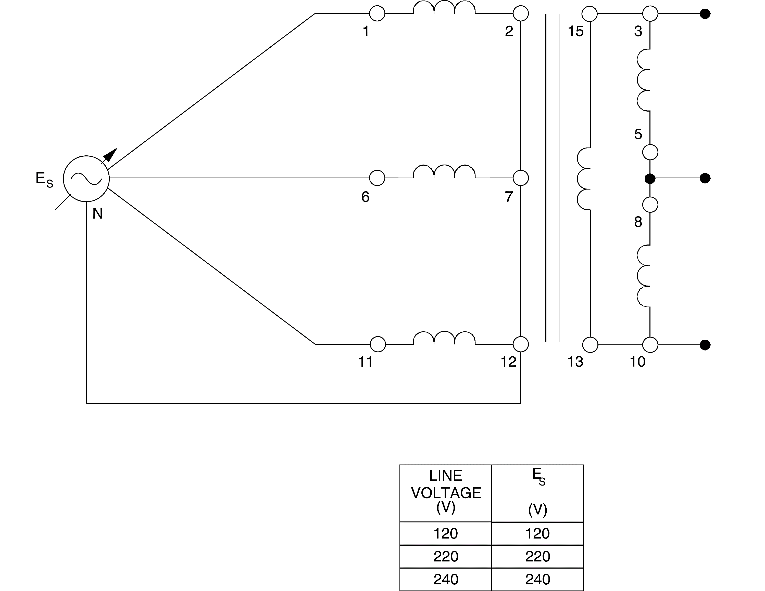

Figure . Connections Wye – Delta

1. Connect the transformer module in the delta-wye configuration shown in Figure 4.1.1.
2. Connect meter inputs E1, E2, and E3 to measure the line voltages at the primary and record the results. Record also the average value of the primary line voltage given by the meter.

|  |  |  |
| --- | --- | --- |
| E1-6 = 402.2 V | E1-11 = 397.5 V | E6-11 = 401.3 V |
| Average line voltage (primary) = 400.3 V | | |

1. Does the average primary line voltage indicate that the sum of the three primary line voltages is approximately zero?

|  |  |  |  |
| --- | --- | --- | --- |
| ✓ | Yes |  | No |

1. Observe the voltage phasors on the *Phasor Analyzer*. Are they approximately equal with a 120® phase shift between each of them?

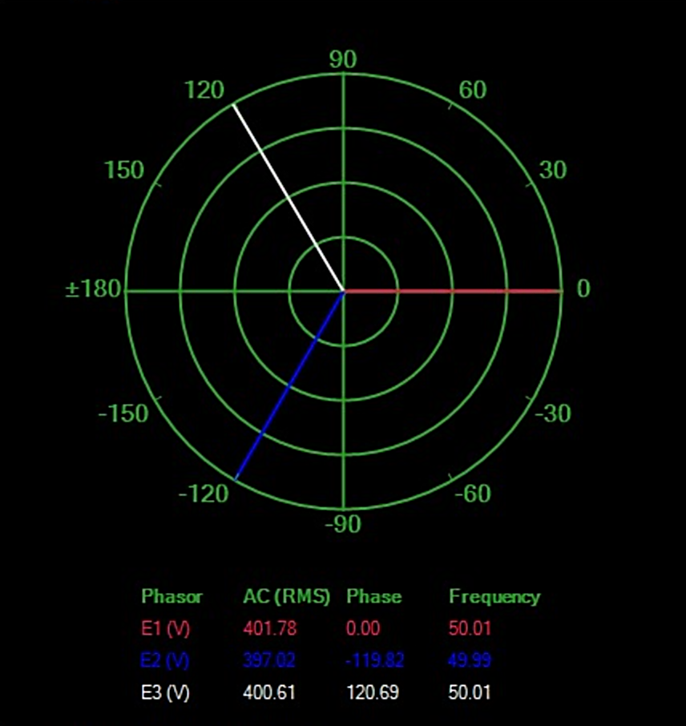

|  |  |  |  |
| --- | --- | --- | --- |
| ✓ | Yes |  | No |

1. Turn off the power without modifying the setting of the voltage control. Connect meter inputs E1, E2, and E3 to now measure the line voltages at the secondary. Turn on the power and record the line voltages as well as the average value of the secondary line voltage [meter Avg. (E1, E2, E3)].

|  |  |  |
| --- | --- | --- |
| E3-5 = 231.9 V | E8-10 = 230.0 V | E13-15 = 229.9 V |
| Average line voltage (secondary) = 230.6 | | |

1. Does the average secondary line voltage indicate that the sum of the three secondary line voltages is approximately zero?

|  |  |  |  |
| --- | --- | --- | --- |
| ✓ | Yes |  | No |

1. Observe the voltage phasors on the *Phasor Analyzer*. Does the display confirm they are equal with a 120® phase shift between each of them?

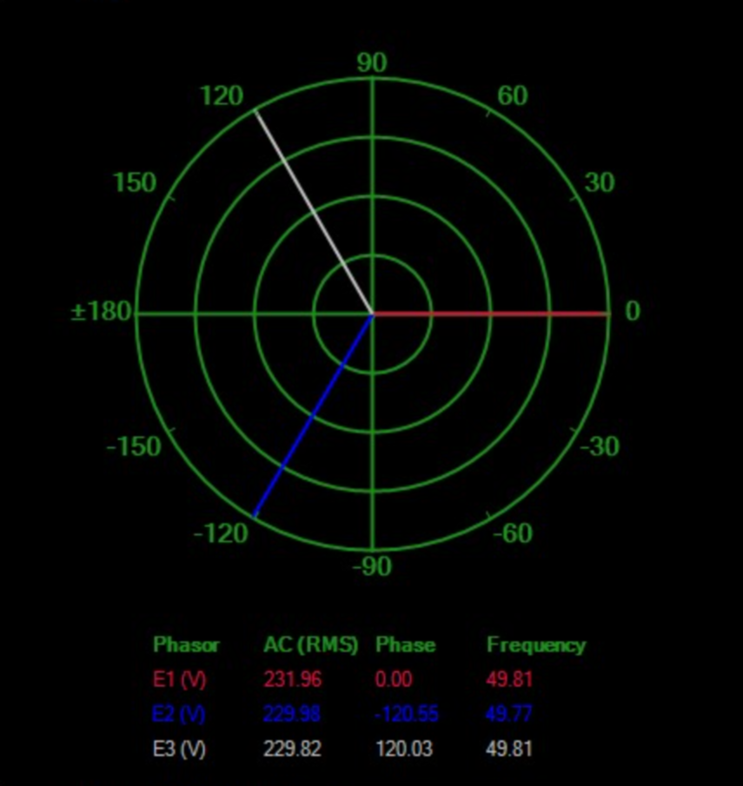

|  |  |  |  |
| --- | --- | --- | --- |
| ✓ | Yes |  | No |

1. Turn off the power without modifying the setting of the voltage control. Connect meter input E2 to measure line voltage E1-6 on the primary side. Turn on the power and compare the voltage phasor of E1-6 on the primary side with that of E3-5 on the secondary side. Does the *Phasor Analyzer* display confirm a phase shift of around 30E between the two?

|  |  |  |  |
| --- | --- | --- | --- |
| ✓ | Yes |  | No |

1. Calculate the ratio Average secondary line voltage / Average primary line voltage using the values recorded in steps 2 and 5. Is it approximately equal to 1/√3?

|  |  |  |  |
| --- | --- | --- | --- |
| ✓ | Yes |  | No |

1. Turn off the power and connect the Three-Phase Transformer module in the delta-wye configuration shown in Figure 4.1.2.

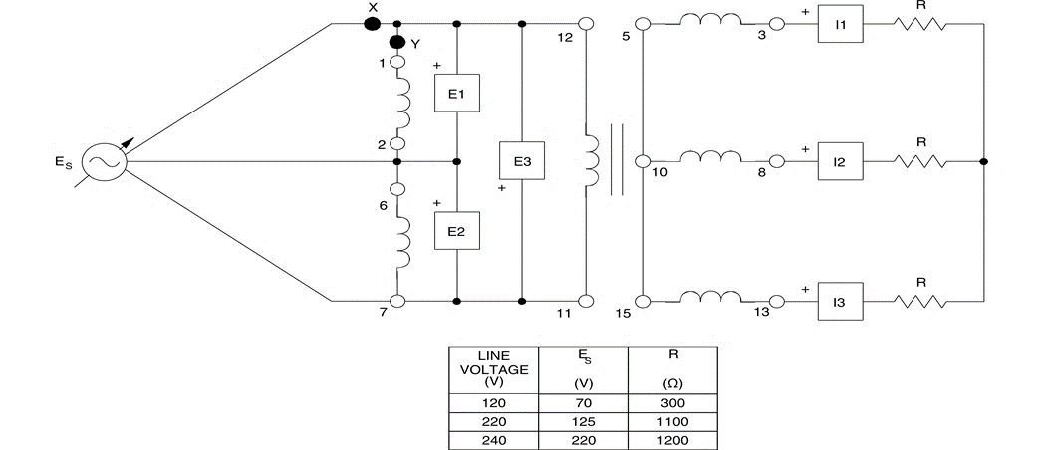

Figure . Connections Delta – Wye

1. Connect inputs E1, E2, and E3 to measure the line voltages at the primary, turn on the power, and adjust the voltage control to obtain the line-to-line voltage of ES given in Figure 7.3. Record the value of the line voltages, as well as the average value of the primary line voltage.

|  |  |  |
| --- | --- | --- |
| E1-2 = 220.6 V | E6-7 = 221.3 V | E11-12 = 220.9 V |
| Average line voltage (primary) = 220.9 V | | |

1. Also make changes to measure and record the values for the line voltages at the secondary.

|  |  |  |
| --- | --- | --- |
| E3-8 = 380.7 V | E8-13 = 380.4 V | E13-3 = 383.3 V |
| Average line voltage (secondary) = 381.4 V | | |

1. Calculate the ratio Average secondary line voltage / Average primary line voltage using the values recorded in steps 15 and 16. Is it approximately equal to √3?

|  |  |  |  |
| --- | --- | --- | --- |
| ✓ | Yes |  | No |

1. Turn off the power without modifying the setting of the voltage control. Connect meter input E1 to measure line voltage E1-2 on the primary side. Turn on the power and compare the voltage phasor of E1-2 on the primary side with that of E3-5 on the secondary side. Does the *Phasor Analyzer* display confirm a phase shift of around 30E between the two?

|  |  |  |  |
| --- | --- | --- | --- |
| ✓ | Yes |  | No |

# Conclusion

In this lab we intended to verify the theoretical relationships between primary and secondary current and voltages. Hence, we configured the transformer connections in delta-wye and wye-delta formation. Average line voltages on primary and secondary side were measured and the relationships that existed between them were confirmed i.e., the ratio of primary to secondary line voltage, the sum of line voltages of primary, the phase difference between the line voltages etc. Relations of delta-wye and wye-delta were analyzed. All the relationships were understood practically after their confirmation.