**Department of Electrical Engineering**

**Faculty Member: ____________________ Dated: ________________**

**Semester: __________________________ Section: ________________**

**EE-260: Electrical Machines**

**Lab 7: Three Phase Transformer Connections and Operations (part b)**

|  |  | **PLO4/**  **CLO5** | **PLO4/**  **CLO5** | **PLO5/**  **CLO6** | **PLO8/**  **CLO7** | **PLO9/**  **CLO8** |
| --- | --- | --- | --- | --- | --- | --- |
| **Name** | **Reg. No** | **Viva / Quiz / Lab Performance** | **Analysis of data in Lab Report** | **Modern Tool Usage** | **Ethics and Safety** | **Individual and Team Work** |
|  |  | **5 Marks** | **5 Marks** | **5 Marks** | **5 Marks** | **5 Marks** |
|  |  |  |  |  |  |  |
|  |  |  |  |  |  |  |
|  |  |  |  |  |  |  |
|  |  |  |  |  |  |  |

**Lab 7: Three Phase Transformer Connections and Operations (part b)**

**Wye – Delta and Delta – Wye Connections**

**EXERCISE OBJECTIVE**

When you have completed this exercise, you will be familiar with the voltage and current ratios of three-phase transformers connected in delta-wye and wye-delta configurations. Measurements of primary and secondary voltages will demonstrate that these configurations create a phase shift between the incoming and outgoing voltages.

**DISCUSSION**

As seen in the previous exercise, primary and secondary voltages in delta-delta and wye-wye connections are in phase and the voltage at the secondary is equal to the voltage at the primary times the inverse of the turns ratio. In delta-wye and wye-delta connections however, there will be a 30® phase difference between the primary and secondary voltages. Also, in the delta-wye configuration, the line voltage at the secondary is equal to the line voltage at the primary times the inverse of the turn ratio times √3. On the other hand, in the wye-delta configuration, the line voltage at the secondary is equal to the line voltage at the primary times the inverse of the turn ratio times 1/√3.

The 30® phase shift between the primary and secondary does not create any problems for isolated groups of loads connected to the outgoing lines from the secondary. However, if the outgoing lines from the secondary of a three-phase transformer have to be connected in parallel with another source, the phase shift might make such a parallel connection impossible, even if the line voltages are the same. Recall that in order for three-phase circuits and sources to be connected in parallel, line voltages must be equal, have the same phase sequence, and be in phase when the parallel connection is made.

Figure 7.1 shows a three-phase transformer, with a turn’s ratio equal to 1:1, connected in the delta-wye configuration and feeding a three-phase load. The voltage across each primary winding EPRI equals the incoming line voltage, but the outgoing line voltage Esec is √3 times that voltage because the voltage across any two secondary windings is √3 times greater than the voltage across a single secondary winding. Note that if the three-phase transformer had a turns ratio of 1:10, the line voltage at the secondary would be 10 x √3 times greater the line voltage at the primary, because the inverse of the turns ratio is multiplied by the √3 factor. The line current in the secondary is the same as the phase current, but the line current in the primary is √3 times greater than the corresponding phase current.

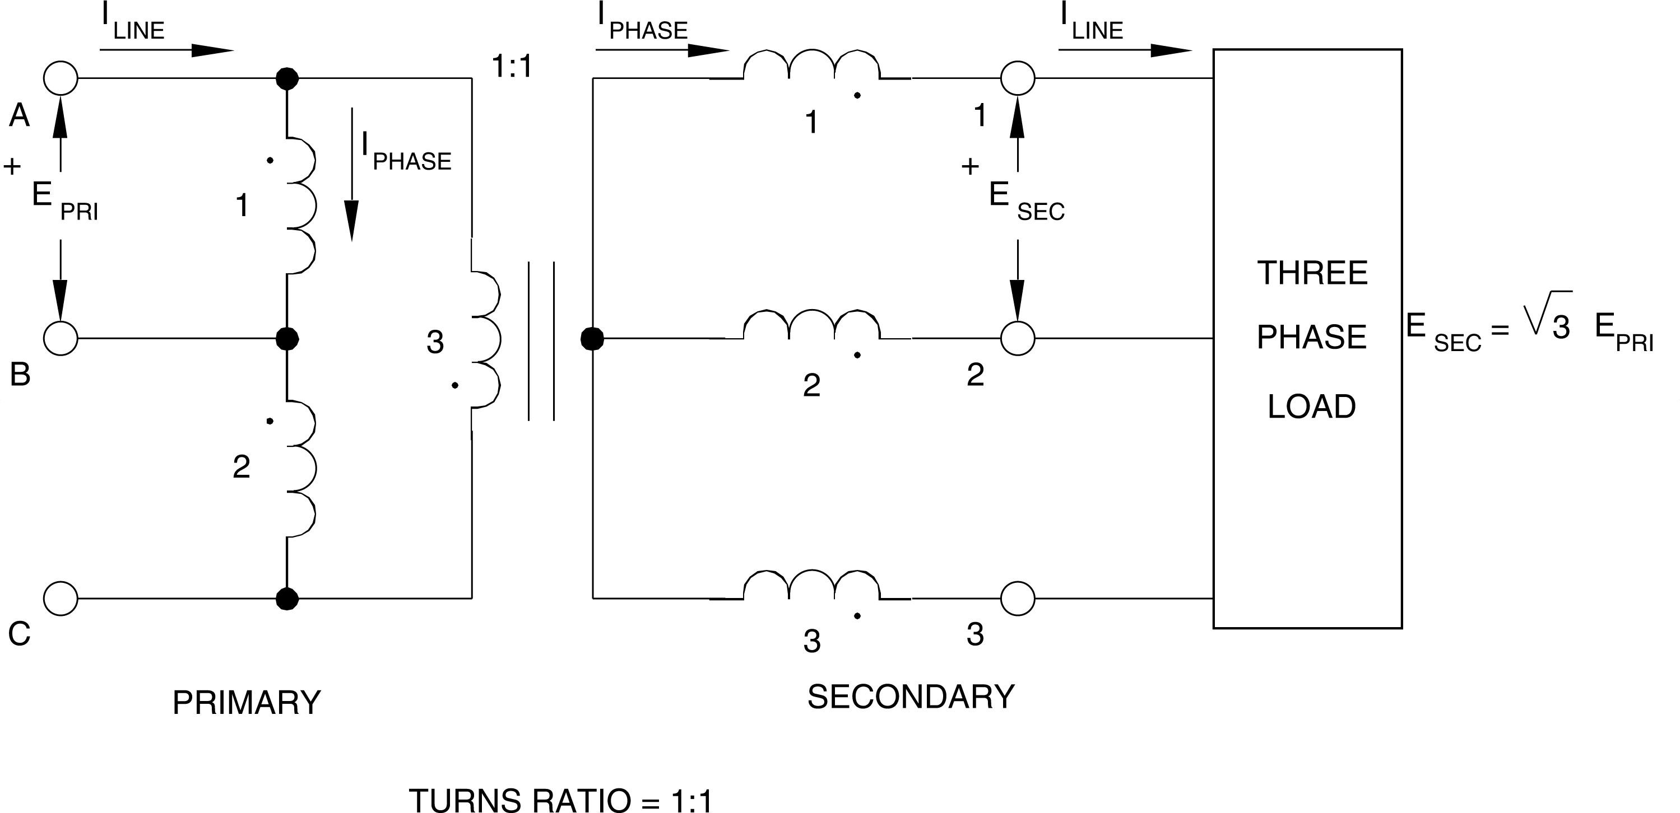

**Figure 7.1 Three-Phase Delta-Wye Configurations**

**EQUIPMENT REQUIRED**

Refer to the Equipment Utilization Chart in Appendix C to obtain the list of equipment required for this exercise.

**PROCEDURE**

**CAUTION!**

**High voltages are present in this laboratory exercise! Do not make or modify any banana jack connections with the power on unless otherwise specified!**

1. Install the Power Supply, data acquisition module, Resistive Load, and Three-Phase Transformer modules in the EMS Workstation.
2. Make sure that the main switch of the Power Supply is set to the O (OFF) position, and the voltage control knob is turned fully ccw. Set the voltmeter select switch to the 4-5 position, and then ensure the Power Supply is connected to a three-phase wall receptacle.
3. Ensure that the POWER INPUT of the data acquisition module is connected to the main Power Supply, and ensure the USB port cable from the computer is connected to the data acquisition module. Set the 24 V - AC power switch to the 1 (ON) position.
4. Display the *Metering* application.
5. Connect the Three-Phase Transformer module in the wye-delta configuration shown in Figure 7.2. Make sure that the voltage within the delta is zero before closing the delta.

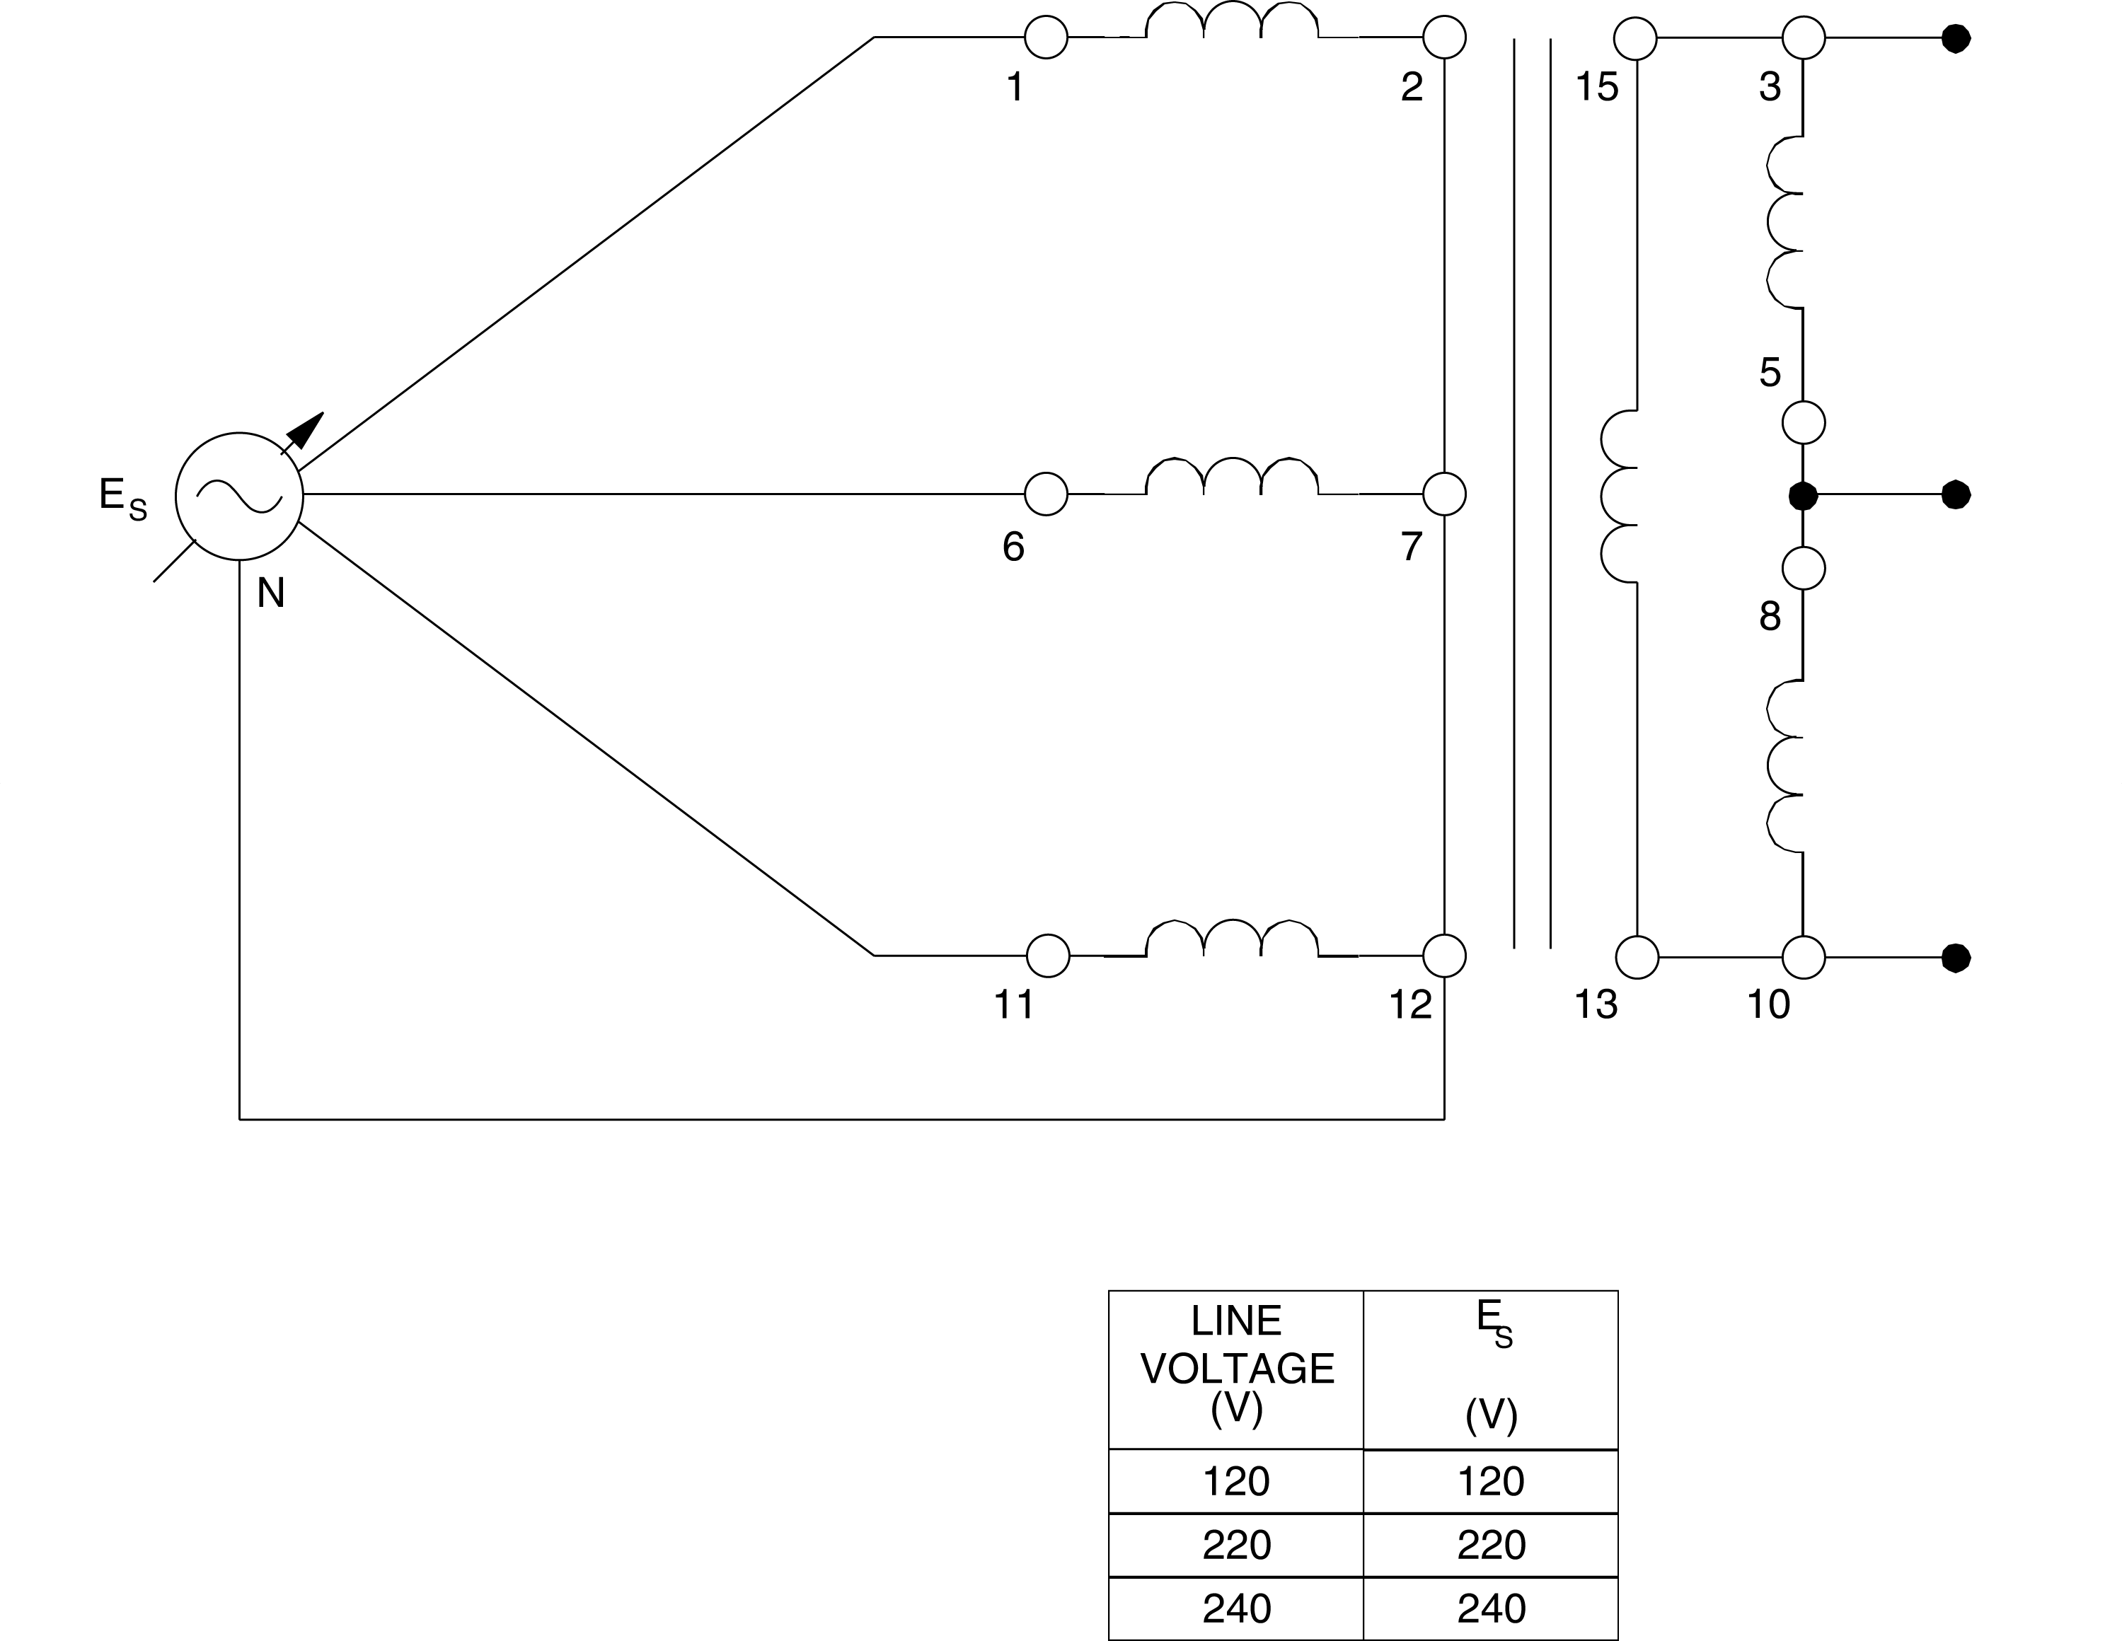

**Figure 7.2 Three-Phase Transformer Connected in Wye-Delta**

1. Turn on the power and adjust the voltage control to obtain the line-to-line voltage ES equal to 381 volts. Connect meter inputs E1, E2, and E3 to measure the line voltages at the primary and record the results. Record also the average value of the primary line voltage given by the meter Avg. (E1, E2, E3).

E1-6 = V E11-1 = V E6-11 = V

Average line voltage (primary) = V

***Hint: Sum the voltages via E4 = E1 + E2 + E3 and then divide by 3.***

1. Does the average primary line voltage indicate that the sum of the three primary line voltages is approximately zero?

G Yes G No

1. Observe the voltage phasors on the *Phasor Analyzer*. Are they approximately equal with a 120® phase shift between each of them?

G Yes G No

1. Turn off the power without modifying the setting of the voltage control. Connect meter inputs E1, E2, and E3 to now measure the line voltages at the secondary. Turn on the power and record the line voltages as well as the average value of the secondary line voltage [meter Avg. (E1, E2, E3)].

E3-5 = ______V E8-10 = V E13-15 = _____V

Average line voltage (secondary) = _______V

***Hint: Sum the voltages via E4 = E1 + E2 + E3 and then divide by 3.***

1. Does the average secondary line voltage indicate that the sum of the three secondary line voltages is approximately zero?

G Yes G No

1. Observe the voltage phasors on the *Phasor Analyzer*. Does the display confirm they are equal with a 120® phase shift between each of them?

G Yes G No

1. Turn off the power without modifying the setting of the voltage control. Connect meter input E2 to measure line voltage E1-6 on the primary side. Turn on the power and compare the voltage phasor of E1-6 on the primary side with that of E3-5 on the secondary side. Does the *Phasor Analyzer* display confirm a phase shift of around 30E between the two?

G Yes G No

1. Calculate the ratio Average secondary line voltage / Average primary line voltage using the values recorded in steps 6 and 9. Is it approximately equal to 1/√3?

G Yes G No

1. Turn off the power and connect the Three-Phase Transformer module in the delta-wye configuration shown in Figure 7.3.
2. Connect inputs E1, E2, and E3 to measure the line voltages at the primary, turn on the power, and adjust the voltage control to obtain the line-to-line voltage of ES given in Figure 7.3. Record the value of the line voltages, as well as the average value of the primary line voltage.

E1-2 = V E6-7 = V E11-12 = V

Average line voltage (primary) = V

***Hint: Sum the voltages via E4 = E1 + E2 + E3 and then divide by 3.***

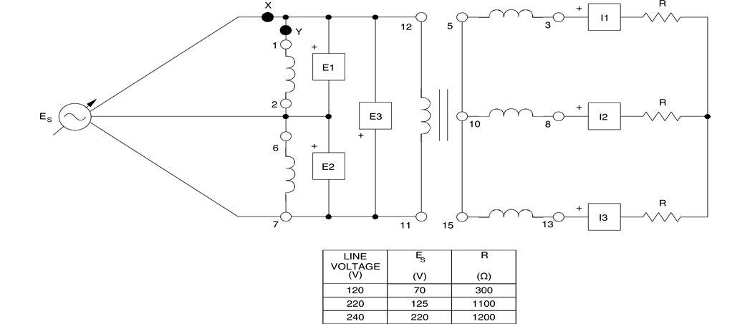

**Figure 7.3 Three-Phase Transformer Connected in Delta-Wye**

1. Also make changes to measure and record the values for the line voltages at the secondary,

***Note: Connect Voltmeter E4 at terminals 1 and 2 of Three -Phase Transformer Bank Module and set input voltages strictly equal to 220 volts shown by E4***

E3-8 = V E8-13 = V E13-3 = V

Also find the average value of the secondary line voltage

Average line voltage (secondary) = V

***Hint: Sum the voltages via E4 = E1 + E2 + E3 and then divide by 3***

1. Calculate the ratio Average secondary line voltage / Average primary line voltage using the values recorded in steps 15 and 16. Is it approximately equal to √3?

G Yes G No

1. Turn off the power without modifying the setting of the voltage control. Connect meter input E1 to measure line voltage E1-2 on the primary side. Turn on the power and compare the voltage phasor of E1-2 on the primary side with that of E3-5 on the secondary side. Does the *Phasor Analyzer* display confirm a phase shift of around 30E between the two?

G Yes G No

1. Ensure that the Power Supply is turned off, the voltage control is fully CCW, and remove all leads and cables.

**CONCLUSION**