**Department of Electrical Engineering and   
Computer Science**

**Faculty Member:** Ms. Neelma Naz  **Dated:** 11/11/2022

**Semester:** 5th **Section:** BEE 12C

**EE-260:** **Electrical Machines**

Lab 8: Three Phase Alternator Characteristics

Group Members

|  |  |  |  |  |  |  |  |
| --- | --- | --- | --- | --- | --- | --- | --- |
|  |  | | **PLO4/**  **CLO5** | **PLO4/**  **CLO5** | **PLO5/ CLO6** | **PLO8/ CLO7** | **PLO9/ CLO8** |
| **Name** | | **Reg. No** | **Viva / Quiz / Lab Performance** | **Analysis of data in Lab Report** | **Modern Tool Usage** | **Ethics and Safety** | **Individual and Teamwork** |
|  | |  | **5 Marks** | **5 Marks** | **5 Marks** | **5 Marks** | **5 Marks** |
| Danial Ahmad | | 331388 |  |  |  |  |  |
| Hassan Rizwan | | 335753 |  |  |  |  |  |
| Muhammad Umer | | 345834 |  |  |  |  |  |
| Syeda Fatima Zahra | | 334379 |  |  |  |  |  |

**Table of Contents**

3 Three Phase Alternator Characteristics 3

3.1 Objectives 3

3.2 Equipment 3

3.3 Introduction 3

3.4 Lab Instructions 3

4 Lab Tasks 4

4.1 Procedure 4

4.1.1 No Load Characteristics 4

4.1.2 Short Circuit Characteristics 5

4.1.3 Load Test Characteristics 6

4.1.4 Unbalanced Load 9

4.1.5 Analysis 10

5 Conclusion 10

**Table of Figures**

# Three Phase Alternator Characteristics

## Objectives

* To obtain no load saturation curve of the alternator
* To obtain the short-circuit characteristics of the alternator
* To determine the voltage regulation characteristics of the alternator with resistive, capacitive and inductive loading
* To observe the effect of unbalanced loads on the output voltage

## Equipment

Hardware

* LabVolt Proprietary Toolkit

Software

* *LVDAC*



## Introduction

A three-phase alternator consists of three coil windings, unlike a single-phase alternator, which has one winding. An alternator aims to produce AC (alternating current) stator output with two basic winding designs: delta wound and wye style. It has three single-phase windings spaced such that the voltage induced in any one phase is displaced by 120º from the other two. Determining voltage regulation of an alternator is essential as it explains how well the alternator is performing. In this lab we will test the no load characteristics and also the short circuit characteristics of the alternator, and we will see the relation of voltage and current in each case.

## Lab Instructions

All questions should be answered precisely to get maximum credit. Lab report must ensure following items:

* Lab objectives
* Results (Graphs/Tables) duly commented and discussed
* Conclusion

# Lab Tasks

## No Load Characteristics

1. Using your Synchronous Motor/Generator, four pole Squirrel Cage induction motor, power supply, DC Voltmeter/Ammeter, AC Ammeter and AC Voltmeter, connect the circuit as following.

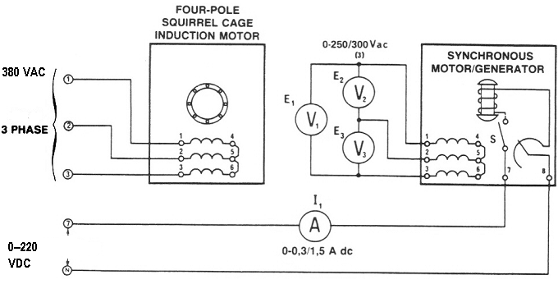

1. With zero DC excitation (switch S open), measure and record E1 and E3 (use the lowest ranges of the voltmeters)

|  |  |  |
| --- | --- | --- |
| E1 = 7.814 V | E2 = 7.732 V | E3 = 7.612 V |

*Explain why there is an AC voltage generated in the absence of DC excitation.*

**Answer:** This occurs due to residual magnetization in the machine's rotor. There is sufficient magnetism present even in the absence of DC excitation to produce voltage at the alternator's output terminals.

1. Turn on the rotor excitation toggle switch of the Synchronous Motor/Generator (down position). Gradually increase the DC excitation from zero to 0.05 A DC using the power supply voltage control.

|  |  |  |  |  |
| --- | --- | --- | --- | --- |
| I1  A | E1  V | E2  V | E3  V | Eave |
| 0 | 7.814 | 7.732 | 7.612 | 7.719 |
| 0.05 | 8.534 | 8.446 | 8.322 | 8.434 |
| 0.1 | 92.13 | 91.14 | 89.71 | 90.99 |
| 0.15 | 170.1 | 168.7 | 166.8 | 168.53 |
| 0.2 | 237.3 | 235.8 | 234 | 235.70 |
| 0.25 | 292.7 | 290.8 | 289.3 | 290.93 |
| 0.3 | 335 | 332.9 | 331.8 | 333.23 |
| 0.35 | 368.9 | 366.7 | 365.8 | 367.13 |

1. Plot your recorded average voltage values (y-axis) vs DC current (x-axis) values from the table.



## Short Circuit Characteristics

1. Use your synchronizing module to connect the circuit shown as follows. Note that the switch is wired to present a dead short across the alternator windings when it is closed.

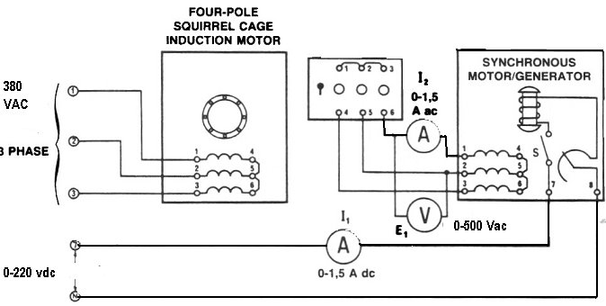

1. Set the power supply voltage control at its full CCW position (for zero DC voltage). Turn on the power supply. The motor should be running. Close the rotor excitation switch of the Synchronous Motor/Generator. Apply short circuit to your alternator by closing the synchronizing switch
2. Gradually increase the DC excitation from zero to 0.2 A DC using the power supply voltage control. Measure and record I2 in the following table.

|  |  |
| --- | --- |
| I1  A (DC) | I2  A (AC) |
| 0 | 0.015 |
| 0.05 | 0.114 |
| 0.1 | 0.22 |
| 0.15 | 0.327 |
| 0.2 | 0.427 |

1. Plot the field DC current I1 (x-axis) vs the armature current I2 (y-axis).



## Load Test Characteristics

1. Connect the equipment as shown in the following figure.

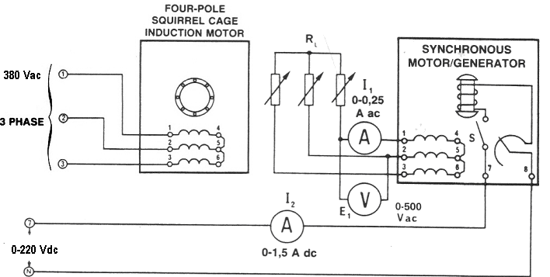

1. Set the power supply voltage control at its full CCW position (for zero DC voltage). Connect the three phase resistive load to the synchronous generator output. Turn on the power supply. The motor should be running. Adjust the DC excitation of the alternator until the output voltage E1 = 380 V AC at no load case.
2. Adjust the **resistive load** to the values shown in table then measure and record the terminal voltage VT and the armature current I1.

|  |  |  |  |
| --- | --- | --- | --- |
| R  Ω | VT  V (AC) | I1  A (AC) | VR |
| ∞ | **380** | 0.007 | 0 % |
| 4400 | 362.5 | 0.056 | 4.82 % |
| 2200 | 353.1 | 0.107 | 7.61 % |
| 1467 | 342.7 | 0.155 | 10.88 % |
| 1100 | 331.8 | 0.202 | 14.52 % |
| 733 | 309.2 | 0.28 | 22.89 % |
| 629 | 298.2 | 0.315 | 27.43 % |



1. Repeat step 3 for three phase inductive load.

|  |  |  |  |
| --- | --- | --- | --- |
| XL  Ω | VT  V (AC) | I1  A (AC) | VR |
| ∞ | 380 | 0.05 | 0 % |
| 4400 | 359.32 | 0.09 | 5.75 % |
| 2200 | 339.27 | 0.12 | 12.00 % |
| 1467 | 319.77 | 0.16 | 18.83 % |
| 1100 | 302.59 | 0.19 | 25.58 % |
| 733 | 286.7 | 0.21 | 32.54 % |
| 629 | 272.05 | 0.24 | 39.68 % |



1. With an inductive load, does the stator MMF aid or oppose the rotor MMF?

|  |  |
| --- | --- |
| Aid | Oppose ✓ |

1. Repeat step 3 for three phase capacitive load but adjust the DC excitation of the alternator until the output voltage **E1 = 255 V AC** at no load case.

|  |  |  |  |
| --- | --- | --- | --- |
| XL  Ω | VT  V (AC) | I1  A (AC) | VR |
| ∞ | **255** | 0.007 | 0 % |
| 4400 | 276.4 | 0.045 | -7.74 % |
| 2200 | 301.5 | 0.093 | -15.42 % |
| 1467 | 332.7 | 0.154 | -23.35 % |
| 1100 | 360.4 | 0.216 | -29.24 % |
| 733 | 421.2 | 0.378 | -39.45 % |
| 629 | 448.9 | 0.471 | -43.19 % |



1. With capacitive load, does the stator MMF aid or oppose the rotor MMF?

|  |  |
| --- | --- |
| Aid ✓ | Oppose |

## Unbalanced Load

1. Connect the circuit shown in the following figure. Note that only one of the alternator phases has a load.

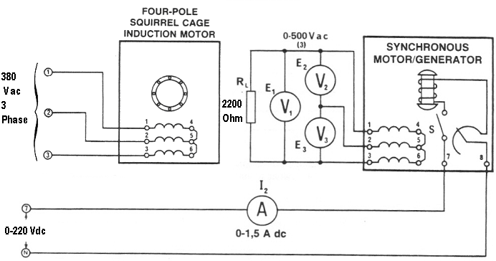

1. Adjust the DC excitation of the alternator until the voltage E, across the 2200 Ω load is 380 V AC. Measure and record the two other phase vol­tages E2 and E3.

|  |  |
| --- | --- |
| E2 = 371.1 V | E3 = 388.9 V |

1. Reconnect the three AC voltmeters so they will measure the voltages across each of the three stator windings. Measure and record the voltages across each of the alternator windings.

|  |  |  |
| --- | --- | --- |
| E1-4 = 211.7 V | E2-5 = 224.0 V | E3-6 = 221.3 V |

1. Did the single-phase load produce a large unbalance?

|  |  |
| --- | --- |
| Yes ✓ | No |

## Analysis

1. Explain why the alternator output voltage increases with capacitance loading.

**Answer:** Reactive power is introduced into the circuit if the load is capacitive, and as reactive power and voltage are directly proportional, an increase in reactive power will result in a rise in voltage at the load end of the circuit.

1. Could it be dangerous to connect an alternator to a long transmission line, if the line had a high capacitance? Explain.

|  |  |
| --- | --- |
| Yes ✓ | No |

**Answer:** Capacitive load aids the MMF of the stator, and hence, with long transmission lines having high capacitance, even if the line is isolated there is the possibility of lethal residual voltages still being present in the lines, making it dangerous to connect an alternator to long transmission lines.

1. The rotor of an alternator, at rated power, dissipates more heat at a low power factor (lagging) load than at a high power factor load, explain.

**Answer:** The reactive power increases with a decrease in power factor; the circuit draws more current to match the reactive energy requirements in order to maintain a stable apparent power, and thus the total current in the circuit increases. This directly affects the copper losses ($I^{2}R$) in the rotor of the alternation, and hence, dissipates more heat.

# Conclusion

In this lab we were introduced to the four pole Squirrel Cage induction motor, and we observed the relation between voltage and current under no load, short circuit, and unbalanced load conditions. We learned more about the voltage regulation characteristics of different types of loads including resistive, capacitive, and inductive. Using LabVolt toolkit and LDVAC we plotted graphs of saturation curves by inputting values at different voltages and drawing a graph of voltage vs current. We answered a couple of questions towards the end of the lab to further solidify our knowledge on the relationship between types of loads and voltage regulation.