# Department of Electrical Engineering

|  |  |
| --- | --- |
| **Faculty Member:____________________** | **Dated: ________________** |
| **Semester:__________________________** | **Section: ________________** |

**EE 260: Electro Mechanical System**

**Lab08: Three Phase Alternator Characteristics**

|  |  |  |  |  |  |  |
| --- | --- | --- | --- | --- | --- | --- |
| **Name** | **Reg. No** | **Viva /Quiz Marks / 5** | **Analysis of Data**  **5** | **Modern Tool usage/5** | **Ethic $ safety** | **Individual and team work/5** |
|  |  |  |  |  |  |  |
|  |  |  |  |  |  |  |
|  |  |  |  |  |  |  |
|  |  |  |  |  |  |  |

**Lab08: Three Phase Alternator Characteristics / P4**

**Objectives:**

**Conduct an experiment:**

* To obtain no load saturation curve of the alternator.
* To obtain the short- circuit characteristics of the alternator.
* To determine the voltage regulation characteristics of the alternator with resistive, capacitive and inductive loading.
* To observe the effect of unbalanced loads on the output voltage.

**Equipment:**

|  |  |  |  |
| --- | --- | --- | --- |
| **S No.** | **Description** | **Module No.** | **Quantity** |
| 1 | Three phase power supply | EMS 8821 | 1 |
| 2 | Synchronous Motor/Generator | EMS 8241 | 1 |
| 3 | Four – pole Squirrel Cage Induction Motor | EMS 8221 | 1 |
| 4 | Synchronizing Module | EMS 8621 | 1 |
| 5 | DC Voltmeter/ Ammeter | EMS 8412 | 1 |
| 6 | Voltmeter | EMS 8426 | 1 |
| 7 | Ammeter | EMS 8425 | 1 |
| 8 | Timing Belt | EMS 8942 | 1 |
| 9 | Connecting Leads Set | EMS 8941 | 1 |
| 10 | Variable Resistance | EMS 8311 | 1 |
| 11 | Variable Inductance | EMS 8321 | 1 |
| 12 | Variable Capacitance | EMS 8331 | 1 |
| 13 | Hand Tachometer | EMS 8920 | 1 |

Table 1

**Discussion:**

Alternators are the most important source of electric energy. Alternators generate an Ac voltage whose frequency depends entirely on the speed of rotation.

fe = nm P/120

Where:

fe = electrical frequency.

nm = speed of rotor.

P = number of poles.

The output voltage of an alternator (ac generator) depends on the speed, power factor of the load and essentially on the total flux in the air-gap.

EA = Kф w

Where:

K = constant.

ф = flux in the machine

w = electrical radians per second

As the Dc field excitation of the alternator is increased, while its speed is held constant, the magnetic flux and the output voltage will increase in direct proportion to the current. However, with progressive increases in the Dc field current, the flux will eventually reach a high enough value to saturate the iron in the alternator. Which means that there will be smaller increase in the flux for given increase in Dc field current. Because the generated voltage directly related to the magnetic flux intensity, it can be used as a measure of the degree of saturation.

The equivalent circuit for a synchronous generator contains three quantities that must be determined:

1. The relation between field current and flux.
2. The synchronous reactance.
3. The armature resistance.

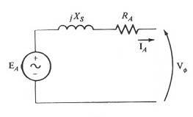

Figure 1- Equivalent circuit of a synchronous generator.

The following technique used to determine these quantities:

1. **Open circuit test:**

The generator turned at rated speed, the terminals are disconnected from all loads and the field current gradually increased from zero then reassured the terminal voltage at each step. In this case EA = VT due to open load ( IA = zero)

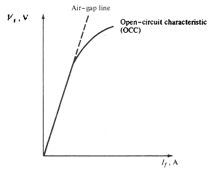

Figure 2- Open circuit characteristics.

1. **Short circuit test:**

In this test the terminals of the generator shorted by using ammeters to measure the armature current while the field current increases from zero.

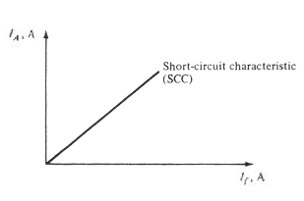

Figure 3- Short circuit test.

The internal machine impedance equal:

Zs = √ (RA2 + Xs2) = EA/IA

So from the open and short circuit test we can determine EA and IA at same field current. But it should be in the linear region to accurate.

At no load, this flux is established and determined exclusively by the dc field excitation. Under load, however, the air-gap flux is determined by the ampere-turns of the rotor and the ampere-turns of the stator. The latter may aid or oppose the MMF (magneto­motive force) of the rotor depending on the power factor of the load. Leading power factors assist the rotor, and lagging power factors oppose it.

Because the stator MMF has such an important effect on the magnetic flux, the vol­tage regulation of alternators is quite poor. That is why the dc field current must con­tinuously be adjusted to keep the voltage constant under variable load conditions.

If one phase of a three-phase alternator is heavily loaded, its voltage will decrease due to the IA and XL drops in the stator winding. This voltage drop cannot be com­pensated for by modifying the dc field current because the voltages of the other two phases will also be changed. Therefore, it is essential that three-phase alternators do not have loads that are badly unbalanced.

**Procedure:**

**Warning: high voltages are present in this laboratory experiment! Do not make any connections with the power on! The power should be turned off after completing each individual!**

**No load characteristics:**

1. Using your Synchronous Motor/Generator, four pole Squirrel Cage induction motor, power supply, DC Voltmeter/Ammeter, AC Ammeter and AC Voltmeter, connect the circuit shown in Figure 4. The four pole Squirrel Cage induction motor will be used to drive the Synchronous Motor/Generator as an alternator. Its speed will be assumed constant during this laboratory experiment. Note that the four pole Squirrel Cage induction motor is connected to fixed 380 V Ac, 3-phase output of the power supply terminals 1,2 and 3. The rotor of the alternator is connected to the variable 0-220 V Dc output of the power supply, terminals 7 and N.

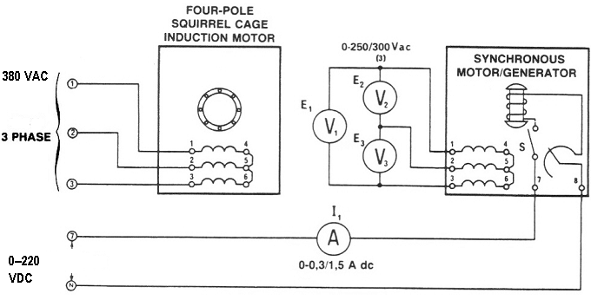

Figure 4

2. a) Couple the four pole Squirrel Cage induction motor to the Synchronous Motor/Generator with the timing belt.

b) Set the field rheostat of the Synchronous Motor/Generator at its full cw position( for zero resistance).

c) Set the power supply voltage control at its full ccw position( for zero Dc voltage)

3. a) Turn on the power supply. The motor should be running.

b) With zero Dc excitation (switch S open), measure and record E1 and E3 (use the lowest ranges of the voltmeters)

E1 = ………….V Ac E 2=..................V Ac E3 = ………….V Ac

c) Explain why there is an Ac voltage generated in the absence of Dc excitation.

4. a) Turn on the rotor excitation toggle switch of the Synchronous Motor/Generator(down position). Gradually increase the Dc excitation from zero to 0.05 A Dc using the power supply voltage control.

b) Measure and record in table 2 the three generated voltages E1, E2 and E3

|  |  |  |  |  |
| --- | --- | --- | --- | --- |
| **I1**  **A** | **E1**  **V** | **E2**  **V** | **E3**  **V** | **Eave** |
| **0** |  |  |  |  |
| **0.05** |  |  |  |  |
| **0.1** |  |  |  |  |
| **0.15** |  |  |  |  |
| **0.2** |  |  |  |  |
| **0.25** |  |  |  |  |
| **0.3** |  |  |  |  |
| **0.35** |  |  |  |  |

Table 2

c) Repeat b) for each of the Dc current listed in table 2.

d) Return the voltage to zero and turn of the power supply

5. a) Calculate and record in table 2 the average output voltage of the Synchronous Motor/Generator for each of listed Dc currents.

b) Plot your recorded average voltage values (y-axis) vs Dc current (x-axis) values from table 2.

**Short circuit characteristics:**

6. Use your synchronizing module to connect the circuit shown in figure 5. Note that the switch is wired to present a dead short across the alternator windings when it is closed.

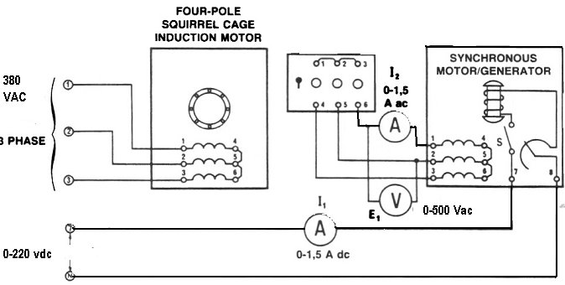

Figure 5

7. a) Couple the four pole Squirrel Cage induction motor to the Synchronous Motor/Generator with the timing belt.

b) Set the field rheostat of the Synchronous Motor/Generator at its full ccw position( for max. resistance).

c) Set the power supply voltage control at its full ccw position( for zero Dc voltage).

8. a) Turn on the power supply. The motor should be running.

b) Close the rotor excitation switch of the Synchronous Motor/Generator.

c) Apply short circuit to your alternator by closing the synchronizing switch.

1. a) Gradually increase the Dc excitation from zero to 0.2 A Dc using the power supply voltage control.

b) Measure and record I2 in table 3.

|  |  |
| --- | --- |
| **I1**  **A (Dc)** | **I2**  **A (Ac)** |
| **0** |  |
| **0.05** |  |
| **0.1** |  |
| **0.15** |  |
| **0.2** |  |

Table 3

c) Plot the field Dc current I1 (x-axis) vs the armature current I2 (y-axis).

**Load test characteristics:**

1. Connect the equipment as shown in figure 6.

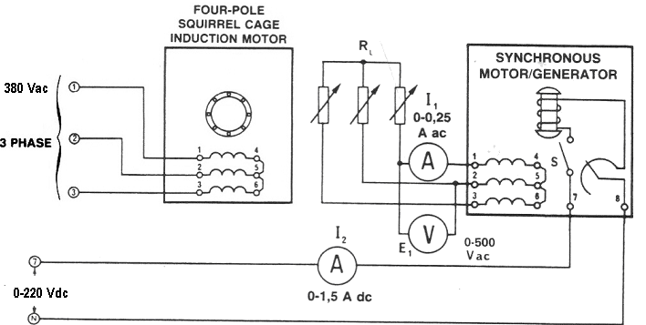

Figure 6

11. a) Couple the four pole Squirrel Cage induction motor to the Synchronous Motor/Generator with the timing belt.

b) Set the field rheostat of the Synchronous Motor/Generator at its full cw position( for zero resistance).

c) Set the power supply voltage control at its full ccw position( for zero Dc voltage).

d) Connect the three phase resistive load to the synchronous generator output.

e) Turn on the power supply. The motor should be running.

f) Adjust the dc excitation of the alternator until the output voltage E1 = 380 V Ac at no load case.

1. Adjust the resistive load to the values shown in table 4 then measure and record the terminal voltage VT and the armature current I1.

|  |  |  |  |
| --- | --- | --- | --- |
| **R**  **Ω** | **VT**  **V (Ac)** | **I1**  **A (Ac)** | **VR** |
| **∞** | **380** |  |  |
| **4400** |  |  |  |
| **2200** |  |  |  |
| **1467** |  |  |  |
| **1100** |  |  |  |
| **733** |  |  |  |
| **629** |  |  |  |

Table 4

1. Return the voltage to zero and turn off the power supply.
2. Calculate and record in table 4 the alternator voltage regulation.

VR = (Vnl – Vfl/**/** Vfl ) x 100 %

1. Plot the load characteristics (VT (y-axis) vs I1 (x-axis)).
2. Repeat step 11 for three phase inductive load.

|  |  |  |  |
| --- | --- | --- | --- |
| **XL**  **Ω** | **VT**  **V (Ac)** | **I1**  **A (Ac)** | **VR** |
| **∞** | **380** |  |  |
| **4400** |  |  |  |
| **2200** |  |  |  |
| **1467** |  |  |  |
| **1100** |  |  |  |
| **733** |  |  |  |
| **629** |  |  |  |

Table 5

1. Repeat steps 13, 14 and 15.
2. With an inductive load, does the stator MMF aid or oppose the rotor MMF?

Aid Oppose

1. Repeat step 11 for three phase capacitive load but adjust the Dc excitation of the alternator until the output voltage **E1 = 255 V Ac** at no load case.

|  |  |  |  |
| --- | --- | --- | --- |
| **XC**  **Ω** | **VT**  **V (Ac)** | **I1**  **A (Ac)** | **VR** |
| **∞** | **255** |  |  |
| **4400** |  |  |  |
| **2200** |  |  |  |
| **1467** |  |  |  |
| **1100** |  |  |  |
| **733** |  |  |  |
| **629** |  |  |  |

Table 6

1. Repeat steps 13, 14 and 15.
2. With capacitive load, does the stator MMF aid or oppose the rotor MMF?

Aid Oppose

**Unbalanced load:**

Connect the circuit shown in. Figure 7.***Note that only one of the alternator phases has a load.***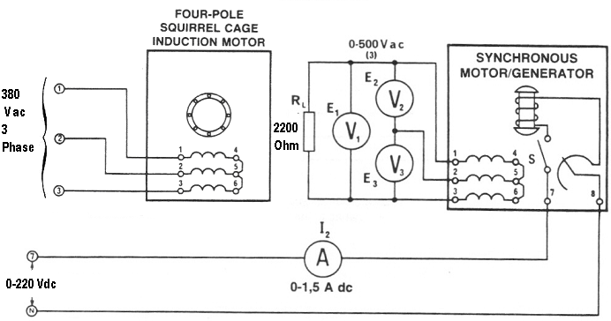

Figure 7

1. Adjust the dc excitation of the alternator until the voltage E, across the 2200 Ω load is 380 V ac. Measure and record the two other phase vol­tages E2 and E3.

E2 = …………… V Ac

E3 = …………… V Ac

1. ***Turn off the Power Supply without touching any of the variable controls.***
2. ***Reconnect the three AC voltmeters so they will measure the voltages across each of the three stator windings.***
3. Turn on the Power Supply. Measure and record the voltages across each of the alternator windings.

E 1 to 4 = ……………………… V ac

E 2 to 5 = ……………………… V ac

E 3 to 6 = ……………………… V ac

1. Return the voltage to zero and turn off the Power Supply.
2. Did the single-phase load produce a large unbalance?

Yes No

**Analysis:**

1. Explain why the alternator output voltage increases with capacitance loading.
2. Could it be dangerous to connect an alternator to a long transmission line, if the line had a high capacitance? Explain.

Yes No

1. The rotor of an alternator, at rated power, dissipates more heat at a low power factor (lagging) load than at a high power factor load, explain.

**Note:**

1. Produce your analysis based on the objectives and the results obtained.

Submit a Formal and group Laboratory Report