**Department of Electrical Engineering and   
Computer Science**

**Faculty Member:** Ms. Neelma Naz  **Dated:** 2/12/2022

**Semester:** 5th **Section:** BEE 12C

**EE-260:** **Electrical Machines**

Lab 9: Three Phase Synchronous Generator Synchronization

Group Members

|  |  |  |  |  |  |  |  |
| --- | --- | --- | --- | --- | --- | --- | --- |
|  |  | | **PLO4/**  **CLO5** | **PLO4/**  **CLO5** | **PLO5/ CLO6** | **PLO8/ CLO7** | **PLO9/ CLO8** |
| **Name** | | **Reg. No** | **Viva / Quiz / Lab Performance** | **Analysis of data in Lab Report** | **Modern Tool Usage** | **Ethics and Safety** | **Individual and Teamwork** |
|  | |  | **5 Marks** | **5 Marks** | **5 Marks** | **5 Marks** | **5 Marks** |
| Danial Ahmad | | 331388 |  |  |  |  |  |
| Hassan Rizwan | | 335753 |  |  |  |  |  |
| Muhammad Umer | | 345834 |  |  |  |  |  |
| Syeda Fatima Zahra | | 334379 |  |  |  |  |  |

**Table of Contents**

3 Three Phase Synchronous Generator Synchronization 3

3.1 Objectives 3

3.2 Equipment 3

3.3 Introduction 3

3.4 Lab Instructions 3

4 Lab Tasks 4

4.1 Connections 4

4.2 Procedure 4

5 Conclusion 6

**Table of Figures**

Figure 1 4

# Three Phase Synchronous Generator Synchronization

## Objectives

* When you have completed this exercise, you will be able to synchronize a three-phase synchronous generator with the AC power network using the Synchronous Motor/Generator and the Synchronizing Module

## Equipment

Hardware

* LabVolt Proprietary Toolkit

Software

* *LVDAC*



## Introduction

Most of the electricity consumed today is produced by three-phase synchronous generators. Since a huge amount of electricity is consumed every day, AC power networks are generally made up of a large number of synchronous generators all operating at the same frequency. A synchronous generator must never be connected to an AC power network before verifying synchronization. Connecting a non-synchronized generator to an AC power network could cause severe damage to the generator, because of the high torque that would be applied to the generator's shaft and the huge currents that would flow in the generator windings at connection.

## Lab Instructions

All questions should be answered precisely to get maximum credit. Lab report must ensure following items:

* Lab objectives
* Results (Graphs/Tables) duly commented and discussed
* Conclusion

# Lab Tasks

## Connections

Connect the equipment as shown in Figure 1. On the Synchronous Motor / Generator, set the EXCITER switch to the 1 (close) position and the EXCITER knob to the mid position. On the Synchronizing Module, set the switch to the O (open) position.

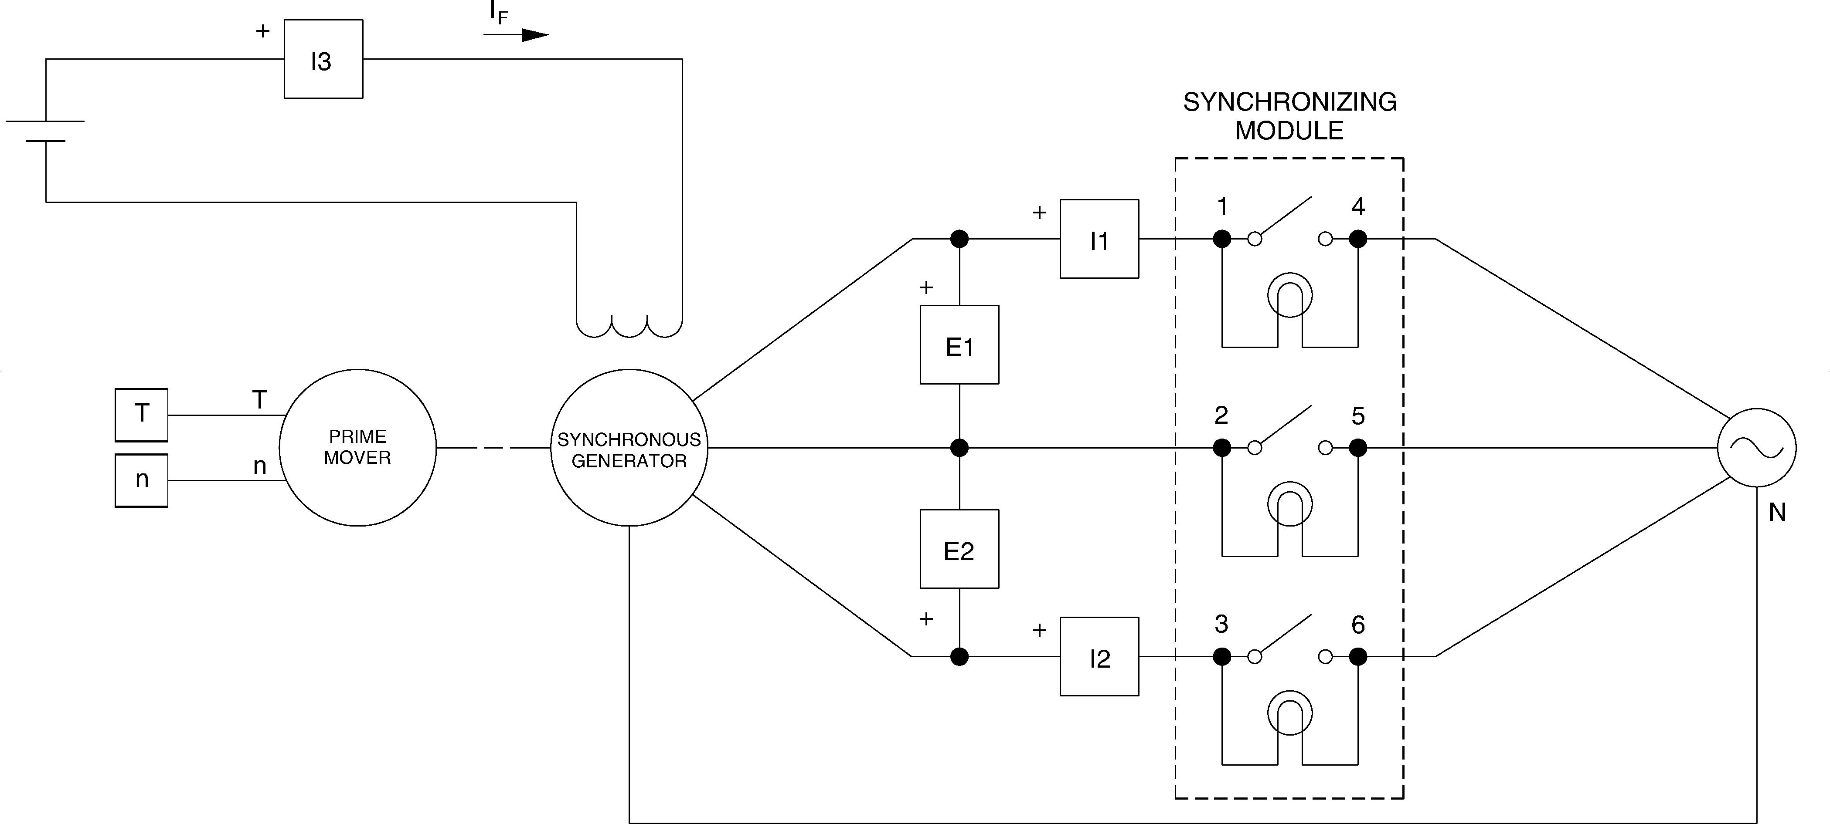

Figure

## Procedure

1. Set the Four-Quadrant Dynamometer / Power Supply or the Prime Mover / Dynamometer to operate as a prime mover.
2. On the Synchronous Motor / Generator, interchange the connections of the leads at terminals 1 and 2. Set the prime mover speed at the nominal speed of the Synchronous Motor / Generator minus approximately 75r/min.
3. On the Synchronous Motor / Generator, set the EXCITER knob so that the line-to-line output voltage EO of the synchronous generator (indicated by meter E line 1 in the Metering window) is equal to the nominal value. Observe the lamps on the Synchronizing Module.
4. Does the phase sequence of the synchronous generator correspond to that of the three-phase power network? Why?

**Answer:** No, the lamps do not flash on-and-off in synchronism implying they have a different phase sequence than that of the AC network.

1. Leave the prime mover speed set as it is. Turn the Power Supply off. On the Synchronous Motor/Generator, interchange the connections of the leads at terminals 1 and 2.
2. Turn the Power Supply on. Observe the lamps on the Synchronizing Module. Does the phase sequence of the synchronous generator correspond to that of the three-phase power network? Why?

**Answer:** Yes, the lamps now flash on-and-off in synchronism due to the alternation of two phases, making the phase sequence of the synchronous generator the same as that of the AC network

1. Set the prime mover speed so that the brightness of the lamps on the Synchronizing Module changes very slowly (if necessary). Is the generator synchronized with the three-phase power network the instant the lamps are dimmed completely?

|  |  |
| --- | --- |
| Yes ✓ | No |

1. On the Synchronizing Module, set the switch to the 1 (closed) position at an instant the lamps are dimmed completely. This connects the synchronous generator to the three-phase power network. In the Metering window, observe the active power indicated by the meter active power. Is a significant amount of active power exchanged between the synchronous generator and the AC power network?

|  |  |
| --- | --- |
| Yes ✓ | No |

1. In the Metering window, make sure that the torque correction function of the Torque meter is enabled. Slowly increase the prime-mover speed setting to increase the generator input torque until the Torque meter reads 1.0 Nm. While doing this, observe the active power and the generator speed indicated by meters Active Power and Speed.

Describe what happens.

**Answer:** The generator speed, indicated by N on the metering window, is unaffected while the active power is positive, indicating that the synchronous generator is supplying active power to the AC power network.

1. Does the synchronous generator supply active power to the AC power network?

|  |  |
| --- | --- |
| Yes ✓ | No |

1. Slowly set the prime-mover speed setting so that the active power indicated by meter Act. Power decreases to approximately zero. While doing this, observe the generator input torque indicated by the Torque meter. The synchronous generator is now "floating" on the AC power network. Where does the power to overcome friction come from?

**Answer:** The prime mover is supplying the power required to overcome friction.

1. Slowly decrease the prime-mover speed setting to decrease the generator input torque until the Torque meter reads -1.0 Nm. While doing this, observe the active power, the generator input torque, and the generator speed indicated by meters Active Power, Torque, and Speed. Describe what happens.

**Answer:** The generator speed, indicated by N on the metering window, is unaffected while the active power is negative, indicating that the synchronous generator is now consuming active power and acting as a motor.

1. Increase the prime-mover speed setting until the torque indicated by the Torque meter (generator input torque) is equal to 1.0 Nm. The synchronous generator is now delivering the nominal active power (approximately) to the AC power network.
2. On the Synchronous Motor / Generator, slowly set the EXCITER knob to the MAX position to increase the field current. While doing this, observe the active power, the reactive power, the generator input torque, and the generator speed indicated by the meters.

Describe what happens.

**Answer:** The speed of the synchronous generator remains the same, the torque remains the same and the active power supplied does not vary significantly. However, the synchronous generator stops consuming reactive power and starts supplying reactive power to the AC power network.

1. Does the synchronous generator supply reactive power to the AC power network?

|  |  |
| --- | --- |
| Yes ✓ | No |

1. On the Synchronous Motor / Generator, slowly set the EXCITER knob to the MIN. position to decrease the field current. While doing this, observe the reactive power indicated by meter Reactive Power in the metering window.

Describe what happens.

**Answer:** The generator is now consuming reactive power from the AC power network.

1. Is it possible to adjust the field current so that the power factor of the synchronous generator is unity?

|  |  |
| --- | --- |
| Yes ✓ | No |

# Conclusion

In this lab, we learned and performed synchronization of a three-phase synchronous generator with an infinite bus, which in this case is the power being supplied from WAPDA, by interchanging phase sequences, observing brightness of lamps on a synchronizing module and the rate of switching of the lamps. We also observed that changing torque changes the supplying/consuming active power behavior of the generator, whereas altering the field current, and hence the induced voltage, changes the supplying/consuming reactive power behavior of the generator.