**Department of Electrical Engineering**

**Faculty Member: ____________________ Dated: ________________**

**Semester: __________________________ Section: ________________**

**EE-260: Electrical Machines**

**Lab9: Three Phase Synchronous Generator Synchronization**

|  |  |  |  |  |  |  |
| --- | --- | --- | --- | --- | --- | --- |
|  |  | **PLO4/**  **CLO5** | **PLO4/**  **CLO5** | **PLO5/**  **CLO6** | **PLO8/**  **CLO7** | **PLO9/**  **CLO8** |
| **Name** | **Reg. No** | **Viva / Quiz / Lab Performance** | **Analysis of data in Lab Report** | **Modern Tool Usage** | **Ethics and Safety** | **Individual and Team Work** |
|  |  | **5 Marks** | **5 Marks** | **5 Marks** | **5 Marks** | **5 Marks** |
|  |  |  |  |  |  |  |
|  |  |  |  |  |  |  |
|  |  |  |  |  |  |  |
|  |  |  |  |  |  |  |

## EXERCISE OBJECTIVE

When you have completed this exercise, you will be able to synchronize a three- phase synchronous generator with the ac power network using the Synchronous Motor / Generator and the Synchronizing Module.

## DISCUSSION

Most of the electricity consumed today is produced by three-phase synchronous generators. Since a huge amount of electricity is consumed every day, ac power networks are generally made up of a large number of synchronous generators all operating at the same frequency. When the power demand increases, additional generators are connected to the ac power network. Before connecting a three-phase synchronous generator to an ac power network, the following conditions are to be observed:

* + - The frequency of the voltages produced by the generator must be equal to the ac power network frequency.
    - The value of the voltages produced by the generator must be equal to the ac power network voltage.
    - The phase sequence of the voltages produced by the generator must be the same as that of the ac power network.
    - The voltages produced by the generator must be in phase with the ac power network voltages.

A generator is said to be synchronized when all these conditions are met. A synchronous generator must never be connected to an ac power network before verifying synchronization. Connecting a non-synchronized generator to an ac power network could cause severe damage to the generator, because of the high torque that would be applied to the generator's shaft and the huge currents that would flow in the generator windings at connection.

Once a synchronous generator is connected to an ac power network, no current flows between the generator and the ac power network because they produce voltages having the same amplitude and phase. As a result, the generator supplies neither active nor reactive power to the ac power network. In this case, the generator is said to be "floating" on the ac power network. Furthermore, its frequency can no longer be changed by adjusting the torque applied to the generator's shaft. This is because the ac power network is so powerful that it imposes its own frequency. However, adjusting the torque applied to the generator's shaft allows changing the amount of active power that is exchanged between the generator and the ac power network. Increasing the torque increases the amount of active power that is delivered to the ac power network. Conversely, decreasing the torque decreases the amount of active power that is delivered to the ac power network. The generator could even receive active power from the ac power network, and thus operate as a synchronous motor, if the torque applied to the generator's shaft were decreased to zero.

As in three-phase synchronous motors, the amount of reactive power that is exchanged between a synchronous generator and the ac power network can be changed by adjusting the field current. The field current is usually adjusted so that no reactive power is exchanged between the generator and the ac power network, i.e., so that the power factor of the generator is unity. This minimizes the line currents and allows the size of the conductors connecting the generator to the ac power network to be reduced to minimum.

Figure 9.1 shows a simple circuit used to synchronize and connect a generator and an ac power network. In this circuit, a three-phase synchronous generator is connected to a three-phase power network (three-phase power source) through three lamps and a three-pole switch set to the open position. A voltmeter and a frequency meter are connected to the generator output to measure its voltage and frequency.

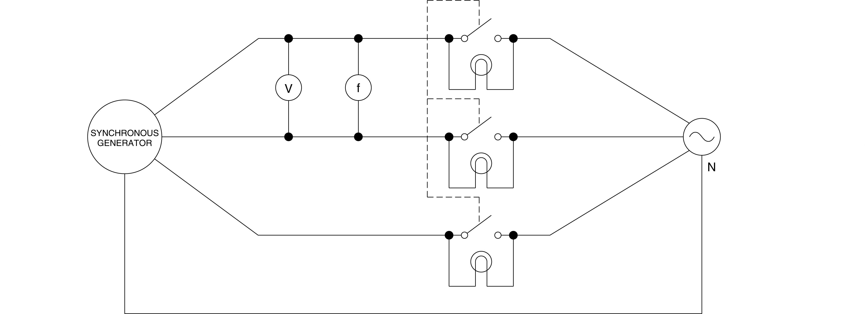**Figure 9.1 Circuit Used to Synchronize and Connect a Generator and an AC Power Network**

The speed and field current of the synchronous generator are first adjusted so that the generator frequency and voltage are approximately equal to the nominal voltage and frequency of the ac power network. The brightness of the lamps will change in synchronism when the phase sequence of the generator is the same as that of the ac power network. On the other hand, the lamp brightness will change out of synchronism if the phase sequence of the generator differs from that of the ac power network. In this case, the connections of two of the three line wires of the synchronous generator must be interchanged to reverse its phase sequence.

Once the phase sequence of the synchronous generator is correct, the speed of the generator is adjusted so that the rate at which the lamp brightness changes is as low as possible. This adjusts the frequency of the generator to that of the ac power network. The field current of the generator is then adjusted so that the lamps become completely dimmed as their brightness decreases. This adjusts the generator voltage to that of the ac power network. The switch can then be closed at any instant the lamps are dimmed completely (the voltages are in phase at this instant only) to safely connect the synchronous generator to the ac power network.

## Procedure Summary

In the first part of the exercise, you will set up the equipment in the Workstation, connect the equipment as shown in Figure 9.2, and make the appropriate settings on the equipment.

In the second part of the exercise, you will synchronize a three-phase synchronous generator with the three-phase power network. You will then connect the synchronous generator to the three-phase power network.

In the third part of the exercise, you will vary the torque applied to the generator's shaft and the field current IF and observe how this affects the operation of the synchronous generator.

## EQUIPMENT REQUIRED

Refer to the Equipment Utilization Chart in Appendix C to obtain the list of equipment required for this exercise.

## PROCEDURE

**CAUTION!**

**High voltages are present in this laboratory exercise! Do not make or modify any banana jack connections with the power on unless otherwise specified!**

## Setting up the Equipment

1. Install the equipment required in the EMS workstation. Mechanically couple the prime mover / dynamometer module to the Synchronous Motor / Generator.
2. On the Power Supply, make sure the main power switch is set to the O (off) position, and the voltage control knob is turned fully counterclockwise. Ensure the Power Supply is connected to a three-phase power source.

**Note:** *If you are using the Four-Quadrant Dynamometer / Power Supply, Model 8960-2, connect its POWER INPUT to a wall receptacle. If you are using the Prime Mover / Dynamometer, Model 8960-1, connect its LOW POWER INPUT to the 24 V - AC output of the Power Supply.*

1. Ensure that the data acquisition module is connected to a USB port of the computer. Connect the POWER INPUT of the data acquisition module to the 24 V - AC output of the Power Supply. On the Power Supply, set the 24 V - AC power switch to the 1 (on) position.

**Note:** *If you are using the Four-Quadrant Dynamometer / Power Supply, Model 8960-2, turn it on by setting its POWER INPUT switch to the 1 (on) position.*

1. Start the Metering application. Connect the equipment as shown in Figure 9.2. On the Synchronous Motor / Generator, set the EXCITER switch to the 1 (close) position and the EXCITER knob to the mid position. On the Synchronizing Module, set the switch to the O (open) position.

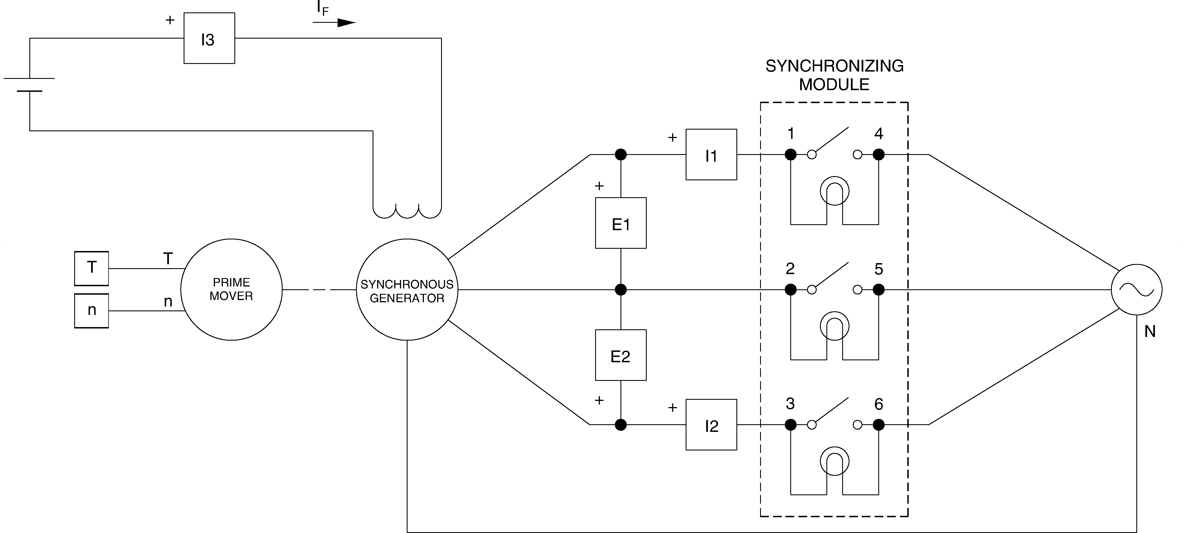

**Figure 9.2 Circuit Used to Synchronize and Connect a Generator and an AC Power Network**

1. Set the Four-Quadrant Dynamometer / Power Supply or the Prime Mover / Dynamometer to operate as a prime mover.
2. On the Synchronous Motor / Generator, interchange the connections of the leads at terminals 1 and 2. Set the prime mover speed at the nominal speed of the Synchronous Motor / Generator minus approximately 75r/min.
3. On the Synchronous Motor / Generator, set the EXCITER knob so that the line-to-line output voltage EO of the synchronous generator (indicated by meter E line 1 in the Metering window) is equal to the nominal value. Observe the lamps on the Synchronizing Module.

Does the phase sequence of the synchronous generator correspond to that of the three-phase power network? Why?

1. Leave the prime mover speed set as it is. Turn the Power Supply off. On the Synchronous Motor / Generator, interchange the connections of the leads at terminals 1 and 2.
2. Turn the Power Supply on. Observe the lamps on the Synchronizing Module. Does the phase sequence of the synchronous generator correspond to that of the three-phase power network? Why?
3. Set the prime mover speed so that the brightness of the lamps on the Synchronizing Module changes very slowly (if necessary). Is the generator synchronized with the three-phase power network at the instants the lamps are dimmed completely?

G Yes G No

1. On the Synchronizing Module, set the switch to the 1 (closed) position at an instant the lamps are dimmed completely. This connects the synchronous generator to the three-phase power network. In the Metering window, observe the active power indicated by meter active power. Is a significant amount of active power exchanged between the synchronous generator and the ac power network?

G Yes G No

1. In the Metering window, make sure that the torque correction function of the Torque meter is enabled. Slowly increase the prime-mover speed setting to increase the generator input torque until the Torque meter reads 1.0 Nm. While doing this, observe the active power and the generator speed indicated by meters Active Power and Speed.

**Note:** *The synchronous generator delivers active power when the value indicated by meter Act. Power is positive.*

Describe what happens.

Does the synchronous generator supply active power to the ac power network?

G Yes G No

1. Slowly set the prime-mover speed setting so that the active power indicated by meter Act. Power decreases to approximately zero. While doing this, observe the generator input torque indicated by the Torque meter. The synchronous generator is now "floating" on the ac power network. Where does the power to overcome friction come from?
2. Slowly decrease the prime-mover speed setting to decrease the generator input torque until the Torque meter reads -1.0 Nm. While doing this, observe the active power, the generator input torque, and the generator speed indicated by meters Active Power, Torque, and Speed. Describe what happens.
3. Increase the prime-mover speed setting until the torque indicated by the Torque meter (generator input torque) is equal to 1.0 Nm. The synchronous generator is now delivering the nominal active power (approximately) to the ac power network.

On the Synchronous Motor / Generator, slowly set the EXCITER knob to the MAX position to increase the field current. While doing this, observe the active power, the reactive power, the generator input torque, and the generator speed indicated by the meters.

**Note:** *The synchronous generator delivers reactive power when the value indicated by meter React. Power is positive.*

Describe what happens.

Does the synchronous generator supply reactive power to the ac power network?

G Yes G No

1. On the Synchronous Motor / Generator, slowly set the EXCITER knob to the MIN. position to decrease the field current. While doing this, observe the reactive power indicated by meter Reactive Power in the metering window.

Describe what happens.

Is it possible to adjust the field current so that the power factor of the synchronous generator is unity?

G Yes G No

1. On the Synchronizing Module, set the switch to the 0 (open) position
2. On the Power Supply, turn the voltage control knob fully counterclockwise then set the 24 V - AC power switch to the O (off) position.

**Note:** *If you are using the Four-Quadrant Dynamometer / Power Supply, Model 8960-2, turn it off by setting its POWER INPUT switch to the O (off) position.*

Remove all leads and cables.

## CONCLUSION