

**EE-260:** **Electrical Machines**

**Project Proposal**

Analysis of Artificial Neural Network-Based Vector   
Controller for Synchronous Motors

|  |  |  |
| --- | --- | --- |
| MATLAB - Wikipedia, la enciclopedia libre | Neural - Free computer icons | Motor Symbol in iOS7 Minimal Icons |

**Group Members**

|  |  |
| --- | --- |
| **Name** | **CMS ID** |
| Danial Ahmad | 331388 |
| Hassan Rizwan | 335753 |
| Muhammad Umer | 345834 |
| Syeda Fatima Zahra | 334379 |

**Table of Contents**

2 Introduction 3

3 Design Factors 3

3.1 Key Performance Indicators (KPIs) 3

3.2 Research References 3

4 Block Diagram 4

5 Workflow 4

6 Conclusion 5

# Introduction

In the paper titled *“Neural-Network Vector Controller for Permanent-Magnet Synchronous Motor Drives”,* an artificial neural network vector controller is proposed for alleviating fundamental issues with conventional controllers. Conventional PI Vector Controllers (PIVC) are unable to tackle the cumulative decoupling inaccuracy problem, as is the case with other proportional-integral based systems, hence, an artificial neural network is designed and trained to penalize the system in case of positive decoupling events. The robustness and adaptive performance of the proposed neural network controller is tested against conventional vector controllers under several motor parametric variations and dynamic control conditions in our analysis report. Lastly, we shall propose and imbue our own theoretical concepts to the proposed system, improving the efficiency and stability relative to the original model.

# Design Factors

## Key Performance Indicators (KPIs)

Key Performance Indicators (KPIs) are quantitative or qualitative measures of the achievements of a research institute. The mission of each institute should be articulated as a limited set of KPIs for each strategic goal. In context of research journals/articles, KPIs refer to the main objectives achieved within a specific period of time, without novel ideas being superseded before coming to fruition.

We shall extract the KPIs of individual and distinct papers mentioned in Section 3.2 before using our critical thinking skills to implement novel ideas/improvements to the existing proposed architectures.

## Research References

We aim to utilize the following set of research papers in implementing this paper on Simulink as well as training our neural network from scratch. Moreover, the KPIs extracted from the relevant research paper will contribute directly towards novel improvements to the core research paper.

|  |  |
| --- | --- |
| **Title** | **Authors** |
| *\* Neural-Network Vector Controller for Permanent-Magnet Synchronous Motor Drives* | *Shuhui Li, Hoyun Won, Xingang Fu, Michael Fairbank, Donald C. Wunsch, Eduardo Alonso* |
| Model Predictive Control - A Simple and Powerful Method to Control Power Converters | Samir Kouro, Patricio Cortés, René Vargas, Ulrich Ammann |
| Direct torque control of permanent magnet synchronous machine drives with a simple duty ratio regulator | Yuan Ren, Z. Q. Zhu, Jiaming Liu |

# Block Diagram

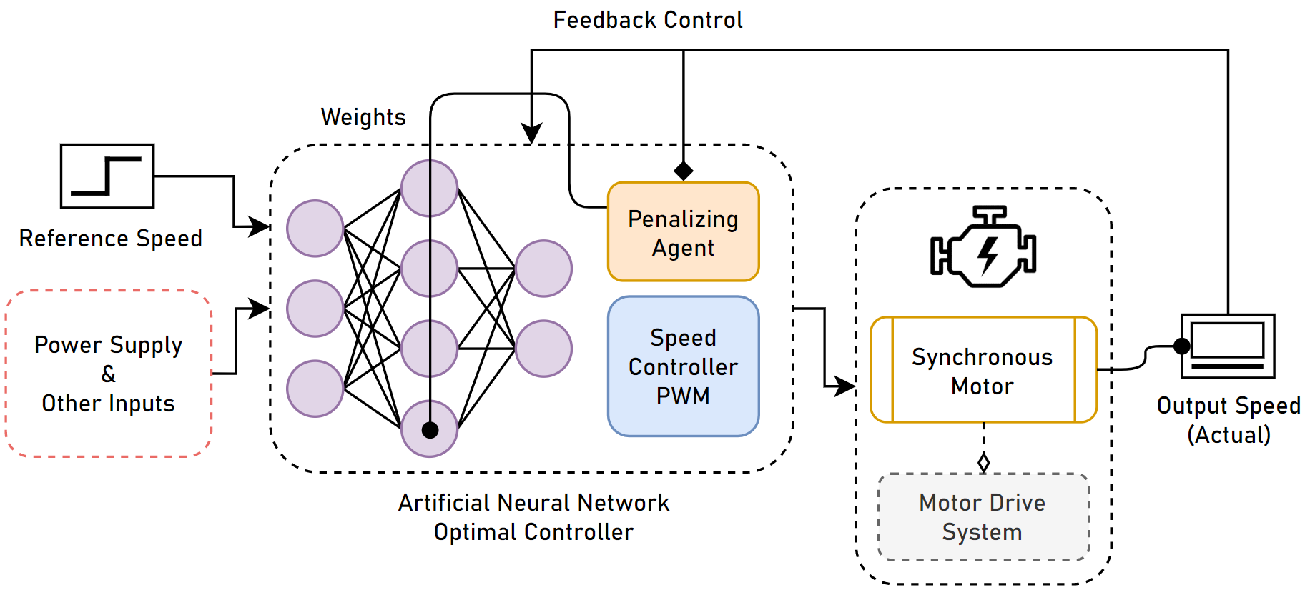

# Workflow

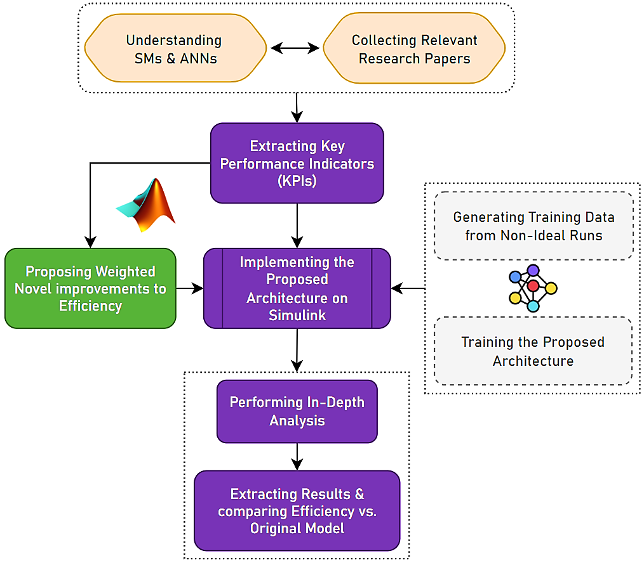

# Conclusion

In this analysis report, we aim to prove that the neural network vector controller, compared to the conventional vector control, produces the fastest response speed, lowest overshoot, and, in general, the best performance. Moreover, since a neural network is trained under variable system parameters, the ANN-based vector controller shows enhanced performance when the sampling time changes and system parameters are difficult to identify, especially in hardware experiment conditions.

We implement all of our design philosophy in MATLAB Simulink, as it supports both training and testing of the proposed ANN. Lastly, we aim to verify that the ANN-based vector controller retains satisfactory performance under a variety of runtime motor parameters, despite the NN being trained using nominal characteristics.