

**NATIONAL UNIVERSITY OF SCIENCES & TECHNOLOGY**

**Electronic Circuit Design (EE-313)**

**Assignment # 1**

Common Emitter Amplifier Design

|  |  |
| --- | --- |
| Submitted to: | Dr. Shakeel Alvi |
| Submitted by: | Muhammad Umer |
| Class: | BEE-12C |
| Semester: | 5th |
| Dated: | 24/09/2022 |
| CMS ID: | 345834 |

# Assignment Solution

## MATLAB Code

Following code is treated as a boilerplate for plotting both single stage and cascaded CE amplifier graphs on MATLAB. Appropriate comments are added for the reader’s understanding.

% Transient Plot

WaveData = importdata('waveform/waveform.txt');

time = WaveData.data(:, 1);

Vin = WaveData.data(:, 2);

Vout = WaveData.data(:, 3);

figure('Name', 'Transient Plot');

% Vout vs t

subplot(2, 1, 1)

plot(time, Vout, 'r')

title('V(Out)')

grid

xlabel('Time (s)')

ylabel('Voltage (V)')

xticks(0:0.1:1.5)

% Vin vs t

subplot(2, 1, 2)

plot(time, Vin)

title('V(In)')

grid

xlabel('Time (s)')

ylabel('Voltage (V)')

xticks(0:0.1:1.5);

%%

% Bode Plot

BodeData = readtable('bode_plot/bode.txt', 'VariableNamingRule', 'preserve');

Vn = BodeData.('V(out)');

f = BodeData.('Freq.');

for k = 1:numel(Vn)

V(:, k) = sscanf(Vn{k}, '(%fdB,%f)');

end

figure('Name', 'Bode Plot');

% Decibel vs Freq.

subplot(2, 1, 1)

semilogx(f, V(1, :), 'r-o', 'MarkerIndices', 1:50:length(V(1, :)))

grid

xlabel('Frequency (Hz)')

ylabel('Magnitude (dB)')

% Phase vs Freq.

subplot(2, 1, 2)

semilogx(f, V(2, :), '-o', 'MarkerIndices', 1:50:length(V(1, :)))

grid

xlabel('Frequency (Hz)')

ylabel('Phase (°)')

sgtitle('V(out)')

Single Stage CE Amplifier

### Circuit

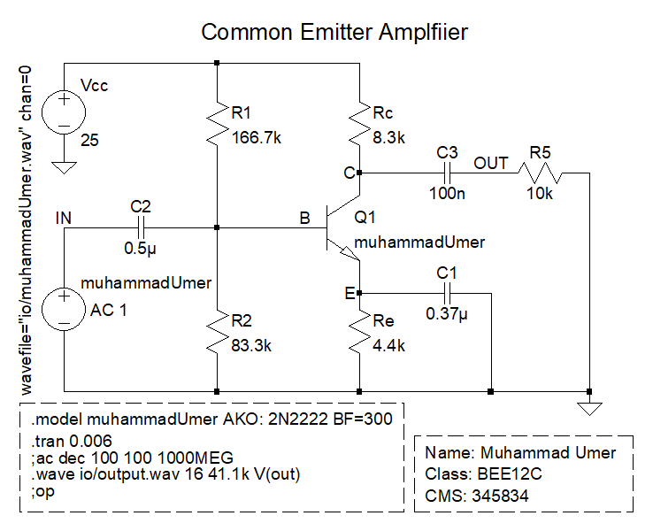

Figure ‑ Schematic

### Waveforms





**Comments:** From the transient analysis, we can observe that our input signal (in blue) [range: +0.5V to -0.8V] gets amplified by the designed common emitter amplifier to the output signal (in red) [range: +5.8V to -5.8V] with little noise.

### Bode Plot





### Gain

|  |  |
| --- | --- |
|  |  |
| Voltage Cursor | Current Cursor |

By applying a sinusoidal signal and performing transient analysis, we can get the value of voltage gain directly by using the formula:

Addition of the bypass capacitor, although introduces noise, but it allows for a larger gain, essentially making it a trade-off. Substituting values from the figure, we obtain:

Following the same line of thought for calculating current gain, , we obtain the value:

## Cascaded CE Amplifier

### Circuit

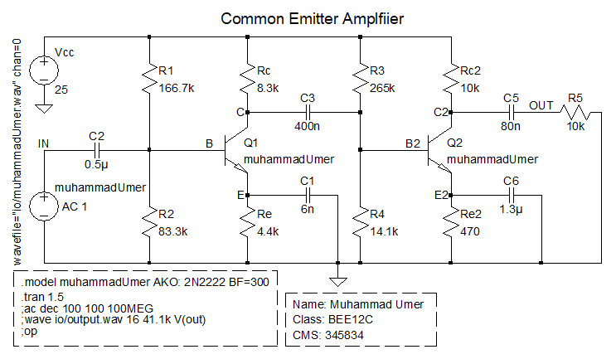

Figure ‑ Schematic

### Waveforms





**Comments:** From the transient analysis, we can observe that our input signal (in blue) [range: +0.5V to -0.8V] gets amplified by the cascaded common emitter amplifier to the output signal (in red) [range: +8.2V to -14.76V] with little noise, albeit a bit more compared to that of single stage.

### Bode Plot





### Gain

|  |  |
| --- | --- |
|  |  |
| Voltage Cursor | Current Cursor |

By applying a sinusoidal signal and performing transient analysis, we can get the value of voltage gain directly by using the formula:

Addition of the bypass capacitor, although introduces noise, but it allows for a larger gain, essentially making it a trade-off. Substituting values from the figure, we obtain:

Following the same line of thought for calculating current gain, , we obtain the value:

# Conclusion

In this assignment, students learnt about the steps and procedures necessary to design a classical discrete arrangement biased common emitter voltage amplifier and used it to amplify a recorded signal. LTSpice was used to simulate the circuits, and the extracted simulated data was then fed into MATLAB for plotting purposes. Lastly, we cascaded a common emitter stage onto a common emitter amplifier and verified that the overall voltage gain increases through cascading.