

NATIONAL UNIVERSITY OF SCIENCES & TECHNOLOGY

Electronic Circuit Design (EE-313)

Assignment # 2

Analysis of BJT Current Mirrors and

Cascaded Amplifiers

|  |  |
| --- | --- |
| Submitted to: | Dr. Shakeel Alvi |
| Submitted by: | Muhammad Umer |
| Class: | BEE-12C |
| Semester: | 5th |
| Dated: | 5/10/2022 |
| CMS ID: | 345834 |

# Assignment Solution

## BJT Cascode

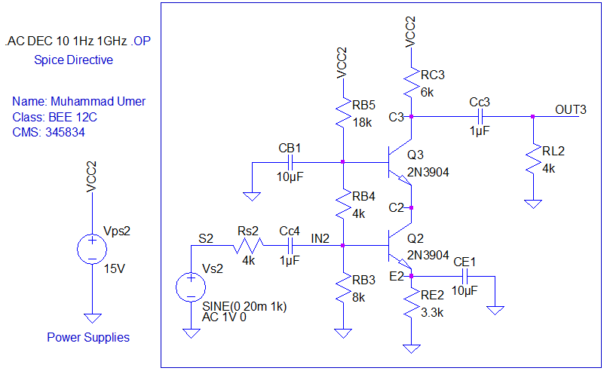

### Gain



*Gain of Cascoded Amplifier: $G_{V}=\frac{V_{OUT}}{V_{IN}}$*

*Calculations: $\frac{V_{OUT_{P-P}} }{V_{IN_{P-P}}}=\frac{(264.4-(-276.1))×{10}^{-3}}{19.99×{10}^{-3}}=27.297\frac{V}{V}$*

### Bode Plot



## BJT Mirror for ROUT Calculations

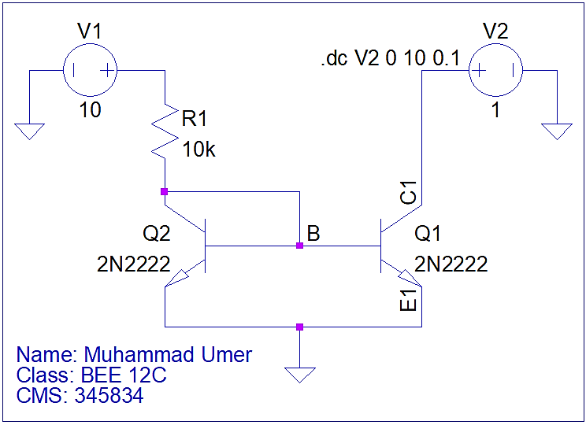

*As there is no load at the collector of Q1 transistor, $R_{out}=r_{o}$*

For BJT circuits, $r_{o}$ can be calculated using the relation:

$$r_{o}={\left(\frac{∇I_{c}}{∇V_{CE}}\right)}^{-1}$$

For the present case, emitter is grounded (0 V); the relation, thus, transforms to:

$$r_{o}={\left(\frac{∇I_{c}}{∇V_{C}}\right)}^{-1}$$

In LTSpice, one can plot the derivative (change) of a variable with respect to another, by using the notation D(). To plot $r_{o}$, we use $\frac{D\left(V\left(c1\right)\right)}{D\left(Ic\left(Q1\right)\right)}$ as the trace in the expression editor.



## BJT Mirror with Changing Load

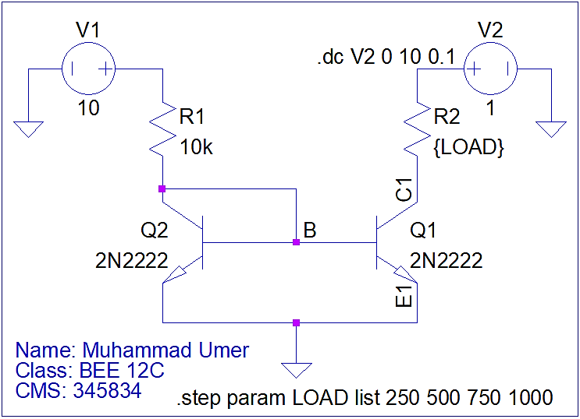

To verify that current remains constant for various loads, we perform parametric sweep on the load resistor R2. Stepping it up from 250 to 1000 $Ω$ in steps of 250, we can get a plot showcasing the respective currents passing through the load resistor, and, as is expected, current mirror keeps the current constant even under different load conditions.



# Conclusion

In this assignment, we learned two important configurations of BJTs; cascoded common emitter amplifier as well as the current mirror. We observed that we can achieve a relatively stable gain as well as bandwidth with a cascoded configuration (with one stage focused towards gain, and the other towards bandwidth) than a simple BJT amplifier where trade-offs are inevitable. Lastly, we proved the fundamental property of current mirrors, i.e. constant characteristics of load current under various loads, by applying parametric sweep analysis on the current mirror.