**Department of Electrical Engineering and   
Computer Science**

**Faculty Member:** Dr. Shakeel Alvi  **Dated:** 13/09/2022

**Semester:** 5th **Section:** BEE 12C

**EE-313:** **Electronic Circuit Design**

Lab 1: Simulation Using Advanced Features of PSpice

Group Members

|  |  |  |  |  |
| --- | --- | --- | --- | --- |
| **Name** | **Reg. No** | **Report**  **Marks** | **Viva**  **Marks** | **Total**  **Marks** |
|  |  | **10 Marks** | **5 Marks** | **15 Marks** |
| Danial Ahmad | 331388 |  |  |  |
| Muhammad Ahmed Mohsin | 333060 |  |  |  |
| Muhammad Umer | 345834 |  |  |  |
| Tariq Umar | 334943 |  |  |  |
|  |  |  |  |  |

**Table of Contents**

3 Simulation Using Advanced Features of PSpice 4

3.1 Objectives 4

3.2 Equipment 4

3.3 Introduction 4

3.4 Lab Instructions 4

4 Lab Tasks 5

4.1 Creating and Simulating a Transformer Circuit in PSpice 5

4.1.1 Circuit 5

4.1.2 Reversing the primary and secondary of Transformer 5

4.1.3 Change the transformation ratio and print graphs for input and output voltages 6

4.2 Rectifier Circuit 6

4.2.1 Circuit 6

4.2.2 Peak to peak value of ripple voltage along with graph 7

4.3 Use of Parametric Sweep 7

4.3.1 Circuit 7

4.3.2 Changing the load resistance from 250 to 1000 ohm in steps of 250 ohm 8

4.3.3 Comment on the effect of ripple voltage as result of changing load resistance 8

5 Conclusion 8

**Table of Figures**

Figure 4.1.1‑a: Circuit 5

Figure 4.1.1‑b: Simulation Curve 5

Figure 4.1.2‑a: Reversed Curve 5

Figure 4.1.3‑a: Circuit 6

Figure 4.2.1‑a: Circuit 6

Figure 4.2.2‑a: Simulation Curve 7

Figure 4.3.1‑a: Simulation Curve 7

Figure 4.3.2‑a: Simulation Curve 8

# Simulation Using Advanced Features of PSpice

## Objectives

* To simulate slighly more advanced circuits, such as the transformers and a peak detector, using the PSpice simulation software. This familiarize the student with some more features of PSpice.

## Equipment

Software

* *PSpice*



## Introduction

PSpice is a powerful tool that allows one to quickly obtain the complete list of voltages and currents for any given circuit. Moreover it can be used to display simulation results graphically.The graphing tool is really powerful and has many variations which will be helpful n understanding component characteristics, behaviour and performance under various stimulations and circuit conditions. The student is encouraged to explore various features of PSPICE and master its use.

## Lab Instructions

All questions should be answered precisely to get maximum credit. Lab report must ensure following items:

* Lab objectives
* Results (Graphs/Tables) duly commented and discussed
* Conclusion

# Lab Tasks

Creating and Simulating a Transformer Circuit in PSpice

### Circuit

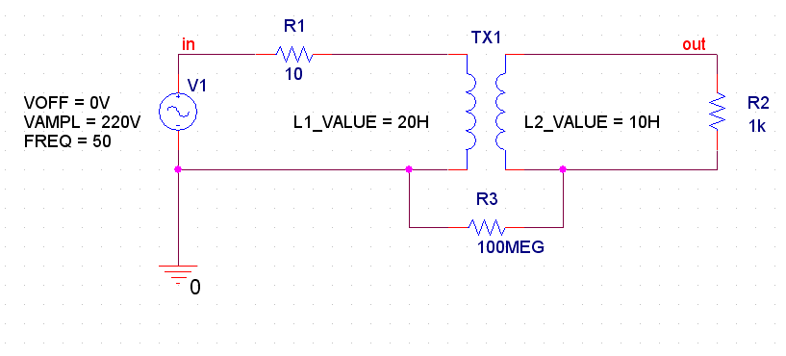

Figure ‑: Circuit

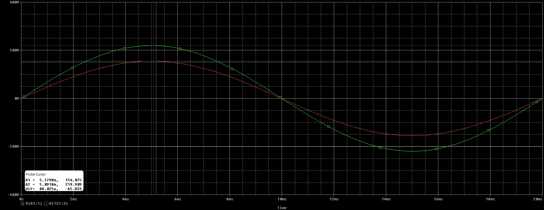

Figure ‑: Simulation Curve

### Reversing the primary and secondary of Transformer

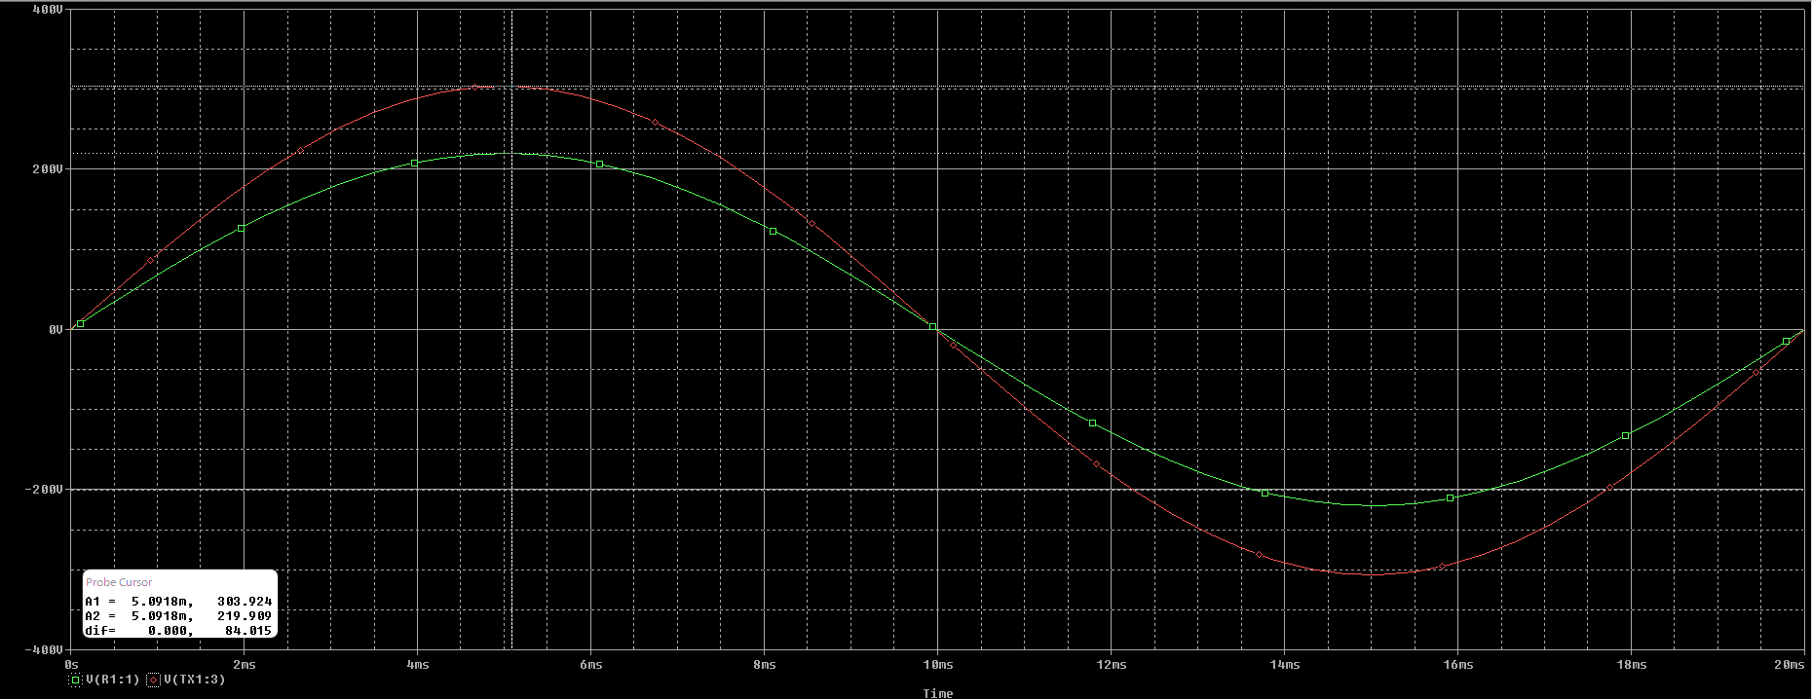

Figure ‑: Reversed Curve

**Comments:** Upon reversing the primary and secondary windings of the Transformer, it becomes a **step-up** transformer as evident from the curve. The input voltage (green) steps up to the output voltage (red).

### Change the transformation ratio and print graphs for input and output voltages

**Formulas:**

Turn Ratio:

Transformation Ratio:

With transformation ratio of, say, , implying that L2 is 33.75H and L1 is 15H. We would expect an input of 220V to be stepped-up to 330V.

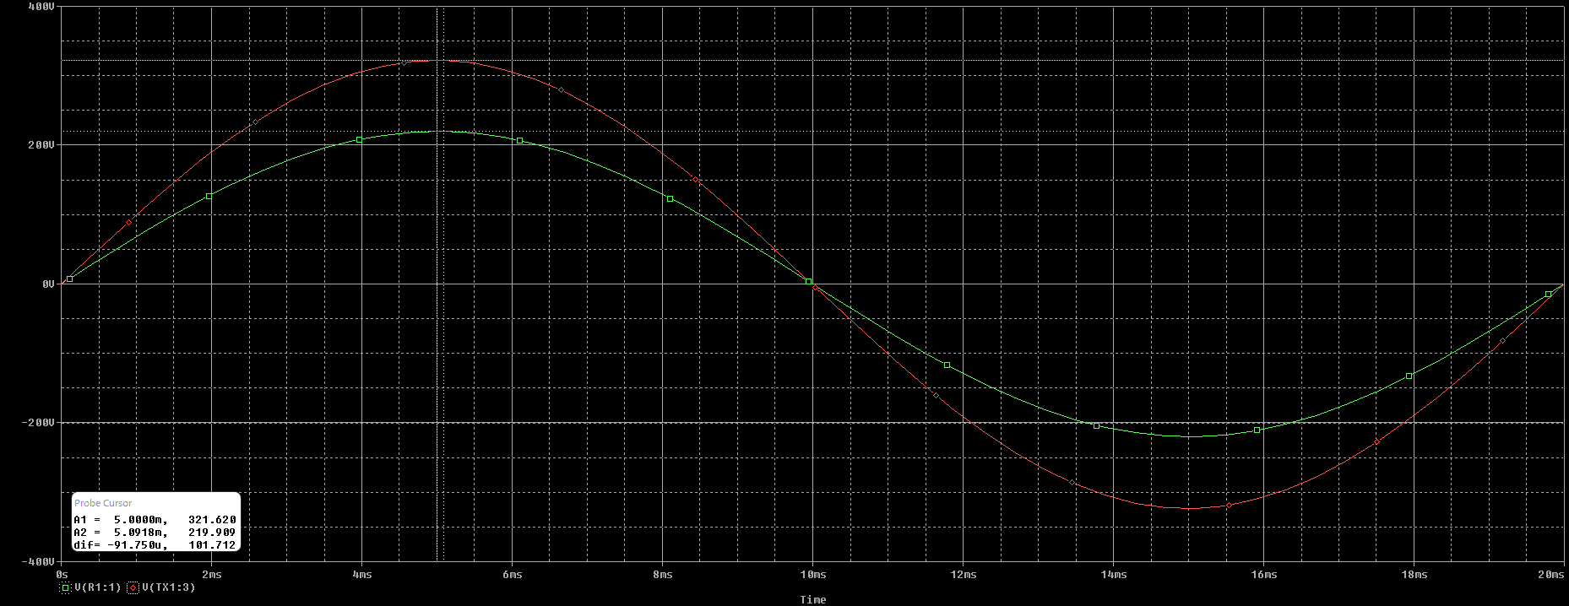

Figure ‑: Circuit

Rectifier Circuit

### Circuit

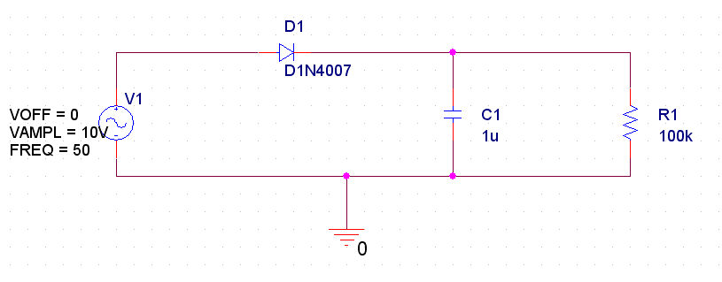

Figure ‑: Circuit

### Peak to peak value of ripple voltage along with graph

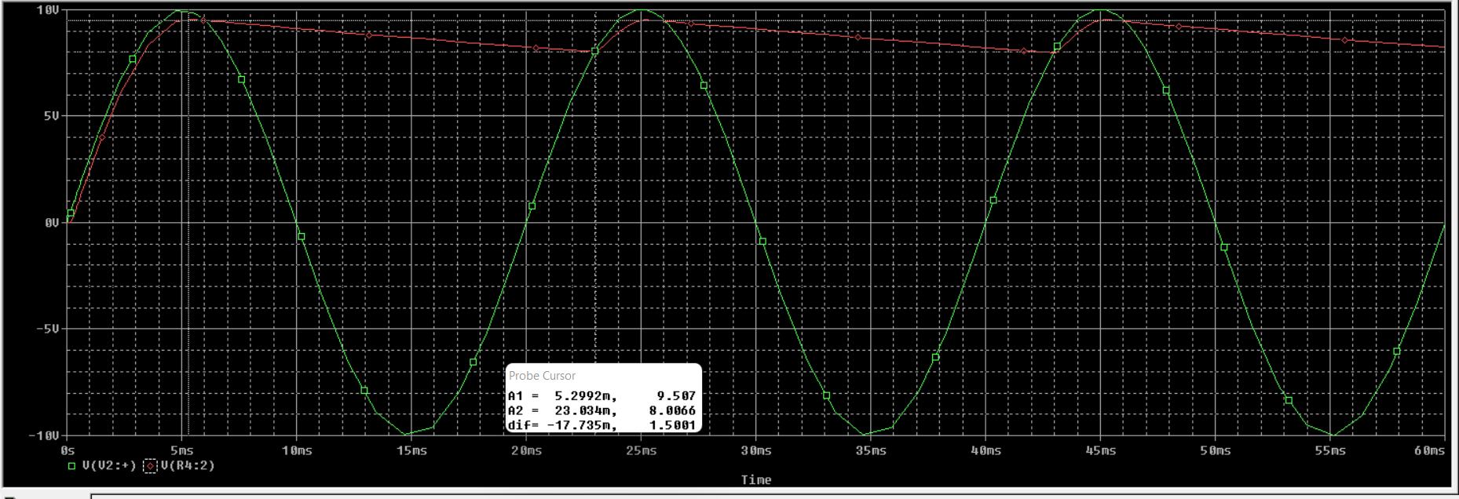

Figure ‑: Simulation Curve

**Answer:** From the graph,

Ripple Voltage P-P:

## Use of Parametric Sweep

### Circuit

It is interesting to see the effect of the load resistance on the output voltage and its ripple voltage. This can be done using PARAM part.

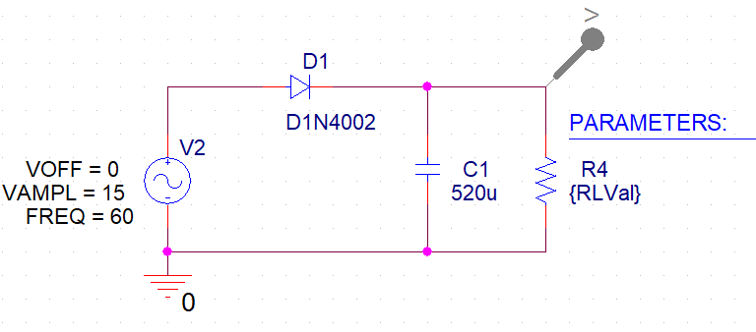

Figure ‑: Simulation Curve

We will now observe, and prove that the relation between ripple voltage and the time constant RC holds by utilizing the parametric sweep simulation of PSpice. We will increase the value of the load resistor R in steps of 250 Ohms from 250 Ohms to 1000 Ohms.

### Changing the load resistance from 250 to 1000 ohm in steps of 250 ohm

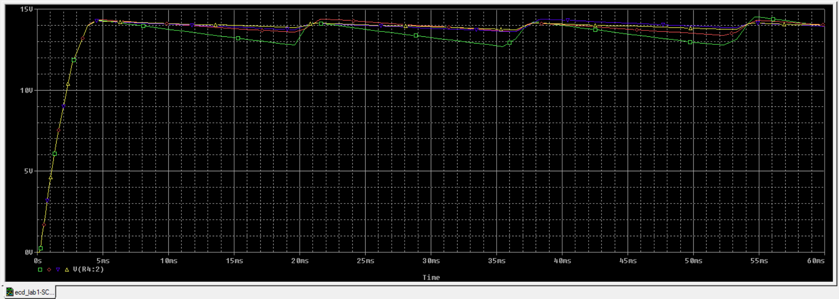

Figure ‑: Simulation Curve

### Comment on the effect of ripple voltage as result of changing load resistance

**Comments:** As the load resistance increases, so does the value of the RC constant and from the formula; , we can infer that as the value of RC increases (the denominator), the value of ripple voltage decreases and we get a more smoother curve.

# Conclusion

In this lab, we have revised our familiarity with PSpice and performed various transient simulations on transformers. We built a rectifier circuit and validated the formula of ripple voltage as well as computing its p-p voltage. Lastly, we extended our PSpice knowledge by doing a parametric sweep to verify the variance of ripple voltage with the time constant RC.